JavaScript Lessons

getElementById

**INDEX by code type**

GetElementById……………………………………………………………………… p. 3

HTML Content Change………………………………………………………. p. 7

**LESSON 1**

<!DOCTYPE html>

<html lang="en" xmlns="http://www.w3.org/1999/xhtml">

<head>

<meta charset="utf-8" />

<title>JavaScripts/ECMAScripts</title>

<!--PLEASE NOTE:---------------------------------------------------------------------->

<!--This page uses JavaScript from the EMCAScript Edition 7 of the year 2016.-->

<!--JavaScript/ECMAScript(1-7) was created to be best supported in browsers

that include Netscape & Mozilla Firefox, however, ECMAScript 7 is new and

therefore it is poorly supported in ALL browsers. ECMAScript 7 is only

being used for the purpose of practice since it is not fit for current versions of

major browsers. Major browsers that the W3Schools Website list includes

IE10, Edge 12, Opera 15, Safari 6, Firefox 4 & 21, and Chrome 23; and

although Vivaldi 1.11 is not on the list it is a contender.-->

<!--Internet Explorer 9 uses EMCAScript5/2011's equivalent with

Microsoft JScript 9.0/2011, therefore this script is not compatible with IE9/10.-->

<!--END OF NOTE----------------------------------------------------------------------->

</head>

<body>

<p>

<h1>JavaScript/ECMAScript Lessons</h1>

<h4>Lesson 1: document.getElementById</h4>

<hr />

Before reading the lesson, please note that the abbreviation JS is used here to represent JavaScript

so that the entire word does not have to be written out.<br /> Also, please note that you can reference

the W3School's website to find the source from where I base the 'Date & Time' lesson.<br />

The JS code that makes the time appear when the user clicks the button is broken down as follows:

"document.getElementById('demo').innerHTML = Date()".<br /> The JS code is placed inside the

HTML element tag < button > < / button >.<br /> The HTML tag code includes the 'type' attribute

with the "button" variant, followed by the onclick attribute, where the JS code is placed

as the variant for the 'onclick' attribute of the 'button' element tag.<br /> So, the first

attribute you will see is the 'type' with button, and the second attribute is the 'onclick'

attribute with the JS code.<br />

<br />

< button type = " button " onclick = " JS code here " > followed by user instructions < / button >.

<br />

<br />The 'type' attribute creates the 'id' for the place where the date and time will display on the screen

< p id = " demo " ></ p >.<br /> The "document.getElementById('#').innerHTML = #()" is considered a

nested HTML element content where the getElementById creates the ID demo that is later retrieved by the

paragraph element tag.<br /> The .innerHTML instructs what content [Date()] the demo ID is to display

inside the page.<br /> The getElementById can be used to create ID's to perform all sorts of functions.<br />

One function can be changing attributes of an element tag or even changing the variant of an attribute.

<hr />

<br />

<h3>Sample:</h3><br />

In all, the following is what you have:

</p>

<p>

<h5>Hidden Code: </h5>

< button type = "button"

onclick = "document.getElementById('demo').innerHTML = Date()">

Click me to display Date and Time.

< / button >

< p id="demo">< / p >

</p>

<!------------------------------------'Date & Time' Script------------------------------------------>

<!--Code script is the from W3Schools Website for displaying 'Date & Time'.-->

<!--https://www.w3schools.com/js/tryit.asp?filename=tryjs_myfirst.-->

<!--This is the start of the 'Date & Time' script.-->

<h5>Displayed Function: </h5><h2>My First JavaScript</h2>

<button type="button"

onclick="document.getElementById('demo').innerHTML = Date()">

Click me to display Date and Time.

</button>

<p id="demo"></p>

<!--Will show like the following sample: Mon Sep 18 2017 06:48:20 GMT-0400 (Eastern Daylight Time)].-->

<!--This is the end of the 'Date & Time' script.-->

<!--------------------------------------------------------------------------------------------------->

<button type="button" onclick="javascript:window.location.href='html2-lesson2.html'" style="background-color:yellow">Lesson 2</button>

</body>

</html>

*\*See Opera Browser Test in Figure 1 for this exercise.*

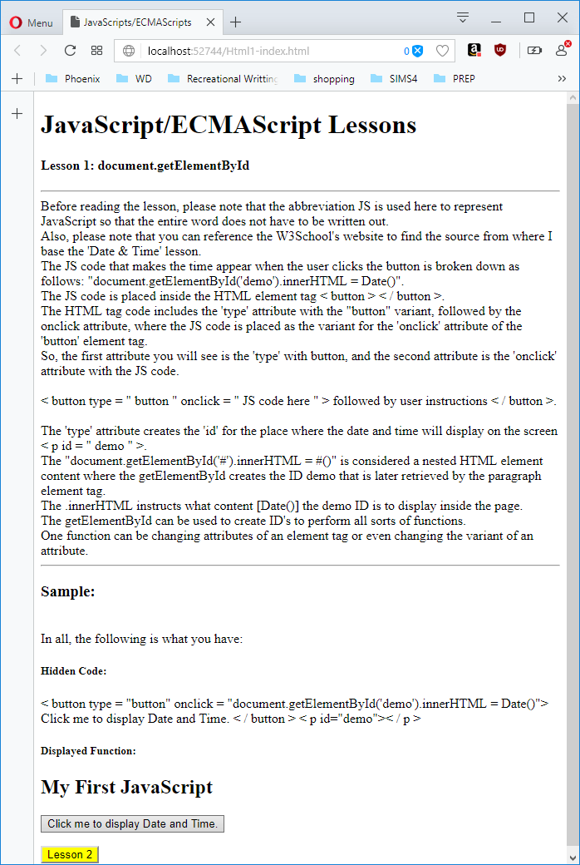

Figure 1

**LESSON 2**

<!DOCTYPE html>

<html lang="en" xmlns="http://www.w3.org/1999/xhtml">

<head>

<meta charset="utf-8" />

<title></title>

</head>

<body>

<p>

<h1>JavaScript/ECMAScript Lessons Continued...</h1>

<h4>Lesson 2: HTML Attributes & Variable Changes</h4>

<hr />

As before, the abbreviation JS is used here as well as in all future lessons to represent JavaScript

so that the entire word does not have to be written out.<br /> Also, as mentioned before, you can reference

the W3School's website to find the source from where I base all lessons.<br />

Previously, the first half of the JS code was explained to show how it creates the id.<br />

Now in this lesson is the review of the part of the JS code that creates the action, through

the HTML portion of the getElementById attribute.<br />

In the last lesson, .innerHTML was used to display the date and time.<br /> This time HTML

instructs what to change in the display.<br /> The HTML is going to be used to

to change an attribute of an element tag and it will be used to change the variant of an attribute.<br />

In the first portion of the sample, you see the HTML element for source being used to swap-out the image when the

button is clicked.<br />

In the second portion of the sample, you see the HTML element for Style being used to make the image vanish and return.<br />

The samples just show that any HTML element can be used to make changes, so long the id is created

with the document.getElementById part of the attribute.

<hr />

<h3>Sample:</h3><br />

In all, the following is what you have:

</p>

<p>

<h5>Hidden Code: </h5>

< button onclick = "document.getElementById('bigEyes').src='pic_eyesopen.gif'">Wake up< /button>

< img id="bigEyes" src="pic_eyesopen.gif" style="width:100px">

< button onclick="document.getElementById('bigEyes').src='pic_eyesshut.gif'">Go to sleep< /button>< br />

< button type="button" onclick="document.getElementById('bigEyes').style.display='none'">Go away< /button>

< button type="button" onclick="document.getElementById('bigEyes').style.display='block'">Come back< /button>

</p>

<!------------------------------------'HTML Content' Script------------------------------------------>

<!--Code script is the from W3Schools Website for displaying 'HTML Content'.-->

<!--https://www.w3schools.com/js/js_intro.asp.-->

<!--This is the start of the 'HTML Content' script.-->

<pre>

<h5>Displayed Function: </h5><h2>Big Eyes</h2>

<img id="bigEyes" src="pic_eyesopen.gif" style="width:100px">

<button onclick="document.getElementById('bigEyes').src='pic_eyesopen.gif'">Wake up</button>

<button onclick="document.getElementById('bigEyes').src='pic_eyesshut.gif'">Go to sleep</button>

<button type="button" onclick="document.getElementById('bigEyes').style.display='none'">Go away</button>

<button type="button" onclick="document.getElementById('bigEyes').style.display='block'">Come back</button>

</pre>

<!--This is the end of the 'HTML Content' script.-->

<!--------------------------------------------------------------------------------------------------->

<button type="button" onclick="javascript:window.location.href='Html1-index.html'" style="background-color:yellow">Lesson 1</button>

</body>

</html>

*\*See Opera Browser Tests in Figures 2 through 5 for this exercise.*

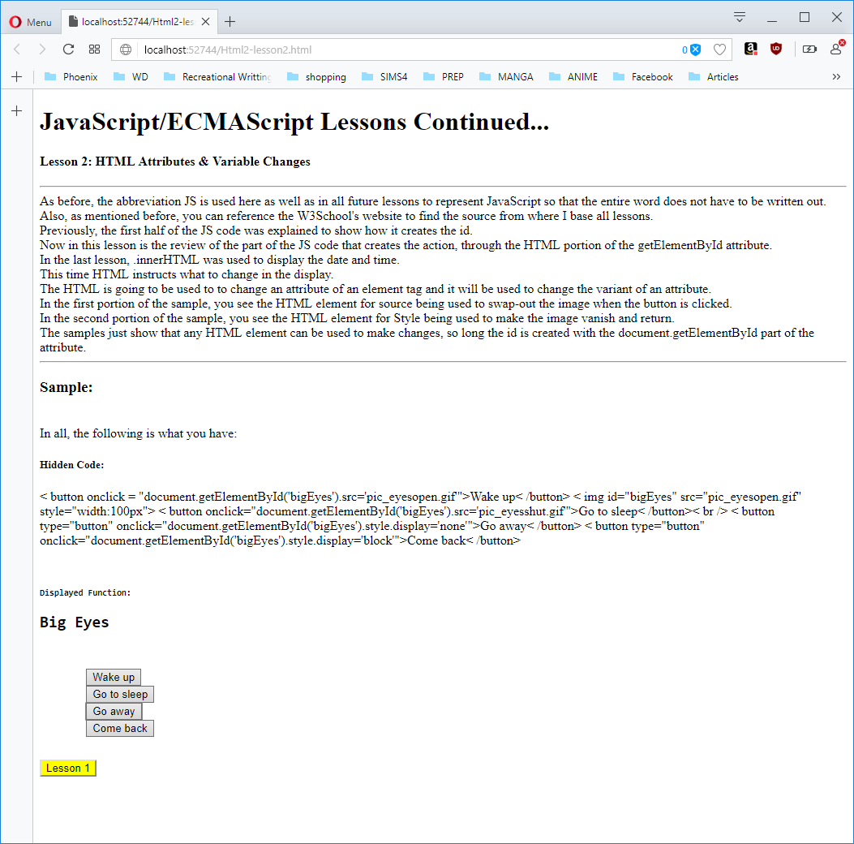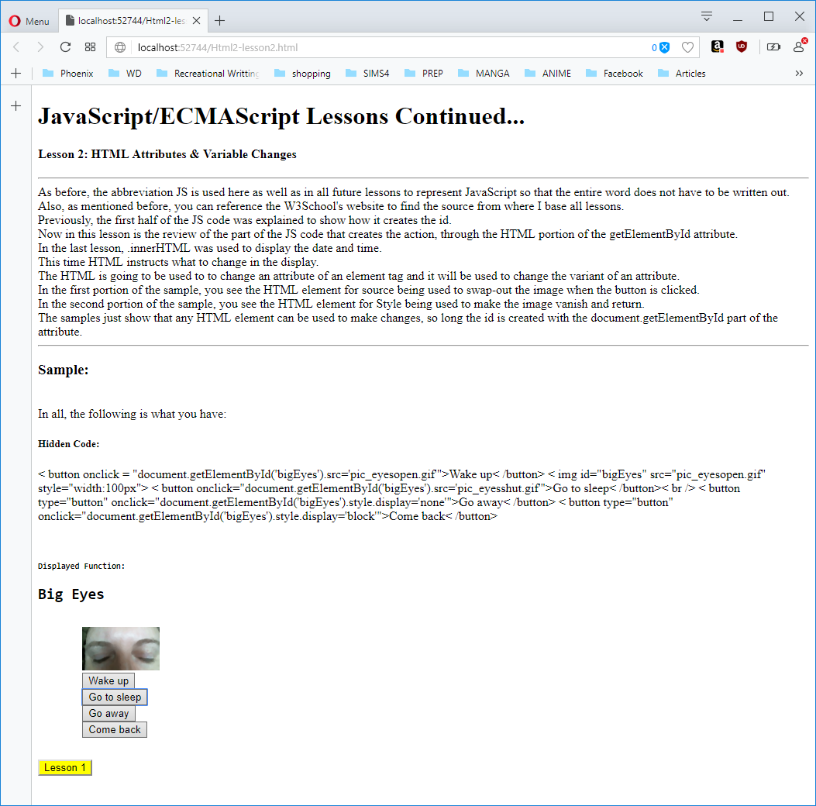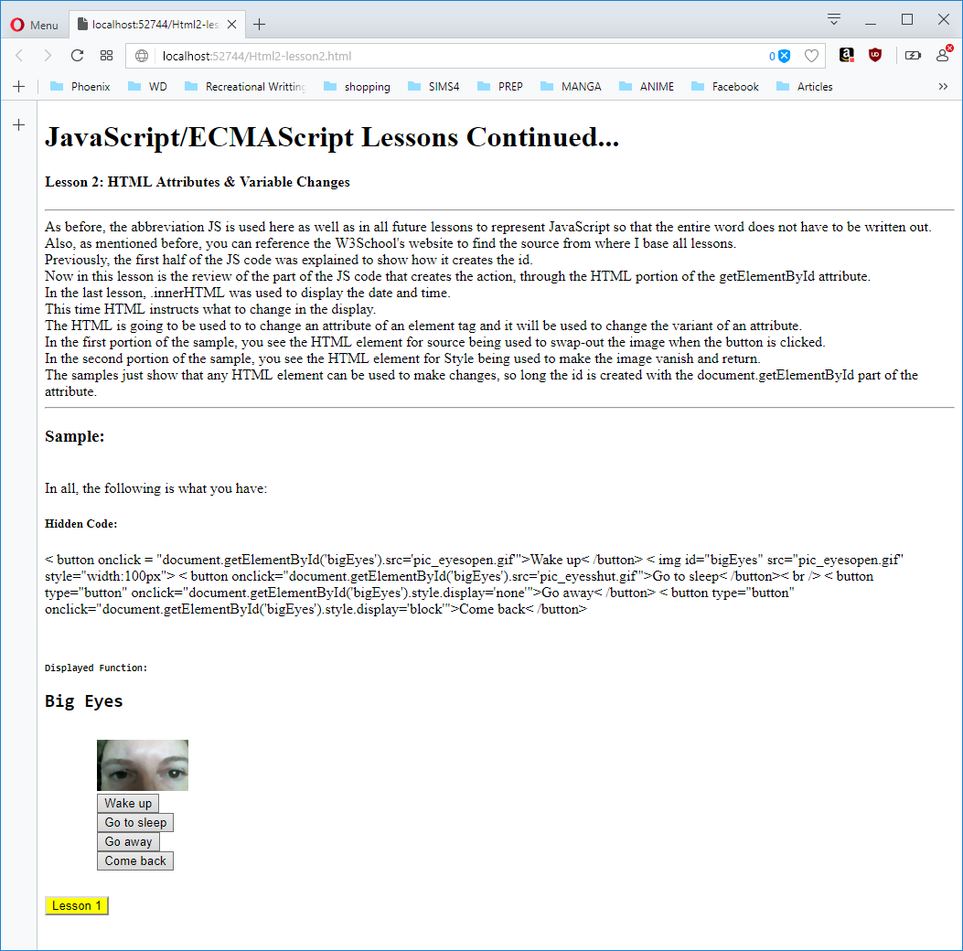

Figure 4: Go away button test

Figure 3: Go to sleep button & Come back button test

Figure 2 – On load, ‘Wake up’ button & ‘Come back’ button tests