Favorite Bus Trips is a mobile application that helps users manage a list of their favorite bus trips. Users can add, update, delete, and mark bus trips as visited. The application also allows users to view visited trips and track travel history. Data should be stored locally using AsyncStorage or SQLite, and the app must be compatible with both Android and iOS platforms.
Data Structure
Each Bus Trip includes the following attributes:
Field | Type | Description
id | integer | Unique identifier (auto-generated)
busNumber | string | Bus number or bus code, e.g., "123", "FUTA-01", "TB-15"
route | string | Bus travel route, e.g., "Ho Chi Minh City – Can Tho", "Can Tho – Rach Gia"
operator | string | Bus operating company, e.g., "Phuong Trang", "Thanh Buoi", "Mai Linh"
rating | integer | User rating from 1 to 5, e.g., 4
visited | boolean | Travel status of the bus trip. true = Visited, false = Unvisited

General Requirements:
- A Resources folder containing sample data is provided. The project must include images and provided assets.
- Project folder name: su26_studentID (Replace studentID with your actual student ID).
- Development Tool: Visual Studio Code.
- Technology: Use NPM and EXPO to build the application.
- Data Storage: Use AsyncStorage or SQLite to manage data.
- Use Bottom Tab Navigator to switch between screens.
- UI Enhancement: Implement proper styling, icons, and interactive elements to improve user experience.

Tasks to be Completed:

Task 1: Favorite Bus Trips List Screen (Home Screen) (2.5 points)
Create the main screen that displays a list of favorite bus trips (see Figure 1). This screen must include:
- Display a list of favorite bus trips using FlatList. Each item must display: Bus Number, Route, Operator, Rating, and Visited/Unvisited Status (0.5 points)
- Use Bottom Tab Navigator to switch between screens. (0.5 points)
- When the app runs for the first time, the bus trip list should be empty. Users can add new bus trips using an "Add Bus Trip" button. (0.5 points)
- Display an image banner on Home Screen List screen. (0.5 points)
- Tapping on a bus trip should navigate to a detailed view screen (0.5 points)

Task 2: Add New Bus Trip Screen (1.5 points)
Create the "Add New Bus Trip" screen (see Figure 3) where users can enter detailed information for a new bus trip:
- Include the following fields: Bus Number, Route, Operator, and Rating (from 1 to 5)
Note: The id field is automatically generated, and the visited field defaults to false. Users do not need to input these two fields.
- Save the new bus trip to database and immediately update the Home screen list (1.0 point)
- Pressing the Back button should return to the Home screen. (0.5 point)

Task 3: Bus Trip Detail and Edit Screen (Detail Screen) (3.5 points)
Create the "Bus Trip Detail" screen (see Figure 4), allowing users to view and update the detailed information of a bus trip
Note: Display the ID field as read-only.
- The detail screen must provide the following actions:
  - Update: Save changes to Bus Number, Route, Operator, and Rating (1.0 point)
  - Mark Visited/Unvisited: Toggle the visited status of the bus trip. (1.0 point)
  - Delete: Remove the bus trip from the list completely (1.0 point)
  - Pressing the "Back" button should return to the Home screen. (0.5 point)

Task 4: Visited Bus Trips Screen (1.5 points)
Create the screen (see Figure 5) that displays all bus trips the user has marked as visited:
- Display a list of visited bus trips using FlatList. (0.5 point)
- Show the total number of Unvisited bus trips for comparison purposes. (1.0 point)

Task 5: Additional Requirements (1.0 point)
- Validate input fields (all fields are required, Rating must be between 1 and 5) and provide immediate feedback for add, update, delete, and mark visited/unvisited actions, including confirmation before deletion (see Figure 2). (0.5 points)
- Apply proper styling, icons, and layout to improve usability. (0.5 points)

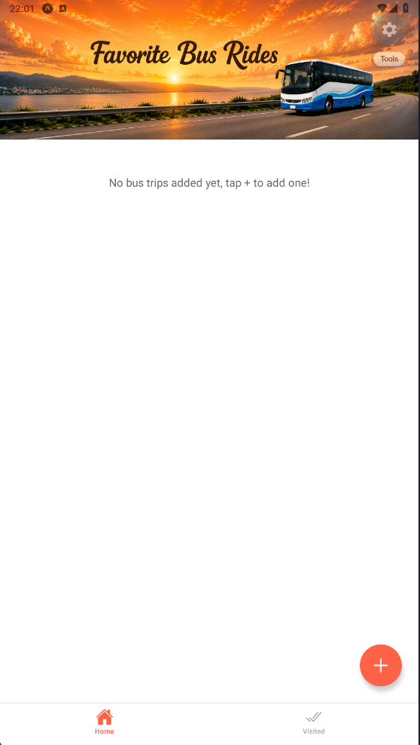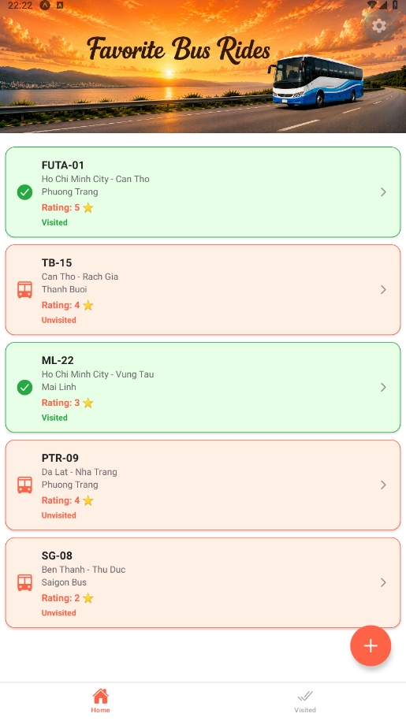
Figure 1: Home Screen before and after adding a bus trip.

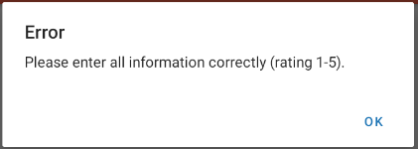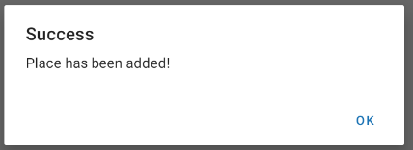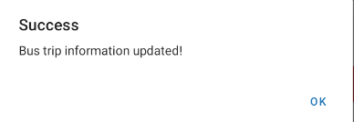
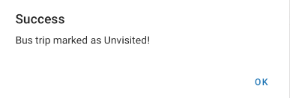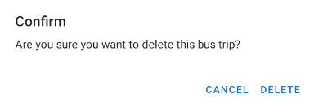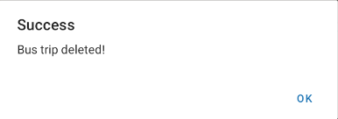
Figure 2: Screens showing input validation, delete confirmation dialog, and feedback messages for add, update, delete, and mark visited/unvisited actions.

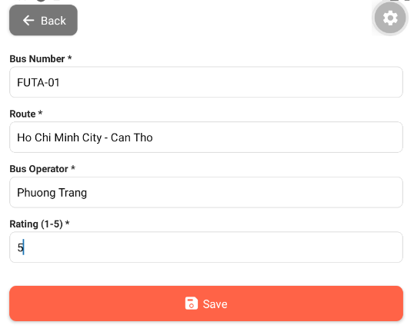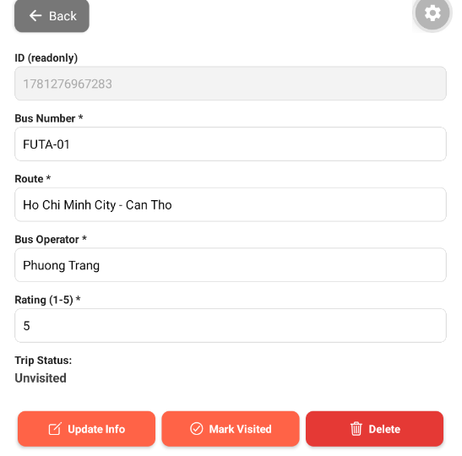
Figure 3: Add New Bus Trip Screen with input fields, validation, and a submit button.
Figure 4: Favorite Bus Trip Detail Screen with options to update, delete, or mark as visited/unvisited.

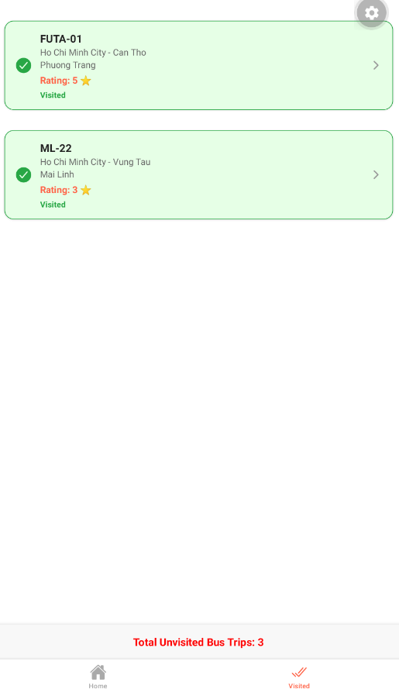
Figure 5: Displays visited bus trips and shows the total number of unvisited bus trips at the bottom.

