Flutter Shopping Platform App Demo

This is a mobile timer demo application built with **Flutter** and **Dart**.

Each task has its own smooth countdown animation, customizable duration, and colorful UI interactions.

Project Structure

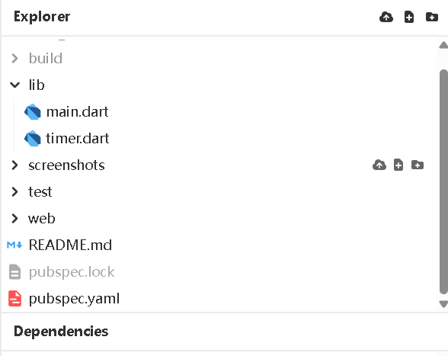

.

├── lib/

│ ├── main.dart

│ └── timer.dart

├── screenshots/

├── pubspec.yaml

├── README.md

├── README.doc

# App entry point

# Multi-task timer screen & logic

# Optional folder for UI screenshots # Dependencies & metadata

# You're reading it!

# Doc version of readme file

📦 Dependencies (Changes to pubspec.yaml)

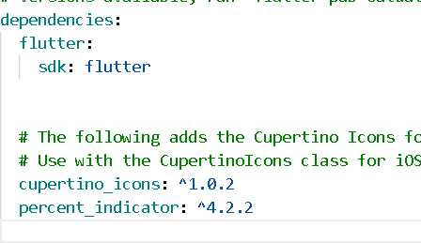

dependencies: flutter:

percent_indicator: ^4.2.2

Zapp Url: https://zapp.run/edit/appday86-zldm06laldn0? entry=lib/main.dart&file=lib/timer.dart

Github Url: https://github.com/tantss333/final_exam.git

📲 How to Install and Run the App

**Install Flutter SDK**

 [Flutter installation guide](https://flutter.dev/docs/get-started/install)

**Option-1: run on Zapp**

https://zapp.run/edit/appday86-zldm06laldn0? entry=lib/main.dart&file=lib/timer.dart

**Option-2 Clone github repository:**

git clone https://github.com/tantss333/final_exam.git cd final_exam

1. **Install dependencies:**

flutter pub get

1. **Run the app:**

 **In Zapp**: run the app on Zapp link directly

 **In IDE**: Be sure that load the project from the root folder, for example: **final_exam**

 In **Intellij**: click ▶ next to main.dart

 Or via terminal:

flutter run

🖼 Screenshots

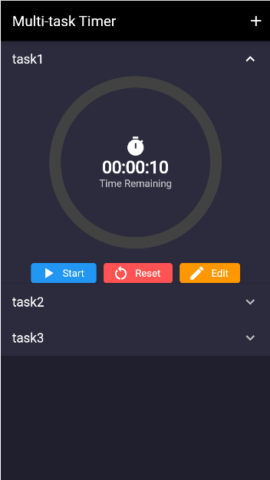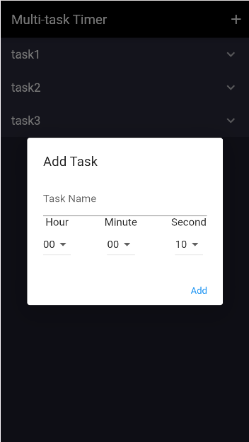

Main Page Add Task Page

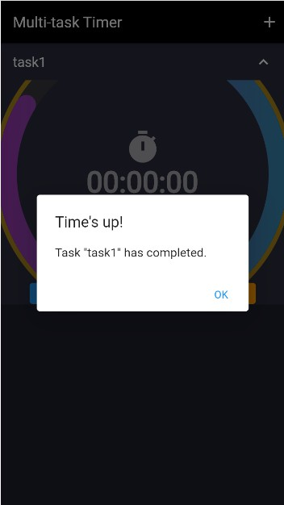 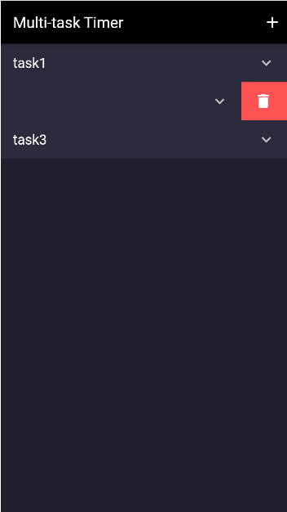

Prompt Function Delete Function

✨ Features

✅ Add multiple tasks with custom time (HH:MM:SS)

🎨 Dark-themed UI with colorful action buttons

⭕ Gradient circular countdown indicators

✨ Cool animated popup when a timer finishes

🛠 Edit, start, reset, or delete each task individually

🎮 How to Use

Tap ➕ to add a new task

Choose hour, minute, and second from dropdowns

Tap ▶ to start, 🔁 to reset,  to edit, or swipe to ❌ delete

When time is up, a glowing animated popup will appear

⚠ Notes

 Make sure assets are declared in pubspec.yaml (e.g. resource/images/)

 If you're using a custom folder like assets/, update image paths accordingly

📌 Author

 Student: Sheng Tan  Student ID: 1252550