TANUSHRI G V S

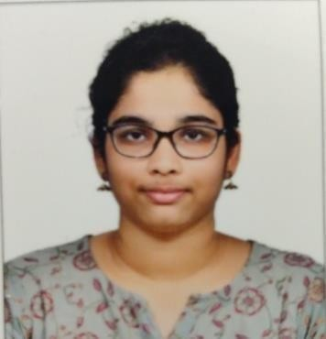**3rd Year B.Tech Artificial Intelligence and Data Science**

**Rajalakshmi Engineering College**

**Contact Information**

**E-mail**: [tshri033@gmail.com](mailto:tshri033@gmail.com)

**Phone Number** : 7305626895

**LinkedIn** : https:/[/www.linkedin.com/in/tanushri-g-v-s-](http://www.linkedin.com/in/tanushri-g-v-s-)

a2b848257?utm_source=share&utm_campaign=share_via&utm_content=profile&utm_medium

=android_app

# Skills

### Programming Languages:

* Proficient in C and C++ programming languages.
* Strong understanding of Core Java concepts and principles.
* Familiarity with Python , including basic syntax and data structures.
* Knowledge of Go-Lang fundamentals.

### Web Development:

* Experience in HTML , with the ability to create and structure webpages.
* Basic understanding of CSS for styling webpages.
* Basic understanding of Java Script.

### Databases:

* Basic knowledge of SQL.
* Familiar with MongoDB for handling NoSQL databases.

**Data Science & Analytics:**

* Basic understanding of Data Science principles and tools.
* Experience with data analysis techniques and data visualization.
* Familiarity with tools like Excel, Python (Pandas, Matplotlib), and basic knowledge of machine learning concepts.

### Artificial Intelligence:

* Basic understanding of prompt engineering.
* Intermediate knowledge of Generative AI (GenAI).
* Basic understanding of Natural Language Processing (NLP) and Computer Vision (CV).

### SoftSkills:

* Excellent English communication skills, both written and verbal.
* Competent in public speaking, with the ability to articulate ideas effectively.

# Education

## Rajalakshmi Engineering College

* 2022 - Present
* CGPA : 8.48

## Nazareth Matriculation Higher Secondary School

* 12th Bio - Maths , 2021 - 2022
* Grade : 98%

## Nazareth Matriculation Higher Secondary School

* 10th , 2019 - 2020
* Grade : 96.6%

# Club Activities

* Board Member in Yi YUVA REC–MIS Team
* Member- Atrium Club REC , Debating Union REC , GDSC REC

# Internships

* Internship completed in Web Development and Design by Oasis Infobyte
* Internship completed in Artificial Intelligence by YHills Edutech
* Internship completed in Generative AI by Skillible
* Internship ongoing in Graphic Desing by Oasis Infobyte
* Internship applied for Full Stack and Data Science domains in Codetech IT Solutions

# Achievements

* First Prize in Just a Minute (JAM) competition
* Second Prize in Paper Presentation at Saveetha Engineering College

# Workshops

* Attended AI Workshop at IITM Research Park
* Completed Generative AI (GenAI) program from GDSC
* Completed SAWIT.AI Learnathon supported by GUVI , HCLTech , AICTE, NASSCOM and Women Techmakers by Google for Developers

**Certifications**

* Career Essentials in Generative AI by Microsoft and Linkedin
* Google AI Essentials in Coursera Sponsored by Grow with Google
* Ongoing – Learnathon by ICT Academy

# Projects

* A Home Page of Disney Plus Hotstar using HTML , CSS, and JS
* Ongoing Data Science project – Skill Recommendation and job recommender using resumes from users

# LanguagesKnown

## English

* Fluent in both spoken and written

## Tamil

* Fluent in both spoken and written

## French

* Basics in spoken and written