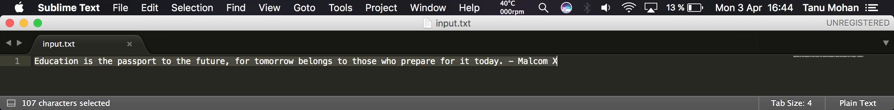 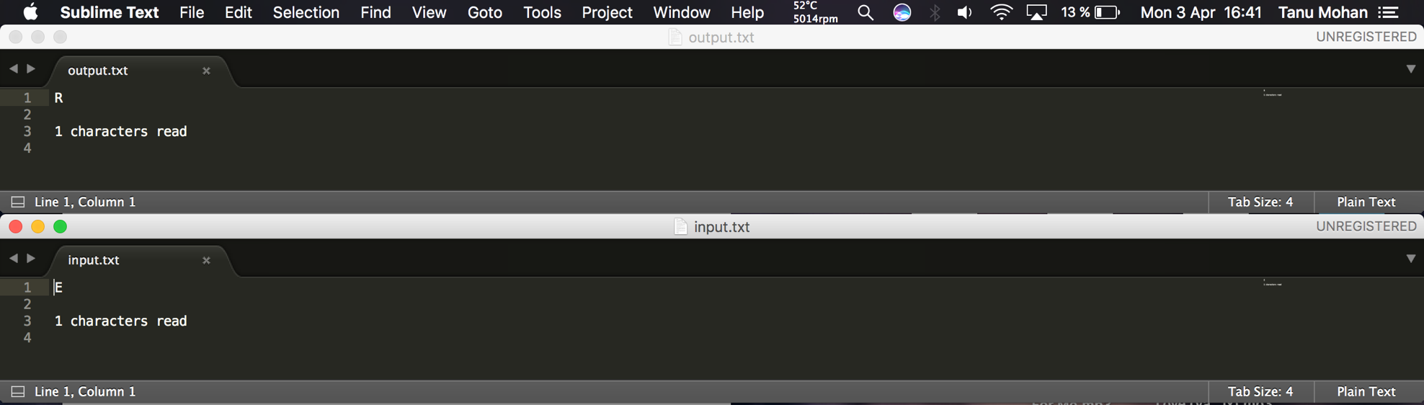 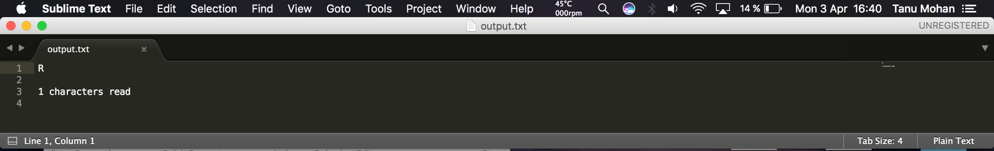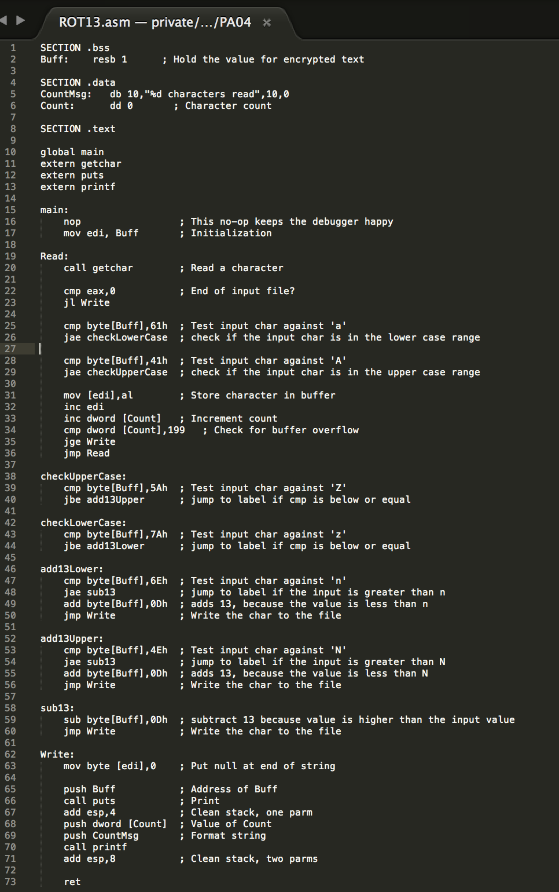

The count is different because I did not figure out why it did not want to encode every char. It encoded back properly but it is because it was only 1 char. Main problem is that it did not write the rest, I know it read every char because if I remove the ROT13 part it prints the whole text back.