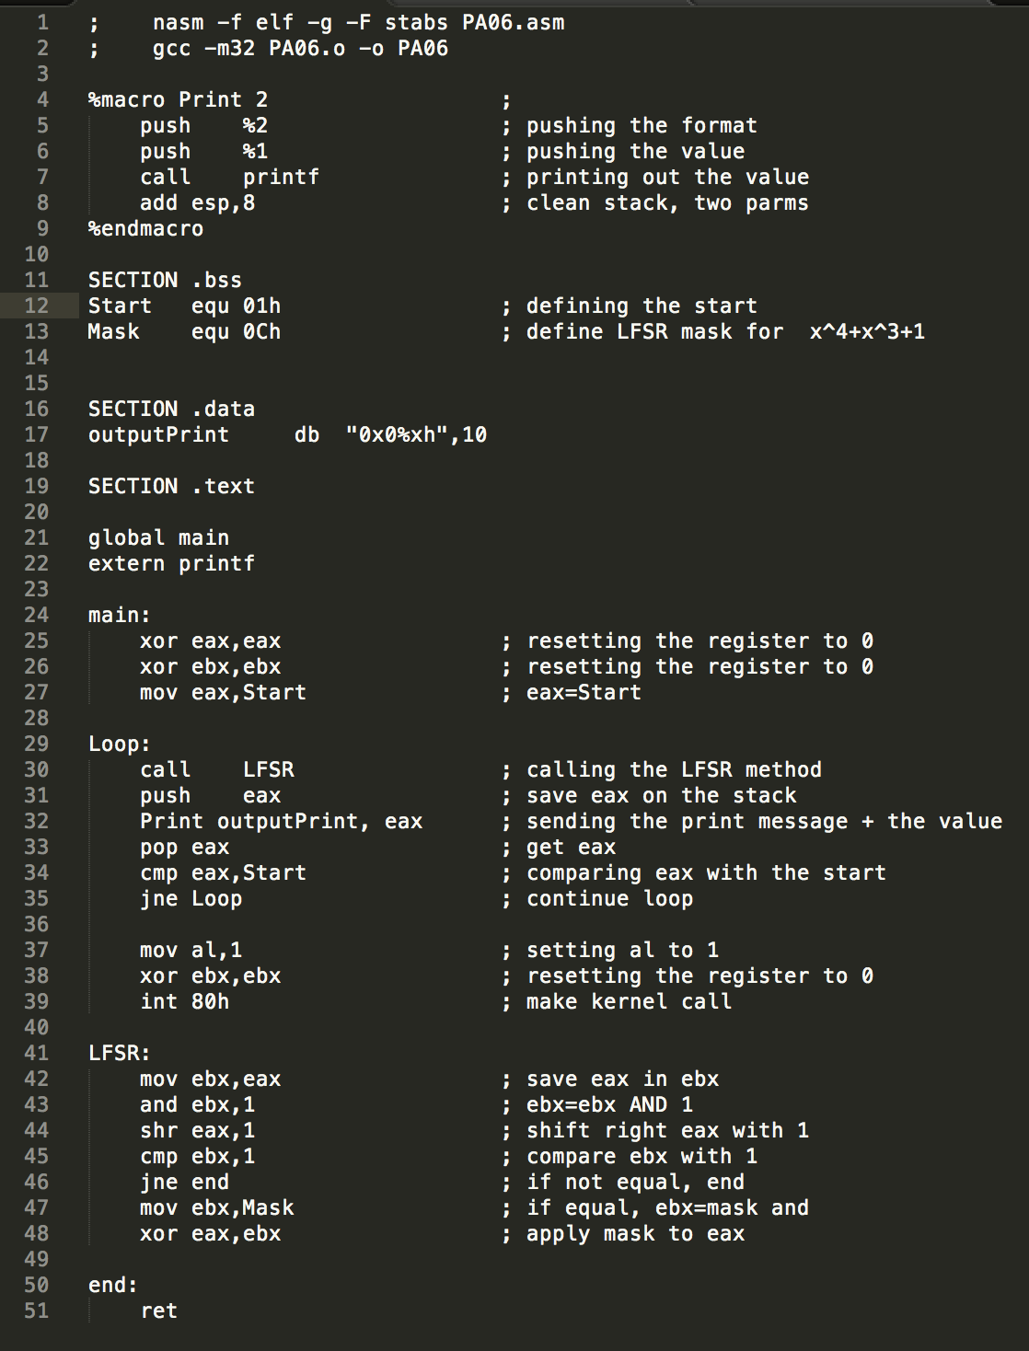

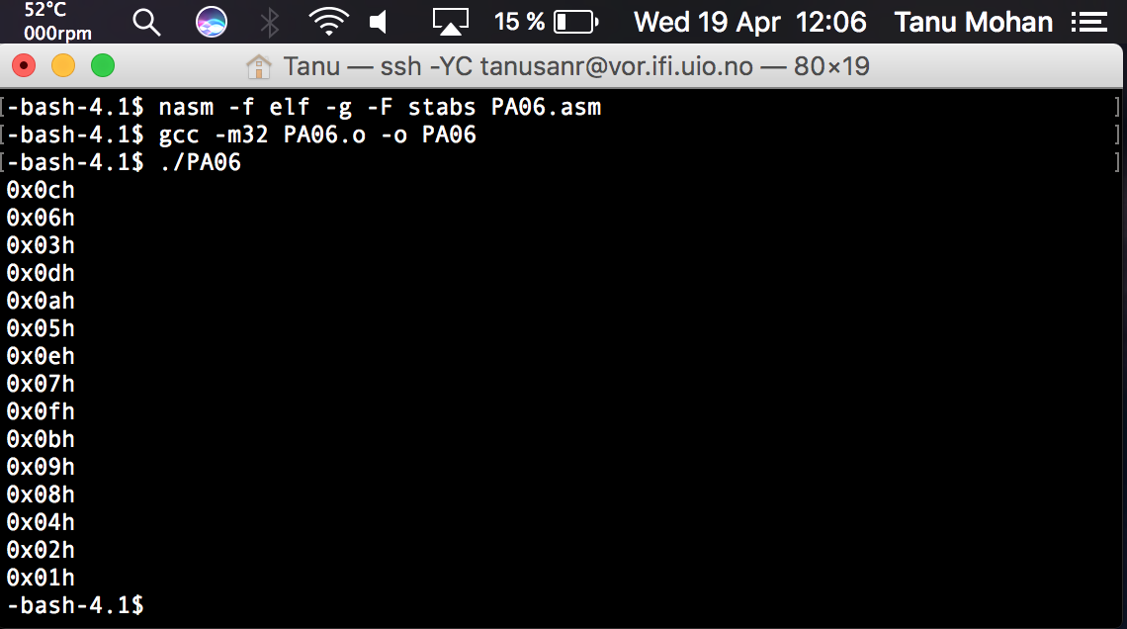

Tried to implement the print in bit, but it gave seg. fault or printed wrong so I left that part out. I think I did what the assignment asked, wasn’t to sure how to do it so I tried and now it prints in hex at least.