ANALYTICS REPORT &
INSIGHTS DOCUMENTATION
AI/ML Research Specialist Internship | Task 5
Prepared by: Tanvi Gadkar | BCA

1. Executive Summary
This report demonstrates how data analysis can support business decisions through clear objectives, key performance indicators (KPIs), visualizations, interpretation, and actionable recommendations. The case study uses an illustrative six-month retail dataset to examine revenue trends, order volume, product-category performance, and sales-channel contribution. Because the data is synthetic and created for demonstration, the figures are examples rather than claims about an actual company. In the sample, total revenue rises from ₹12,000 in January to ₹18,200 in June, while the online channel contributes more revenue than the in-store channel. Electronics is the highest-revenue category in the illustrative category comparison. The report recommends monitoring conversion, average order value, margins, and customer retention before allocating additional budget.

2. Business Objective and Key Questions
Business scenario: a small retail business wants a concise monthly performance report to understand revenue movement and decide where to focus marketing and operational effort.
- How is monthly revenue changing over the six-month period?
- Does order volume move in the same direction as revenue?
- Which product categories contribute the most revenue?
- How do online and in-store sales compare?
- What additional metrics are needed before making budget or inventory decisions?

3. Dataset and Methodology
The demonstration dataset contains monthly revenue and order counts, revenue by product category, and revenue by sales channel. It is a small synthetic dataset designed to demonstrate the reporting workflow. A real business report should use verified transaction-level data, document the date range and currency, and reconcile totals with the source system before publication.
Methodology: define business questions; inspect and validate data; calculate descriptive summaries and KPIs; compare trends and segments; create charts; interpret findings in context; identify limitations; and translate observations into prioritized next steps.

4. Key Performance Indicators (KPIs)
KPI | Illustrative result | Business meaning
January revenue | ₹12,000 | Baseline for the period
June revenue | ₹18,200 | End-of-period revenue
Revenue growth Jan–Jun | 51.7% | Change from January to June: (18,200 − 12,000) / 12,000
Total revenue across six months | ₹88,700 | Sum of monthly revenue values
Total orders across six months | 845 | Sum of monthly order counts
Online channel share | 59.1% | ₹51,200 / ₹86,700 across the two shown channels

5. Trend Analysis
Revenue increases overall from ₹12,000 in January to ₹18,200 in June, an illustrative rise of approximately 51.7%. The series has a small decline in March before growing in April, May, and June. This suggests a generally positive trend in the sample, but six observations are not enough to establish seasonality or forecast future performance. A real report should compare against targets, the same period last year, discounts, campaign dates, and gross margin.
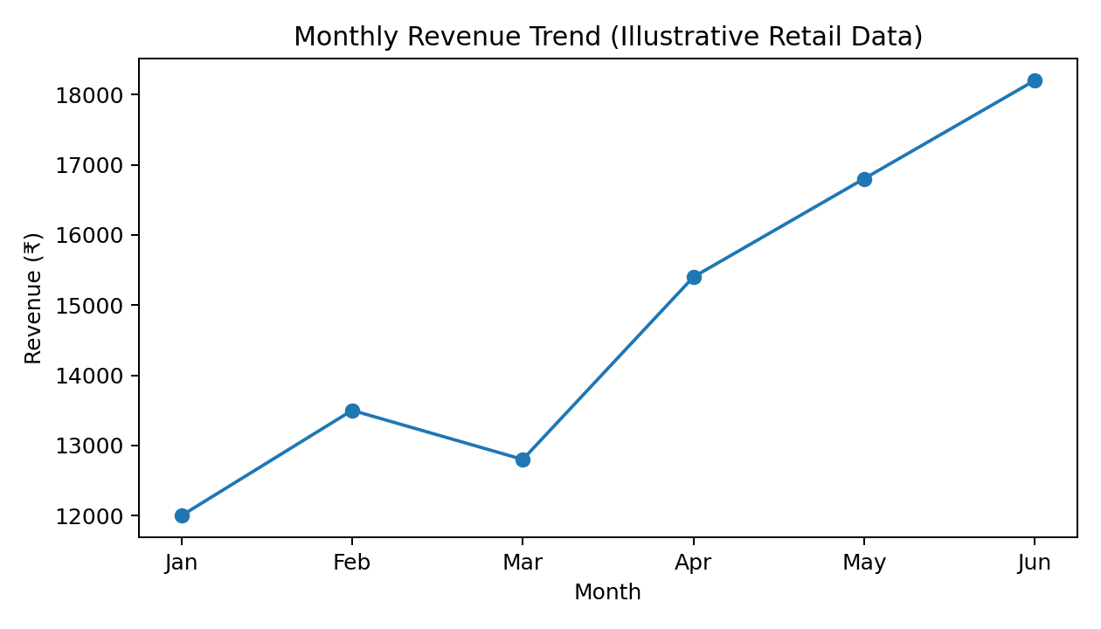

6. Product Category Analysis
In the illustrative category table, Electronics has the highest revenue at ₹28,500, followed by Home at ₹22,400, Clothing at ₹19,800, and Beauty at ₹16,000. Higher revenue does not automatically mean higher profit. Before increasing stock or marketing spend, the business should compare gross margin, returns, stock availability, and category-level customer acquisition costs.
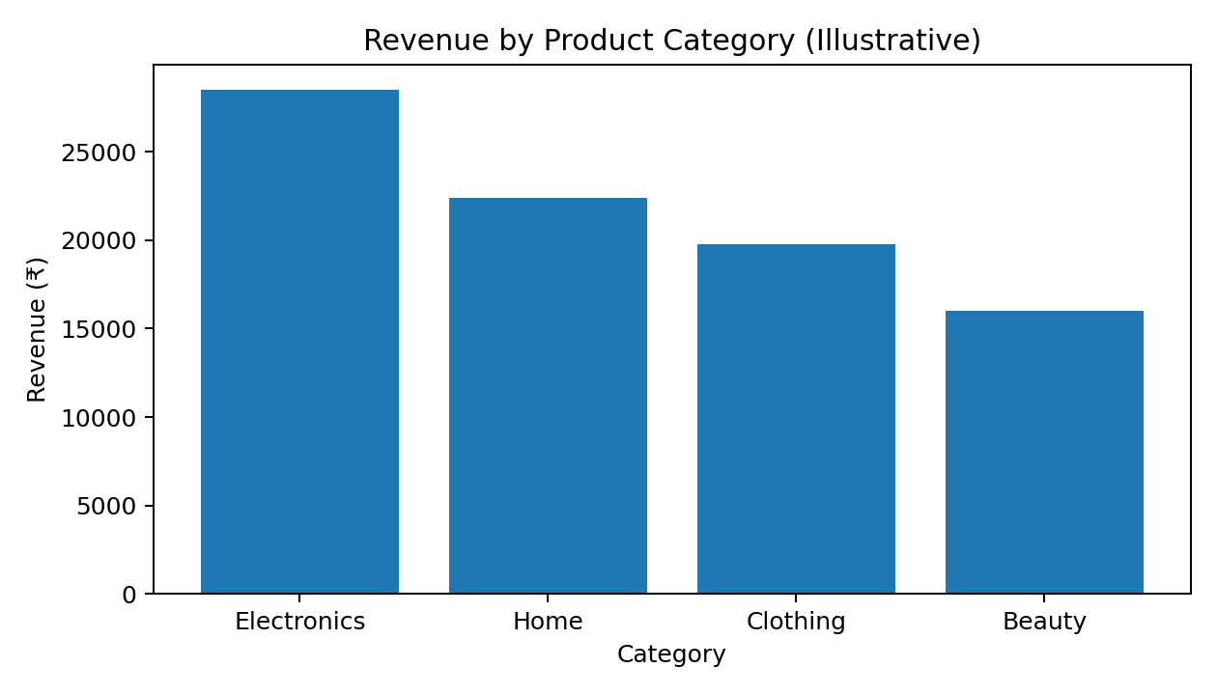

7. Sales Channel Analysis
The illustrative channel comparison shows ₹51,200 from online sales and ₹35,500 from in-store sales. Online accounts for approximately 59.1% of the combined ₹86,700 shown for these two channels. This indicates that online is the larger channel in this example. A real decision should also consider channel costs, fulfillment expense, customer experience, returns, and profit rather than revenue alone.
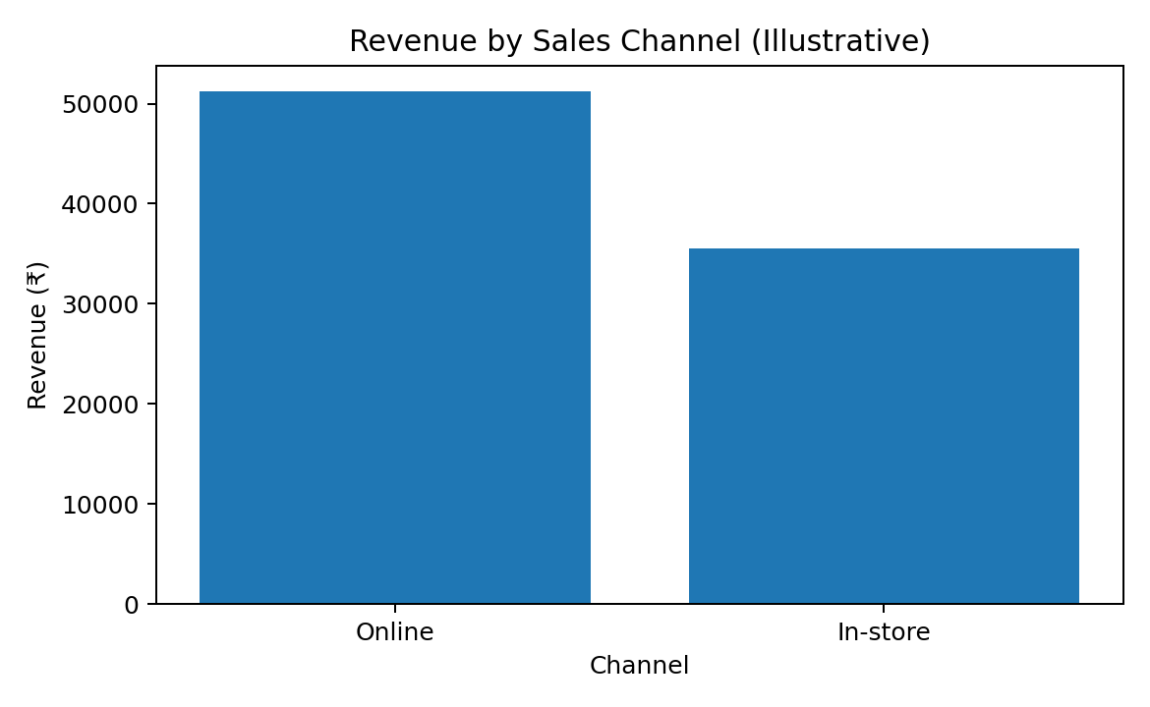

8. Data Quality and Reporting Controls
- Validate data types, date formats, currency units, and consistent category names.
- Check for missing transaction dates, revenue values, order IDs, and product categories.
- Identify duplicate transaction IDs and investigate duplicates before deleting records.
- Confirm whether revenue includes taxes, discounts, shipping, cancellations, and refunds.
- Reconcile chart totals and KPI calculations with the source system.
- Label synthetic or incomplete data clearly and avoid presenting illustrative findings as actual company performance.

9. Business Insights and Interpretation
- Overall revenue grows across the six-month illustrative period; the business should investigate which products, campaigns, or customer segments contributed to the increase.
- March shows a temporary decline relative to February; review stock availability, promotional activity, pricing, and traffic for that month before assigning a cause.
- Electronics is the largest revenue category in the sample; evaluate its margin and stock turnover to determine whether it deserves additional inventory investment.
- Online revenue exceeds in-store revenue in the sample; compare profitability and customer acquisition costs by channel before shifting budget.
- Order counts rise overall from 120 in January to 170 in June; comparing revenue per order would help separate order growth from changes in average order value.

10. Actionable Recommendations
Priority | Recommended action | Metric to monitor | Timing
High | Create a weekly KPI dashboard and validate revenue against source records. | Revenue, orders, refunds, gross margin | Start immediately
High | Investigate the March dip using campaign, inventory, and traffic data. | Sessions, conversion rate, stock-outs | Within 1 week
Medium | Review Electronics profitability and inventory turnover before increasing stock. | Gross margin, sell-through, returns | Within 2 weeks
Medium | Compare online and store contribution after channel costs. | Contribution margin, CAC, fulfillment cost | Within 2–3 weeks
Medium | Track average order value and repeat-purchase rate alongside order counts. | AOV, repeat rate, customer retention | Monthly

11. Suggested Reporting Dashboard
A stakeholder dashboard should show headline KPI cards for total revenue, revenue growth, orders, average order value, and gross margin; a monthly revenue line chart; a category comparison bar chart; a channel comparison; and filters for date, product category, and channel. Every chart should have a clear title, labeled axes, consistent units, and a short interpretation. The dashboard should distinguish actual values from targets and identify the last refresh date.

12. Conclusion and Limitations
This report illustrates a professional analytics workflow: establish business questions, define KPIs, examine trends and segments, communicate findings visually, acknowledge limitations, and recommend measurable actions. In the sample, revenue increases over the period, Electronics leads the category comparison, and online is the larger of the two sales channels shown. These results are illustrative only because the dataset is synthetic, small, and aggregated. The report does not establish why performance changed, and revenue alone cannot measure profitability. Before acting, stakeholders should validate the underlying data and add margin, costs, customer, inventory, and target information.

13. Example Python Calculations
import pandas as pd
import matplotlib.pyplot as plt
monthly = pd.DataFrame({
"month": ["Jan", "Feb", "Mar", "Apr", "May", "Jun"],
"revenue": [12000, 13500, 12800, 15400, 16800, 18200],
"orders": [120, 130, 125, 145, 155, 170]
})
monthly["revenue_per_order"] = monthly["revenue"] / monthly["orders"]
growth = (monthly["revenue"].iloc[-1] - monthly["revenue"].iloc[0]) / monthly["revenue"].iloc[0] * 100
print("Total revenue:", monthly["revenue"].sum())
print("Total orders:", monthly["orders"].sum())
print(f"January to June revenue growth: {growth:.1f}%")
print(monthly)
monthly.plot(x="month", y="revenue", kind="line", marker="o", legend=False)
plt.title("Monthly Revenue")
plt.ylabel("Revenue (₹)")
plt.tight_layout()
plt.show()

14. References
1. Pandas documentation: https://pandas.pydata.org/docs/
2. Matplotlib documentation: https://matplotlib.org/stable/
3. Microsoft Power BI documentation: https://learn.microsoft.com/power-bi/
4. Google Analytics Help: https://support.google.com/analytics/
5. The figures and metrics in this report are based on an illustrative synthetic dataset created for learning purposes.
End of Report

