FINAL DATA SCIENCE
CAPSTONE PROJECT
Intelligent Career Recommendation System
AI/ML Research Specialist Internship | Task 6
Prepared by: Tanvi Gadkar | BCA

1. Executive Summary
This capstone proposes an Intelligent Career Recommendation System that helps learners explore career paths based on their skills, interests, experience, and learning goals. The system is designed as a decision-support prototype, not as a definitive authority on a person's future. It combines structured skill profiles, a transparent weighted matching approach, exploratory analysis, and visual reporting to produce understandable recommendations and skill-gap suggestions. This report documents the problem, requirements, data approach, methodology, evaluation plan, visualizations, limitations, and future improvements. Any sample match scores shown are illustrative and are not measured model performance.

2. Problem Statement
Students and early-career learners may find it difficult to choose a suitable technology career because job titles, required skills, and learning pathways can be confusing. A structured tool can compare a learner's self-reported skills with role-specific skill requirements and suggest roles to explore, along with missing skills to learn.

3. Objectives
- Collect a learner profile containing skills, interests, experience level, and preferred work areas.
- Represent career roles using transparent skill-requirement profiles.
- Calculate an interpretable match score for each role.
- Identify skill gaps and suggest learning priorities.
- Visualize role matches and skill profiles.
- Evaluate recommendation quality using test cases and user feedback before deployment.

4. Scope and Requirements
Scope: a prototype that accepts a learner's skill ratings and compares them with a small curated set of technology career profiles. The initial roles may include Data Analyst, Data Scientist, Machine Learning Engineer, and Business Intelligence Analyst. The system provides explanations and learning suggestions. It does not guarantee employment, salary, or job placement.

Functional requirements
- Allow a learner to enter or update skill ratings on a consistent scale.
- Store role profiles and required skills in a structured format.
- Compute and rank role-match scores.
- Display top recommendations with the reasons behind each match.
- Show skill gaps and suggested next learning topics.
- Allow results to be reviewed and regenerated after profile updates.

Non-functional requirements
- Clear, accessible interface and understandable explanations.
- Consistent calculations and reproducible results.
- Protect profile data and collect only information needed for recommendations.
- Avoid biased or deterministic claims about a learner's ability or future.
- Document assumptions, limitations, and evaluation criteria.

5. Data Collection and Preparation
For a prototype, role-skill requirements can be curated from publicly available occupational descriptions, job postings, and official learning or certification outlines. Each record should include role name, skill, expected proficiency, and source/date reviewed. Learner data can be collected through a voluntary self-assessment using a consistent scale. For privacy, the prototype should use fictional or anonymized learner profiles during development.
Preparation steps include standardizing skill names (for example, 'machine learning' and 'ML'), validating rating ranges, handling blank responses explicitly, removing duplicate role-skill rows, and separating role definitions from learner profiles. Feature engineering may include skill-gap values, normalized ratings, interest alignment, and a weighted match score. Any data gathered from job listings should be checked for date, geography, and role-specific context.

6. Methodology
A transparent weighted matching method is suitable for the first prototype because it is easy to explain and does not require a large labeled dataset. For each role, compare the learner's normalized skill ratings with the role's target skill levels. Weight important skills more heavily, calculate an overall match score, and list the largest skill gaps. A later version can compare this baseline with content-based recommendation or supervised learning if reliable labeled outcome data becomes available.

Example scoring approach
For each skill, let learner_rating and required_rating use the same 0–5 scale. A simple match component can be max(0, 1 − abs(learner_rating − required_rating) / 5). The role score is the weighted average of the skill components, multiplied by 100. This is a transparent prototype formula, not a scientifically validated measure of career suitability. Interests and stated goals can be incorporated as separate factors and displayed independently.

7. Illustrative Results and Visualizations
The following figures use invented example values to demonstrate how results might be displayed. They are not based on a completed user study or a trained model, and the scores must not be presented as verified accuracy or real predictions.
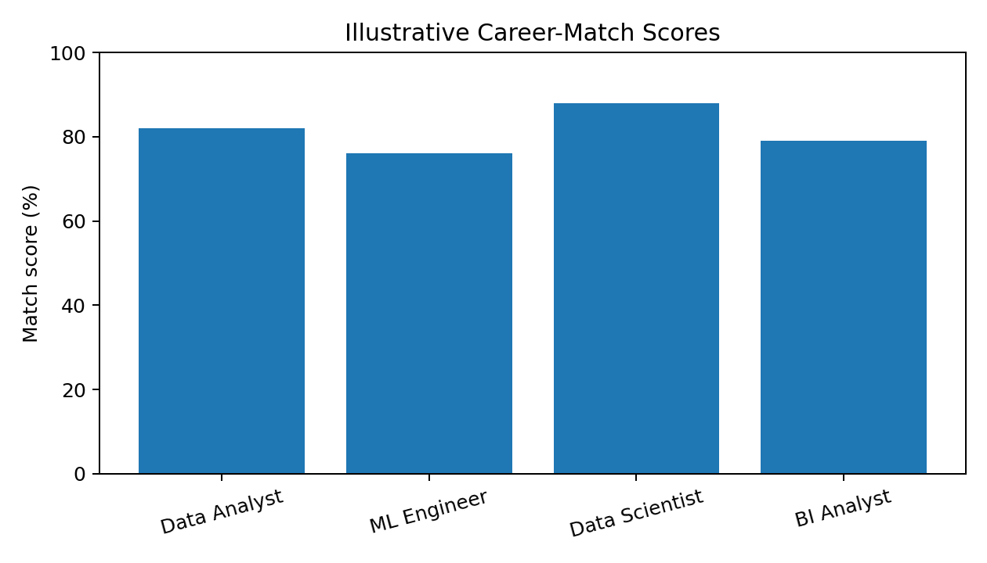
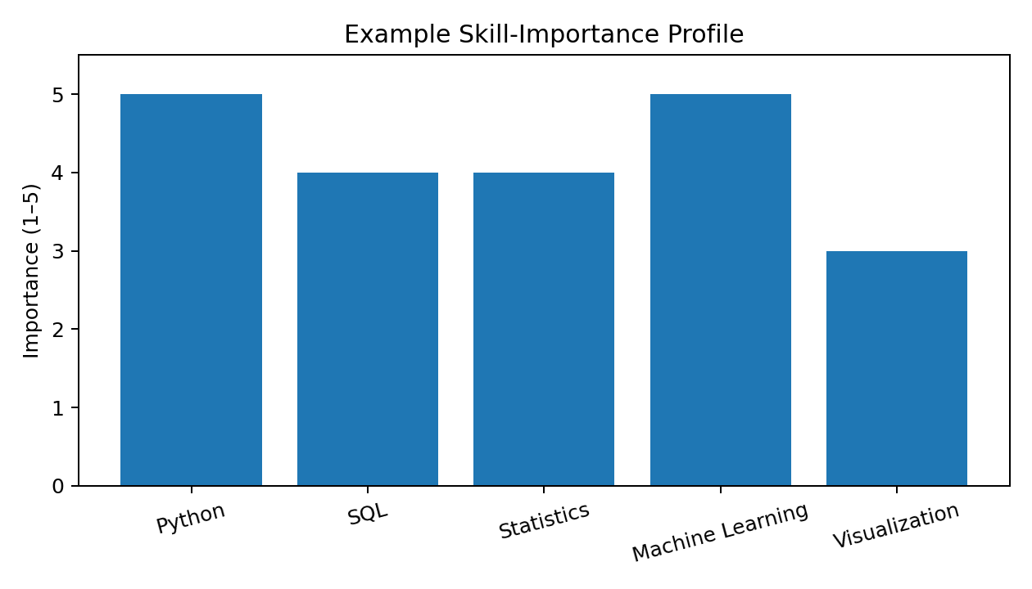
A real implementation should generate these charts directly from the recommendation engine's output and clearly show the profile inputs, scoring rules, date of role-profile review, and the explanation for each recommendation.

8. Evaluation Plan
Evaluation should include functional tests for valid and invalid ratings, blank fields, ties between roles, and profile updates. Unit tests should verify the scoring formula with hand-calculated examples. Recommendation quality should be assessed through structured feedback from volunteer users or career advisors, including whether suggested roles seem relevant and whether skill-gap explanations are useful. If a labeled benchmark dataset becomes available, suitable ranking metrics such as Precision@K or NDCG@K can be considered. No real evaluation score is claimed in this proposal.

9. Key Insights and Practical Recommendations
- Provide explanations alongside recommendations so learners can see which skills contributed to a match.
- Show skill gaps as learning opportunities rather than as judgments about ability.
- Allow multiple career paths to appear instead of presenting one role as the only correct choice.
- Review role requirements regularly because technology job descriptions change.
- Avoid collecting sensitive personal information and make profile data editable or removable.
- Ask users for feedback and test the system across varied skill levels and backgrounds.

10. System Architecture and Suggested Technology
Suggested prototype architecture: React frontend for profile entry and results; FastAPI backend for validation and recommendation logic; a structured role-skill dataset stored in CSV or SQLite; Pandas/NumPy for data preparation; Matplotlib or Seaborn for analysis charts; and pytest or equivalent tests for scoring and API behavior. A later version could add authentication, a database migration plan, deployment, and monitoring after privacy and security review.

11. Limitations and Ethical Considerations
- Self-reported skill ratings may be inaccurate and should not be treated as objective ability measures.
- Role requirements vary by company, location, seniority, and time.
- A weighted score reflects chosen assumptions and cannot guarantee job success or satisfaction.
- Without representative labeled data, supervised model accuracy cannot be meaningfully claimed.
- The system should be tested for unfair patterns and must not make high-impact decisions on behalf of employers.

12. Future Scope
- Expand role profiles using verified and regularly reviewed sources.
- Add curated learning resources mapped to individual skill gaps.
- Provide a comparison view for several roles and alternative learning paths.
- Run usability testing and document measurable evaluation results.
- Deploy a secure web prototype with consent, deletion controls, and clear disclaimers.
- Only explore machine-learning ranking after obtaining appropriate, representative, permissioned data.

13. Conclusion
The Intelligent Career Recommendation System is a practical capstone concept that brings together data preparation, feature engineering, transparent scoring, exploratory analysis, visualization, testing, and responsible communication. It aims to help learners explore possible career paths and understand the skills they may wish to develop. The current report defines the design and evaluation approach; illustrative charts are included for presentation only. A completed implementation should replace illustrative results with outputs generated by executed code and report test results honestly before being described as deployed or validated.

14. References and Resources
- Python documentation: https://docs.python.org/3/
- Pandas documentation: https://pandas.pydata.org/docs/
- NumPy documentation: https://numpy.org/doc/
- Scikit-learn documentation: https://scikit-learn.org/stable/
- FastAPI documentation: https://fastapi.tiangolo.com/
- React documentation: https://react.dev/
End of Report

