Global Olympic Sports Performance Analysis
Project Documentation: Data Analytics with Tableau
Submitted by: TANU MOURYA
Platform: Skillwallet | Date: 23rd October 2026

1. Abstract
This project analyses Olympic Games data from 1992 to 2026 across 60 countries to understand which factors drive Olympic success. Using Tableau, four datasets were joined, cleaned and visualized in two interactive dashboards and a data story. The dashboards were published to Tableau Public and embedded in a Flask web application. The analysis covers medal achievements, athlete participation, regional efficiency, host-nation advantage and the relationship between sports investment and medal outcomes.

2. Problem Statement
Olympic performance reflects athletic achievement and also the effectiveness of a country’s sports infrastructure, athlete development programmes and investment strategies. However, the volume of historical data makes it hard for stakeholders to see meaningful patterns. This project turns that data into dashboards and stories that support data-driven decisions.

2.1 Objectives
- Analyse medal achievements across nations and over time.
- Identify sport categories with the highest medal return per athlete.
- Compare regional medal efficiency and its link to investment.
- Highlight host-nation advantage across Olympic editions.
- Deliver the results as interactive Tableau dashboards, a story and a Flask web application.

2.2 User Scenarios
Persona | Role | How the project helps
Ms. Priya | National Olympic Committee performance strategist | Uses Avg Medals per Athlete by Sport Category and Global Performance Metrics by Country to target investment in high-yield sports (e.g., Rowing 6.916, Shooting 6.731).
Mr. Carlos | Sports investment analyst at an international funding agency | Uses the Investment vs. Medal Performance bubble chart and Medal Efficiency by Region pie to find overperformers (Slovakia, Georgia, Ethiopia) and high-potential regions.
William Robert | Broadcast journalist and data storyteller | Uses the medal trend line, host-nation comparison and regional donut chart to build documentary narratives.

3. Tools and System Requirements
Item | Details
Software | Tableau Desktop / Tableau Public; Python 3 with Flask; a text editor
Hardware | Dual-core CPU (Intel i5 / Ryzen 5 recommended), 8 GB RAM (16 GB recommended), 2–3 GB free storage
Operating system | Windows 10/11 (64-bit) or macOS
Browser | Latest Chrome, Edge or Safari
Front end | Bootstrap 5, Font Awesome, Tableau Embedding API v3

4. Data Collection
The dataset was downloaded from Kaggle, extracted to a local folder and connected to Tableau as flat CSV files.
File | Rows | Columns | Purpose
athletes.csv | 8,000 | 26 | Athlete-level participation and sport category
medal_results.csv | 910 | 19 | Medals, efficiency, investment per country and year
games_summary.csv | 18 | 10 | Per-edition totals and host country
alltime_country_rankings.csv | 60 | 13 | All-time country totals and regions

The files were related in Tableau using noc_code and year as common keys.

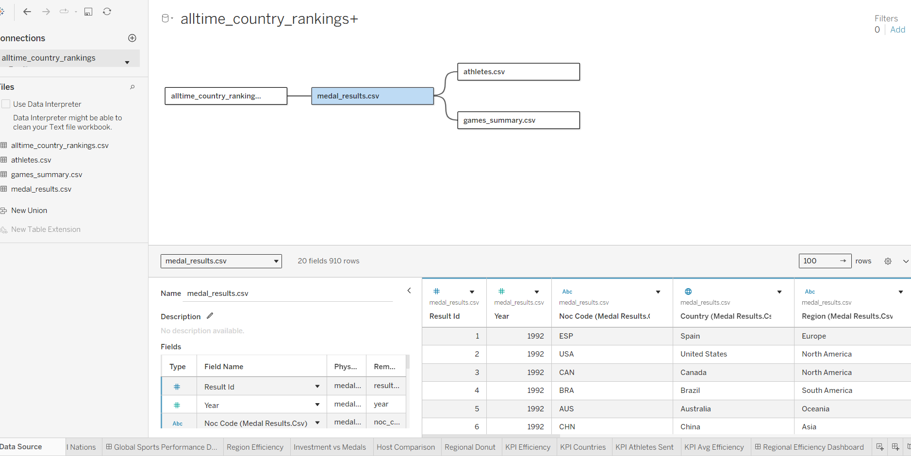

5. Data Preparation
- Data type validation: numeric fields (total_medals, medal_efficiency_pct, avg_efficiency_pct, sports_investment, athletes_sent, gold, silver, bronze, medal_points) were confirmed numeric; year was set as a discrete integer for time-based filtering.
- Null and zero handling: rows with null critical medal counts were identified and excluded from aggregated views using data-source filters.
- Relationship setup: the four CSVs were related on noc_code and year, enabling cross-dataset analysis.
- Region verification: seven region values were confirmed consistent (Africa, Asia, Europe, Europe/Asia, North America, Oceania, South America).
- Efficiency verification: medal_efficiency_pct was cross-checked against (total_medals / athletes_sent) × 100.
- KPI validation: Global Athlete Participation (910), Total Sports Categories (60), Total Nations (18) and Regional Performance Efficiency (33.2%) were validated before placement in dashboard tiles.

6. Data Visualizations
The project uses KPI cards, a filled map, line chart, horizontal and vertical bar charts, pie chart, packed-bubble chart and donut chart.
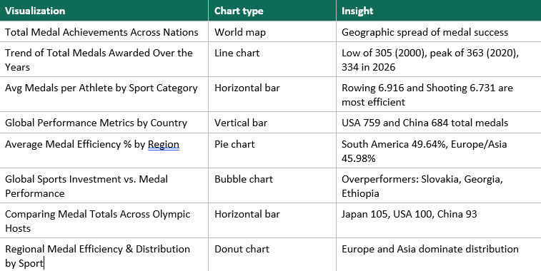

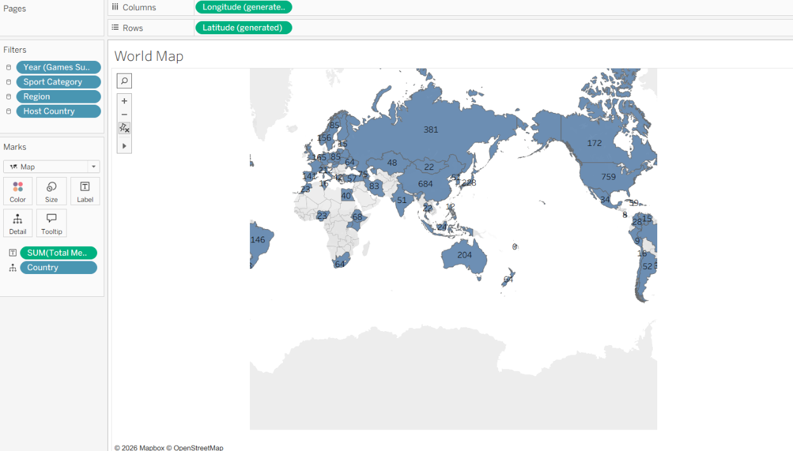

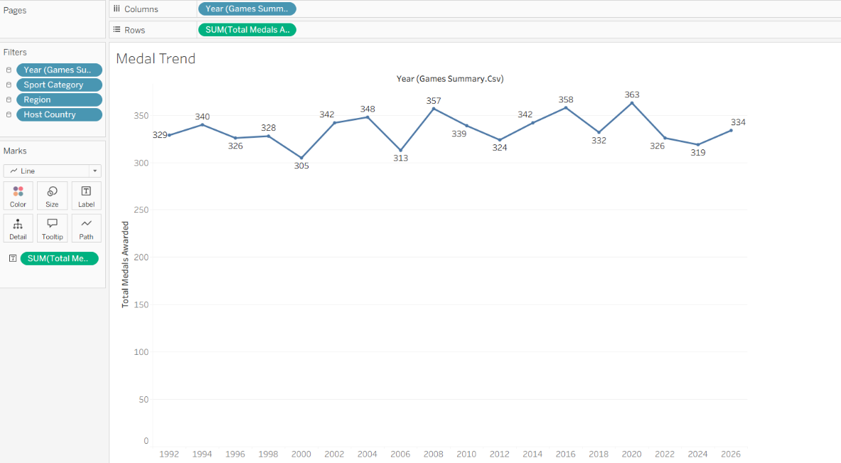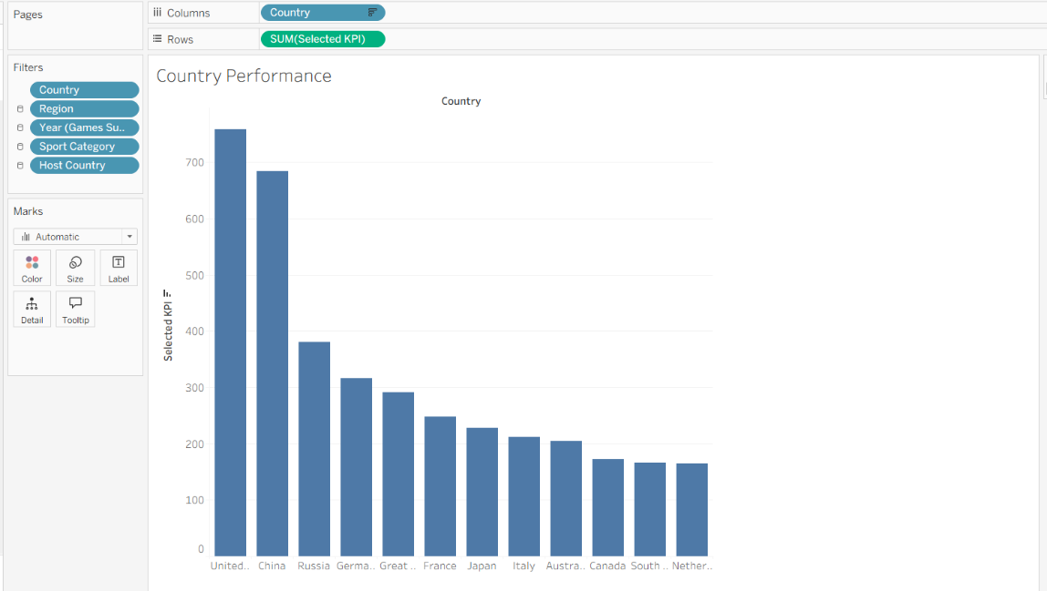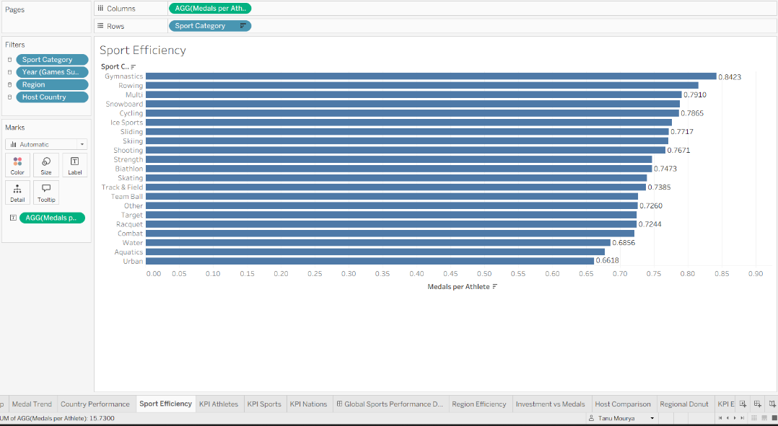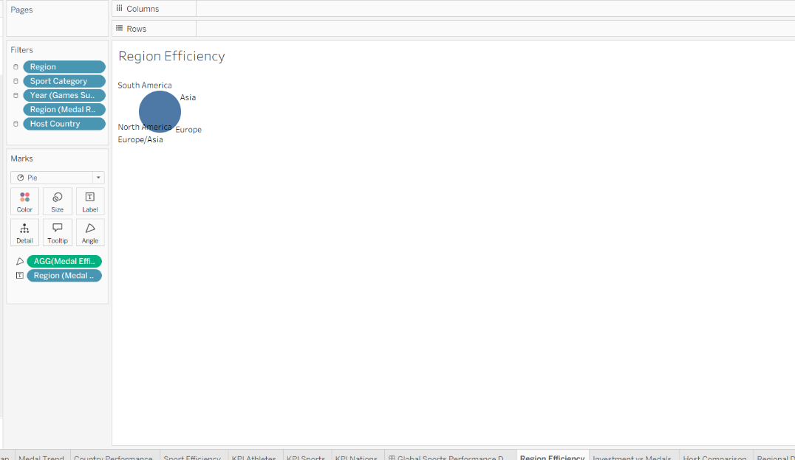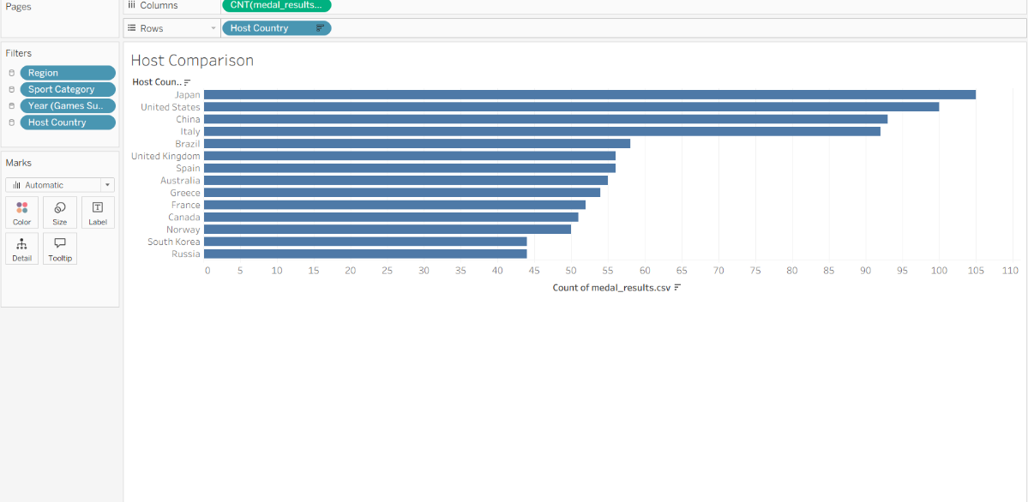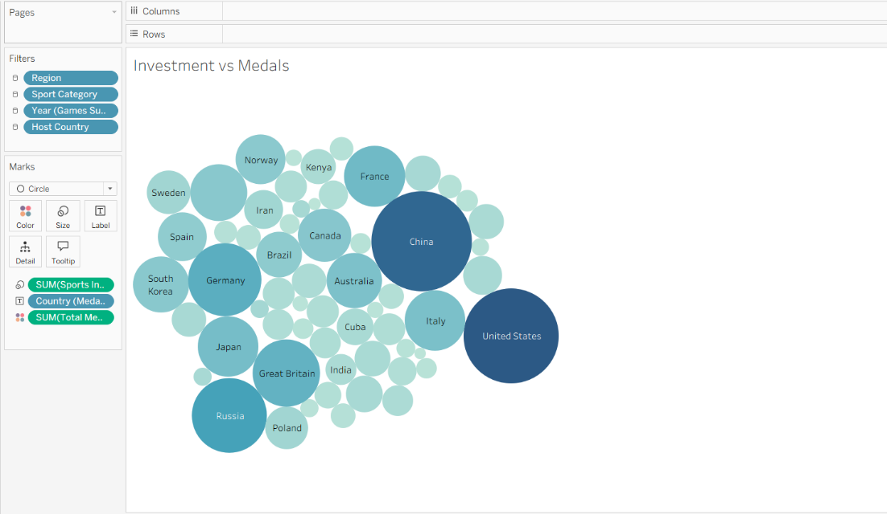

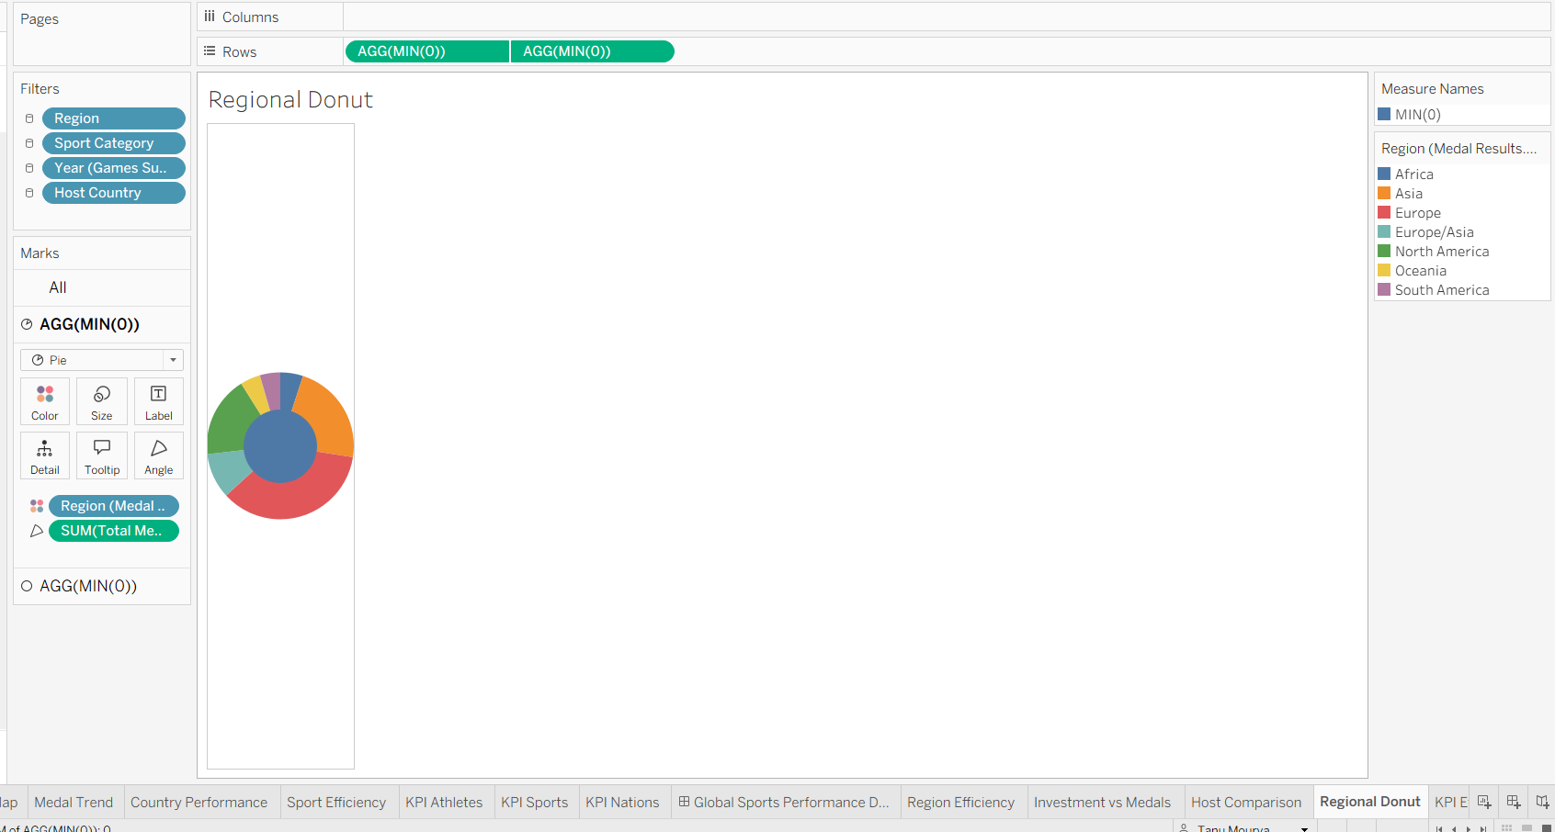

7. Dashboards
Two dashboards share a dark teal and green background with gold and white titles, KPI tiles at the top, a structured chart grid and filter panels on the right so that all charts update together.

7.1 Dashboard 1: Global Sports Performance Analytics
- KPIs: Global Athlete Participation (910), Total Sports Categories (60), Total Nations (18)
- Charts: world map, medal trend line, avg medals per athlete bar, global performance by country bar
- Filters: Country, Year, Sport Category, KPI Selector

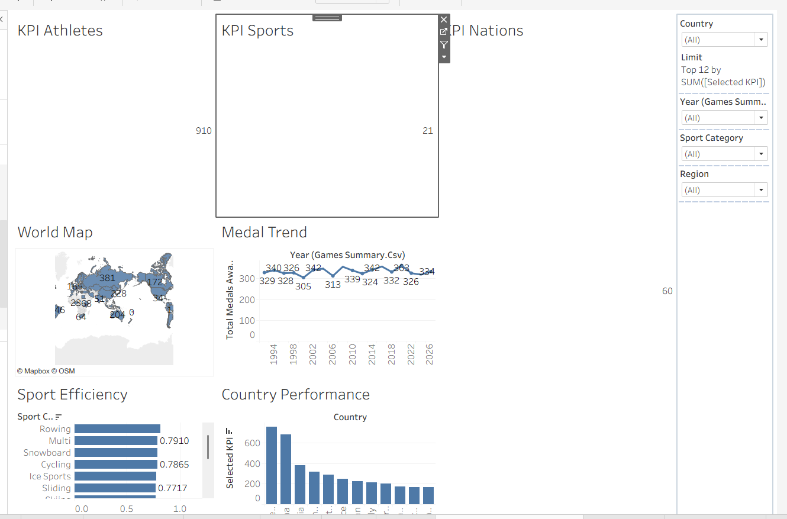

7.2 Dashboard 2: Olympic Performance and Regional Efficiency
- KPIs: Regional Performance Efficiency (33.2%), Countries Participating (60), Athlete Participation Count (8,000), Average Medal Efficiency (31.8%)
- Charts: regional efficiency pie, investment vs. medals bubble, host-nation bar, regional donut by sport
- Filters: Region, Host Country

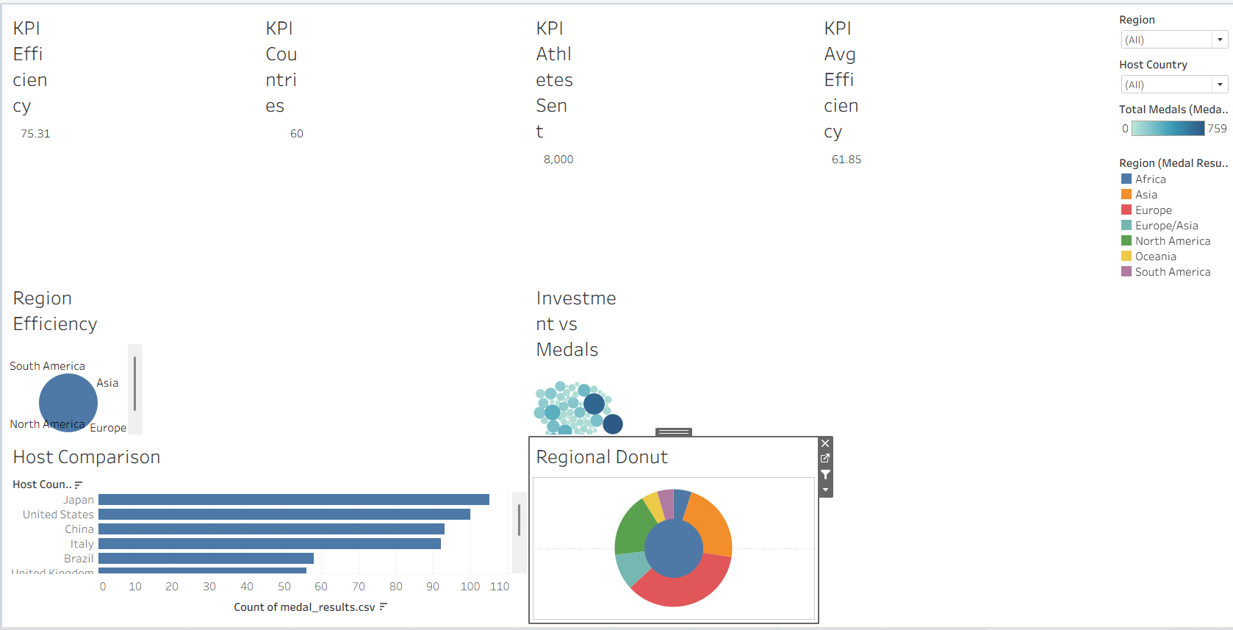8. Story
The Tableau story presents the findings as a sequence of scenes, each with a caption that states the takeaway.
- Scene 1: medal totals over time
- Scene 2: leading nations on the map and country bar chart
- Scene 3: most efficient sport categories
- Scene 4: regional efficiency and investment
- Scene 5: host-nation advantage
(Adjust the list above to match the number of scenes in your final story.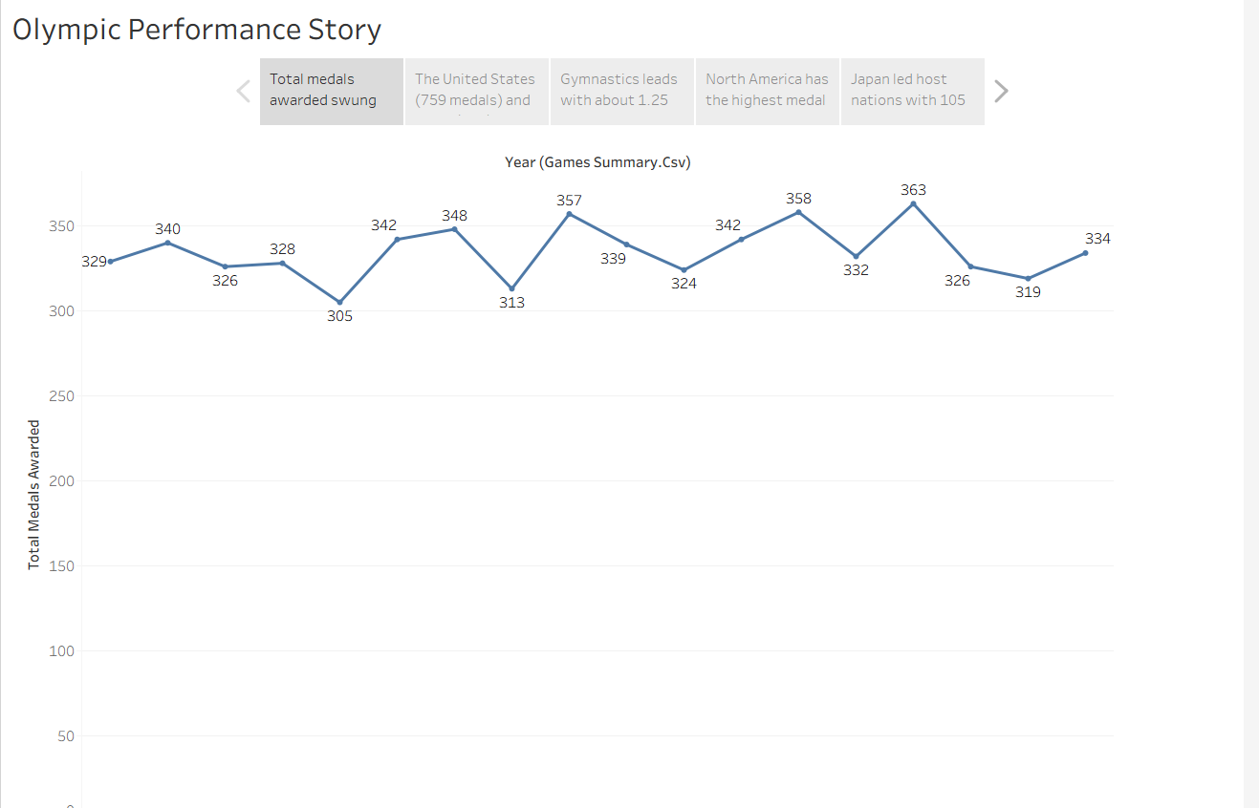

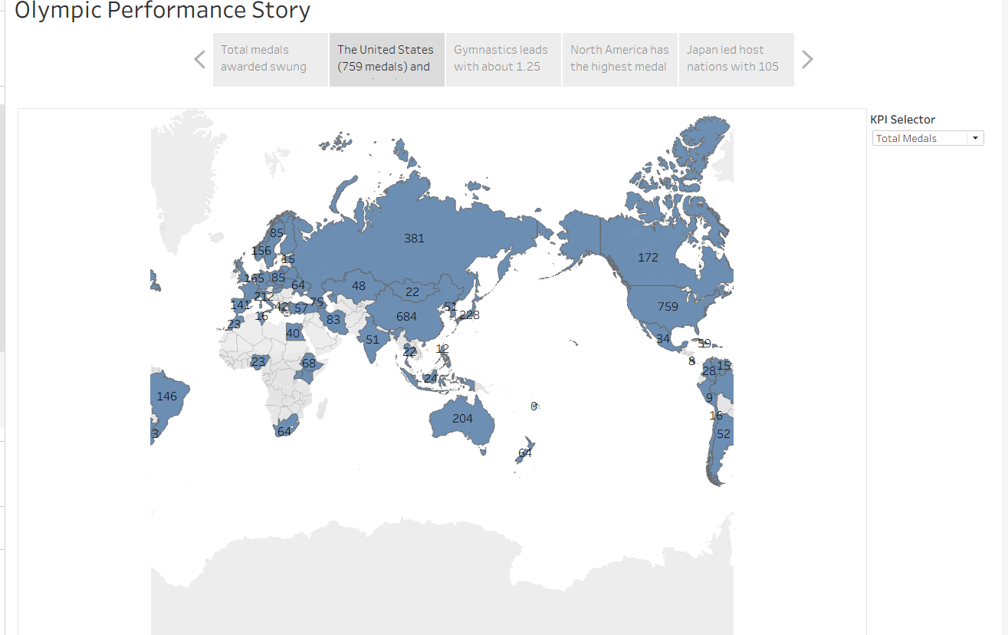

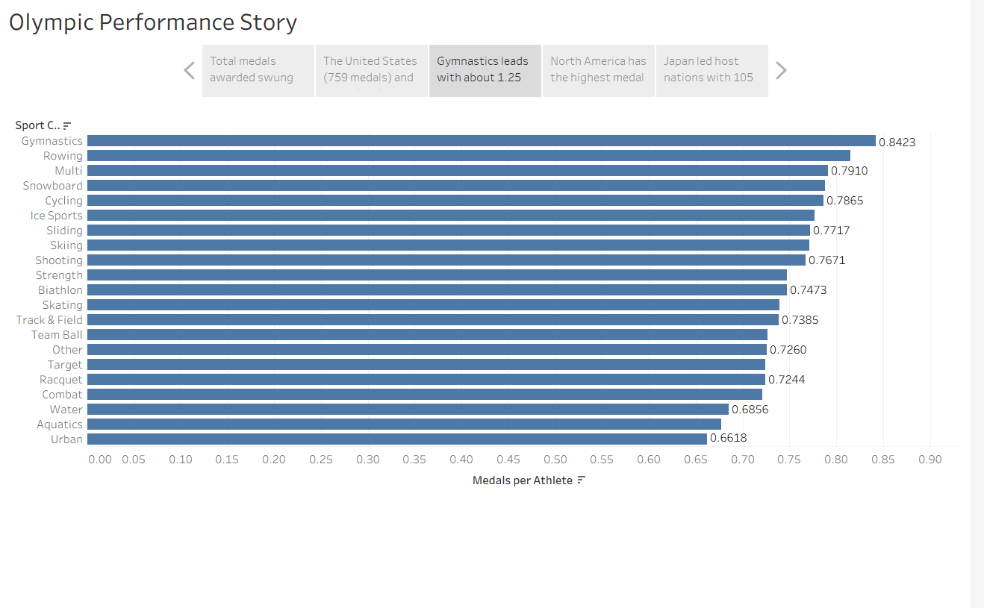

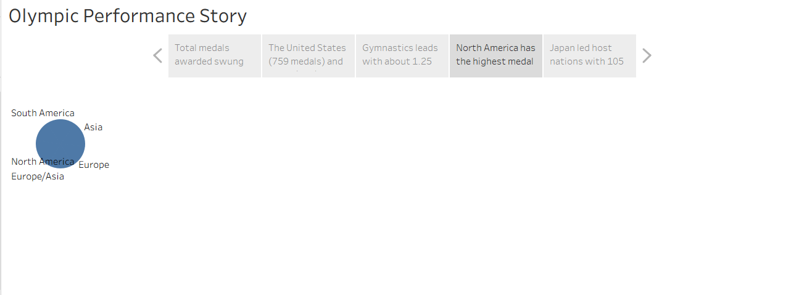

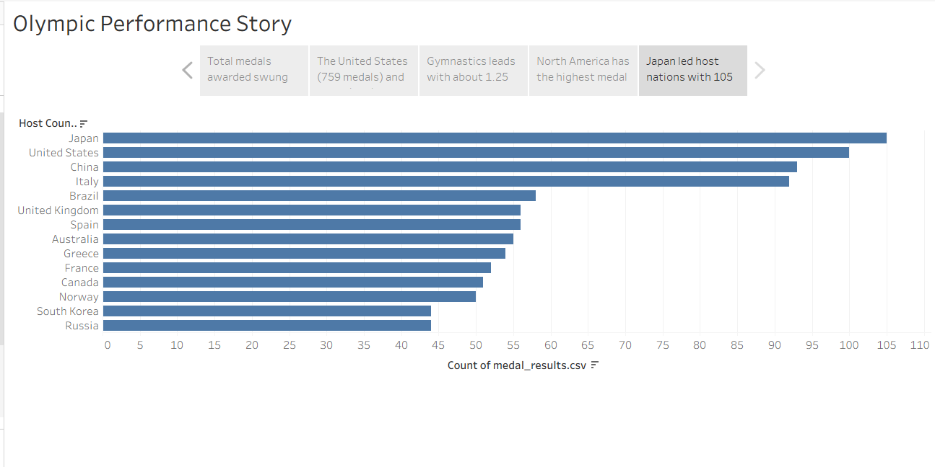

9. Performance Testing
Parameter | Result
Amount of data loaded | 8,000 + 910 + 18 + 60 rows across four flat CSVs; Tableau’s in-memory engine handled all aggregations without server-side processing, and all visuals rendered within acceptable time.
Utilization of filters | Dashboard 1: Country (60), Year (1992–2026), Sport Category (21). Dashboard 2: Region (7), Host Country. Plus KPI Selector parameter.
Calculation fields | Year extraction, KPI Selector (CASE on parameter), Medal Efficiency %, Medals per Athlete, Weighted Medal Points, Efficiency Tier. (Edit to list exactly what you built.)
Visualizations / graphs | KPI tiles (both dashboards), world map, line, 2 horizontal bars, vertical bar, pie, bubble, donut.

10. Web Integration with Flask

10.1 Publishing to Tableau Public
- Clean up unused sheets to reduce file size.
- In Tableau Desktop choose File → Save to Tableau Public and sign in.
- Name the workbook and click Save.
- Copy the share link for each dashboard and the story.

10.2 Flask Project Structure
tableau_flask/
app.py
templates/ (base.html, index.html, dashboard.html, story.html)
static/ (css/style.css, img/)
requirements.txt

app.py defines four routes (/, /dashboard1, /dashboard2, /story). Each dashboard page loads the Tableau embedding script and renders a <tableau-viz> element pointing to the published URL. The Tableau Public links are stored in one dictionary at the top of app.py.

10.3 Running the Application
- pip install -r requirements.txt
- python app.py
- Open http://127.0.0.1:5000 in a browser

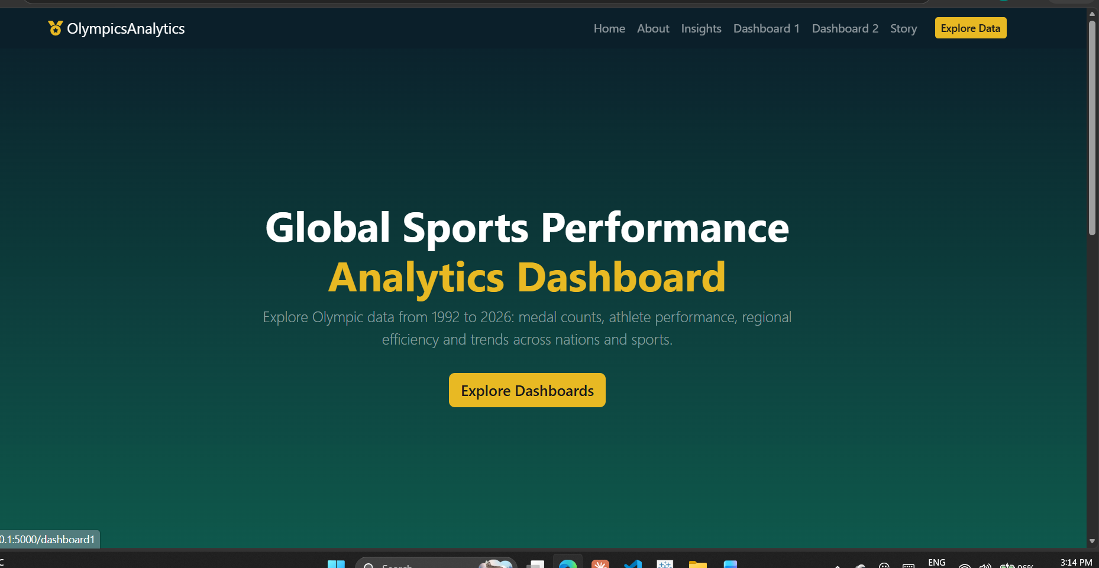

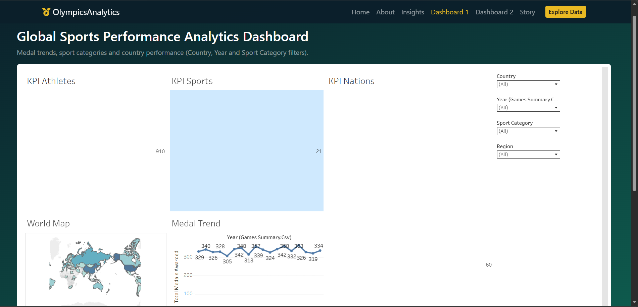

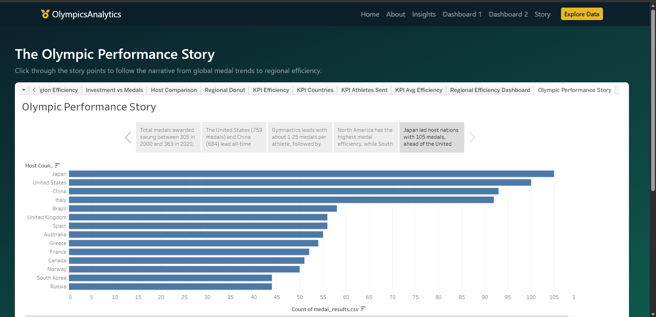11. Results and Insights
- The United States (759 medals) and China (684) lead all-time totals.
- Total medals awarded varied from 305 (2000) to 363 (2020); 2026 recorded 334.
- Gymnastics about 1.25 and Shooting deliver the highest medal return per athlete.
- South America (49.64%) and Europe/Asia (45.98%) lead regional efficiency.
- Japan led host nations with 105 medals, ahead of the US (100) and China (93).
- Slovakia, Georgia and Ethiopia win more medals than their investment suggests.
- Gymnastics about 1.25 medals per athlete
- North America as the highest-efficiency region and South America as the lowest

12. Conclusion
The project shows that Olympic success is shaped by both scale and efficiency. Tableau dashboards and a story make the patterns accessible to strategists, funders and journalists, and the Flask application delivers them as a polished web experience. Future work could add predictive models for medal outcomes, per-capita normalisation and real-time data updates.

13. References
- Kaggle: Olympic dataset used for the project
- Tableau Public and Tableau Embedding API documentation
- BootstrapMade free templates
- Flask documentation

