**Order Level Analysis**

1) Order Distribution at slot & Delivery area Level

|  |  |
| --- | --- |
| **Row Labels** | **Count of Order Drop Geo** |
| After Noon | 5924 |
| Evening | 4712 |
| Late Night | 945 |
| Morning | 6033 |
| Night | 5209 |
| **Grand Total** | **22823** |

Insight:

Max orders are delivered in the morning slot.

2) Areas having highest increase in monthly orders (from Jan to Sep) in absolute orders.

Highest increase in monthly orders (from Jan to Sep): HSR Layout

3) **Delivery Charges at Slot & Month Level**

People are willing to pay maximum delivery charges at late night. Max charges are 8.2%

4) **Discount at Slot & Month Level**

Max discounts are given in the month of April in the evening slot which is 19%.

**5) Discount at Slot & Month Level**

Maximum discount is given at Jamnagar in Morning Slot i.e. approx. 60%.

Completion Level Analysis

1. Completion rate at slot vs day of the week

**Insights:**

100% late night orders are delivered on Sun, Sat & Tuesday

Least Completion rate is on Wed, Late night.

No. of orders are more on weekends.

1. Completion rate at drop area level.

0% orders have been delivered in Cox Town & Viveka Nagar.

8) Number of products ordered level.

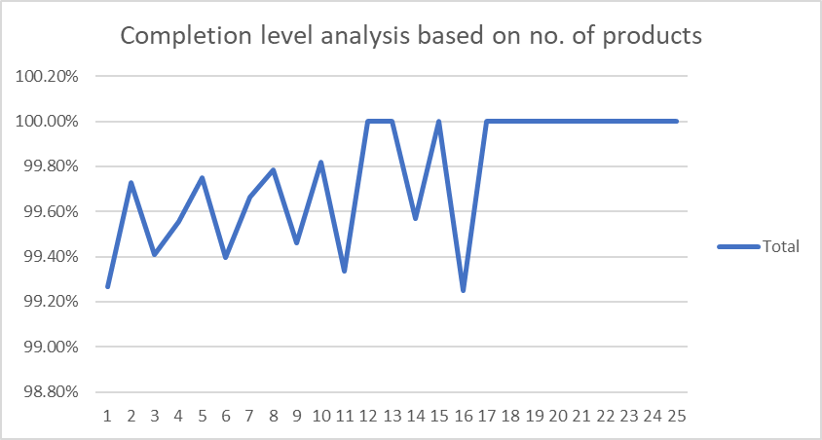

Order with more items have better completion rate.

1. Self-Analysis

* More late night orders are received on weekend.
* Orders with more number of item are expected to be completed more.
* There are few far off places where orders are not getting delivered.

**Customer Level Analysis**

**10)**

**Order placed from organic are most completed**

**Orders placed from offline campaign are least completed.**

**12) Aggregated LTV at Source Level**

Orders Placed through snapchat is of the max aggregated LTV and that of through Instagram is the least.

13) Aggregated LTV at Month Level

Max value orders are places in the May.

**14) Average Revenue (Product amount after discount) per order at different customer acquisition source level?**

Google is giving us the maximum revenue and minimum revenue is generated by Instagram

15) Average Revenue (Product amount after discount) per order at acquisition month level

Average Revenue Per order is maximum in the May.

16)

* As per our observation, May has been the best month in terms of LTV and Average revenue per order.
* Snapchat gives us the customers with highest LTV whereas max average revenue per order is given by Google it means customer coming from Google have ordered even with lesser discounts.

**Delivery Analysis:**

Insights:

* May is the busiest month when it comes to delivery time.
* Max delivery time is taken at Mahadevpura

Insight:

* Maximum orders have been delivered in the May on weekdays & Weekends

Afternoon and evening slots are taking more time to deliver. Possible reason might be traffic situation.