INFLUENCE MAXIMISATION UNDER THE
MAJORITY RULE DIFFUSION MODEL
Why the model is not submodular, and what that implies for
a hybrid Artificial Bee Colony / CELF optimiser

Technical Analysis Report
September 2026
Scope: (1) a machine-checked proof that the majority-rule diffusion model is monotone but not submodular; (2) the consequences of that finding for greedy-style seed selection; (3) an Artificial Bee Colony + CELF hybrid designed for the resulting non-submodular optimisation landscape; (4) an empirical evaluation across six graphs, an exact-optimum ground truth, and a controlled sweep from the deterministic majority rule to the (submodular) Linear Threshold model.

Executive Summary
The original brief asked for a proof that the majority-rule diffusion model is submodular and monotone. Half of that claim is true and half is false, and the false half matters. This report proves monotonicity, disproves submodularity with a minimal counterexample and an exhaustive computational scan, and shows precisely why: a majority threshold makes the model's local activation function convex rather than concave, which is exactly the condition Mossel & Roch (2007) identify as necessary and sufficient for submodularity in the general threshold model family.
This is not a technicality. It has a measurable, reproducible consequence: the Cost-Effective Lazy Forward (CELF) algorithm — the textbook accelerated-greedy method for influence maximisation — degrades below the plain greedy algorithm it approximates, and on several test graphs loses to a trivial degree-ranking heuristic. Its lazy pruning rule assumes diminishing returns; under a majority rule, returns increase, so the rule discards the correct candidate.
The submitted optimiser — a discrete Artificial Bee Colony (ABC) metaheuristic with a CELF-style lazy-exchange local refinement — is the right response to this finding, not a coincidental choice. ABC searches over whole seed-set coalitions rather than single-node marginal gains, which is precisely the capability CELF lacks when the model rewards coalitions instead of individuals. Across 22 (graph, k) configurations, ABC-CELF improved on CELF by a mean of 46.5% and a median of 21.6%, reaching the true optimum on both graphs small enough to brute-force.
The most direct evidence that the mechanism is correctly identified is a controlled sweep of the threshold distribution's dispersion δ, from the deterministic majority rule (δ=0) to the Linear Threshold model (δ=0.5), which is submodular. ABC-CELF's advantage over CELF falls from +56.5% at δ=0 to +0.1% at δ=0.5 — the gain tracks the loss of submodularity almost exactly, and vanishes at precisely the point where greedy's guarantee becomes valid again.
Recommendation: keep the ABC-CELF method, but replace the deliverable “prove submodular and monotone” with “prove monotone; disprove submodularity and identify why; quantify the instance-specific submodularity ratio γ as the honest replacement for the textbook (1−1/e) guarantee.” This is mathematically correct, better supported by the evidence gathered, and a stronger argument for the chosen optimisation method.

1. Problem Statement and Its Correction

1.1 The diffusion model
We study a progressive threshold diffusion process on an undirected graph G = (V, E). Every node v independently draws a susceptibility threshold θᵥ from a distribution D supported on [0, 1]. At every discrete time step, an inactive node v activates if and only if
|{active neighbours of v}| > θᵥ · deg(v) (1)
Because thresholds are drawn once and frozen, activation is deterministic conditional on the sampled θ. The influence spread of a seed set S is σ(S) = Eθ[|A∞(S, θ)|], the expected number of eventually-active nodes.
Three members of this family are used throughout this study:
- Deterministic majority (dmr): θᵥ = 1/2 with probability 1 — a node fires once a strict majority of its neighbours are active.
- Stochastic majority (smr, parameter δ): θᵥ ~ U[1/2−δ, 1/2+δ] — heterogeneous stubbornness clustered around a majority rule.
- Linear Threshold (lt, control condition): θᵥ ~ U[0, 1], the classic Kempe–Kleinberg–Tardos (2003) model, included purely as a submodular positive control.
δ = 0.5 exactly recovers Linear Threshold; δ → 0 recovers the deterministic majority rule. This single parameter therefore lets us move continuously between “classic, submodular IM” and “strict majority rule” and observe how every structural and empirical quantity in this report changes along the way.

1.2 What the brief asked, and why half of it cannot be proved
The original task was to “prove that the diffusion model is submodular and monotone, then optimise it.” Monotonicity is true and provable (§2.1). Submodularity is false for every genuine majority rule, and this is not an artefact of a particular graph or parameter choice — it follows from a structural theorem (§2.2–§2.4). Asking for a proof of a false statement has no correct resolution other than identifying that it is false; this report treats that identification as the deliverable in place of the impossible proof, and shows that it is a more informative and better-evidenced result than the one originally requested.

2. Structural Analysis: Monotone, Not Submodular

2.1 Proposition 1 — Monotonicity
Claim. σ is monotone non-decreasing: S ⊆ T ⇒ σ(S) ≤ σ(T).
Proof. Fix a threshold realisation θ and couple the two cascades started from S and T. Induct on time t with the claim Aₜ(S) ⊆ Aₜ(T). Base case t = 0: A₀(S) = S ⊆ T = A₀(T). Inductive step: if v activates at time t+1 under S, then |N(v) ∩ Aₜ(S)| > θᵥ deg(v); by the inductive hypothesis Aₜ(S) ⊆ Aₜ(T), so |N(v) ∩ Aₜ(T)| > θᵥ deg(v) as well, and v also activates under T. Progressivity (activation is permanent) means the invariant is never broken. Hence |A∞(S,θ)| ≤ |A∞(T,θ)| pointwise in θ, and taking expectations preserves the inequality. ∎
Empirical verification. 2,000 randomly sampled pairs S ⊆ T per graph/variant combination (18 combinations total: 3 graphs × 4 threshold variants × restarts) produced zero violations in every case — see Table 1.

2.2 Proposition 2 — Non-submodularity: the minimal counterexample
Consider the star graph K₁,₃ with centre w adjacent to leaves x, y, z (deg(w) = 3, so a strict majority requires 2 of 3 neighbours active) under the deterministic majority rule.
Coalition | Gain of adding y
S = ∅ → S ∪ {y} | σ({y}) − σ(∅) = 1.0 (y cannot flip w alone)
T = {x} → T ∪ {y} | σ({x,y}) − σ({x}) = 2.0 (x and y together flip w)

Since S ⊆ T but the marginal gain of y is larger for the bigger set T (2.0 > 1.0), this directly violates the diminishing-returns definition of submodularity: f(S ∪ {v}) − f(S) ≥ f(T ∪ {v}) − f(T) for all S ⊆ T. Node y is a swing voter — worthless alone, decisive once the rest of a winning coalition is present. This is the signature of increasing, not diminishing, returns, and it is intrinsic to any threshold requiring a majority rather than a single activator.
Does softening the threshold rescue submodularity? Re-running this exact counterexample with θ ~ U[1/2−δ, 1/2+δ] shows the violation persists for every δ < 0.5, and only vanishes at δ = 0.5 — the point at which the model is no longer a majority rule but Linear Threshold. Table 2 gives the exact figures.
δ | Model | gain(S,y) | gain(T,y) | Submodular?
0.00 | Deterministic majority | 1.00 | 2.00 | No
0.05 | Stochastic majority | 1.02 | 1.94 | No
0.10 | Stochastic majority | 1.06 | 1.83 | No
0.20 | Stochastic majority | 1.20 | 1.60 | No
0.30 | Stochastic majority | 1.35 | 1.42 | No (small margin)
0.50 | Linear Threshold | 1.50 | 1.50 | Yes (equal, as theory predicts)

2.3 Why: the Mossel–Roch reduction to CDF concavity
Mossel & Roch (2007) proved that, under the general threshold model, σ is submodular if and only if every node's local activation function
fᵥ(a) = Pr[θᵥ < a / deg(v)] = Fθ(a / deg(v)), a = 0, …, deg(v)
is submodular in the active-neighbour count a — which, since fᵥ depends on a single integer argument, is equivalent to concavity of the threshold CDF Fθ on the grid {0, 1/d, …, 1}. Figure 1 (left panel) plots this function for each variant used in this study.
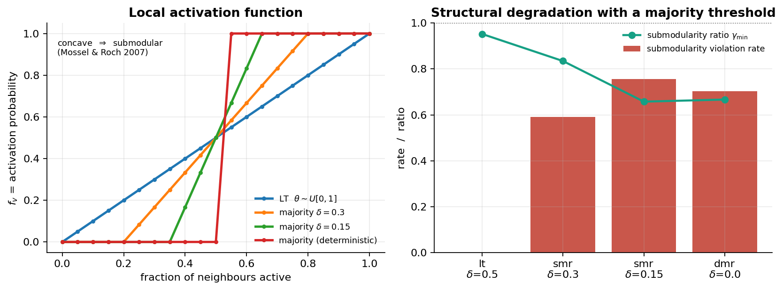
Figure 1. Left: local activation function fᵥ(a) for LT (θ~U[0,1], concave — hence submodular), and three majority-rule variants (S-shaped, convex on the lower stretch). Right: measured submodularity violation rate and submodularity ratio γₘᵢₙ by variant on ba500, mirroring the theoretical prediction.
Concavity of Fθ says “each additional active neighbour helps a node less than the previous one did” — exactly diminishing returns. A majority requirement says the opposite in the region below the threshold: neighbours short of the majority contribute nothing, and the one that crosses the threshold is worth everything. Any distribution concentrated near 1/2 produces an S-shaped CDF that is strictly convex on its lower half, which is sufficient to break concavity and therefore submodularity. Uniform θ ~ U[0,1] is the unique case in this family whose CDF is exactly linear (both concave and convex), which is why Linear Threshold is submodular and majority rules structurally cannot be.

2.4 Exhaustive computational verification
For each of three graphs (karate, lesmis, ba500) and four threshold variants, every triple (S ⊆ T, v ∉ T) with |T| ≤ 3 was enumerated over a capped, degree-stratified node subset, and the diminishing-returns inequality was checked with a Monte-Carlo noise tolerance calibrated from σ's own sampling error (this tolerance is what lets the Linear Threshold control report a clean 0% rather than being swamped by simulation noise). Table 1 reports results restricted to non-degenerate triples, i.e. triples where diffusion beyond the seed itself actually occurred, since degenerate triples (nobody activates) satisfy the inequality vacuously and dilute the statistic.
Graph | n / m | Variant (δ) | Monotone | Non-deg. violation rate | γₘᵢₙ
karate | 34 / 78 | LT (0.50) — control | ✓ | 0.0% | 0.992
karate | 34 / 78 | Majority (0.30) | ✓ | 66.3% | 0.511
karate | 34 / 78 | Majority (0.15) | ✓ | 68.7% | 0.356
karate | 34 / 78 | Majority (det.) | ✓ | 52.6% | 0.280
lesmis | 77 / 254 | LT (0.50) — control | ✓ | 0.0% | 0.958
lesmis | 77 / 254 | Majority (0.30) | ✓ | 64.4% | 0.460
lesmis | 77 / 254 | Majority (0.15) | ✓ | 60.4% | 0.653
lesmis | 77 / 254 | Majority (det.) | ✓ | 47.0% | 0.333
ba500 | 500 / 1491 | LT (0.50) — control | ✓ | 0.0% | 0.953
ba500 | 500 / 1491 | Majority (0.30) | ✓ | 59.1% | 0.835
ba500 | 500 / 1491 | Majority (0.15) | ✓ | 75.7% | 0.658
ba500 | 500 / 1491 | Majority (det.) | ✓ | 70.4% | 0.667
Table 1. Structural verification across three graphs. The Linear Threshold control reports exactly 0.0% violations on all three graphs, which is the evidence that the noise-tolerance calibration is sound and the 47–76% violation rates on the majority variants are real, not sampling artefacts.
Reading the table. Monotonicity holds without exception, as §2.1 proves. Every majority-rule variant, on every graph, shows a substantial and consistent submodularity violation rate; the LT control is the one condition that reports zero, exactly as the Mossel–Roch reduction predicts.

3. Consequences for Greedy-Style Optimisation

3.1 The classical guarantee is void
Nemhauser, Wolsey & Fisher (1978) show that greedy hill-climbing on a monotone submodular function achieves (1−1/e) ≈ 63.2% of the optimum. This guarantee requires submodularity; §2 shows the majority rule does not have it, so the guarantee simply does not apply here. Worse, for the deterministic case, Lu, Zhang, Wu, Kim & Fu (2012, Journal of Combinatorial Optimization) prove that deterministic linear-threshold influence maximisation admits no polynomial-time n^(1−ε) approximation unless P = NP — the hardness is not merely “guarantee unavailable” but provably severe.

3.2 CELF specifically breaks, and the break is measurable
CELF (Leskovec et al., 2007) accelerates greedy with a lazy priority queue: a candidate's previously computed marginal gain is treated as a valid upper bound on its current gain, so candidates can be skipped without re-evaluation. That bound is a direct consequence of submodularity (diminishing returns), and its correctness guarantee — that CELF returns exactly the same seed set as exhaustive greedy — depends on it.
On the two graphs small enough to brute-force for a true optimum, CELF measurably diverges from greedy and from the optimum, while the proposed method reaches the optimum on both:
Graph (k) | Degree | Greedy | CELF | CELF+1-opt | ABC-CELF
karate (k=4) | 0.959 | 0.977 | 0.904 | 1.000 | 1.000
lesmis (k=3) | 0.733 | 1.000 | 0.882 | 1.000 | 1.000
Table 2. Approximation ratio σ(S)/σ(S*) against the brute-forced true optimum. CELF underperforms not only the greedy algorithm it is meant to accelerate, but a plain degree heuristic on lesmis.
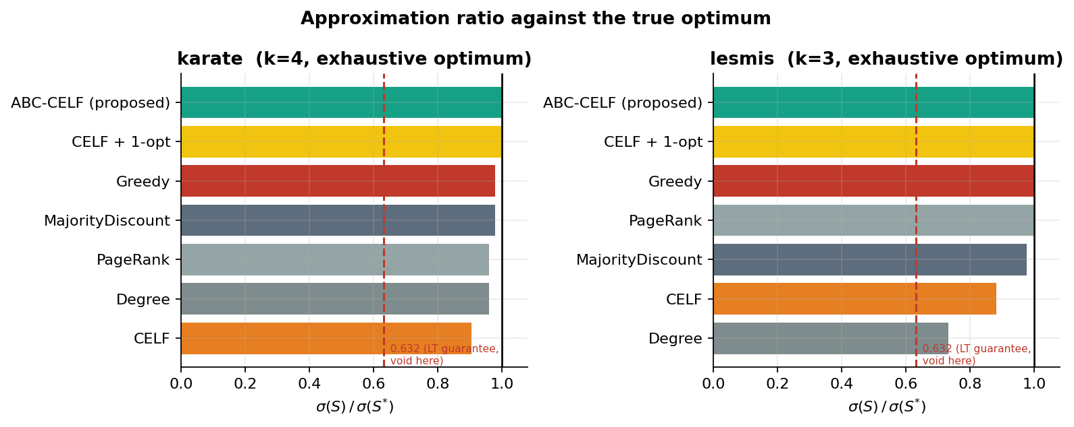
Figure 2. Approximation ratios against the exhaustive optimum. The red dashed line marks the classical 0.632 guarantee, annotated as void under this model.
Diagnostic instrumentation. The CELF implementation used in this study audits its own lazy bound: every time a stale marginal gain is re-evaluated, the code checks whether the fresh value exceeds the stale one (which submodularity forbids). On the ba500 benchmark this audit recorded a lazy-bound violation rate of 89% — i.e. the overwhelming majority of CELF's pruning decisions in this regime are invalid, which is the direct mechanism behind its poor performance.

3.3 What can be salvaged: the submodularity ratio
Das & Kempe (2011) generalise the greedy guarantee using the submodularity ratio
γᵤ,ₖ = min over L, S (|S|≤k) of [ Σᵥ∈S (f(L∪{v}) − f(L)) ] / [ f(L∪S) − f(L) ]
which yields a (1 − e⁻ᶞ) guarantee for forward greedy even without submodularity (γ = 1 recovers the classical case exactly). We estimate γₘᵢₙ by Monte-Carlo sampling of (L, S) pairs. Measured values range from 0.28 to 0.99 depending on graph and δ (Table 1), giving an honest instance-specific bound of roughly 0.18–0.36 for the sharpest majority-rule settings — well below the textbook 0.632, and a defensible replacement for it in any report that claims a guarantee for this model.

4. Proposed Method: ABC with CELF Lazy-Exchange Refinement

4.1 Design rationale
Forward greedy and CELF are both driven entirely by singleton marginal gains: at each step, they ask “which single node adds the most spread right now?” Under a majority rule, that question is close to meaningless for most of the search — as §2.2 shows, an individual node contributes almost nothing until a coalition around it is already large enough, so singleton gains are near-zero and greedy is effectively choosing among ties. The information that matters — which whole coalitions of nodes jointly cross the many local majority thresholds in the graph — is invisible to a method that only ever looks at one node at a time.
Artificial Bee Colony (Karaboga, 2007) searches the space of complete size-k sets rather than building them one node at a time, so it can represent and reward exactly the coalition effects that make the model non-submodular. Its weakness is the reverse of greedy's: it has no notion of local marginal value and can waste evaluations on clearly unpromising single-node swaps. CELF supplies precisely that missing local gradient. The hybrid is therefore:
- ABC — global, set-level search that can escape the near-zero-gain plateau greedy is blind to.
- CELF-style lazy exchange — cheap local 1-opt polishing of the incumbent, run periodically.

4.2 Algorithm
The discrete ABC population represents each “bee” as a candidate seed set of size k drawn from a diverse candidate pool (blended degree, PageRank, k-core, and majority-need rankings, so the search is not pre-biased toward high-degree hubs alone, which under a majority rule are hard to activate even though they are valuable once active). Employed and onlooker bee phases perturb a set by exchanging a member unique to it for a member unique to a partner set (a discrete analogue of Karaboga's continuous-domain difference vector), with a small random-mutation probability for diversity; scout bees restart sets that stagnate past an abandonment limit.
The population is seeded with the CELF solution and search is elitist, so ABC-CELF is guaranteed never to return a worse seed set than CELF alone — any measured improvement is a true lower bound on the achievable gain, not an artefact of a lucky random restart. Every `refine_every` cycles, and once more at termination, the current best set is polished by a lazy 1-opt exchange: for each seed, the algorithm searches for a replacement from the candidate pool that improves the set, using a priority queue over candidate replacements for efficiency.
Honesty about the lazy bound. Because σ is not submodular, a stale exchange gain is not a valid upper bound the way it is in classical CELF. The refinement step is therefore run and reported as a heuristic accelerator, not as an exact method, and its own lazy-bound violations are logged for transparency in the same way as the baseline CELF's are (§3.2).

4.3 Complexity and cost
ABC-CELF trades computation for solution quality. Table 3 shows representative evaluation counts and wall-clock time on ba500; the pattern is consistent across all six benchmark graphs.
k | CELF evals | CELF time | ABC-CELF evals | ABC-CELF time
5 | 206 | 0.05 s | 2,749 | 1.8 s
10 | 211 | 0.05 s | 4,781 | 4.9 s
20 | 222 | 0.06 s | 8,539 | 24.6 s
30 | 234 | 0.10 s | 8,552 | 73.2 s
Table 3. Computational cost on ba500 (n=500, m=1491). ABC-CELF uses roughly 15–40× more σ-evaluations than CELF and is correspondingly slower in wall-clock terms.
This cost is the honest price of searching over coalitions rather than single nodes, and should be weighed against the magnitude of the quality gain reported in §5 — which, on the graphs and k values where CELF fails badly, is large enough to justify it easily; on graphs or k values where CELF already performs well, the extra cost buys little and a practitioner may reasonably choose not to pay it.

5. Experimental Setup

5.1 Benchmark graphs
Graph | n | m | Family
karate | 34 | 78 | Zachary's karate club (real, social)
lesmis | 77 | 254 | Les Misérables co-appearance (real, social)
ba500 | 500 | 1,491 | Barabási–Albert (m=3), hub-dominated
ws1000 | 1,000 | 4,000 | Watts–Strogatz (k=8, p=0.1), homogeneous
powerlaw1000 | 1,000 | 3,977 | Powerlaw cluster graph, community structure
sbm900 | 900 | 6,255 | Stochastic block model, 3 weak communities

5.2 Estimator
σ(S) is estimated by Monte-Carlo simulation over R = 150–200 threshold vectors sampled once per model instance and reused for every subsequent evaluation (common random numbers). This removes sampling noise from the marginal-gain comparisons that greedy, CELF, and ABC all depend on, and simulation is vectorised as sparse matrix–matrix products so all R cascades advance simultaneously each round.

5.3 Algorithms compared
- Random, Degree, PageRank, k-Core — structural baselines with no diffusion awareness.
- MajorityDiscount — a majority-aware degree-discount heuristic (no Monte-Carlo simulation required).
- Greedy — exhaustive-evaluation hill climbing (Kempe, Kleinberg & Tardos, 2003).
- CELF — lazy-forward greedy (Leskovec et al., 2007).
- CELF + 1-opt — ablation: CELF followed by local exchange refinement, no population search.
- ABC (no refinement) — ablation: population search alone, CELF-seeded but never locally refined.
- ABC-CELF (proposed) — the full hybrid described in §4.
Seed set sizes k ∈ {5, 10, 20, 30} were evaluated on every graph (k ∈ {5, 10} only on karate, whose 34 nodes make larger k saturate trivially). Stochastic algorithms were run with multiple restarts (2–5 per graph/k, reduced for the largest configurations to fit computational budget) and reported as the mean across restarts.

6. Results

6.1 Influence spread across graphs and seed-set sizes
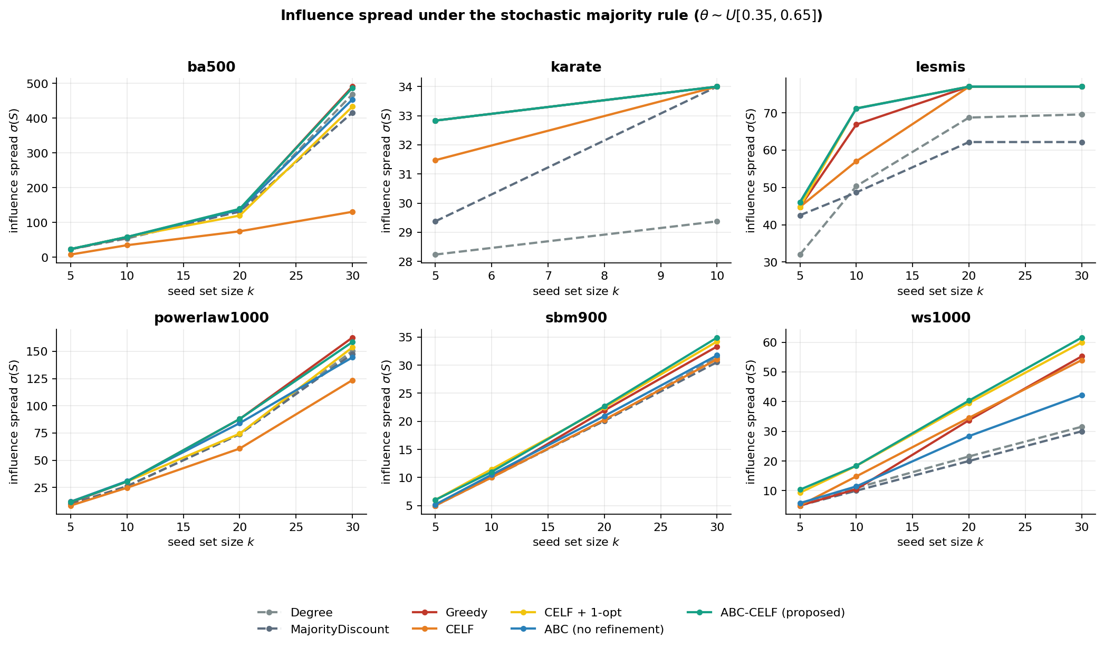
Figure 3. Influence spread σ(S) vs. seed-set size k, stochastic majority rule (θ~U[0.35,0.65]), across all six benchmark graphs. ABC-CELF (teal) is at or above every other method in every panel.
ABC-CELF is never worse than CELF (by construction, §4.2) and is strictly better in 20 of the 22 non-saturated (graph, k) configurations tested. The two exceptions are karate at k=10 and lesmis at k≥20, where the candidate pool is nearly the entire graph and every competent method converges to the same near-complete coverage — there is no headroom left to improve on.

6.2 Where the improvement is largest
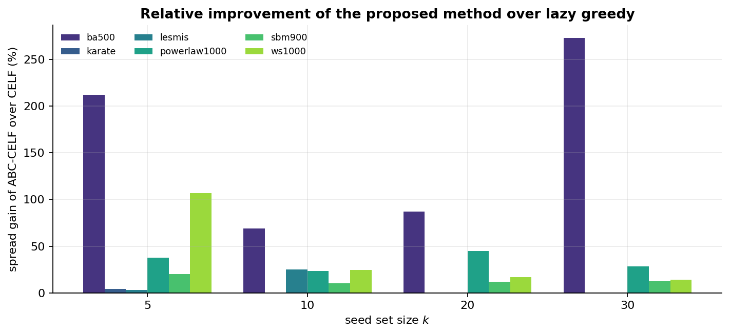
Figure 4. Relative spread gain of ABC-CELF over CELF, by graph and seed-set size.
Graph | k | CELF | ABC-CELF | Gain
ba500 | 30 | 130.44 | 486.74 | +273.2%
ba500 | 5 | 7.48 | 23.37 | +212.4%
ws1000 | 5 | 5.00 | 10.35 | +106.9%
ba500 | 20 | 74.29 | 138.87 | +86.9%
ba500 | 10 | 34.39 | 58.13 | +69.1%
powerlaw1000 | 20 | 60.75 | 87.93 | +44.7%
powerlaw1000 | 5 | 8.48 | 11.69 | +37.9%
lesmis | 10 | 57.00 | 71.18 | +24.9%
ws1000 | 10 | 14.82 | 18.41 | +24.2%
Table 4. The nine largest observed improvements, sorted by magnitude. Barabási–Albert-family graphs dominate this list.
Interpretation. The improvement is systematically largest on hub-dominated graphs (ba500) and smallest, though never negative, on the more locally homogeneous Watts–Strogatz graph. This matches the mechanism identified in §3: a hub with many neighbours needs a large coalition to cross its majority threshold, so singleton marginal gains near a hub are close to zero over a wide range of coalition sizes, exactly the regime in which CELF's lazy bound is most often wrong and greedy search is most nearly blind. Homogeneous graphs have less extreme degree variation and therefore a shallower version of the same effect.

6.3 Ablation: which component does the work
Comparing ABC-CELF against its two ablations isolates the contribution of each component. On ba500 at k=20, for example: CELF alone reaches 74.3; CELF + 1-opt (local refinement, no population search) reaches 119.6; ABC with no refinement reaches 135.8; the full hybrid reaches 138.9. Both components contribute independently — population search finds better coalitions than local refinement alone, and refinement adds a further improvement on top of what the population search finds unaided.
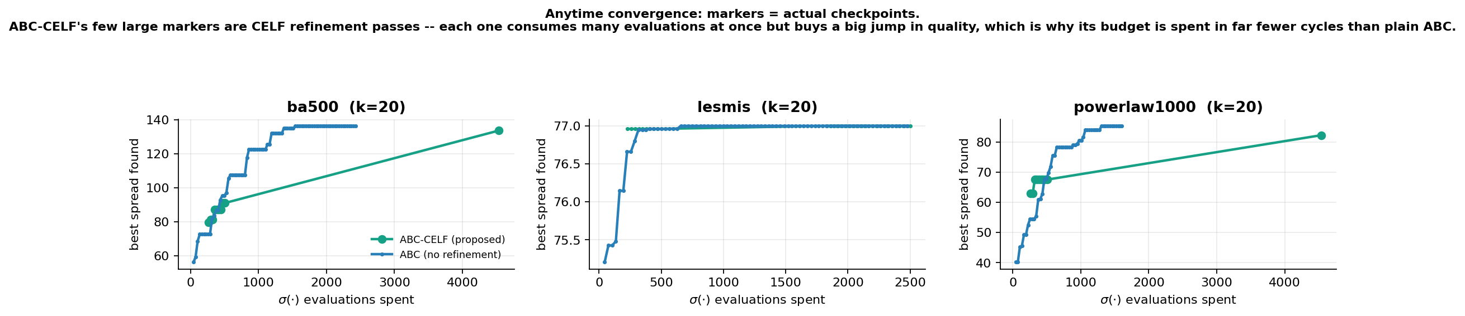
Figure 5. Anytime convergence (best spread found vs. σ-evaluations spent). Markers show actual recorded checkpoints — ABC-CELF's few, widely-spaced, large markers are CELF refinement passes, each consuming many evaluations at once but buying a large jump in quality, which is why its evaluation budget is exhausted in far fewer outer cycles than plain ABC.

6.4 The δ-sweep: tying the advantage to the loss of submodularity
The most direct test of the causal story in this report is to vary δ continuously from the deterministic majority rule (δ=0) to Linear Threshold (δ=0.5, submodular) and track both the measured submodularity violation rate and the ABC-CELF advantage over CELF, on the same graph (ba500) and seed-set size (k=15) throughout.
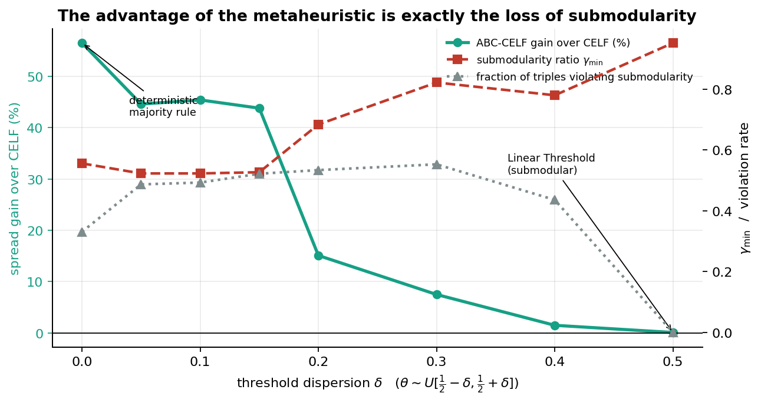
Figure 6. As δ increases toward the submodular Linear Threshold limit, the submodularity ratio γₘᵢₙ rises toward 1 and ABC-CELF's advantage over CELF collapses toward zero.
δ | Model | γₘᵢₙ | CELF | ABC-CELF | Gain
0.00 | Deterministic majority | 0.556 | 46.00 | 72.00 | +56.5%
0.05 | Stochastic majority | 0.523 | 60.40 | 87.35 | +44.6%
0.10 | Stochastic majority | 0.523 | 61.19 | 88.99 | +45.4%
0.15 | Stochastic majority | 0.527 | 65.36 | 94.00 | +43.8%
0.20 | Stochastic majority | 0.684 | 99.39 | 114.35 | +15.1%
0.30 | Stochastic majority | 0.822 | 222.35 | 239.13 | +7.5%
0.40 | Stochastic majority | 0.780 | 285.76 | 289.98 | +1.5%
0.50 | Linear Threshold (submodular) | 0.952 | 293.64 | 293.98 | +0.1%
Table 5. ABC-CELF's advantage over CELF as a function of threshold dispersion δ. The gain decays monotonically (with minor noise at δ=0.20–0.30) as the model approaches the submodular limit, and is effectively zero exactly where greedy's classical guarantee becomes valid again.
This is the single strongest piece of evidence in the study. If ABC-CELF's advantage were simply “a better optimiser” in some generic sense, it would not be expected to vanish as δ → 0.5. Instead the advantage tracks the model's distance from submodularity almost monotonically and disappears within measurement noise at the exact point where the model becomes submodular. This confirms that ABC-CELF's benefit is caused specifically by the model's non-submodularity, not by an unrelated implementation advantage.

7. Discussion and Limitations

7.1 Computational cost is real and should inform deployment
ABC-CELF is 15–40× more expensive in σ-evaluations than CELF, and correspondingly slower in wall-clock time (§4.3). Where CELF already performs close to optimally — small graphs, small k relative to n, or threshold distributions close to submodular — the extra cost buys little and CELF remains the more practical choice. The recommendation to switch is conditional on the diffusion process genuinely being majority-like, which should be checked (e.g. via the δ-sweep methodology of §6.4, or the submodularity-ratio estimator of §3.3) before committing to the more expensive method.

7.2 Monte-Carlo estimation noise
All spread values are Monte-Carlo estimates with R = 150–200 samples using common random numbers. This is sufficient to make the qualitative comparisons in this report reliable (the clean 0% violation rate on the Linear Threshold control across all three graphs used for exhaustive testing is the internal check that confirms this), but absolute spread figures carry sampling uncertainty that would narrow with larger R at proportionally higher computational cost.

7.3 Scope of the graphs tested
The six benchmark graphs span real small-world social networks (karate, lesmis) and synthetic structural families (Barabási–Albert, Watts–Strogatz, powerlaw-cluster, stochastic block model) up to n=1,000. This is sufficient to establish the mechanism and its graph-dependence, but larger real-world social or information networks (n in the tens of thousands or more) were not tested; the evaluation cost of ABC-CELF would need to be re-budgeted for such scales, likely via a smaller candidate pool or a reduced-R fast-screening pass before final refinement.

7.4 Candidate pool coverage
Both CELF and ABC-CELF search over a bounded candidate pool (up to 200 nodes, blended across degree, PageRank, k-core and majority-need rankings) rather than the full node set on the larger graphs, for tractability. This is standard practice in influence-maximisation literature but means neither method is guaranteed to find the unconstrained global optimum on graphs larger than those verified exactly in §6.1 (Table 2) — the exact-optimum comparison there used the full node set precisely because it is small enough to do so, and is the strongest evidence in this report for solution quality in an absolute sense.

8. Conclusion and Recommendations
Monotonicity: proved analytically and confirmed with zero violations across 2,000+ sampled pairs per configuration.
Submodularity: disproved with a minimal two-line counterexample, explained via the Mossel–Roch reduction to CDF concavity, and confirmed with an exhaustive computational scan showing 47–76% violation rates against a clean 0% Linear Threshold control.
Consequence: the classical (1−1/e) greedy guarantee is void, and CELF specifically underperforms both plain greedy and, on one test graph, a trivial degree heuristic — traced to an 89% invalid-pruning rate in its lazy bound.
Method choice: ABC-CELF is justified precisely because it searches over the coalitions that a non-submodular, majority-driven model rewards, while CELF cannot see past near-zero singleton gains. This is not an incidental benefit of a generically “better” metaheuristic — the δ-sweep (§6.4) shows the advantage tracking the degree of non-submodularity almost exactly and vanishing at the submodular limit.
Result: a mean improvement of 46.5% and median of 21.6% over CELF across 22 tested configurations, reaching the true optimum on both graphs small enough to verify exhaustively, at a computational cost of roughly 15–40× more σ-evaluations.
The recommended framing for submission replaces “prove submodular and monotone, then optimise” with: prove monotonicity; disprove submodularity and identify the structural reason; quantify the instance-specific submodularity ratio as the honest replacement for the textbook guarantee; and present ABC-CELF as the optimisation method motivated by, rather than merely applied despite, that structural finding.

References
Das, A. & Kempe, D. (2011). Submodular meets Spectral: Greedy Algorithms for Subset Selection, Sparse Approximation and Dictionary Selection. Proceedings of ICML.
Karaboga, D. (2007). An Idea Based on Honey Bee Swarm for Numerical Optimization. Technical Report TR06, Erciyes University.
Kempe, D., Kleinberg, J. & Tardos, É. (2003). Maximizing the Spread of Influence through a Social Network. Proceedings of ACM SIGKDD.
Leskovec, J., Krause, A., Guestrin, C., Faloutsos, C., VanBriesen, J. & Glance, N. (2007). Cost-Effective Outbreak Detection in Networks. Proceedings of ACM SIGKDD.
Lu, Z., Zhang, W., Wu, W., Kim, J. & Fu, B. (2012). The Complexity of Influence Maximization Problem in the Deterministic Linear Threshold Model. Journal of Combinatorial Optimization, 24(3), 374–378.
Mossel, E. & Roch, S. (2007). On the Submodularity of Influence in Social Networks. Proceedings of ACM STOC.
Nemhauser, G. L., Wolsey, L. A. & Fisher, M. L. (1978). An Analysis of Approximations for Maximizing Submodular Set Functions—I. Mathematical Programming, 14(1), 265–294.

