
MASTER PRODUCT & ENGINEERING DOCUMENT
FinSight Terminal & Kestrel Agent
Product · Architecture · Agent · Security · Quality
Product, requirements, architecture, agent design, security, concurrency, quality and operations in one place.
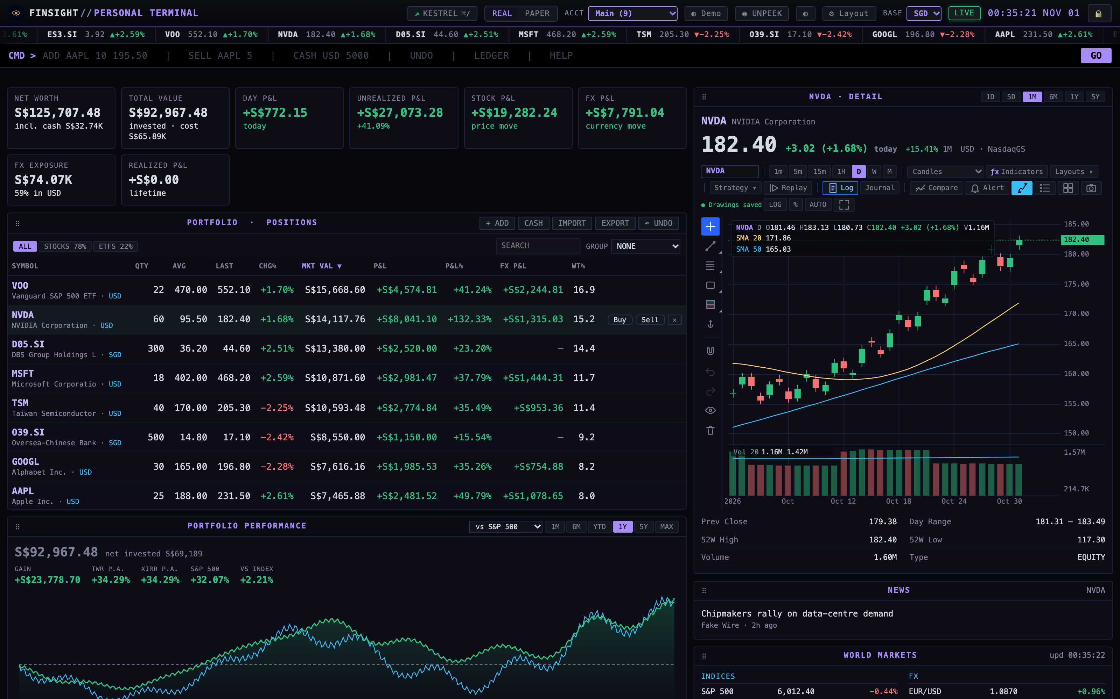
VERSION | DATE | OWNER | STATUS
1.0 | 1 November 2026 | tanueihorng | Living document · reflects main at aa373b7

Contents
Document control
THE PRODUCT
1 Executive summary
2 Problem and motivation
3 Product overview
4 Stakeholders and personas
PART A · PRODUCT AND DESIGN FOUNDATIONS
5 Product requirements and scope
6 User stories
7 User flows
8 Functional specification
9 Non-functional requirements
10 System architecture
11 Technology stack
12 Frontend engineering and UX
PART B · APPLICATION LOGIC AND DATA
13 Backend engineering
14 Database and data architecture
15 APIs and system integration
16 Identity and access management
PART C · AI ENGINEERING AND AGENTIC SYSTEMS
17 Kestrel agent design
18 Investment council design
19 Paper trading design
PART D · SECURITY, CORRECTNESS AND SYSTEM BEHAVIOUR
20 Application security
21 Concurrency and parallelism
22 Performance and scalability
23 Reliability and fault tolerance
24 Testing and quality assurance
25 UAT plan for computer-use testing
PART E · DELIVERY, INFRASTRUCTURE AND OPERATIONS
26 SDLC and governance
27 Infrastructure and environments
28 CI/CD and release engineering
29 Observability and monitoring
30 Production operations and support
PART F · BUSINESS, GOVERNANCE AND SUSTAINABILITY
31 Cost engineering and FinOps
32 Privacy, legal and compliance
33 Documentation and knowledge management
34 Maintainability and future evolution
35 Risks, assumptions and constraints
APPENDICES
Appendix A — Glossary
Appendix B — Terminal commands
Appendix C — Kestrel commands
Appendix D — Traceability matrix
Appendix E — References

Document control
Field | Value
Document | FinSight Terminal — Master Product & Engineering Document
Version | 1.0 (1 November 2026)
Owner | tanueihorng (product owner, sole user, final decision-maker)
Code baseline | main at aa373b7 — Merge paper trading, trade desk, Kestrel limits (FEAT-012)
Audience | New contributors, coding agents, reviewers, demo audiences and UAT testers (including Codex computer use)
Companion files | docs/guide/finsight-guide.html (interactive demo guide), agent/docs/SPEC.md, docs/architecture/SYSTEM.md, docs/BACKLOG.md

Naming
Kestrel is FinSight's built-in AI research agent (sometimes misheard as "Cashier" or "Cursor" in voice notes). Council is Kestrel's multi-specialist review mode. Paper trading is the Alpaca-backed fake-money book.

Status words
This document distinguishes implemented (code exists), verified (tests/evidence recorded), merged (on main) and deployed (running in the owner's personal install). Figures shown in examples come from the synthetic demo portfolio, not from real holdings.

How to read this document
The first part explains the product: the problem FinSight solves, what the terminal and the Kestrel agent do, and who they are for. The rest of the document is organised by the 24 software-engineering domains a complete application has to address, from requirements to long-term ownership. Each domain has its own chapter, written for FinSight specifically and checked against the code at aa373b7.
- Part A — Product and design foundations: requirements and scope, user stories and flows, the functional and non-functional specifications, architecture, technology stack, frontend and UX.
- Part B — Application logic and data: backend, data architecture, APIs and integrations, identity and access.
- Part C — AI engineering and agentic systems: the Kestrel agent, the investment council and agentic paper trading.
- Part D — Security, correctness and system behaviour: security, concurrency, performance, reliability, testing and the UAT plan.
- Part E — Delivery and operations: SDLC, infrastructure, CI/CD, observability, operations and support.
- Part F — Business and sustainability: cost, privacy and compliance, documentation, analytics, maintainability, risks.
No. | Engineering domain | Where this document covers it
01 | Product requirements and scope | §5 Product requirements and scope; §6 User stories; §7 User flows; §8 Functional specification; §9 Non-functional requirements
02 | System architecture | §10 System architecture
03 | Technology stack selection | §11 Technology stack
04 | Frontend engineering and UX | §12 Frontend engineering and UX
05 | Backend engineering | §13 Backend engineering
06 | Database and data architecture | §14 Database and data architecture
07 | APIs and system integration | §15 APIs and system integration; §19 Paper trading design
08 | Identity and access management | §16 Identity and access management
09 | Application security | §20 Application security
10 | Concurrency and parallelism | §21 Concurrency and parallelism
11 | Performance and scalability | §22 Performance and scalability
12 | Reliability and fault tolerance | §23 Reliability and fault tolerance
13 | Testing and quality assurance | §24 Testing and quality assurance; §25 UAT plan for computer-use testing
14 | SDLC and governance | §26 SDLC and governance
15 | Infrastructure and cloud | §27 Infrastructure and environments
16 | CI/CD and release engineering | §28 CI/CD and release engineering
17 | Observability and monitoring | §29 Observability and monitoring
18 | Production operations and support | §30 Production operations and support
19 | Cost engineering and FinOps | §31 Cost engineering and FinOps
20 | Privacy, legal and compliance | §32 Privacy, legal and compliance
21 | Documentation and knowledge | §33 Documentation and knowledge management
22 | Product analytics and experiments | §32 Privacy, legal and compliance
23 | Maintainability and evolution | §34 Maintainability and future evolution
24 | AI engineering and agentic systems | §17 Kestrel agent design; §18 Investment council design; §19 Paper trading design

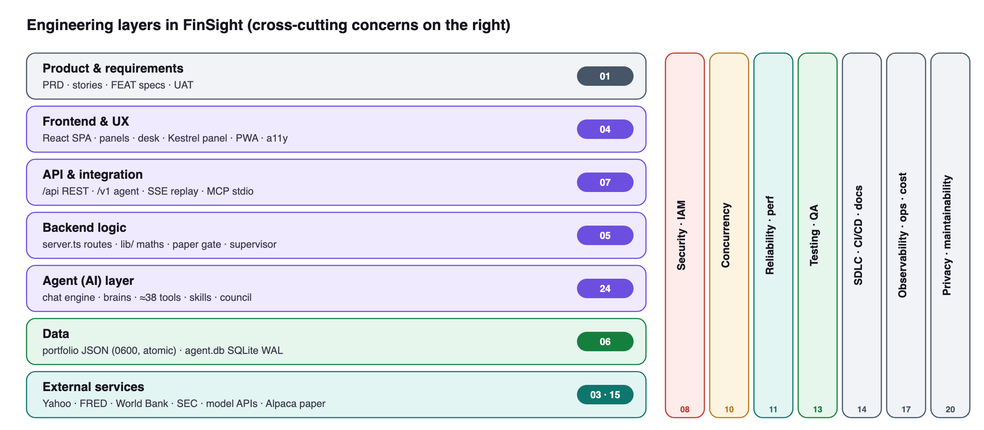
Figure 1 — How the engineering domains sit on FinSight's layers. Security, concurrency, testing and operations cut across every layer.
FINSIGHT
The product
What FinSight and Kestrel are, the problem they solve and who they are for

1. Executive summary
FinSight is a free, Bloomberg-style portfolio terminal that runs entirely on the owner's computer. It tracks a multi-currency, multi-account portfolio with live public market data, and it answers a question most tools hide: how much of my return came from the stock, and how much from the currency?
On top of the terminal sits ↗ Kestrel, a local AI research agent that can see what the user sees — holdings, cash, P&L, events, strategies and the chart in view — and answers with numbers produced by deterministic code, with sources and timestamps. For important decisions, Kestrel can convene an investment council: three specialists and a chair who assess, challenge and synthesise. A paper-trading mode, backed by an Alpaca paper account, lets the user and Kestrel practise with fake money under explicit approval and limits.
0 | 0 | ≈38 | 3 + 1 | 2 | ~600
runtime deps (server) | API keys for market data | agent tools | council specialists + chair | books: REAL · PAPER | automated checks

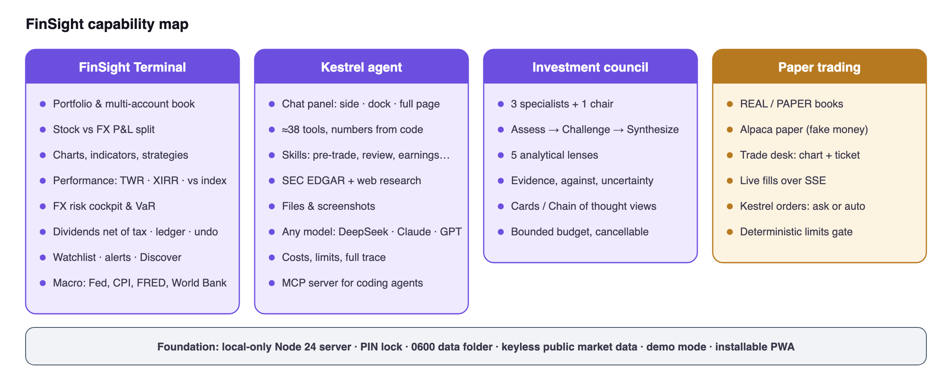
Figure 2 — Capability map
LIVE CAPTURE Screen 1 — The FinSight Terminal running the demo portfolio: summary cards with the stock/FX P&L split, live positions, the NVDA chart and performance vs the S&P 500
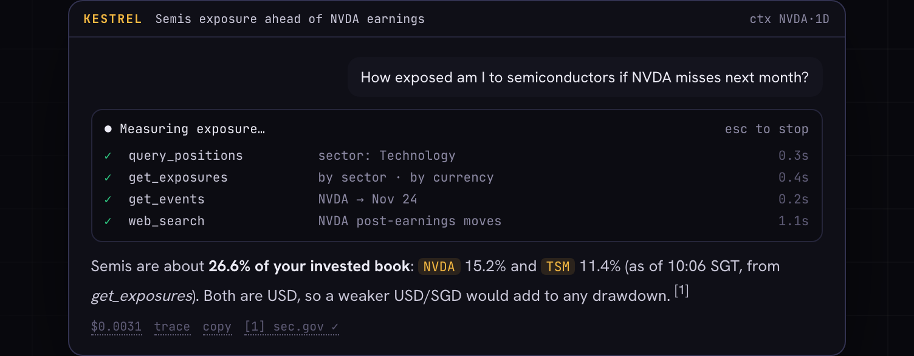
GUIDE RECONSTRUCTION Screen 2 — Kestrel answering a portfolio question: each tool call is shown, the figures come from tools, and the answer carries an as-of time, sources and its cost

2. Problem and motivation

2.1 The problem
A retail investor who funds in one currency and invests in another (for example converting SGD to buy US stocks) faces four recurring problems:
1. Hidden currency effect. Broker screens report gains in one currency. The investor cannot see how much of a gain or loss was the share price and how much was USD/SGD moving.
2. Fragmented view. Holdings sit across brokers and accounts (IBKR, moomoo, Tiger, SGX). No single local view rolls them up in the base currency with true time-weighted and money-weighted returns.
3. Expensive or privacy-hostile tools. Professional terminals are costly; free portfolio sites require uploading holdings to a third party.
4. Untrustworthy AI help. General chatbots invent numbers, do arithmetic badly, forget the user's rules and cannot see the actual book.

2.2 Motivation and vision
FinSight's vision is "a trading floor for one, running entirely on this machine": the depth of a professional terminal, the privacy of a local app, and an AI analyst that is grounded in the user's real data and rules and that shows its work.

2.3 Goals
ID | Goal | Measure of success
G1 | See the whole book in one base currency | All accounts roll up; every holding shows stock P&L and FX P&L
G2 | Make currency risk explicit | Blended entry rate, FX P&L, what-if shock and 1-week VaR available
G3 | Stay private and free | No account, no telemetry, keyless data, data folder outside the repo
G4 | Ground AI answers in facts | Every figure comes from a tool; answers cite asOf/sources; cost visible
G5 | Support better decisions, not automate them | Council gives structured views; the user decides every real trade
G6 | Allow safe practice | Paper book with approval/limits; no live-trading path in code

2.4 Non-goals
- Placing real-money orders with any broker. FinSight records the real book; it never sends real orders.
- Multi-user or hosted SaaS operation. FinSight is single-user and local.
- Licensed, real-time market data. Public endpoints are delayed and best-effort.
- Investment advice. Outputs are research aids; the user is the decision-maker.

3. Product overview

3.1 FinSight Terminal
A local web application (served by node server.ts on port 8000) with a dark, themeable terminal UI. Key areas:
Area | What the user gets
Top bar | ↗ KESTREL (⌘/), REAL/PAPER switch, account picker (All Accounts / ＋ New), Profile, UNPEEK privacy mode, light/dark, ⚙ Layout, base currency, live status, lock
Command bar | Bloomberg-style commands: ADD, SELL, DEL, CASH, UNDO, LEDGER, Q, WATCH, ALERT, NEWS, WHT, MKT, HELP
Summary cards | Net worth, total value, day P&L, unrealized P&L, stock P&L, FX P&L, FX exposure, realized P&L
Positions | Live table with weight and FX P&L, filters, grouping, Buy/Sell trade sheet, import/export, undo
Security detail | Canvas chart: candle types, indicators (SMA/EMA/Bollinger/RSI/MACD/volume), strategies, replay, journal, compare, drawing tools, chart alerts
Analytics | Performance (TWR, XIRR, vs S&P 500 / MSCI World / All-World / Nasdaq / STI in base currency), net-worth breakdown, allocation donut, sector heatmap
FX Risk | USD exposure, blended entry, spot drift, FX P&L, per-buy FX history, what-if slider, 1σ/95% weekly VaR, target exposure, convert now vs later
Income & history | Dividends net of withholding tax (yield on cost, next ex-date), recent activity, ledger with realized gains by year
Watch & alert | Watchlist, price/trend/RSI/MA alerts with desktop notification, toast and beep
Discover | Movers among held/watched symbols, US market movers (Yahoo screens), US IPO calendar (Nasdaq), upcoming earnings
Macro | World markets, econ calendar (next Fed decision and dot plot, CPI/PCE/jobs/GDP), FRED series, World Bank indicators, inflation gauges
Personalisation | Movable panels, accent palettes (Violet/Amber/Teal/Phosphor), Mono/Sans/Serif fonts, light mode

The terminal, filled with the demo portfolio
The screens below come from the running app with the synthetic demo book (9 holdings across USD and SGD, fake market data). No real holdings are shown.
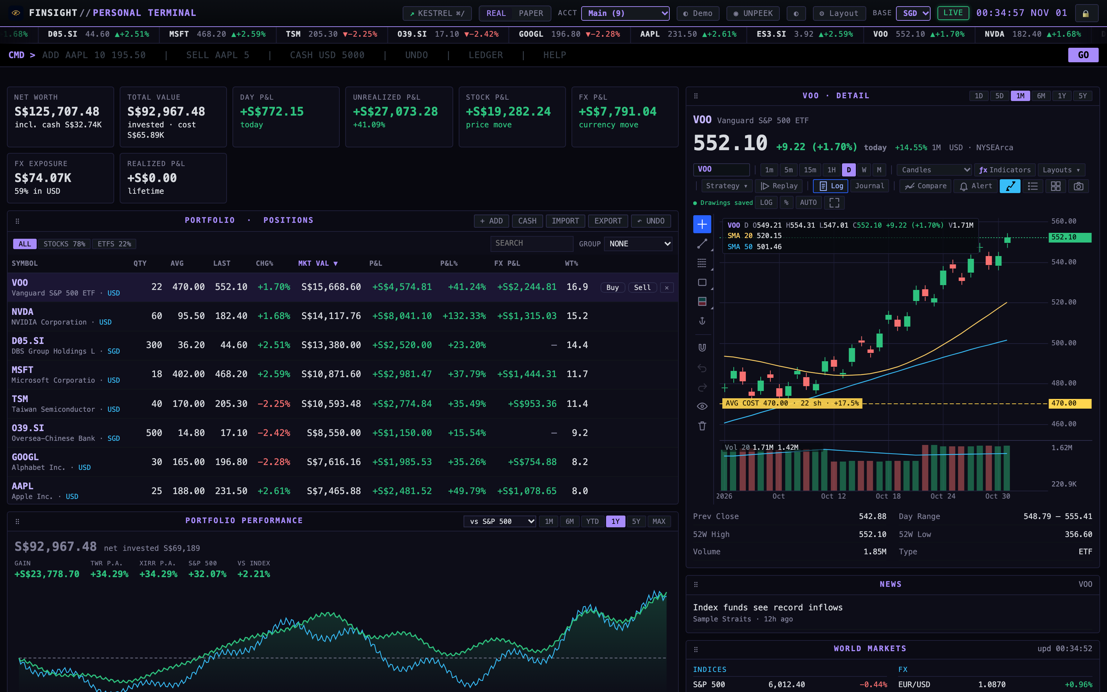
LIVE CAPTURE Screen 3 — Terminal home: top bar (Kestrel, REAL/PAPER, account, UNPEEK, layout, base currency), ticker, command bar, summary cards and positions
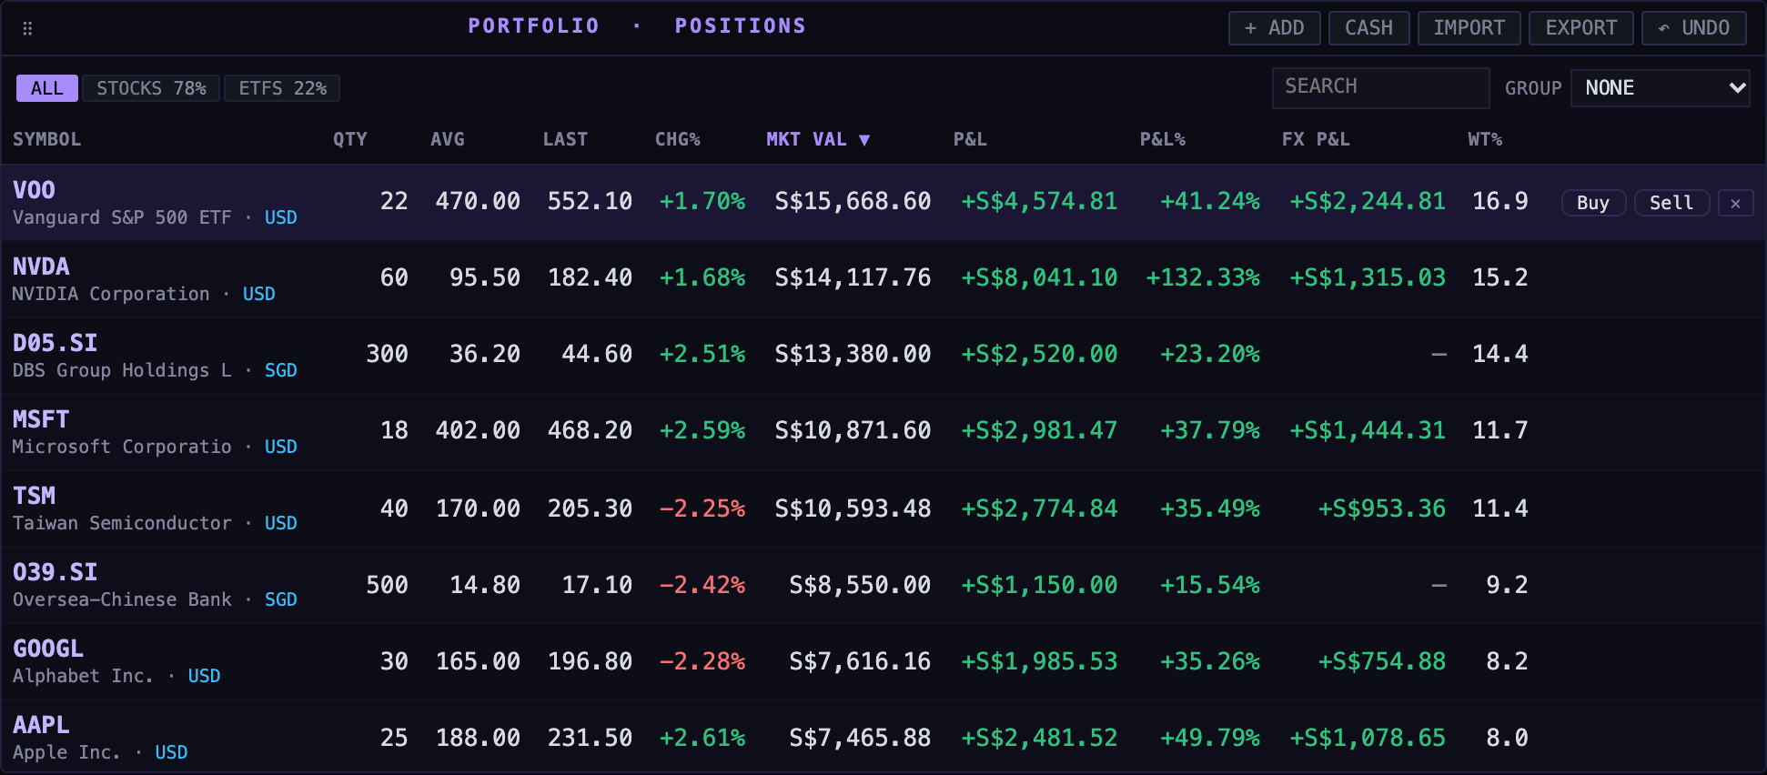
LIVE CAPTURE Screen 4 — Positions: quantity, average cost, last price, market value in SGD, P&L, P&L %, FX P&L and weight per holding
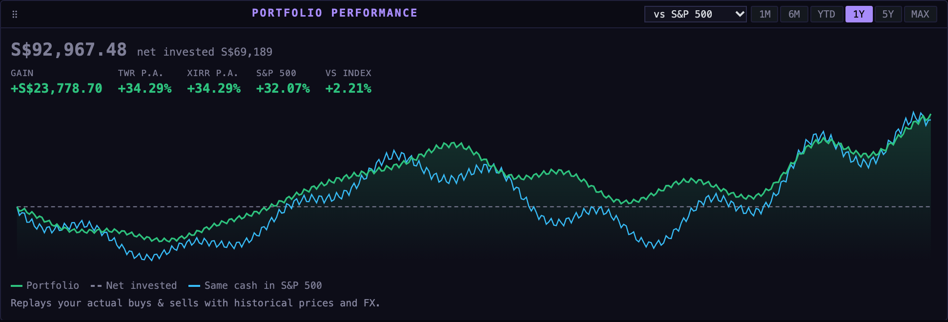
LIVE CAPTURE Screen 5 — Performance: time-weighted and money-weighted return against the S&P 500, in the base currency
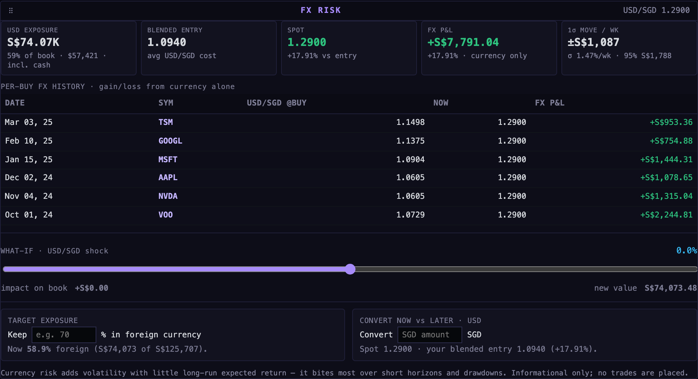
LIVE CAPTURE Screen 6 — FX Risk: USD exposure, blended entry rate, spot drift, FX P&L, per-buy history, a what-if shock slider and conversion planning
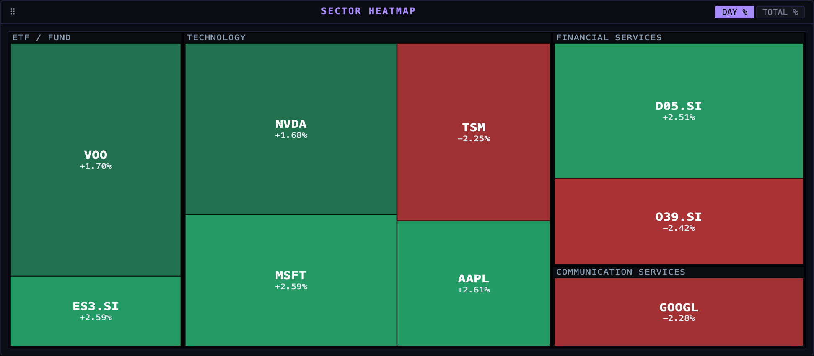
LIVE CAPTURE Screen 7 — Sector heatmap: tile size is position weight, colour is the day's move
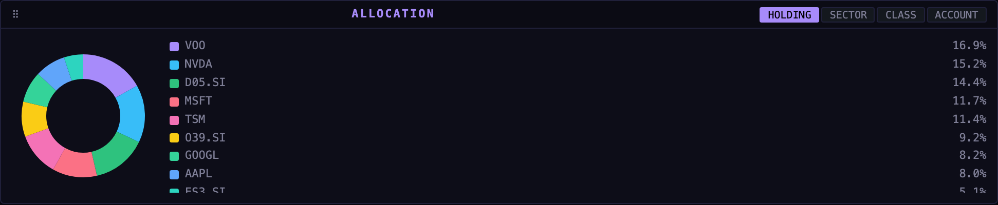
LIVE CAPTURE Screen 8 — Allocation by holding (switchable to sector, asset class or account)
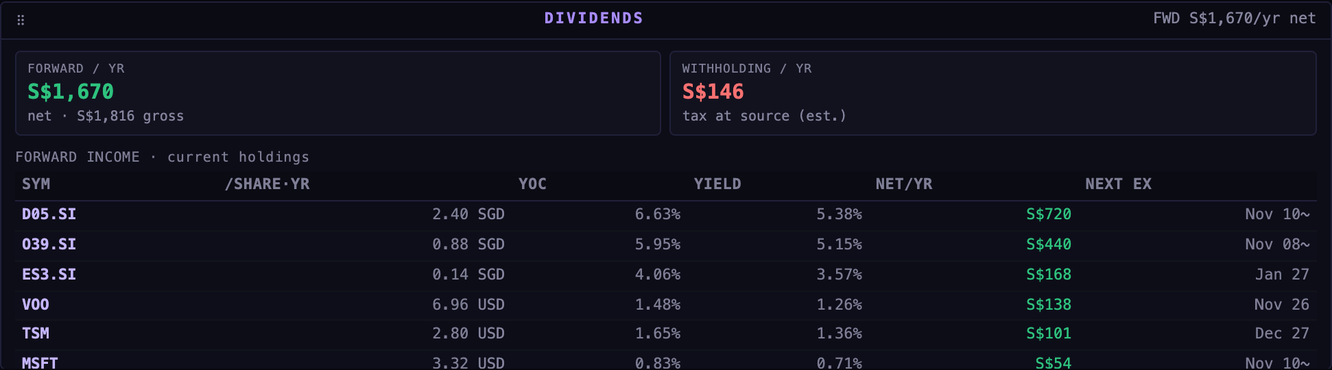
LIVE CAPTURE Screen 9 — Dividends: forward income net of withholding tax, yield on cost and the next ex-date
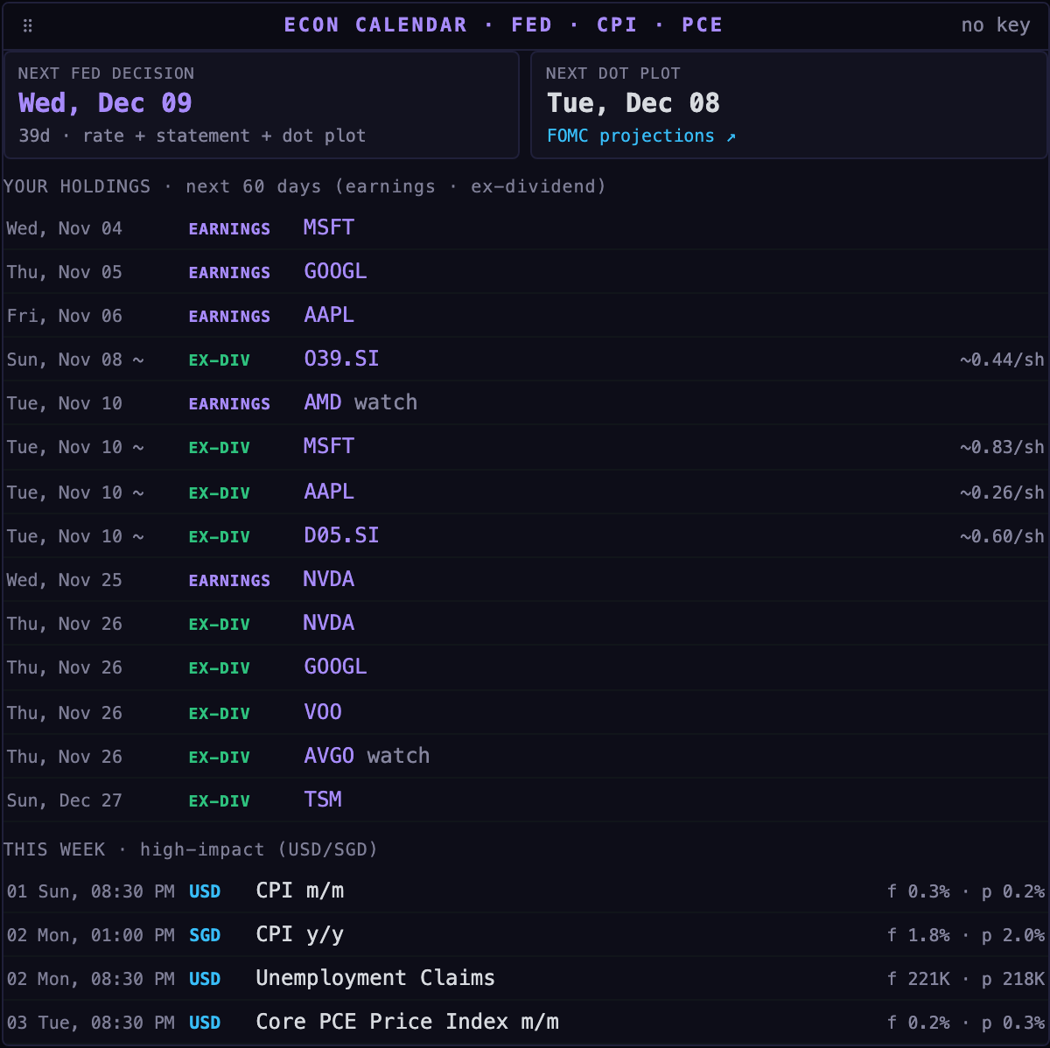
LIVE CAPTURE Screen 10 — Econ calendar: next Fed decision and dot plot, holdings' earnings and ex-dividend dates, this week's high-impact releases
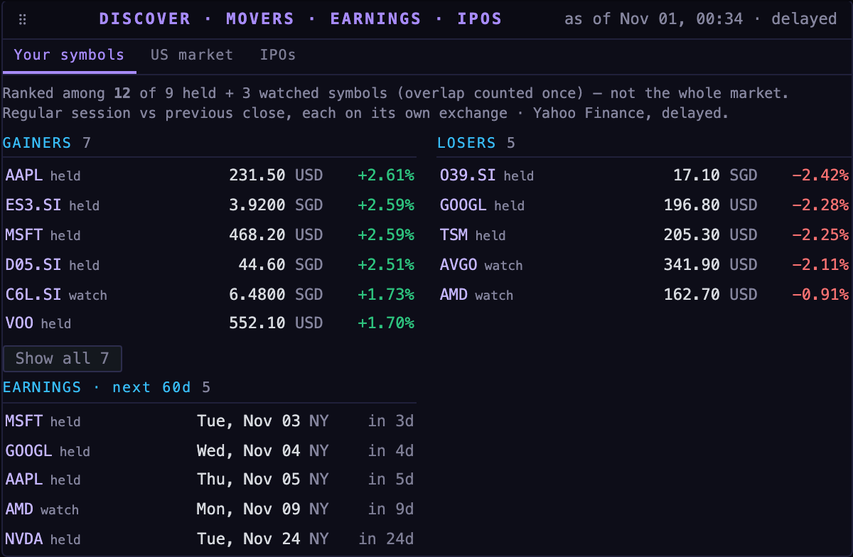
LIVE CAPTURE Screen 11 — Discover: movers among held and watched symbols, and upcoming earnings
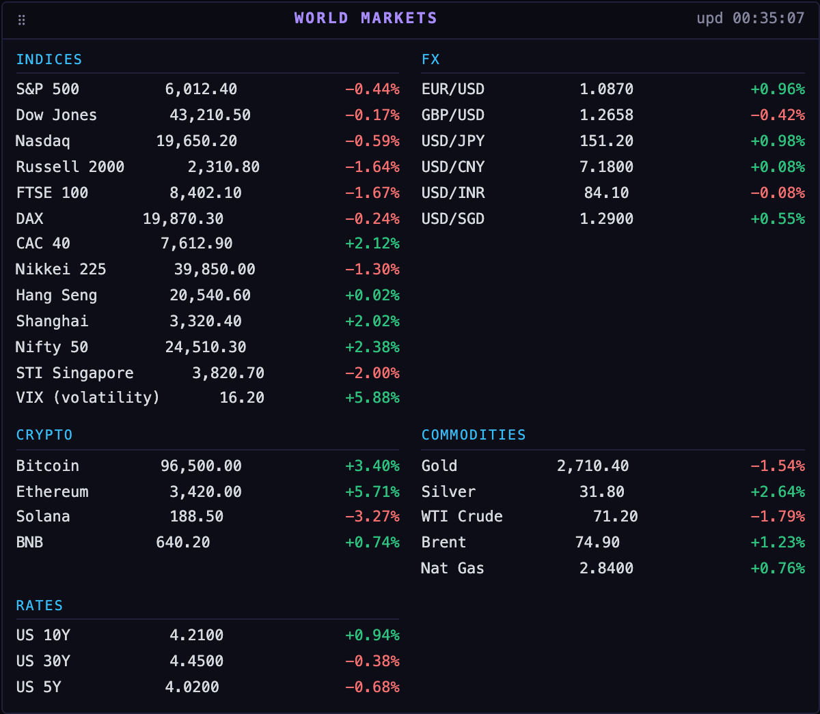
LIVE CAPTURE Screen 12 — World markets: indices, FX, crypto, commodities and rates

3.2 ↗ Kestrel — AI research agent
A supervised local service (port 8100) behind FinSight's PIN. It chats in a panel that can be a side drawer, a docked terminal panel, a full page with a workspace column, or a collapsed capsule. It uses ≈38 tools for portfolio facts, strategies, SEC EDGAR, web research, files, records and (in paper mode) paper orders. Skills (/pre-trade-check, /position-review, /earnings-review, /why-did-it-move, /strategy-scan) run repeatable playbooks. It works with DeepSeek (default), Claude, OpenAI-compatible models or the Claude Code CLI, shows cost per answer and keeps a full trace.
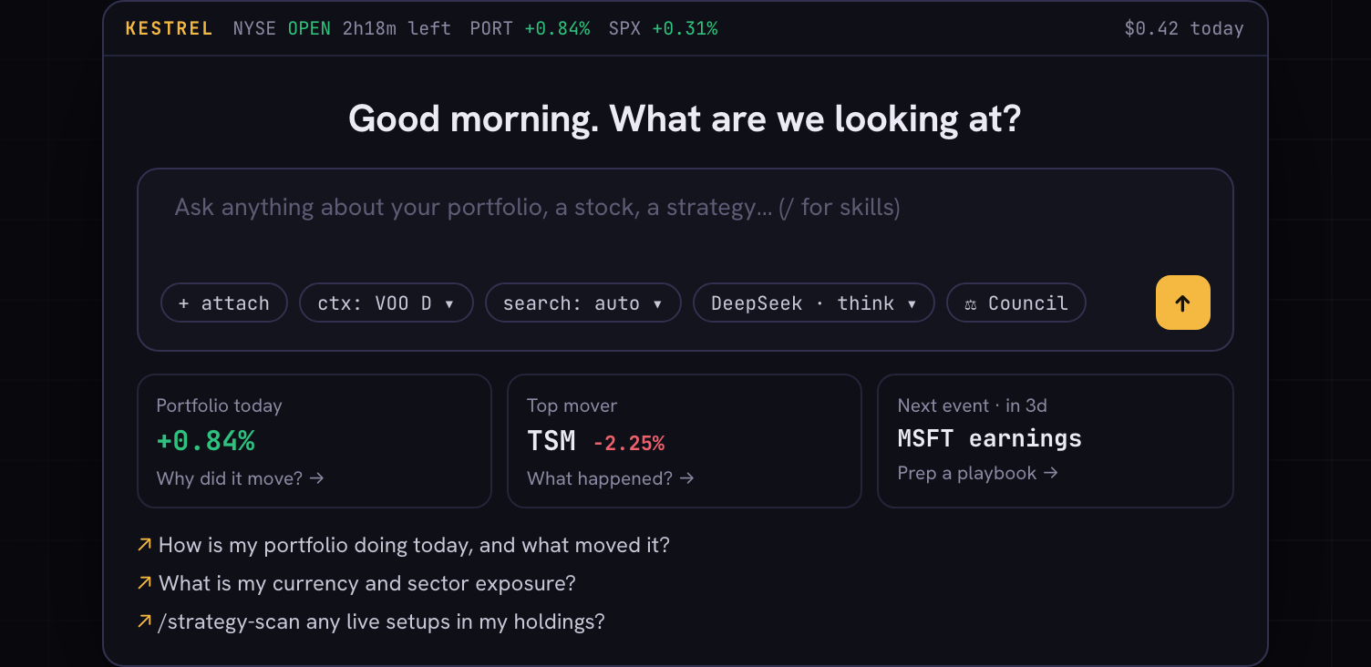
GUIDE RECONSTRUCTION Screen 13 — Kestrel start screen: the ask box with attach, context, search mode, model and ⚖ Council, plus briefing tiles built from the book

3.3 Investment council
An explicit mode (⚖ Council or /committee) in which Business & Growth, Macro & Valuation and Portfolio Risk specialists assess a decision independently, run a challenge round, and a Kestrel Chair synthesises what they agree on, what is still needed and what would change the view. Five lenses (Balanced, Growth, Speculative/Catalyst, Hedge Fund, Macro) tune emphasis without changing rules or data.
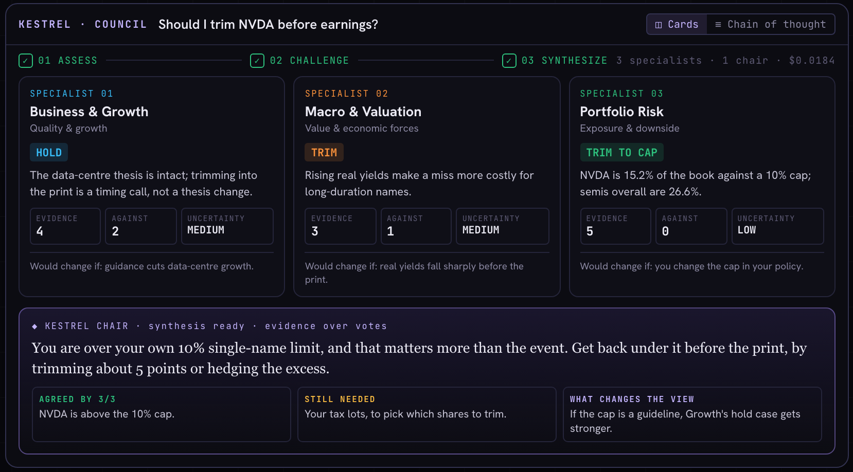
GUIDE RECONSTRUCTION Screen 14 — Council result, Cards view: each specialist's verdict, evidence and uncertainty, with the chair's synthesis below

3.4 Paper trading
A second book next to the real one. The user connects an Alpaca paper key pair; FinSight mirrors Alpaca's fills into a paper portfolio so every existing view works. A trade desk (chart, docked ticket, positions/orders/history/Kestrel/settings tabs) places market and limit orders. Kestrel can place paper orders too: Ask me first (pending ticket to approve) or Autonomous, inside optional deterministic limits.
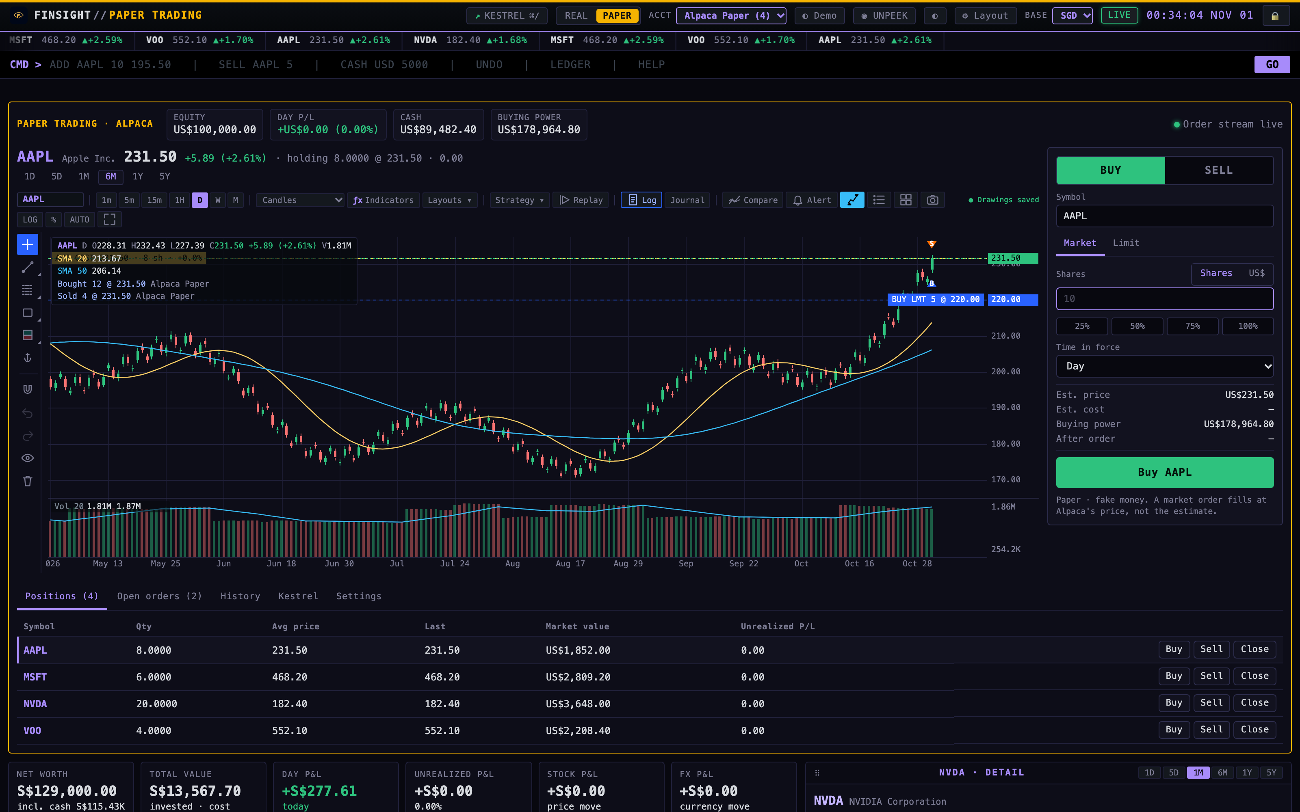
LIVE CAPTURE Screen 15 — Paper trade desk after real fake-broker orders: account strip, AAPL chart with buy/sell fill markers and an open limit line, the docked ticket and four paper positions

3.5 Demo mode
npm run demo starts an isolated FinSight and Kestrel on port 8003 with a synthetic portfolio (PIN 2468) in ~/FinSightDemo. It never touches real data and is the recommended environment for demos and UAT.

4. Stakeholders and personas
Persona | Description | Primary needs
Owner-investor (primary) | Technically capable individual investor in Singapore, funds in SGD, holds US/SG/HK equities and ETFs across brokers | One private view; FX clarity; grounded research; rules enforced; safe practice
Demo audience | Friends, peers or reviewers watching a walkthrough | Understand value quickly without seeing real holdings (demo mode, UNPEEK)
Contributor / coding agent | Developer or AI coding agent (Claude Code, Codex, Cursor) changing the code | Clear specs, boundaries, quality gates, docs-as-code process (AGENTS.md)
UAT tester | Human or Codex computer-use agent executing acceptance scripts | Deterministic environment (demo + fake market), precise steps and expected results (§25)
External MCP client | Claude Code / Codex / Cursor using FinSight tools over MCP | Same read-only tools and citation rules as Kestrel

Single-user by design
There is exactly one user class with full authority. There is no multi-tenancy, no roles and no remote access. All security controls assume an attacker is another process, web page or document on the same machine — not a second legitimate user.

PART A
Product and design foundations
Domains 01–04: requirements, architecture, technology stack, frontend and UX

5. Product requirements and scope
Domain 01 Product requirements and scope
This chapter fixes what FinSight is for and where its edges are. The user stories, flows and specifications in the next chapters elaborate it.

5.1 Problem statement and business goals
A Singapore-based investor who funds in SGD and buys US, SG and HK securities cannot see how much of a return came from the stock and how much from the currency. Holdings are spread across brokers, professional tools are expensive, and general chatbots invent numbers. FinSight's goals G1–G6 (§2) turn this into measurable outcomes: one base-currency view, explicit FX risk, privacy at no cost, AI answers grounded in tools, decision support rather than automation, and safe practice with fake money.

5.2 Scope
In scope | Out of scope (by decision)
Multi-account, multi-currency portfolio book with lot-level cost and purchase FX | Real-money order routing to any broker
Analytics: stock vs FX P&L, TWR/XIRR vs index, FX risk, dividends after tax | Multi-user, hosted or SaaS operation
Market data, charting, strategies, alerts, discovery and macro panels from free sources | Licensed real-time data feeds
Kestrel research agent with tools, skills, files, limits and MCP | Investment advice; the user decides every trade
Investment council for structured decision reviews | Shorts, options and margin in the book
Paper trading on Alpaca paper with approval and limits | Scheduled or autonomous agent runs (planned as FEAT-013)

5.3 Prioritisation and roadmap
Work is prioritised in docs/BACKLOG.md. An idea enters the icebox as IDEA-xxx; nothing is built from an idea. When selected, it becomes a feature spec FEAT-xxx with intent, decisions, scope, out-of-scope and acceptance criteria, and is scheduled with a task id (for example PAPER-001). The MVP was the local terminal with the stock/FX split; Kestrel, the council and paper trading followed as separately specified increments. Current status and the roadmap are in §34.

5.4 Business rules and constraints
- No model arithmetic. Every total, weight, size and return is computed by deterministic code; the model only explains (AGENTS.md).
- The user decides. Kestrel never places real orders and never edits records without confirmation; paper orders follow the approval mode.
- Base currency is the unit of truth. Unrealized P&L = Stock P&L + FX P&L in the base currency, using each lot's purchase-time FX.
- Lots are kept. Buys add lots; sells realise P&L against lots; transfers between accounts keep lots, cost and FX.
- Paper and real never mix. The PAPER book mirrors Alpaca fills only; manual edits are refused in PAPER mode.
- No personal data in the repository. Holdings, keys and broker exports live only in the data folder.

5.5 Edge cases the requirements cover
Edge case | Required behaviour
Back-dated trade | Fetch the historical FX rate for the trade date (FR-PF-7)
Duplicate broker import | IBKR fills previewed with duplicate detection before saving (FR-PF-5)
Sell more than held / sell an unknown symbol | Refused with a message; nothing written
Market data source down or rate-limited | Last good values served and flagged stale
Ambiguous company in a council question | Clarification or explicit gap, never a guess from the chart in view (FR-C-6)
Kestrel order breaching a limit | Refused before reaching the broker, with the reason (FR-P-6)
Live Alpaca key entered | Refused before saving (FR-P-1)

5.6 Acceptance criteria and definition of done
Every story in §6 carries acceptance criteria, and every functional requirement in §8 traces to tests (Appendix D). A change is done when its feature spec's acceptance criteria are met, npm run verify and npm run agent:test pass, the affected documentation is updated in the same change, and CHANGELOG.md records it with its commit reference.

5.7 Success metrics
FinSight has no telemetry by design (see §32), so success is measured by observable outcomes rather than usage analytics: every holding shows a stock/FX split; Kestrel answers cite an as-of time and sources and show cost; daily AI spend stays under the cap; council runs complete or fail with an explicit gap; and the UAT catalogue (§25) passes.

5.8 Stakeholder alignment and change management
The owner is the single decision-maker. Changes to agreed behaviour are recorded as dated decisions inside the feature spec; changes that contradict agent/docs/SPEC.md need the owner's approval before code. Coding agents follow AGENTS.md, so human and AI contributors work from the same rules.

6. User stories
Domain 01 Product requirements and scope
Stories follow "As a … I want … so that …" with acceptance criteria (AC). IDs map to functional requirements (§8) and UAT cases (§25).

Epic A — Access and setup
ID | Story | Acceptance criteria
US-A1 | As the owner, I want to lock FinSight behind a PIN so that nobody using my computer can read my portfolio. | PIN required for all /api/* data; wrong PIN shows "Wrong PIN"; repeated failures are throttled; 🔒 locks immediately
US-A2 | As the owner, I want to choose REAL or PAPER before unlocking so that I land in the right book. | Lock screen offers both; choice persists across tabs and reloads; PAPER is visibly marked
US-A3 | As a new user, I want a guided first-run so that I can start in minutes. | Operator card asks name and base currency; offers CSV import, manual add or empty start; reopen from Profile
US-A4 | As a presenter, I want a demo mode so that I can show FinSight without exposing my data. | npm run demo opens port 8003 with synthetic data and PIN 2468; real data folder untouched

Epic B — Portfolio and analytics
ID | Story | Acceptance criteria
US-B1 | As the owner, I want every holding valued in my base currency so that I see one total. | Summary cards and positions use BASE; changing BASE re-prices everything
US-B2 | As the owner, I want gains split into stock and FX parts so that I know what drove returns. | Unrealized = Stock P&L + FX P&L; per-position FX P&L column; lots store purchase FX
US-B3 | As the owner, I want to record buys and sells quickly so that the book stays accurate. | Command bar and trade sheet record trades; sheet previews position after and new average; UNDO reverses
US-B4 | As the owner, I want to import broker statements so that I don't retype holdings. | Plain CSV, IBKR, moomoo, Tiger supported; IBKR fills previewed with duplicate detection
US-B5 | As the owner, I want multiple accounts and transfers so that the book matches reality. | Create accounts; All Accounts view; transfers keep lots, cost and FX; undoable
US-B6 | As the owner, I want true performance vs an index so that I know if I'm adding value. | TWR, XIRR, gain, vs index in base currency for 1M…MAX; benchmark selectable
US-B7 | As the owner, I want to see FX risk so that I can plan conversions. | FX Risk shows exposure, blended entry, spot drift, VaR, what-if, target, convert-now
US-B8 | As the owner, I want dividend income after tax so that I can plan cash flow. | Forward income net of WHT; yield on cost; next ex-date; WHT command changes rates

Epic C — Markets, discovery and alerts
ID | Story | Acceptance criteria
US-C1 | As the owner, I want a full chart for any symbol so that I can analyse price action. | Click a row or Q SYM; timeframes, chart types, indicators, strategies, drawings saved
US-C2 | As the owner, I want price alerts so that I don't have to watch the screen. | ALERT AAPL > 320 or UI; fires notification, toast and beep
US-C3 | As the owner, I want to see what's moving and what's coming so that I can prepare. | Discover tabs (Your symbols, US market, IPOs) with source, as-of and stale flags; rows open detail
US-C4 | As the owner, I want the macro calendar so that I know when rates news lands. | Next Fed decision/dot plot always shown; this week's high-impact releases; holdings' earnings/ex-dates
US-C5 | As a presenter, I want to hide money figures so that I can share my screen. | UNPEEK blanks every money figure including Kestrel/council views

Epic D — Kestrel agent
ID | Story | Acceptance criteria
US-D1 | As the owner, I want to ask questions about my portfolio in plain language so that research is fast. | ⌘/ opens Kestrel; answers stream; figures come from tools with asOf; sources cited
US-D2 | As the owner, I want to see what Kestrel did so that I can trust or challenge it. | Tool calls shown live; per-answer cost; trace of every model/tool/data call
US-D3 | As the owner, I want repeatable playbooks so that important checks are never skipped. | / menu lists skills; /pre-trade-check sizes from real cash and checks concentration and events
US-D4 | As the owner, I want to choose the model and thinking effort so that I balance cost and depth. | Model picker and effort menu; /model; cost per answer and per day visible
US-D5 | As the owner, I want spending limits so that a runaway loop can't cost much. | Per-turn and per-day caps editable (/limits); limits enforced before billable calls
US-D6 | As the owner, I want to give Kestrel files and screenshots so that it can analyse them. | Attach/paste/drop PDFs, DOCX, CSV, images; content treated as untrusted data
US-D7 | As the owner, I want Kestrel to remember my rules only with my consent so that records stay mine. | Stated facts become propose_record_update proposals; nothing changes until confirmed
US-D8 | As a developer, I want FinSight tools in my coding agent so that I can query data from my IDE. | claude mcp add finsight -- node agent/src/cli.ts mcp exposes the registry over stdio

Epic E — Council
ID | Story | Acceptance criteria
US-E1 | As the owner, I want several expert views on a decision so that I avoid one-sided reasoning. | Council runs 3 specialists + chair through Assess → Challenge → Synthesize
US-E2 | As the owner, I want to set an analytical lens so that the review fits my question. | Lens picker (5 lenses) shown when Council is on; lens recorded with the turn
US-E3 | As the owner, I want to see evidence and uncertainty so that I can judge each view. | Cards show verdict, evidence/against counts, uncertainty, would-change-if; Chain of thought view
US-E4 | As the owner, I want the council to admit gaps so that I'm not misled. | Ambiguous company or missing data → clarification/gap, partial status; unverified figures flagged

Epic F — Paper trading
ID | Story | Acceptance criteria
US-F1 | As the owner, I want a paper book so that I can practise without risking money. | PAPER mode with Alpaca paper keys; real book untouched; manual book edits refused
US-F2 | As the owner, I want a professional trade desk so that placing orders is quick and clear. | Account strip, chart linked to ticket, BUY/SELL, Market/Limit, shares or US$, quick sizes, TIF, estimate
US-F3 | As the owner, I want fills to appear live so that I don't refresh. | trade_updates → book resync → SSE; positions, ledger, P&L, chart markers update
US-F4 | As the owner, I want Kestrel to propose or place paper orders under my control so that I can test agentic trading safely. | Ask mode creates pending tickets (Approve/Reject); Auto places directly; limits refuse with reason; only the PIN session can change settings

7. User flows
Domain 01 Product requirements and scope
The five flows below cover every primary journey. §25 turns each into executable UAT scripts.
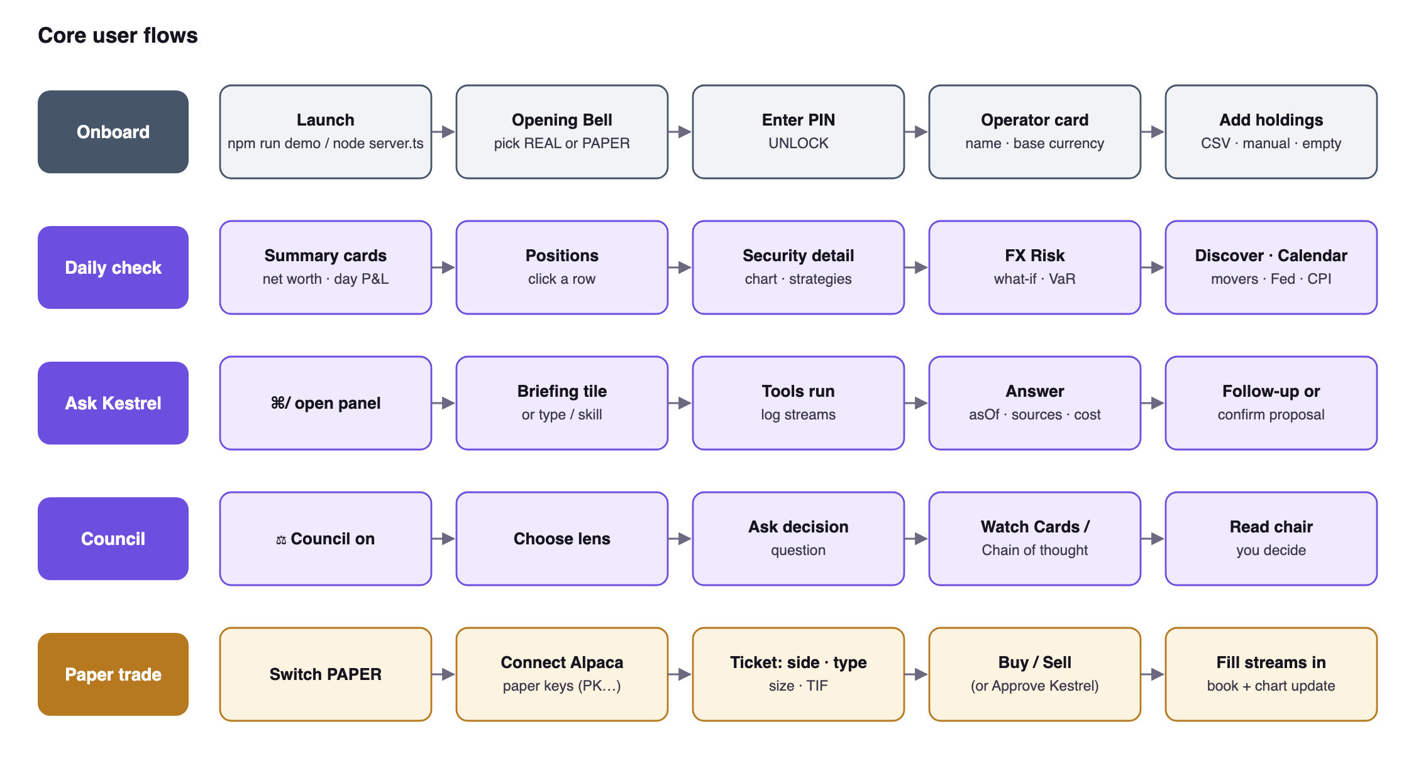
Figure 3 — Core user flows

Flow narratives
Flow | Entry point | Happy path | Key alternate paths
Onboard | Launcher or node server.ts | Opening Bell → choose book → PIN → operator card → import → terminal | Wrong PIN (throttled) · start empty · reopen via Profile · forgot PIN (delete auth.json)
Daily check | Terminal home | Summary cards → positions → click row → chart → FX Risk → Discover → calendar | Stale quotes flagged · UNPEEK for sharing · switch account or base
Ask Kestrel | ⌘/ or ↗ KESTREL | Briefing tile or question → tool log → answer with asOf, sources, cost | Agent offline hint · stop with Esc · limits reached · proposal confirm/dismiss
Council | ⚖ Council pill or /committee | Lens → decision question → cards/chain stream → chair synthesis | Ambiguous subject → clarification · budget refusal · cancel aborts tree
Paper trade | PAPER (lock screen or top bar) | Connect keys → ticket → submit → fill streams → book updates | Live keys refused · limit refusal · Kestrel ticket approve/reject · cancel open order

8. Functional specification
Domain 01 Product requirements and scope
Requirements use MUST for mandatory behaviour. Each FR traces to stories (§6) and tests (Appendix D).

Access, session and modes
ID | Requirement
FR-ACC-1 | The server MUST gate every data API behind a PIN session; the UI shell may load without it.
FR-ACC-2 | PINs MUST be stored scrypt-hashed in auth.json; failed attempts MUST be throttled.
FR-ACC-3 | Session cookies MUST be HttpOnly; SameSite=Strict; idle lock after LOCK_IDLE_MIN minutes when configured.
FR-ACC-4 | The book mode (REAL/PAPER) MUST be stored in book.json and apply to every tab and to Kestrel.
FR-ACC-5 | First run MUST offer the operator card (name, base currency, CSV/manual/empty).

Portfolio, trades and imports
ID | Requirement
FR-PF-1 | Positions MUST be lot-based (q, px, fxUsd, t), preserving purchase-time FX for return decomposition.
FR-PF-2 | Unrealized P&L MUST equal Stock P&L + FX P&L in the base currency.
FR-PF-3 | Buy/sell/edit/delete/cash/import/transfer MUST be undoable (25-step undo stack).
FR-PF-4 | The trade sheet MUST support new symbols, show position-after and new average before saving.
FR-PF-5 | Imports MUST accept plain CSV and IBKR, moomoo and Tiger statements; IBKR fills MUST be previewed with duplicate detection.
FR-PF-6 | Transfers between accounts MUST preserve lots, cost basis and FX; the ledger MUST report realized gains by year and export CSV.
FR-PF-7 | Back-dated trades MUST fetch the historical FX rate for the trade date.

Market data, chart and analytics
ID | Requirement
FR-MD-1 | Quotes, history, FX, search and news MUST come from keyless public sources (Yahoo Finance) with stale-while-revalidate caching and 429 backoff.
FR-MD-2 | The chart MUST support 1m–M intervals, six chart types, indicators, strategy overlays, replay, journal, compare, drawings and alerts.
FR-AN-1 | Performance MUST replay actual trades with historical prices and FX to compute TWR and XIRR, and compare against a chosen index in base currency.
FR-AN-2 | FX Risk MUST show exposure, blended entry, spot drift, FX P&L, per-buy history, what-if shock, 1σ and 95% weekly VaR, target exposure and convert-now estimate.
FR-AN-3 | Dividends MUST be forward-estimated net of per-market withholding (default US 30%), with yield on cost and next ex-date.
FR-DS-1 | Discover MUST label its universe, baseline, session, as-of and stale/failed states; US movers via Yahoo screens; IPOs via Nasdaq with EDGAR links.
FR-MC-1 | The econ calendar MUST always show the next FOMC decision and dot-plot date, plus this week's high-impact releases.
FR-AL-1 | Alerts MUST fire desktop notification, toast and beep for price, trend line, RSI and moving-average rules.

Kestrel agent
ID | Requirement
FR-K-1 | Kestrel MUST run as a supervised loopback service reachable only through FinSight's /api/agent/* proxy.
FR-K-2 | All totals, weights and sizes MUST come from tools (query_positions, get_exposures, size_position…), never model arithmetic.
FR-K-3 | Answers MUST cite asOf/retrievedAt for data and source URL + date for web facts; missing data MUST be reported.
FR-K-4 | Kestrel MUST stream tool calls and text over SSE with event ids for replay; Esc/■ MUST stop a turn.
FR-K-5 | Users MUST be able to switch model and thinking effort; each answer MUST show its cost; /cost reports spend.
FR-K-6 | Limits (defaults: 25 steps, 300 s, US$0.25 per turn, US$5 per day, 20 searches, 25 fetches, 8 council research calls) MUST be enforced and editable.
FR-K-7 | Skills MUST load from agent/skills/*/SKILL.md and user skill folders; / lists commands and skills.
FR-K-8 | Durable facts the user states MUST become propose_record_update proposals; Kestrel MUST NOT edit records directly.
FR-K-9 | Attachments (PDF, DOCX, CSV, images) MUST be readable and treated as untrusted data.
FR-K-10 | The tool registry MUST be exposed over MCP stdio with the same read-only semantics.
FR-K-11 | Chats MUST support new, clear, delete (with confirmation), rename, pin, search and bulk clear.

Council
ID | Requirement
FR-C-1 | Council MUST be explicit (toggle or /committee), never automatic.
FR-C-2 | It MUST run three specialists, one challenge call each and a separate chair, with concurrency two.
FR-C-3 | Specialists MUST use role-scoped tools; paid web search/fetch excluded in this release.
FR-C-4 | Each assessment MUST validate against the versioned contract (verdict, evidence, against, uncertainty, invalidation).
FR-C-5 | Cost MUST be reserved before each call; a quarter of the turn ceiling is held for synthesis; cancellation aborts the tree.
FR-C-6 | Ambiguous subjects or unavailable data MUST yield clarification or gaps, never chart-context substitution.

Paper trading
ID | Requirement
FR-P-1 | Only Alpaca's paper base URL MAY be used; keys MUST be verified against it and live keys refused.
FR-P-2 | Keys MUST be stored 0600 in alpaca-paper.json (or env) and never sent to the browser or agent.
FR-P-3 | The paper book MUST mirror Alpaca fills into paper/portfolio.json; manual book edits MUST be refused in PAPER mode.
FR-P-4 | Orders: market/limit, buy/sell, day/gtc, whole or fractional shares, or notional USD for market orders; cancel open orders.
FR-P-5 | Kestrel tools paper_account, paper_place_order, paper_cancel_order MUST pass the same server gate.
FR-P-6 | Approval ask (default) MUST create pending tickets; auto MUST submit directly; optional limits MUST refuse deterministically with a reason.
FR-P-7 | Only the PIN session MAY change paper settings; every order MUST record origin (user/kestrel + thread).

9. Non-functional requirements
Domain 01 Product requirements and scope
Quality | Requirement / target
Performance | Agent overhead before first provider byte p95 ≤ 150 ms; context pack ≤ 500 ms p95 warm; panel open ≤ 100 ms; no N+1 calls to FinSight; idle CPU ≈ 0 (event-driven)
Availability | Terminal works offline from the persisted cache; failed upstream refreshes serve last-known-good with stale flags
Reliability | A crash mid-turn leaves an interrupted partial message; the supervisor restarts the agent with backoff; DB integrity check and backup before migrations
Security & privacy | Loopback only; PIN; secrets in Keychain or 0600 files; no telemetry; nothing personal in the repo (§20)
Usability | Keyboard command bar, ⌘/ for Kestrel, responsive layout to phone width, installable PWA
Accessibility | Axe checks in the E2E suite, accessible names match visible text, keyboard-operable tabs, reduced-motion support, light mode, high-contrast-friendly tokens
Maintainability | TypeScript strict, erasable syntax for native Node execution, module boundaries, specs before code, ADRs for significant decisions
Portability | macOS primary; Windows/Linux supported for the terminal; Keychain behind an interface with env fallback
Cost | DeepSeek default (≈US$0.0003–0.0008 per simple turn); caps per turn and per day
Scalability | Plugins (brains, skills, strategies, search providers) add capability without core edits; versioned contracts

10. System architecture
Domain 02 System architecture

10.1 Context
FinSight is a local system with one human user. It reaches out to keyless market-data sources, the Alpaca paper API, model providers and research sources. Coding agents can attach to its tools over MCP.
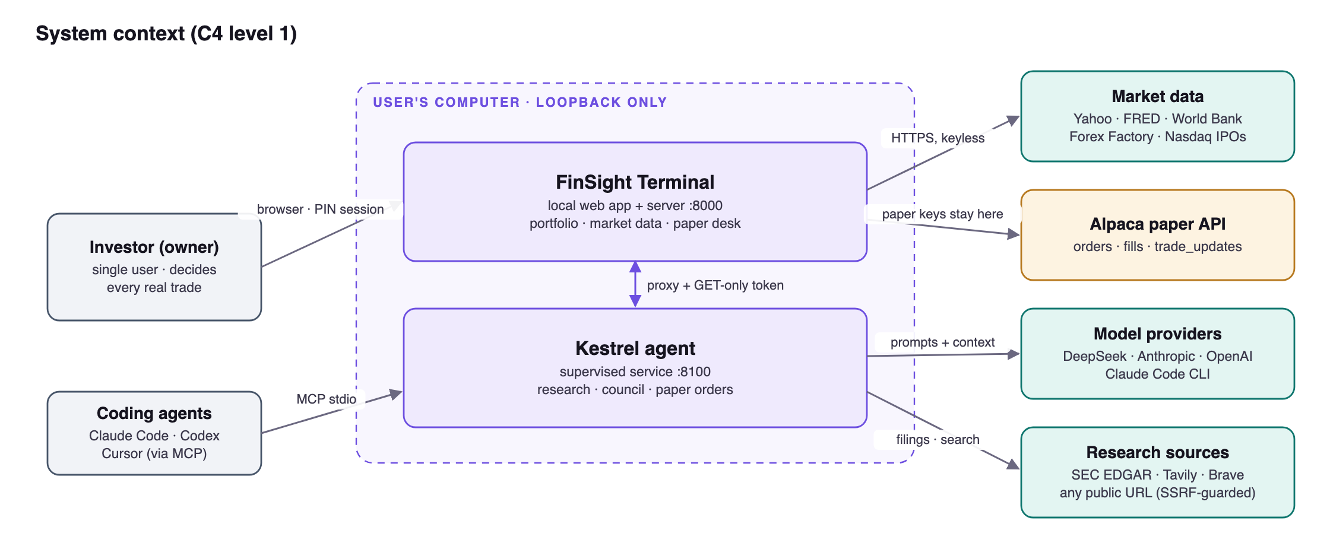
Figure 4 — System context

10.2 Containers and processes
Three processes cooperate on the user's machine: the browser UI, the FinSight server (which also supervises the agent and links to the paper broker) and the Kestrel service. All persistent state lives in FINSIGHT_DATA_DIR, outside the repository.
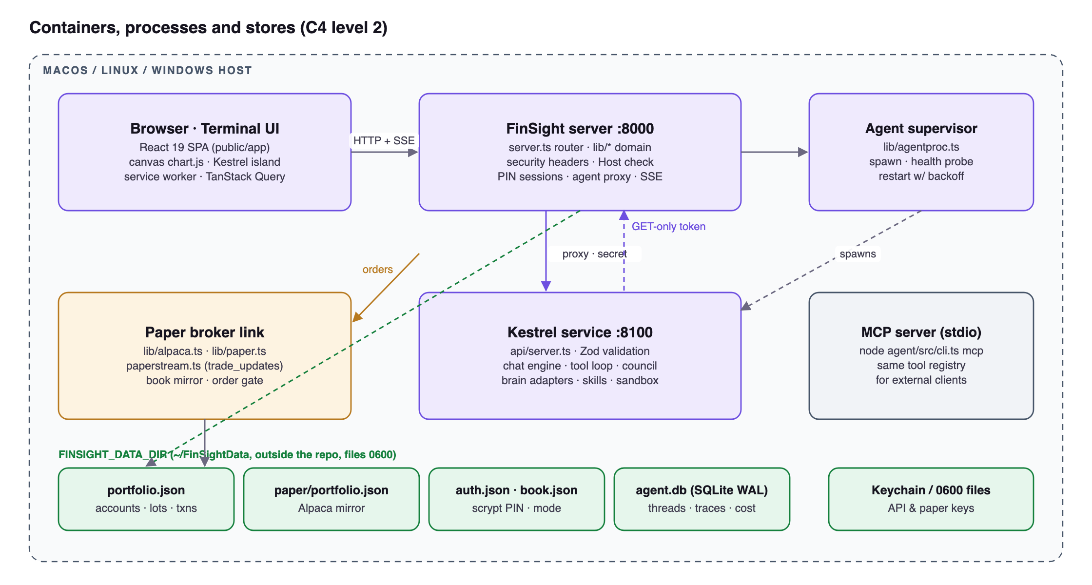
Figure 5 — Containers, processes and stores
Process | Port | Started by | Responsibility
FinSight server | 8000 (8003 demo, 8002 standalone) | node server.ts, start.command, autostart | UI, /api/*, sessions, market data, paper link, agent proxy & supervision
Kestrel service | 8100 (8103 demo) | FinSight supervisor | Chat engine, tools, council, skills, SQLite store
MCP server | stdio | External client | Exposes the tool registry to Claude Code / Codex / Cursor
Strategy sandbox | child process | Kestrel | Executes strategy engines with timeout and memory caps

10.3 FinSight server components
server.ts is only routing, security headers, the session gate and the agent proxy. Domain logic lives in lib/ modules with single responsibilities.
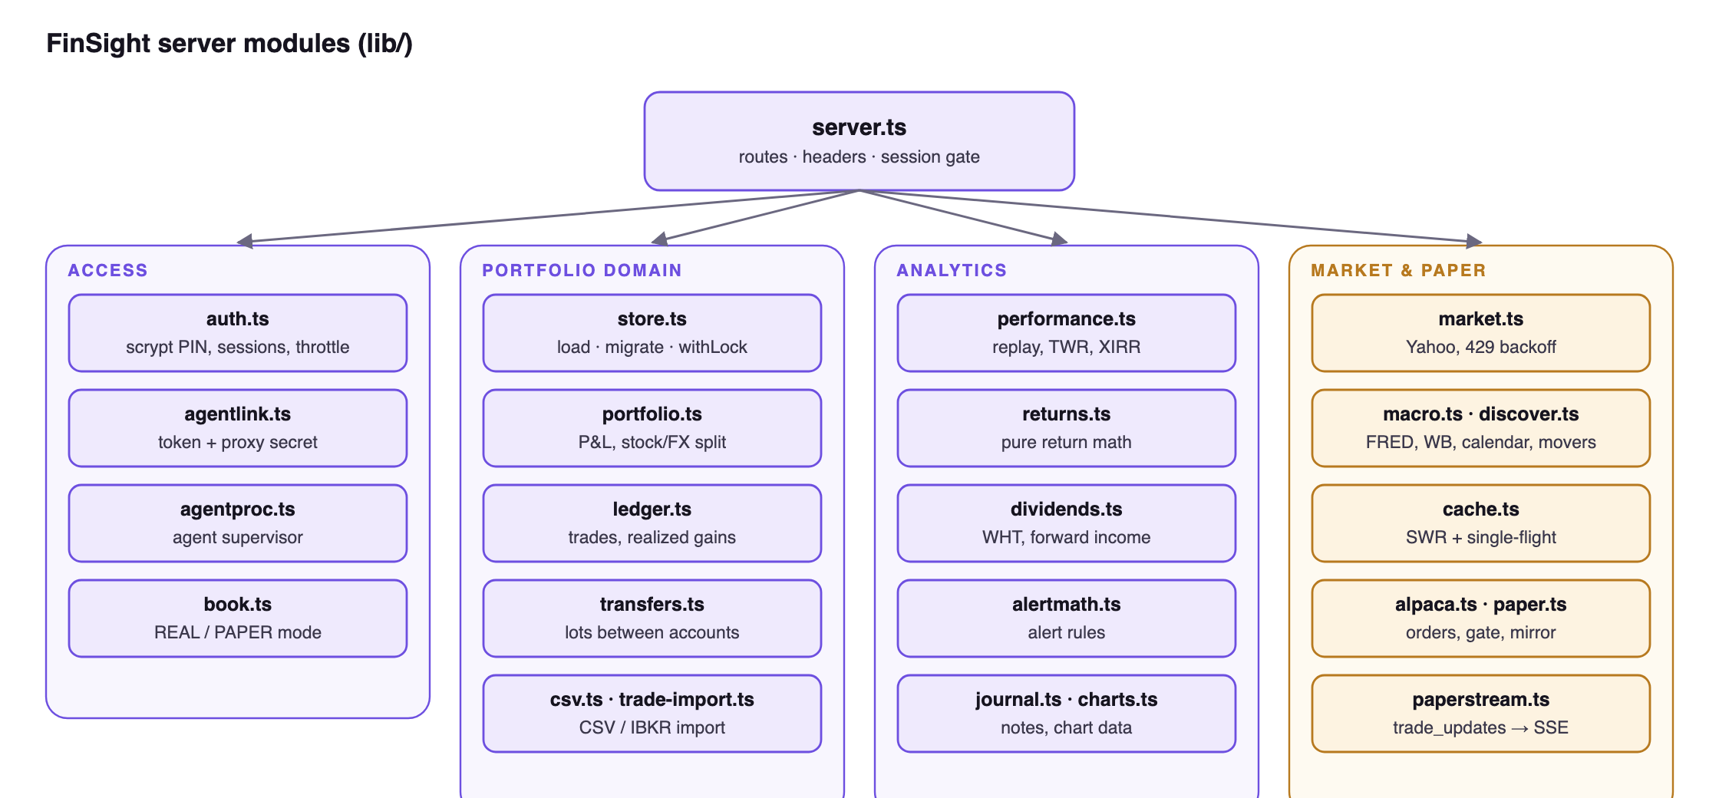
Figure 6 — Server modules

10.4 Kestrel agent components
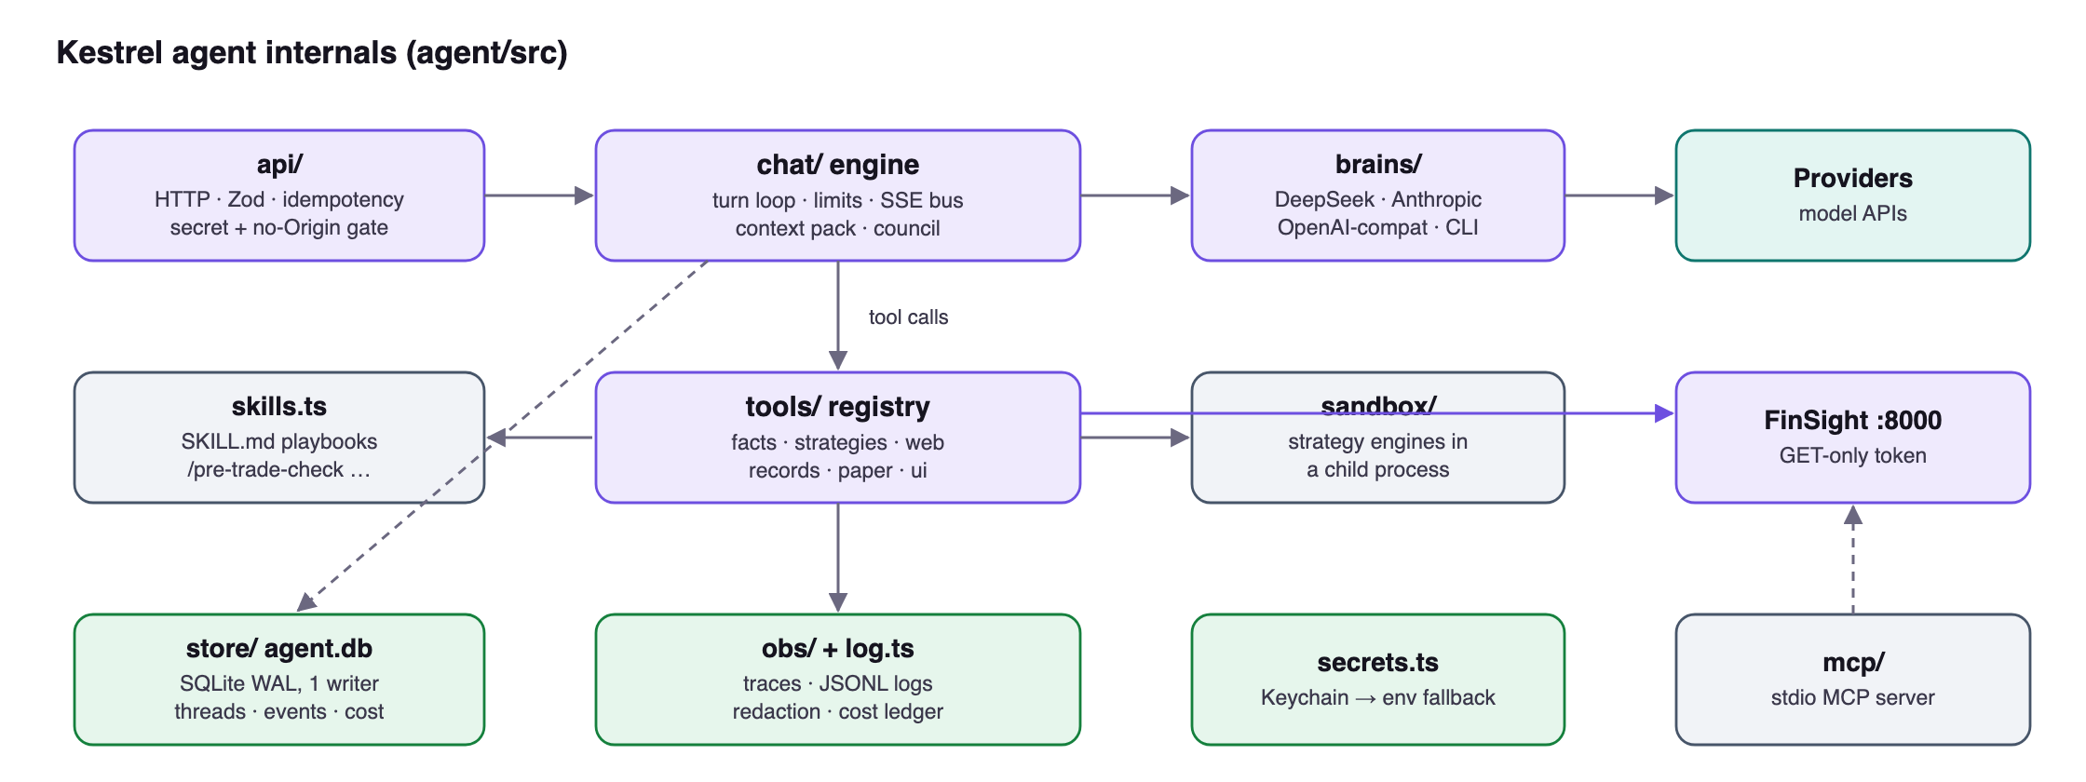
Figure 7 — Kestrel internals

10.5 Key runtime sequences
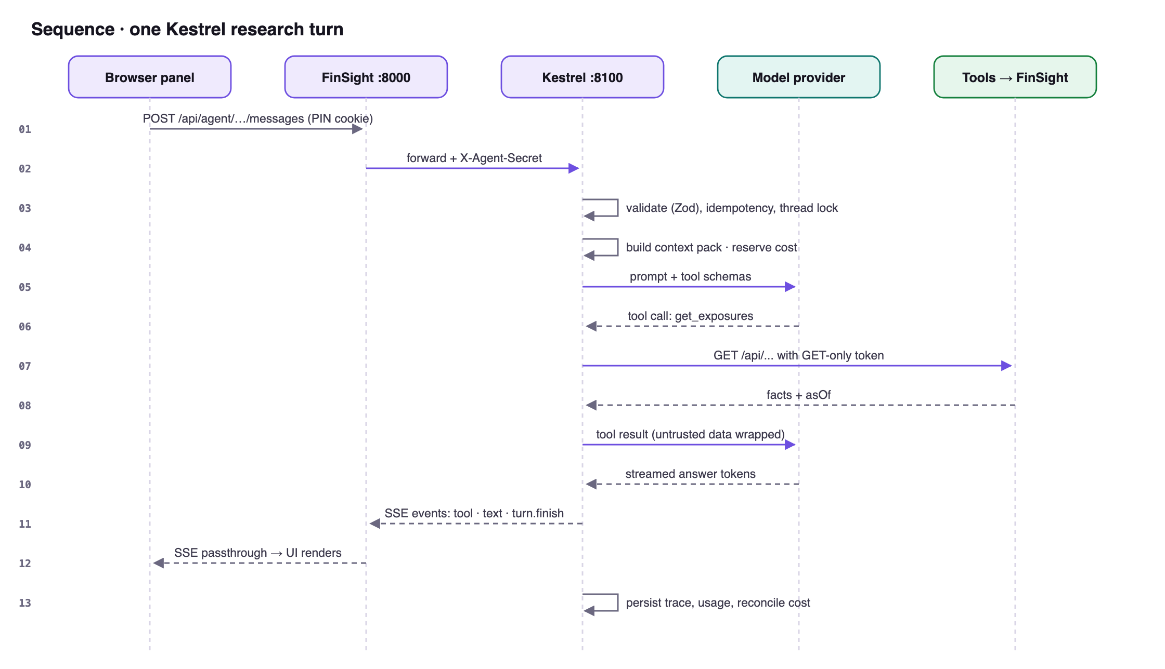
Figure 8 — One Kestrel research turn
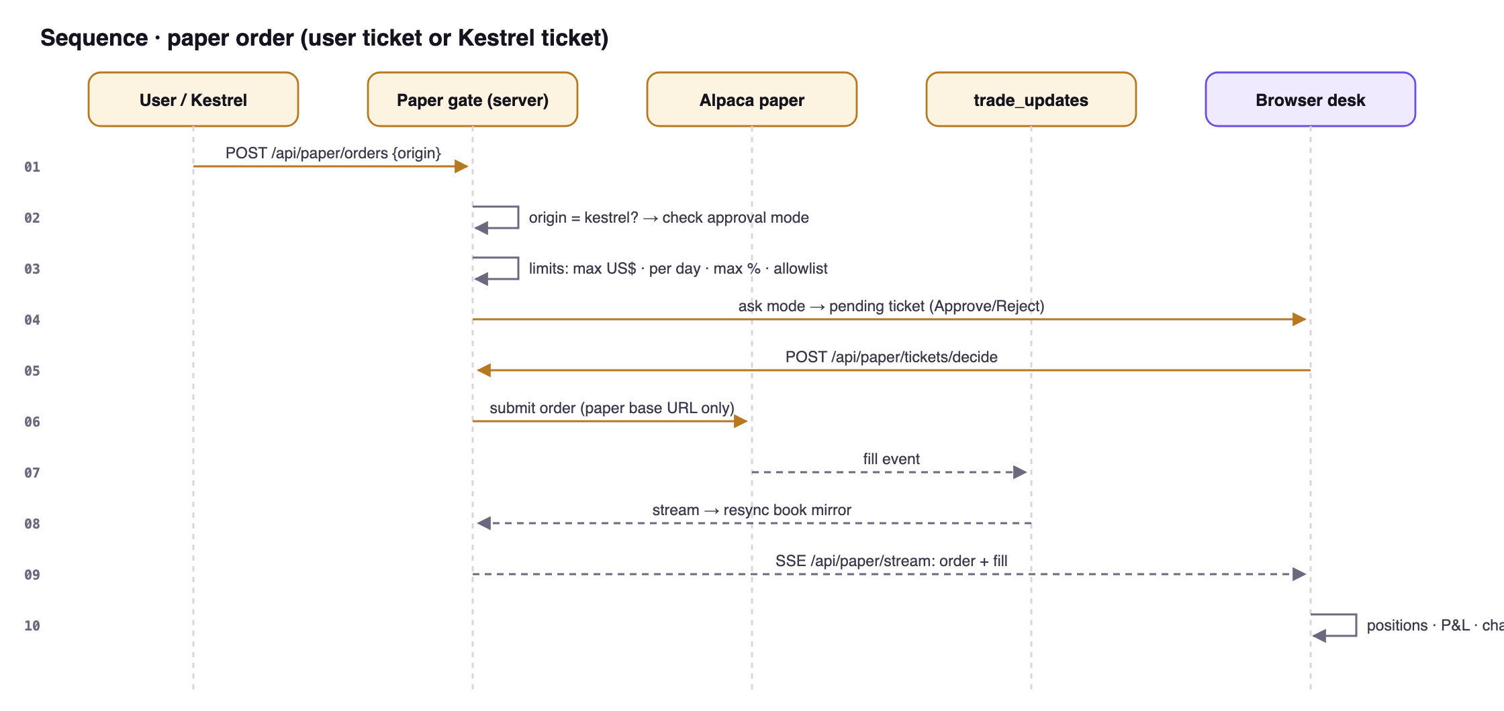
Figure 9 — Paper order through the gate

10.6 Architectural style
FinSight is a modular monolith split into two local processes. The FinSight server owns the book, market data and the UI; the Kestrel service owns the conversation, tools and model calls. They are separate so that the agent can crash, restart or be absent without affecting the terminal, and so that the agent's write access to FinSight can be limited to a token with an allowlist. Inside each process the code is layered: HTTP routing at the edge, domain modules in the middle (lib/, agent/src/chat, agent/src/tools), and storage at the bottom.

10.7 Communication
Path | Style | Why
Browser ↔ FinSight | Synchronous REST/JSON + polling (TanStack Query) + SSE for paper events | Simple, cache-friendly, works offline from the shell
Browser ↔ Kestrel | Through FinSight's /api/agent/* proxy; SSE event stream with replay | One origin, one session gate; long answers stream
Kestrel → FinSight | REST with a rotated token; GET-only plus paper order/cancel | Least privilege for the agent
FinSight → Alpaca | REST for orders + trade_updates stream | Broker is the source of truth for fills
Background work | In-process timers: alert checks (60 s default), cache sweeps, paper resync (5 min), session janitor | No queue infrastructure needed for one user

10.8 Failure boundaries
- Agent down → the terminal keeps working; the panel explains why and the supervisor restarts the agent with backoff.
- Market source down → cached last-good values with stale flags; no blank panels.
- Broker stream down → the desk shows the stream state and resyncs on reconnect.
- Strategy code fails → contained in a sandboxed child process with time and memory limits.
- A UI panel fails to load → contained by IslandBoundary; other panels stay active.

10.9 Key architectural decisions
Decision | Alternatives considered | Reason
Local-only, loopback-bound | Hosted web app | Privacy, zero cost, no accounts
Zero-dependency Node server | Express/Fastify | Small supply-chain surface; nothing to install
JSON files for the book, SQLite for the agent | One database for both | Book is small and human-readable; agent needs transactions, FTS and event replay
Agent as a separate supervised process | Agent inside the server | Fault isolation and least-privilege access
Tools compute, the model explains | Let the model calculate | Correctness and auditability of numbers
Alpaca paper only | Real broker APIs | Safe practice; no real-money path exists in code
Thinking effort as a per-turn choice | Fixed effort | Recorded in agent/docs/ADR-THINKING-EFFORT.md

11. Technology stack
Domain 03 Technology stack selection
Layer | Technology | Why
Runtime | Node.js ≥ 24, native TypeScript (erasable syntax) | No build step for the server; one language end to end
Server | node:http, native fetch, zero runtime dependencies | Small attack surface, nothing to install
Frontend | React 19.3, TypeScript 7, TanStack Query 5, Zustand store | Modern UI with cached queries and simple global state
Bundler | esbuild 0.28 (committed output in public/app/) | Fast, reproducible builds; users skip npm install
Charting | Custom canvas engine (chart.js, indicators.js, strategy.js) | Full control, offline, no licence constraints
Agent | TypeScript; @anthropic-ai/sdk, @modelcontextprotocol/sdk, zod 4 | Model-agnostic adapters, MCP server, validated contracts
Agent storage | SQLite via better-sqlite3 (WAL) | Durable, transactional, single-file
Documents | unpdf, mammoth, @mozilla/readability, linkedom | Read PDFs, Word and web pages safely
Models | DeepSeek Flash/Pro (default), Claude Haiku, Claude Code CLI, GPT-6 Luna/Sol, any OpenAI-compatible | Choice by cost, depth and vision
Data sources | Yahoo Finance, FRED, World Bank, Forex Factory, Nasdaq IPO calendar, SEC EDGAR, Tavily/Brave | Free/keyless where possible
Broker (paper) | Alpaca paper REST + trade_updates stream | Free fake-money US equities
Testing | node:test, Playwright 1.64, @axe-core/playwright | Unit, E2E, accessibility, visual
Secrets | macOS Keychain (finsight-agent), env fallback, 0600 files | Keys never in repo or prompts

11.1 Selection criteria
- One language end to end. TypeScript on Node 24 (run natively with erasable syntax), React in the browser, TypeScript in the agent.
- Smallest possible dependency surface. The server has no runtime npm dependencies; the agent's eight runtime dependencies each solve a problem that is costly to own (SQLite binding, MCP protocol, document parsing, schema validation, a model SDK).
- Free, keyless data. Public market and macro sources so the product works without sign-ups.
- Pluggable vendors. Models, search providers, skills and strategies are plugins, so no single vendor is required.

11.2 Versions, licences and lock-in
All versions are pinned exactly and locked in package-lock.json (root and agent/). FinSight is MIT-licensed; its dependencies use permissive licences. Lock-in is limited to two places: Yahoo's unofficial endpoints for market data (isolated in lib/market.ts, with a deterministic fake market for tests) and Alpaca for paper trading (isolated in lib/alpaca.ts, with a fake broker).

12. Frontend engineering and UX
Domain 04 Frontend engineering and UX
The terminal is a single-page application. It is designed to feel like a professional trading terminal: dense, keyboard-driven and fast, while staying accessible and usable on a phone.

12.1 Application structure
- React 19 + TypeScript source in web/src, one app (App.tsx) composed of feature folders (features/positions, features/kestrel, features/paper, …) loaded as lazy chunks.
- Build: esbuild (scripts/build-web.mjs) emits committed assets to public/app/ (bootstrap, main, chunks, manifest) so users need no npm install to run.
- State: bootstrap.js creates window.FinSight with a Zustand UI store and refresh bus before first paint; server data via TanStack Query with polling suspended while locked or hidden.
- Chart: a self-contained canvas engine (public/chart.js) plus indicator, strategy and journal helpers in plain JS.
- Appearance: tokens on :root in public/styles.css; data-theme, data-font, data-mode applied before paint.
- PWA: service worker precaches the shell from the build manifest; warm cache survives restarts.

12.2 Component architecture and design system
- Each panel is an island: a React component in web/src/features/<name>/ with scoped CSS, registered as a lazy chunk in islands.ts. Islands render into the existing panel frame, so layout, drag and keyboard behaviour stay consistent.
- Shared primitives live in web/src/ui/: Money, Num, Pct, Spark, Loading, Empty, ErrorLine, PanelBody, dialogs, toasts and keyboard/focus helpers. Formatting is centralised in ui/format.ts with unit tests.
- Design tokens (colours, fonts, spacing) are CSS variables on :root; themes switch with data-theme, data-font and data-mode before first paint, so there is no flash.

12.3 State management and data synchronisation
State | Where | Rule
Server data (portfolio, markets, watchlist, alerts, FX risk) | TanStack Query, keyed by base currency and account | Polling every 15–120 s; paused while locked or in a background tab; never copied into Zustand
UI state (selection, layout, panel visibility, mode) | Zustand store on window.FinSight | Persisted to localStorage only for preferences
Mutations | Shared invalidation map and refresh bus | A trade invalidates every query that depends on it
Live events | SSE (Kestrel, paper) | Resume by event id after a drop

12.4 Navigation and interaction
There is no URL router: the terminal is one screen of movable panels. Navigation is by the command bar (ADD, SELL, Q SYM, ALERT…), clicking a position to load Security Detail, the top bar (Kestrel, REAL/PAPER, account, base currency, layout) and keyboard shortcuts (⌘/ Kestrel, ⌘. council view, Esc to stop). Panels can be reordered by drag or from the keyboard.

12.5 Forms, validation and errors
- Forms validate as the user types only in fields the user has edited, and show the outcome before saving (the trade sheet previews Position after and New average; the paper ticket shows estimated price, cost and buying power after the order).
- The server validates again; errors come back as plain sentences (for example "Wrong PIN", or a limit refusal reason) and are shown inline or as a toast.
- Destructive actions (delete chat, remove account) ask first; book edits can be undone (25 steps).

12.6 Loading, empty, error and offline states
Every panel uses the shared Loading, Empty and ErrorLine primitives. Stale market data is labelled with its as-of time; a panel whose source failed says so instead of showing zeros. While the screen is locked, API calls fail fast without touching the network. The service worker caches only the static shell (never API responses), so the terminal opens instantly and shows a clear state when the server is unreachable.

12.7 Accessibility
- Automated axe-core checks in Playwright for the terminal, Kestrel and the activity panel.
- Accessible names match visible text; tabs, dialogs and the command menu are keyboard-operable with managed focus (modalFocus.ts).
- Reduced-motion support for animated views (council motion, ticker); light mode and high-contrast-friendly tokens.
- UNPEEK hides every money figure for screen sharing.

12.8 Responsive design and browser support
The layout reflows from a two-column desktop terminal to a single column on phones (tested at 390 px); the paper ticket stacks below the chart. FinSight targets current Chromium, Safari and Firefox and installs as a PWA.

12.9 Rendering, SEO and internationalisation
Client-side rendering is the right choice for a private, PIN-locked app; SEO does not apply. The UI is in English. Numbers and money are formatted for the selected base currency; market times use each exchange's time zone (for example America/New_York for US sessions) via Intl.DateTimeFormat.

12.10 Frontend performance
esbuild produces content-hashed bundles split into lazy chunks per panel; the chart is a canvas engine that draws thousands of candles without a DOM node per bar; polling stops in background tabs. A chunk-retry guard (shell/chunkGuard.ts) recovers when a deploy replaces chunks under an open tab.
PART B
Application logic and data
Domains 05–08: backend, data, APIs and integration, identity and access

13. Backend engineering
Domain 05 Backend engineering
The backend is the FinSight server (server.ts + lib/) and the Kestrel service (agent/src). Both are plain Node 24 TypeScript with no web framework.

13.1 Responsibilities
Layer | FinSight server | Kestrel service
Edge / controller | server.ts: Host check, security headers, session gate, same-origin check for writes, routing, proxies | api/server.ts: shared-secret check, /v1 routes, Zod request schemas, SSE
Domain / service | lib/portfolio.ts, returns.ts, performance.ts, ledger.ts, dividends.ts, transfers.ts, paper.ts, discover.ts, macro.ts | chat/engine.ts, context.ts, council-*.ts, tools/*, skills.ts, sandbox/host.ts
Integration | market.ts (Yahoo), macro.ts (FRED, World Bank, Forex Factory), alpaca.ts, agentproc.ts | brains/* (DeepSeek, Anthropic, OpenAI-compatible, Claude Code), tools/web.ts, EDGAR
Repository | lib/store.ts: locked, atomic JSON persistence; cache.ts | store/db.ts: SQLite with migrations

13.2 Request lifecycle
1. Set X-Frame-Options: DENY and X-Content-Type-Options: nosniff.
2. Reject requests whose Host is not this machine (DNS-rebinding defence).
3. Serve static files (ETag, hashed assets) or continue to /api/*.
4. Check the session cookie for data APIs; check same-origin for writes.
5. Read the body (Buffers joined before decoding; 25 MB cap for broker statements), validate, call the domain module.
6. Return JSON with Cache-Control: no-store; map errors to 400 (input), 401/403 (auth), 409 (conflict), 429 (throttle) or 502 (upstream).

13.3 Validation and serialisation
The server validates each route's inputs explicitly (symbols, quantities, currencies, PIN format, book names, paper order fields and limits). The agent validates every request, tool input and config file against Zod schemas, and the council output against a versioned contract. Responses are plain JSON; money values are numbers with currency fields, formatted only in the UI.

13.4 Error handling
Domain errors carry a user-readable message and optional status. Upstream failures never leak stack traces to the UI. Unhandled failures in background jobs (for example alert evaluation) are logged and retried on the next tick instead of crashing the process.

13.5 Configuration
Configuration comes from environment variables (listed in §30), the data folder (config.json for the agent, alpaca-paper.json for paper keys) and macOS Keychain for secrets. Defaults are safe: loopback host, paper approval ask, conservative agent limits.

13.6 Background jobs and scheduled tasks
Job | Interval | Module
Price alert evaluation and desktop notification | 60 s (min 15 s, ALERT_INTERVAL) | server.ts
Market cache sweep | hourly | lib/cache.ts
Session and login-throttle janitor | hourly | lib/auth.ts
Paper book resync | every 5 min and on every fill | lib/paper.ts
SSE keep-alive ping | 25 s | server.ts
Agent supervision (start, restart with backoff) | event-driven | lib/agentproc.ts

13.7 Resource cleanup
Timers that should not keep the process alive are unref()'d. On SIGINT, SIGTERM or SIGHUP the server shuts down gracefully and stops the agent it started. The agent drains running turns, closes connections and closes the database on shutdown. Long-lived maps (sessions, throttle entries, cache) are swept so a process that runs for months does not grow without bound.

14. Database and data architecture
Domain 06 Database and data architecture
FinSight stores two kinds of data with different needs, so it uses two storage technologies.
Store | Technology | Why
Portfolio book, settings, paper mirror | JSON documents in FINSIGHT_DATA_DIR | Small, human-readable, easy to back up and inspect; a single writer with a lock is enough
Agent conversations, events, traces, costs, proposals | SQLite (agent.db) in WAL mode via better-sqlite3 | Transactions, indexes, full-text search, event replay, concurrent readers

14.1 Data model
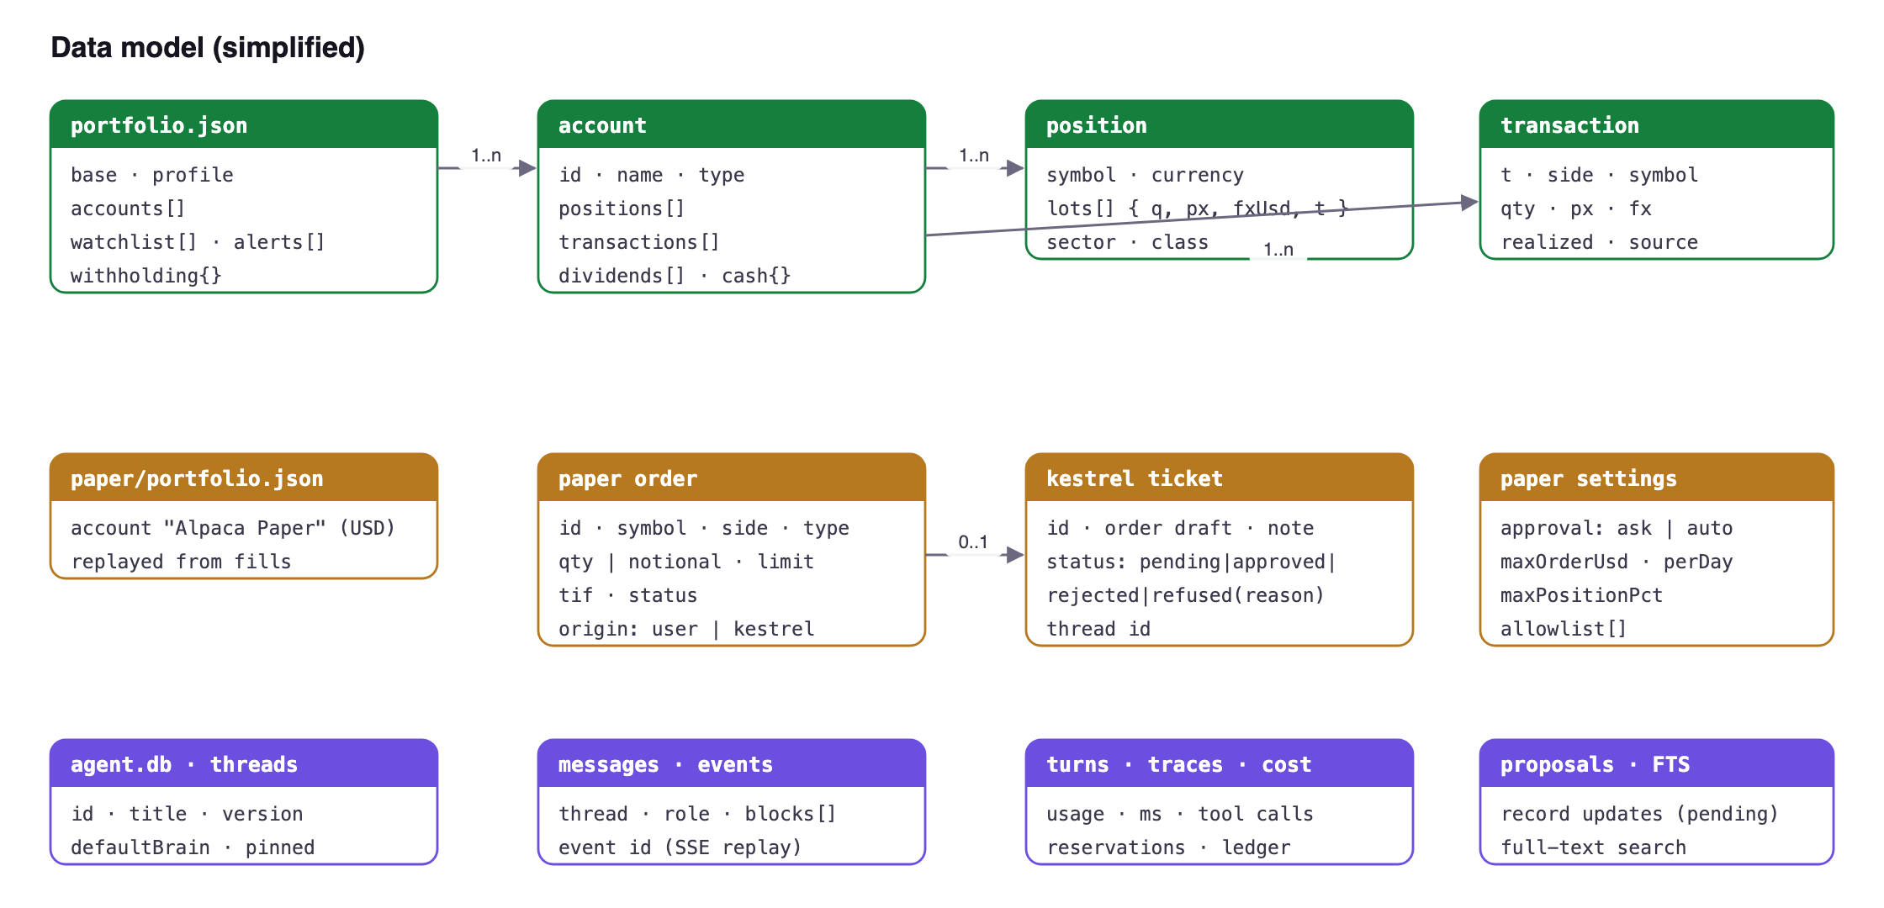
Figure 10 — Data model
File / table | Location | Notes
portfolio.json | data dir | Accounts, positions (lots), transactions, dividends, cash, watchlist, alerts; atomic write, 0600
undo.json | data dir | 25 snapshots for undo
cache.json | data dir | Persisted market cache (≤ 30 days)
auth.json | data dir | scrypt PIN hash + salt
book.json | data dir | REAL / PAPER mode
paper/portfolio.json | data dir | Alpaca mirror book
alpaca-paper.json | data dir | Paper keys, 0600, never served
agent-link.json | data dir | Rotated GET-only token and proxy secret
agent/agent.db | data dir | SQLite WAL: threads, messages, events, turns, traces, cost ledger, proposals, FTS
agent/logs/*.jsonl | data dir | Interaction log, redacted, 14-day retention
records/ | data dir | INVESTMENT_POLICY.md, INVESTOR_PROFILE.md and other user records

14.2 Keys, constraints and integrity
- Accounts, threads, messages, tickets and orders have generated ids; paper orders carry a client_order_id that links each fill to its origin.
- Book invariants are enforced in code: quantities stay non-negative, a sell realises P&L against existing lots, and unrealized P&L always equals stock P&L plus FX P&L.
- SQLite tables use primary keys and foreign keys between threads, messages, turns and events; FTS tables index messages and records for search.

14.3 Transactions and consistency
Every book mutation is a read-modify-write under one in-process lock, written to a temporary file and renamed into place, so a crash leaves either the old or the new file. Multi-row agent writes (a message plus its events and cost) run in one SQLite transaction. Thread updates use an optimistic version; a stale version gets HTTP 409. Details in §21.

14.4 Migrations and schema evolution
The agent database has a schema_migrations table. Before applying a migration to an existing database, the store copies it to agent.db.bak-v<N>, refuses to migrate while another process holds the database, and records each applied version. JSON files are versioned in code and upgraded on load.

14.5 Retention, archival and deletion
Data | Retention
Undo history | Last 25 snapshots
Persisted market cache | Entries older than 30 days dropped
Agent audit logs (logs/*.jsonl) | 14 days by default (logRetentionDays, 1–365)
Chats | Until the user deletes them (/delete, bulk clear)
Portfolio, records, paper mirror | Kept until the user removes them

14.6 Backup, recovery and data quality
- A corrupt portfolio.json is moved aside to a .corrupt.json file rather than overwritten, so it can be restored.
- The agent database is backed up automatically before each migration.
- Full backup is a copy of the data folder (portfolio.json, undo.json, agent/agent.db, records/); restore is copying it back with the server stopped.
- Market data quality: every quote and series carries its source and as-of time; stale and failed states are shown, not hidden.

14.7 Multi-tenancy
Not applicable: there is one user per installation. Separate installations (personal, demo, test) use separate data folders.

15. APIs and system integration
Domain 07 APIs and system integration
FinSight exposes two HTTP APIs on loopback and integrates with several external services.

15.1 API styles and contracts
- FinSigh/api/* — REST/JSON for the browser; SSE for paper order events. Writes require the PIN session and a same-origin reques
- Kestre/v1/* — versioned REST/JSON with Zod-validated bodies, reachable only through FinSight's proxy with a shared secret; SSE for turn event
- MCP (stdio) — the agent's tool registry exposed to Claude Code, Codex or Cursor with the same read-only semantics.

15.2 HTTP API (selected)
Method & path | Purpose
GET /api/portfolio?base= | Portfolio with quotes, P&L, stock/FX split
POST /api/portfolio/buy · sell · … | Book mutations (session + same-origin, locked, undoable)
GET /api/history · /api/history/batch | OHLCV bars (cached)
GET /api/discover?account= | Movers, earnings, exclusions with basis and asOf
GET /api/events | Earnings and ex-dividend dates
GET /api/agent-status · /api/agent/* | Agent health; session-gated proxy to Kestrel
GET /api/paper/state · settings · stream | Paper account, settings, SSE order/fill stream
POST /api/paper/orders · orders/cancel | Place / cancel paper orders (gate applies)
POST /api/paper/tickets/decide | Approve or reject a Kestrel ticket
POST /api/paper/connect · disconnect · settings · sync | Key management, settings (PIN session only), resync

The full endpoint reference is in DOCS.md. Kestrel's own API (/v1/threads, /v1/threads/:id/messages, /v1/threads/:id/events, /v1/brains, /v1/cost, /v1/limits, /v1/health) is reachable only through the proxy.

15.3 SSE event model
Kestrel streams typed events (turn.started, tool start/finish, text deltas, notices, council stage/assessment events, turn.finish with usage and cost). Each event has a monotonically increasing id so a reconnecting client resumes without duplicates. The paper stream (/api/paper/stream) carries order and fill events and stream-state changes.

15.4 Idempotency and duplicate prevention
- Kestrel message creation accepts an idempotency key, so a retried POST does not start a second turn.
- Approving a Kestrel paper ticket is claimed under a lock (pending → approving), so a double click or a second tab cannot send the order twice.
- SSE clients resume from Last-Event-ID, so reconnects neither lose nor repeat events.

15.5 Pagination, filtering and sorting
Lists are small for a single user, so most endpoints return complete sets and the UI filters and sorts (positions by column, group and search; ledger by filter). Chat lists, history batches and search results are bounded server-side.

15.6 External integrations
Service | Used for | Resilience
Yahoo Finance (unofficial) | Quotes, history, FX, search, news, screens, fundamentals | 12 s timeout, host fallback, single-flight cache, stale-while-revalidate, 429 backoff
FRED, World Bank | Macro series and indicators | Cached; panel shows the last good value
Forex Factory, Nasdaq | Economic calendar, IPO calendar | Cached; personal-use terms respected
SEC EDGAR | Filings and financials for Kestrel | Timeouts; content treated as untrusted
Model providers (DeepSeek, Anthropic, OpenAI-compatible) | Kestrel and council reasoning | Per-turn time and cost limits; model can be switched
Search (Tavily, Brave, SearchGPT) | Web research | Per-turn search and fetch limits; SSRF guard on fetch
Alpaca paper | Paper orders, fills, account | Paper base URL constant; stream with resync; fake broker for tests

15.7 Rate limiting and quotas
Login attempts are throttled per IP (after five failures, a delay that grows to five minutes). Kestrel enforces per-turn quotas on steps, seconds, web searches, page fetches and council calls, plus dollar caps per turn and per day. Calls to Yahoo back off on HTTP 429.

15.8 Versioning and compatibility
The agent API is versioned under /v1; the council contract and lenses carry version numbers in shared/council-lenses.ts and council-contract.ts. FinSight's own /api is consumed only by its bundled UI, which ships together with the server, so they change in the same commit.

16. Identity and access management
Domain 08 Identity and access management
FinSight has exactly one user, so identity is simple by design. Access control is about keeping out other processes, web pages and documents on the same machine, and about limiting what the agent can do.

16.1 Authentication
- A numeric PIN set on first run, hashed with scrypt (random salt, run off the event loop) and compared with timingSafeEqual. Stored in auth.json with 0600 permissions.
- Throttling: after five wrong PINs from the same address, further attempts wait 15 s, rising by 15 s per failure up to 5 minutes. Keyed by source address so a third party cannot lock the owner out.
- The lock screen also selects the book (REAL or PAPER) for the session.

16.2 Sessions
- A random session token in an HttpOnly; SameSite=Strict cookie.
- Idle expiry after LOCK_IDLE_MIN minutes (default 480); the 🔒 button locks immediately; an hourly janitor removes expired sessions.
- When locked, the browser stops calling protected APIs and any 401 returns the UI to the lock screen.

16.3 Authorisation
Principal | Can | Cannot
Owner (PIN session) | Everything: book edits, settings, paper keys, limits, approvals | —
Kestrel (rotated agent token) | Read portfolio facts; place and cancel paper orders through the gate | Edit the real book, change settings, limits, approval mode or keys
MCP client | Call the same read-only tools | Write anything
Unauthenticated | Load the UI shell and the lock screen | Read or change any data

The agent token and the proxy secret are random values rotated at every server start and stored in agent-link.json (0600).

16.4 Account lifecycle and recovery
There is no registration, OAuth, MFA or tenant model: they would add risk without benefit for one local user. To reset a forgotten PIN, the owner deletes auth.json in the data folder (holdings are kept) and sets a new PIN on next launch.

16.5 Audit of sensitive actions
Every paper order records its origin (user or Kestrel, with the chat thread), and every Kestrel tool call is in the audit log with its turn id. Record changes proposed by Kestrel are stored as proposals until the owner confirms them.
PART C
AI engineering and agentic systems
Domain 24: the Kestrel agent, the investment council and agentic paper trading

17. Kestrel agent design
Domain 24 AI engineering and agentic systems
Kestrel is FinSight's AI research agent and the centre of its AI engineering. This chapter covers how it is designed; the council and paper trading follow.
GUIDE RECONSTRUCTION Screen 16 — A Kestrel answer: tool calls first, then figures with an as-of time, sources and the answer's cost

17.1 Principles
1. Facts from code, words from the model. Deterministic tools produce every figure; the model explains, compares and cites.
2. Show the work. Tool log, sources, asOf, cost and trace are part of every answer.
3. Read-only toward the real world. No tool can trade real money, move funds, message anyone or edit records; facts become proposals.
4. Untrusted inputs stay data. Web pages, filings and uploads are wrapped as untrusted and cannot issue instructions.
5. Bounded. Step, time, search, fetch and dollar limits per turn and per day.
6. Model-agnostic. Brains are plugins; no feature depends on one vendor.

17.2 Turn lifecycle
1. Validate input (Zod), check idempotency key, take the per-thread turn lock.
2. Build the context pack: a dated, compact snapshot of holdings, cash, policy and page context (symbol, timeframe, strategy).
3. Order the prompt for prompt-cache efficiency (stable system + tools first, volatile context last).
4. Reserve cost against turn and daily caps; call the brain with tool schemas.
5. Execute requested tools with schema validation; shape results with retrieval timestamps; wrap untrusted content.
6. Loop until the model answers or a limit is hit; stream events; persist message, trace, usage; reconcile cost.

17.3 Autonomy levels
Level | Meaning | Status
L0 | Answer in the foreground | Shipped
L1 | Background task (durable, budgeted, resumable) | Specified (FR-5)
L2 | Scheduled or event-triggered runs | Specified, not built — prerequisite of FEAT-013
L3 | Writes proposals the user confirms | Shipped for records; paper orders use the ticket gate

17.4 Limits and cost
Limit | Default | Range
Steps per turn | 25 | 1–50
Seconds per turn | 300 | 5–900
US$ per turn | 0.25 | > 0 – 100
US$ per day | 5 | > 0 – 1000
Searches per turn | 20 | configurable
Fetches per turn | 25 | configurable
Council research calls | 8 | configurable; optional councilTurnUsd, councilOutputTokens

17.5 Skills (playbooks)
Skill | What it does
/pre-trade-check | Objective fit, valuation, sizing from real cash, concentration, liquidity, costs/taxes, invalidation
/position-review | Why owned, weight and P/L, fundamentals trend, strategies, risks → keep / review / reduce-candidate
/earnings-review | Latest 10-Q/10-K from EDGAR vs prior periods and the holding; what the report changes
/why-did-it-move | Separates company, sector/peer, macro and market-wide drivers; review-trigger check
/strategy-scan | Runs every mechanical strategy on holdings/watchlist, ranks setups, sizes the top ones with event checks

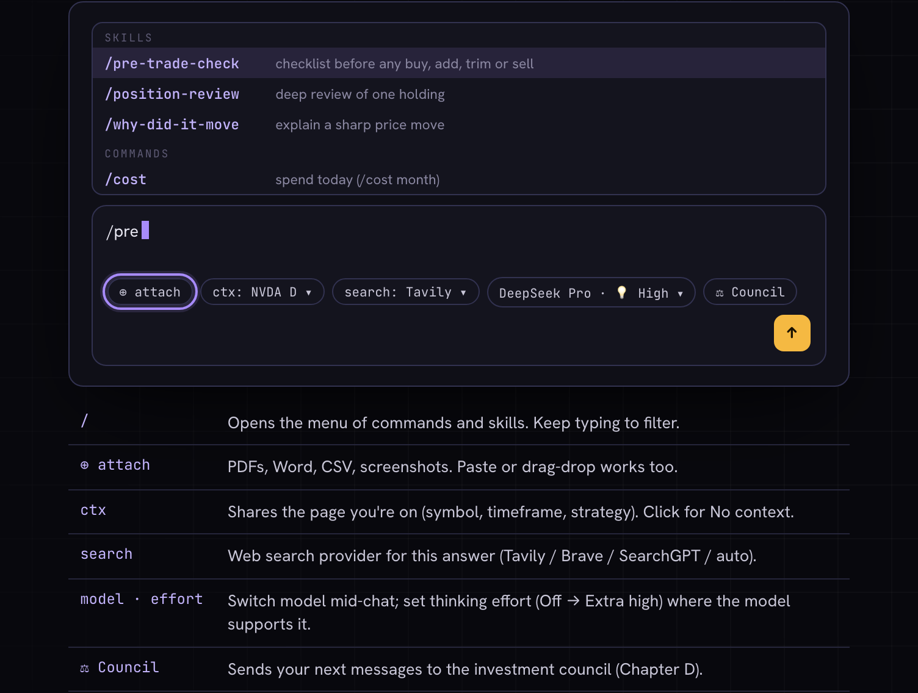
GUIDE RECONSTRUCTION Screen 17 — The composer, control by control: attachments, context, search mode, model and thinking, council and lens
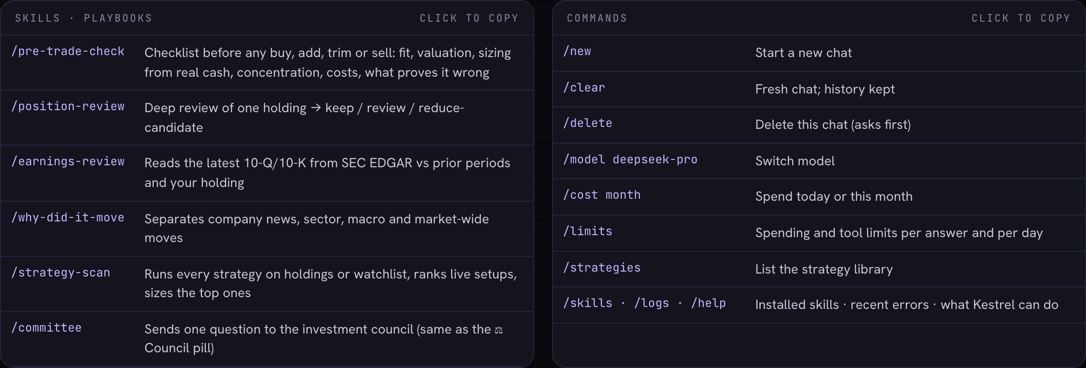
GUIDE RECONSTRUCTION Screen 18 — Commands and skills: / opens playbooks such as /pre-trade-check and /why-did-it-move

17.6 Agent tool registry
Category | Tools
Portfolio facts | get_portfolio, query_positions, portfolio_weights, get_exposures, get_cash, get_accounts, get_context_pack
Market & macro | get_quote, get_history, get_earnings_dates, get_macro_series, get_fund_profile, valuation_metrics
Strategies & sizing | list_strategies, get_strategy, run_strategy, scan_strategies, size_position
Research | edgar_filings, edgar_financials, web_search, fetch_url
Records & memory | get_policy, get_profile, get_decisions, search_memory, propose_record_update
Attachments | list_attachments, read_attachment, search_attachments
UI | render_ui (Intelligent UI views: cards, tables, charts)
Paper (PAPER mode) | paper_account, paper_place_order, paper_cancel_order

17.7 Plugin manifests
Plugin | Location | Defines
Brain | agent/plugins/brains/<id>/ | Provider, model id, pricing, thinking levels, capabilities (deepseek-flash, deepseek-pro, haiku, claude-code, gpt-6-luna, gpt-6-sol)
Skill | agent/skills/<name>/SKILL.md | Agent Skills-format playbook: description, steps, required tools
Strategy | strategy library + manifest.json | Card (prose/metadata) and optional mechanical engine run in the sandbox
Search provider | agent config | Tavily, Brave, SearchGPT; chosen per answer

17.8 Model selection and routing
Brains are plugins with a manifest: provider, model id, pricing, cost tier, thinking levels and capabilities (tools, vision, context size). DeepSeek is the default for cost; Claude, OpenAI-compatible models and the Claude Code CLI are alternatives. The user picks the model and thinking effort per chat (/model); the council's qualified configuration is DeepSeek Flash with thinking off.

17.9 Prompt and context engineering
- A stable system prompt with the product rules (tools for numbers, cite as-of and sources, untrusted content is data).
- A context pack: a dated snapshot of holdings, cash, policy and what is on screen (symbol, timeframe, strategy).
- The user's own records (INVESTMENT_POLICY.md, INVESTOR_PROFILE.md) and skills when invoked.
- Prompt order optimised for provider prompt caching: stable parts first, volatile context last (FEAT-005).

17.10 Retrieval
Kestrel retrieves by tools rather than a vector index: portfolio tools, SEC EDGAR, web search and fetch, full-text search over past chats and records (search_memory) and search inside uploaded files (search_attachments).

17.11 Structured output and validation
Tool inputs and outputs are Zod-validated. UI views returned by render_ui follow a typed spec. Council assessments must validate against the versioned contract and cite evidence ids; one repair attempt is allowed per stage before the result is marked partial.

17.12 Safety: injection, exfiltration and authorisation
- Fetched pages, filings and uploads are labelled untrusted data and cannot issue instructions.
- fetch_url blocks private, loopback, link-local and metadata addresses, pins DNS to the socket and checks redirects.
- No tool can send messages, move money or edit records; durable facts become proposals the user confirms.
- Paper orders are the only write, behind approval mode and limits.

17.13 Evaluation
agent/evals/council-cases.ts and agent/scripts/evaluate-council.ts run synthetic council cases; qualify-ui.ts qualifies Intelligent UI output; agent unit tests cover the tool loop, limits, idempotency and redaction. Evaluations show the pipeline is reliable; they do not claim investment performance.

17.14 Fallbacks and provider outages
If a provider fails, the turn ends with a clear error and the user can switch model in one menu. If Kestrel itself is down, the terminal keeps working and the panel explains how to restart it.

18. Investment council design
Domain 24 AI engineering and agentic systems
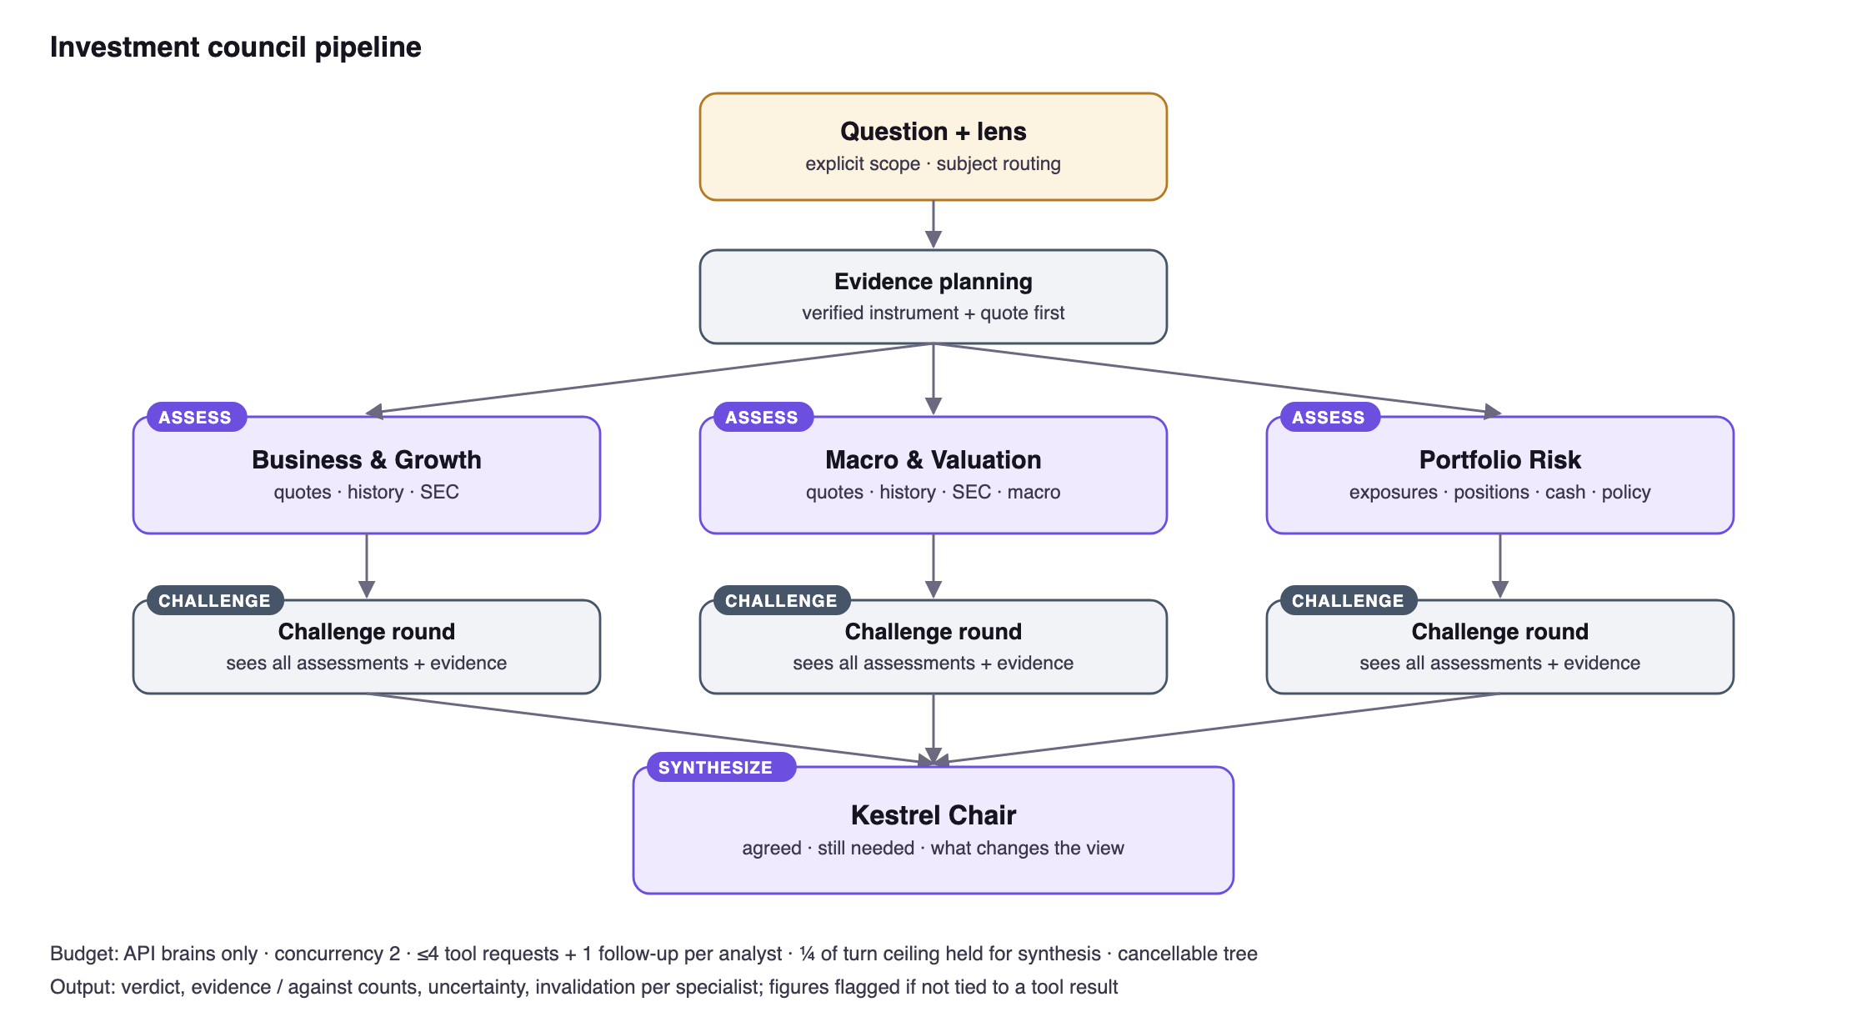
Figure 11 — Council pipeline
Aspect | Design
Roles | Business & Growth · Macro & Valuation · Portfolio Risk · separate Kestrel Chair
Stages | 01 Assess (independent histories) → 02 Challenge (sees all assessments and evidence) → 03 Synthesize
Tools per role | Growth/Macro: quotes, histories, SEC filings/financials · Risk: exposures, positions, cash, policy · paid search excluded
Bounds | API brains only; concurrency 2; ≤ 4 tool requests + 1 follow-up per initial analyst; one validation repair per stage; deadline and context bound
Accounting | Conservative reservation before every call in turn and daily budgets; unknown usage keeps the reservation
Exclusivity | No other reply admitted while a council runs; a council is rejected while another turn runs
Cancellation | Aborts the whole tree; late results cannot complete a run; reload labels orphaned children interrupted
Contract | Versioned lenses and assessment schema in council-contract.ts; shape and reference integrity validated (not factual truth)
Qualified config | DeepSeek Flash, thinking off; 6/6 synthetic reliability rerun; no investment-performance advantage claimed
UI | Cards (verdict, evidence/against, uncertainty, would-change-if, chair row) and Chain of thought lanes; ⌘. switches; compact view in side panel; capsule status

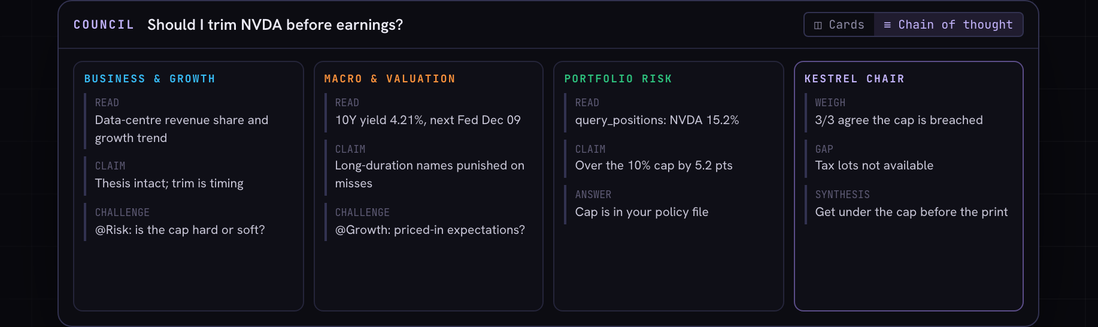
GUIDE RECONSTRUCTION Screen 19 — Chain of thought view (⌘.): what each specialist read, claimed and challenged, and how the chair weighed it
Known limitation
Research readiness stays partial while qualitative claim support lacks an independent check. Work item COUNCILQUALITY-001 tracks deeper evidence collection and honest readiness states.

19. Paper trading design
Domain 24 AI engineering and agentic systems · Domain 07 APIs and system integration
Concern | Design decision
Broker | Alpaca paper API only; base URL is a constant; no live-trading URL exists in code; tests point at a loopback fake (FINSIGHT_FAKE_MARKET=1)
Source of truth | Alpaca holds orders, fills, cash and positions; FinSight replays fill activities into paper/portfolio.json so every view works unchanged
Live updates | Server keeps trade_updates open while keys exist, resyncs on each fill and pushes events over /api/paper/stream
Valuation | Prices stay on the existing quote path (Yahoo, 15 s); Alpaca IEX data is not used for valuation
Orders | Market/limit · buy/sell · day/gtc · fractional shares · notional USD for market orders · cancel
Agent access | paper_account, paper_place_order, paper_cancel_order; every order passes the server gate
Approval | ask (default) → pending ticket on the desk; auto → submit at once
Limits | Max order US$ · Kestrel orders per day · max position % after order · symbol allowlist; each off unless set; refusal reason returned
Settings authority | Changed only from the terminal (PIN session); the agent can read but not change them
Audit | Every order records origin (user / kestrel + thread) and appears in Orders, History and the Kestrel tab
Out of scope | Real-money trading, shorts/options in the book, Alpaca market-data streaming, scheduled agent runs, multi-account paper

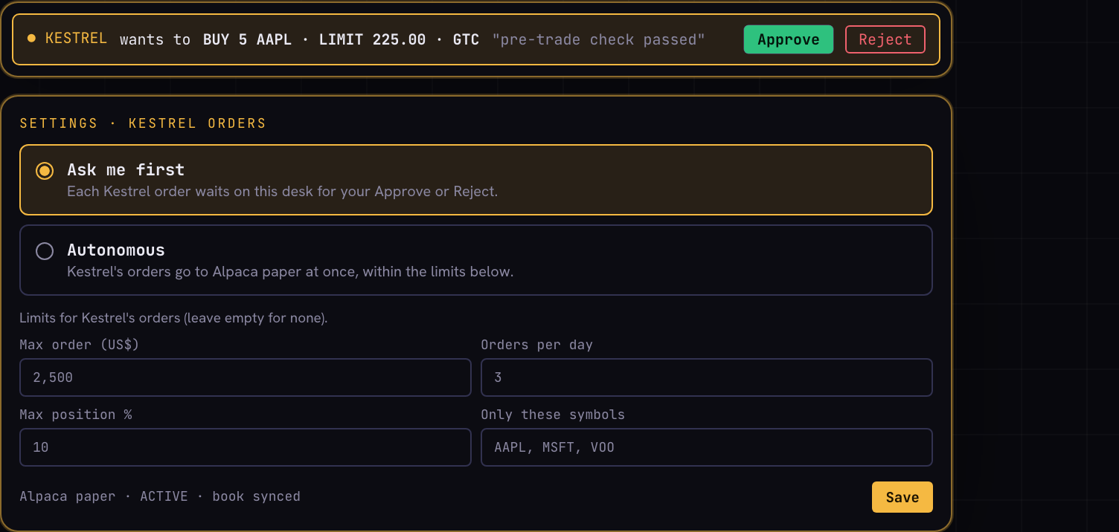
GUIDE RECONSTRUCTION Screen 20 — Kestrel's paper orders: in Ask mode a pending ticket waits for Approve or Reject; the settings tab sets the approval mode and the limits

19.1 Roadmap: agentic trading (FEAT-013, planned)
A daily cycle: trigger → universe → screen (deterministic) → council research → structured TradeProposal (size from size_position, entry/stop/target, thesis, invalidation) → deterministic gate with new limits (stop required, max loss per trade, max open positions, daily drawdown kill switch, market hours, earnings blackout) → bracket order with idempotency key → manage and score. The Alpaca MCP server may be used for data only; its trading toolsets are deliberately not given to Kestrel.
PART D
Security, correctness and system behaviour
Domains 09–13: security, concurrency, performance, reliability, testing

20. Application security
Domain 09 Application security

20.1 Assets and trust boundaries
Assets: portfolio and financial data, broker paper keys, model API keys, the PIN/session, the agent token and proxy secret, and the integrity of answers.
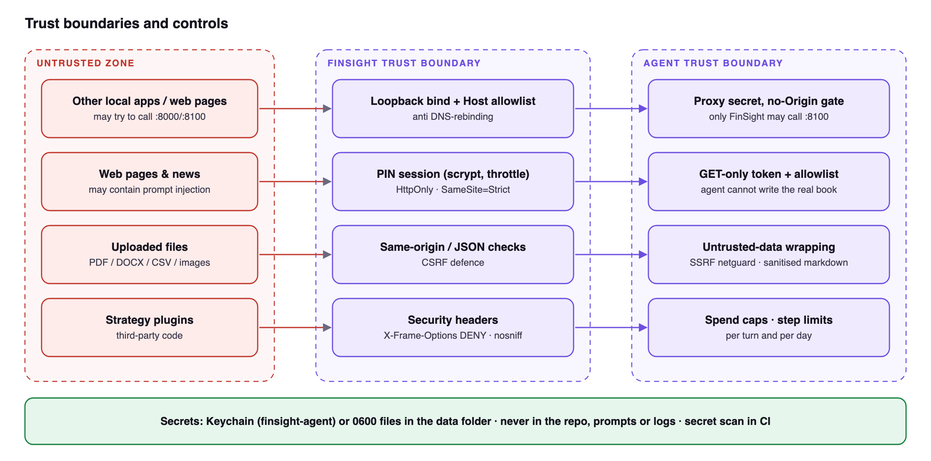
Figure 12 — Trust boundaries and controls

20.2 Threat model (STRIDE summary)
Threat | Example | Control | Verification
Spoofing | Another local process or web page calls :8000/:8100 | Loopback bind, Host allowlist (anti DNS rebinding), PIN session, proxy secret, no CORS | Request without secret / wrong Host → 403
Tampering | CSRF changes the book | SameSite=Strict, same-origin (Sec-Fetch-Site) and Origin checks, JSON content type | Cross-origin POST rejected
Tampering | Agent edits the real book | GET-only token with endpoint allowlist; FinSight sole writer | Token POST → 403
Repudiation | Unclear who placed a paper order | Origin tag + thread on every order; traces and logs | Orders list shows origin
Info disclosure | Keys leak into logs/prompts/repo | Keychain/0600 files, redaction, secret scan in agent:test, nothing personal in repo | Seeded secrets absent from logs/DB
Info disclosure | Screen sharing reveals wealth | UNPEEK blanks money figures everywhere | Visual check
Denial of service / cost | Runaway model loop | Step, time, search, fetch and dollar caps; daily cap | Loop test stops at limit
Elevation | Prompt injection in a web page or PDF | Untrusted wrapping, no write/send tools, proposals need confirmation | Injection eval set
Elevation | SSRF via fetch_url | Netguard blocks private, loopback, link-local, metadata and redirect-to-private | 127.0.0.1, 10/8, 169.254.169.254 blocked
Elevation | Malicious strategy plugin | Child-process sandbox, permission manifest, timeout and memory cap | fs/net/spawn denied
Elevation | Paper agent over-trades | Approval mode, deterministic limits, settings PIN-only, paper URL constant | Limit tests against fake broker
XSS | Model output contains script | Sanitised markdown rendering | Script payloads neutralised
Supply chain | Compromised dependency | Zero runtime deps on server; pinned agent deps; lockfile; minimal surface | CI audit

20.3 Security controls checklist
- Both services bind to 127.0.0.1; no 0.0.0.0.
- Security headers: X-Frame-Options: DENY, X-Content-Type-Options: nosniff, Host header check.
- PIN: scrypt KDF off the event loop, brute-force throttling, optional idle lock.
- Agent link: random 32-byte token and proxy secret rotated at each server start (agent-link.json, 0600).
- Data files written atomically (temp + rename) with 0600 permissions in a folder outside the repo.
- API keys in macOS Keychain service finsight-agent (env fallback); paper keys server-side only.
- Demo and tests use synthetic data, fake market and fake broker — no real data or network.

20.4 Secrets management
Model and search keys are read from macOS Keychain (service finsight-agent) first, then environment variables, then a 0600 env file. Paper keys are stored server-side only and never sent to the browser or the agent. Logs are redacted before writing. agent/scripts/secret-scan.ts runs as part of npm run agent:test and fails the gate if a secret pattern appears in the repository.

20.5 Dependencies and supply chain
The server has no runtime dependencies; the web bundle and the agent use exact pinned versions with lockfiles. The committed web bundle is checked against the source build (npm run check:web), so what ships is what was reviewed.

20.6 Hardening backlog
- Add a strict Content-Security-Policy header (defence in depth for rendered content).
- Add a dependency audit to the release gate for the agent and web dependencies.

21. Concurrency and parallelism
Domain 10 Concurrency and parallelism
FinSight is single-user but highly concurrent: the browser polls, several tabs may be open, Kestrel reads while the user writes, councils run calls in parallel and broker events arrive asynchronously. The controls below keep state consistent.
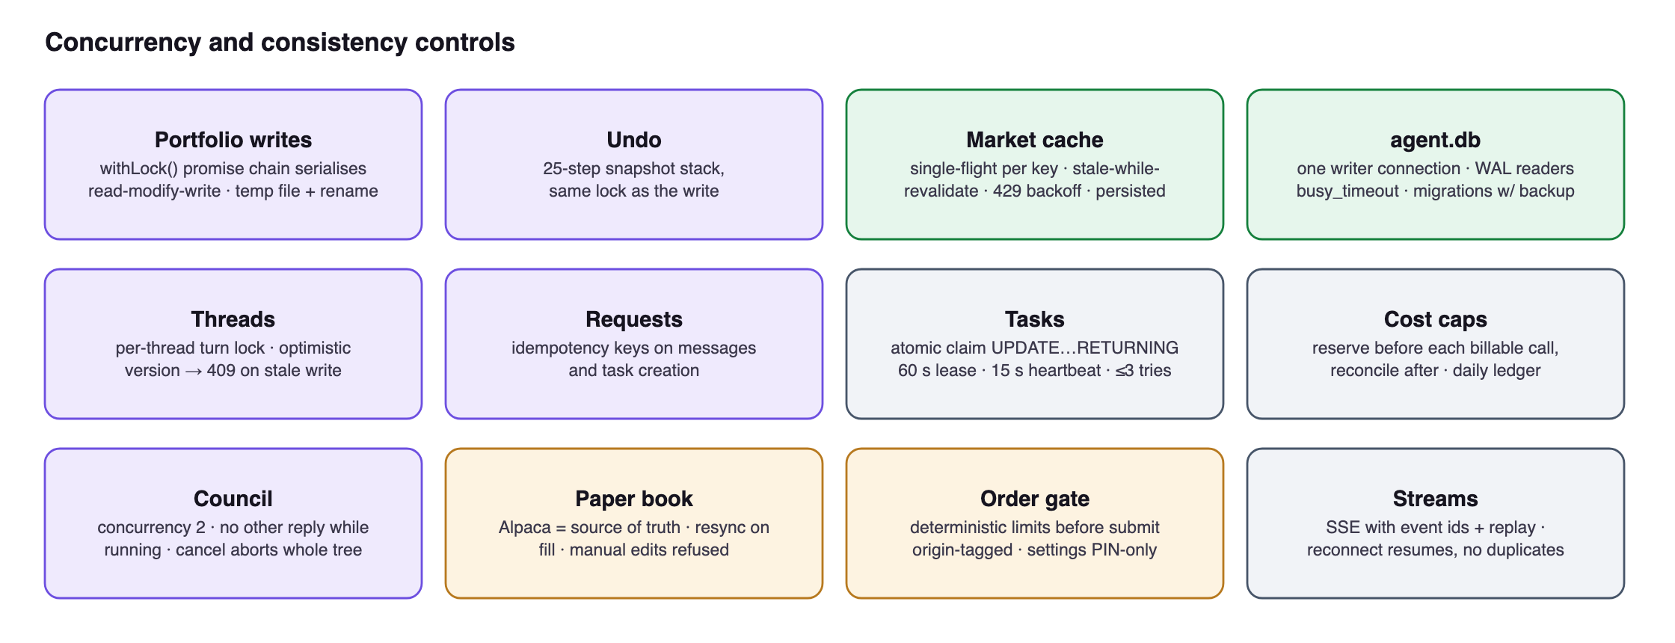
Figure 13 — Concurrency controls
Shared resource | Control | Failure it prevents
portfolio.json | withLock() promise chain serialises every read-modify-write; atomic temp-file rename | Lost updates from two quick trades or two tabs
Market cache | Single-flight per key; stale-while-revalidate; persisted last-good; 429 backoff | Thundering herd on Yahoo; blank panels during outages
agent.db | One writer connection; WAL for concurrent readers; busy_timeout | SQLITE_BUSY and torn writes
Chat threads | Per-thread turn lock; optimistic version, 409 on stale expectedVersion | Two turns interleaving in one thread
Requests | Idempotency keys on message and task creation | Double-submit on retry or flaky network
Background tasks | Atomic UPDATE … RETURNING claim; 60 s lease, 15 s heartbeat, ≤ 3 attempts | Two workers running one task; lost tasks after crash
Spend caps | Reserve before each billable call, reconcile after; persisted daily ledger | Parallel calls overshooting a cap
Council | Concurrency 2; exclusive with other turns; cancellation aborts the tree | Budget races, orphaned children
Plugin registry | Immutable snapshot swapped atomically on reload | Half-loaded plugins during a scan
Paper book | Alpaca as source of truth; resync on every fill; manual edits refused | Divergent local and broker state
SSE streams | Event ids with replay on reconnect | Missed or duplicated events

21.1 Worked example: the user and Kestrel sell the same position at once
The user clicks Sell 8 AAPL on the desk while Kestrel, in Autonomous mode, sends Sell 8 AAPL for the same paper position. The figure shows how each layer keeps the result correct.
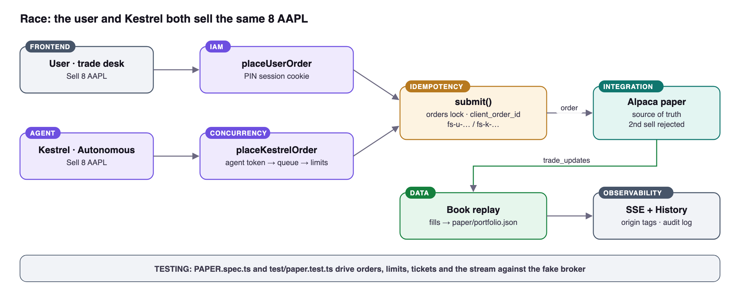
Figure 14 — A concurrent sell from the user and from Kestrel, and the control at each step
Step | What keeps it correct
Both requests arrive | The user's request goes to placeUserOrder; the agent-token request to placeKestrelOrder
Kestrel's limit checks | Kestrel's orders run one at a time through kestrelQueue, so two Kestrel calls cannot both pass the per-day and position checks
Order metadata | Written under the orders lock; each order gets a unique client_order_id (fs-u-… / fs-k-…)
Broker | Alpaca is the source of truth and rejects the second sell for insufficient quantity; the rejection is shown to whoever sent it
Book | Rebuilt by replaying fills from trade_updates, so it cannot record a sale that did not fill
After a dropped stream | Reconnect plus /api/paper/sync reconciles the book with Alpaca
Audit | Both orders keep their origin, visible in History and the Kestrel tab

22. Performance and scalability
Domain 11 Performance and scalability
FinSight runs for one user on one machine, so performance work targets latency and resource use, not throughput. Scale-out techniques are deliberately not used.

22.1 Targets
Measure | Target
Agent overhead before the provider's first byte | p95 ≤ 150 ms
Context pack build (warm) | p95 ≤ 500 ms
Kestrel panel open | ≤ 100 ms
Idle CPU | ≈ 0 (event-driven; polling stops in background tabs)
Calls from the agent to FinSight | No N+1 patterns: batch endpoints such as /api/history/batch

22.2 Caching
Layer | What | Invalidation
Browser shell | Service worker precaches static files and hashed chunks | Cache name bumped when the file set changes; old caches deleted on activate
Static files | ETag on every asset; hashed chunk names | New hash per build
Server market cache | Per-key TTL with stale-while-revalidate, single-flight, persisted last-good (≤ 30 days) | TTL expiry; background refresh
Query cache (browser) | TanStack Query per base and account | Invalidation map after mutations; polling 15–120 s
Model prompt cache | Provider-side caching of the stable prompt prefix | Prompt ordered so volatile parts come last

22.3 Bottlenecks and how they are handled
- Network to data sources — the dominant cost; handled by caching, batching and single-flight.
- Model latency — streamed to the UI so the first tokens arrive quickly; limits stop long loops.
- CPU-heavy strategy runs — moved to a sandboxed child process so the event loop stays free.
- Rendering — canvas chart, lazy panels, no DOM per candle.

22.4 Scalability
Load balancing, autoscaling, CDNs and horizontal scaling do not apply to a single-user local app. FinSight scales in capability instead: new models, skills, strategies and search providers are added as plugins without changing the core.

22.5 Performance testing
web/e2e/perf.spec.ts measures cold and warm loads at desktop and phone sizes, and startup.spec.ts checks start-up behaviour; agent/scripts/cache-probe.ts measures prompt-cache hits. Load, stress and soak tests are not needed at this scale.

23. Reliability and fault tolerance
Domain 12 Reliability and fault tolerance
FinSight should be available whenever the computer is on, never lose a committed change, and degrade visibly rather than fail silently.

23.1 Availability and recovery targets
Target | Value
Availability | Terminal up while the Mac is on (launchd restarts the server if it crashes)
Data loss (RPO) | None beyond the last in-flight write (atomic writes); agent DB backed up before migrations
Recovery time (RTO) | Minutes: restart the server, or copy the data folder back from backup

23.2 Health checks and supervision
- /api/health (FinSight) and /v1/health (Kestrel); /api/agent-status reports the supervisor state; kestrel doctor checks the agent's configuration.
- The FinSight server starts the agent, restarts it with backoff if it exits, and stops restarting after repeated crashes within 10 minutes, with a message pointing to the log.
- launchd (install-autostart.sh) starts the server at login and restarts it if it crashes, so background price alerts keep working.

23.3 Failure handling by situation
Situation | Behaviour
Yahoo / FRED outage or 429 | Serve last-known-good from cache with stale flag; back off and retry in the background
Agent not installed / disabled / crashing | Panel shows the exact reason and fix (npm run agent:install, AGENT_AUTOSTART, log path); supervisor restarts with backoff
FinSight unreachable from agent | FINSIGHT_DOWN tool error; the model tells the user; nothing fabricated
Turn interrupted (crash, stop) | Partial message persisted and marked interrupted/stopped
Limit reached | Turn ends with a clear notice; /limits to adjust
Council subject ambiguous / data missing | Clarification or explicit gap; partial readiness
Paper key invalid or live | Refused before saving with a message
Paper limit breached | Order refused before reaching Alpaca with the reason
Paper stream drops | Status shown on the account strip; resync on reconnect
Corrupt or old data file | Migrations on load; undo snapshots; DB integrity check and backup before migrations

23.4 Single points of failure
The machine itself and the data folder are the single points of failure. This is accepted for a personal tool and mitigated by the owner's normal backups (Time Machine or an encrypted copy of the data folder) and by the fact that broker records remain the external source of truth for the real book.

24. Testing and quality assurance
Domain 13 Testing and quality assurance
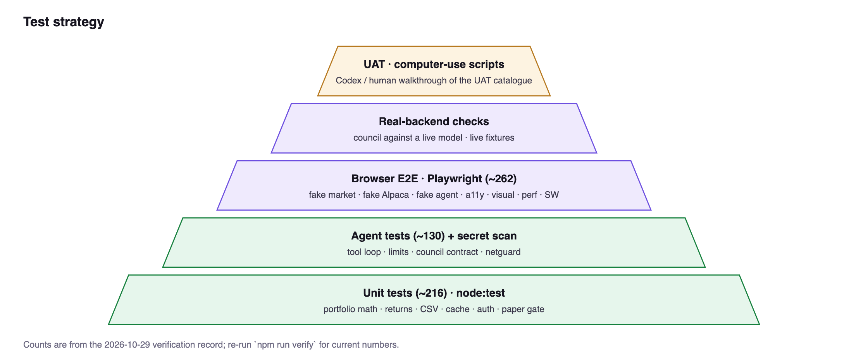
Figure 15 — Test pyramid
Level | Scope | Tooling / fixtures
Unit | Portfolio math, returns, FX split, CSV/IBKR parsing, cache, auth, paper gate and mirror | node:test, pure functions, fixtures in test/fixtures
Agent | Tool loop, limits, idempotency, council contract and orchestration, netguard, redaction | node --test, provider fakes, secret scan
Browser E2E | Every panel and flow, Kestrel streaming, council motion, paper desk, discover, layout drag | Playwright, FINSIGHT_FAKE_MARKET=1, fake-agent.mjs, fake Alpaca
Accessibility | Axe rules on terminal and Kestrel | @axe-core/playwright
Visual | Summary, positions, markets, detail at 1600/390 px, dark and light | Playwright snapshots
Performance & SW | Startup, perf budgets, service-worker upgrade and release | Dedicated specs
Real backend | Council against a live model on synthetic cases | Separate Playwright config
UAT | End-to-end acceptance by a human or Codex computer use | §25 catalogue

24.1 Test data, fixtures and fakes
- Fake market (FINSIGHT_FAKE_MARKET=1): deterministic quotes, history, FX, news and calendars from test/fixtures/market.
- Fake Alpaca (lib/fakealpaca.ts): accepts PK-prefixed test keys, fills orders and emits trade_updates.
- Fake agent (web/e2e/fake-agent.mjs) and a deterministic council brain for the real-backend suite.
- Demo portfolio (scripts/demo.ts): nine synthetic holdings in SGD and USD; demo-safety tests stop it from touching real data.

24.2 Test counts
Suite | Size
Root unit and integration tests (test/) | 29 files
Agent tests (agent/test) | 24 files
Playwright specs (web/e2e) | 48 specs, about 240 tests
UAT catalogue | 30 cases

24.3 Release gate
npm run verify runs the typecheck, unit tests, the web bundle check and the E2E suite; npm run agent:test runs the agent's typecheck, tests and secret scan. Both must pass before a merge to main.

25. UAT plan for computer-use testing
Domain 13 Testing and quality assurance

25.1 Environment
1. Use a disposable data folder and the offline fakes: FINSIGHT_DATA_DIR=<tmp> FINSIGHT_FAKE_MARKET=1 NOTIFY=0 PORT=8031 node server.ts (or npm run demo for the seeded book, PIN 2468).
2. For paper tests with the fake broker, connect with test key id PKE2ETEST1234567890 and the matching E2E secret from web/e2e/PAPER.spec.ts (fake broker accepts PK-prefixed ids).
3. For Kestrel tests without a model key, run node web/e2e/fake-agent.mjs and set AGENT_URL to it; for council tests use a configured DeepSeek key.
4. Viewport 1600×1000 for desktop cases, 390×844 for mobile cases. Record a screenshot at each Expected step.
For Codex computer use
Each case below is self-contained: preconditions, numbered steps using visible labels, and an observable expected result. Treat any mismatch in label text, numbers' presence or state as a failure and capture a screenshot.

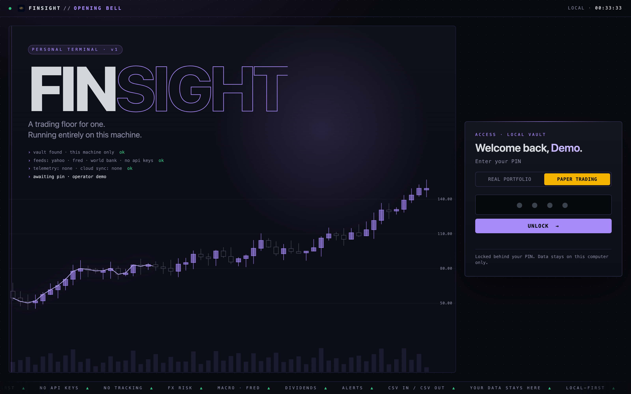
LIVE CAPTURE Screen 21 — UAT starting point: the lock screen, where the tester picks REAL or PAPER and enters the demo PIN

25.2 UAT catalogue
ID | Title | Steps | Expected result
UAT-01 | Unlock real book | Open app → REAL PORTFOLIO → type PIN → UNLOCK | Terminal loads; top bar shows REAL active; summary cards show S$ values
UAT-02 | Wrong PIN | Type 0000 → UNLOCK | "Wrong PIN" shown; terminal stays locked
UAT-03 | Operator card | Profile → set name, base SGD → Start empty → SAVE & CONTINUE | Dialog closes; greeting/profile uses name
UAT-04 | Add via command | CMD: ADD AAPL 10 195.50 → GO | AAPL row appears/updates; toast confirms; UNDO available
UAT-05 | Undo | CMD: UNDO → GO | Previous change reverted; positions match prior state
UAT-06 | Trade sheet | Positions → NVDA row → Buy → Shares 10 → save | Sheet shows You hold / Position after / New average before save; row updates after
UAT-07 | Stock vs FX split | Read Unrealized, Stock P&L, FX P&L cards | Unrealized equals Stock + FX (within rounding)
UAT-08 | Chart | Click VOO row → 1Y → Indicators → add RSI | Security Detail shows VOO; RSI pane appears
UAT-09 | FX what-if | FX Risk → drag what-if slider to −5% | Impact on book shown negative; new value updates
UAT-10 | Alert | CMD: ALERT AAPL > 1 → GO | Alert listed; fires toast/notification (price above 1)
UAT-11 | Discover tabs | Discover → US market → IPOs → Your symbols | Each tab renders with as-of; tab choice persists after reload
UAT-12 | Layout | ⚙ Layout → hide World Bank → DONE; drag Watchlist by ⠿ | Panel hidden; order persists after reload
UAT-13 | Light mode & UNPEEK | Click ◐ → click ◉ UNPEEK | Light theme applied; money figures blanked; click again restores
UAT-14 | Open Kestrel | Press ⌘/ | Panel opens with briefing tiles and suggestions; agent online
UAT-15 | Kestrel answer | Ask "What is my currency and sector exposure?" | Tool log shows exposure tools; answer cites asOf; cost shown
UAT-16 | Skill menu | Type / in composer | Commands and skills listed; /pre-trade-check selectable
UAT-17 | Stop a turn | Ask a long question → press Esc | Turn stops; partial answer marked stopped
UAT-18 | Delete chat | Type /delete → confirm | Chat removed from the Chats rail
UAT-19 | Council | ⚖ Council → lens Balanced → "Should I trim NVDA before earnings?" | Stages Assess/Challenge/Synthesize progress; 3 cards + chair; cost shown
UAT-20 | Council view switch | Press ⌘. during/after council | Toggles Cards ↔ Chain of thought
UAT-21 | Switch to paper | Top bar → PAPER | Amber stripe/PAPER badge; connect panel if no keys; REAL data unchanged
UAT-22 | Reject live keys | Enter key id not starting PK → Connect paper | Refused with message; nothing saved
UAT-23 | Connect paper (fake) | Enter test PK key + secret → Connect paper | Desk appears; account strip shows equity; "Order stream live"
UAT-24 | Market order | Ticket: BUY · SPY · Market · 1 share · Day → Buy SPY | Order fills; Positions (1); chart B marker; ledger entry
UAT-25 | Limit + cancel | BUY · AAPL · Limit 1.00 · GTC → Buy; Open orders → Cancel | Dashed limit line appears then disappears; History shows cancelled
UAT-26 | Kestrel ticket (ask) | Settings: Ask me first → ask Kestrel to buy 1 AAPL in paper | Pending ticket bar with Approve/Reject; Approve places order
UAT-27 | Kestrel limit refusal | Settings: Max order US$ 10 → Save → ask Kestrel to buy 5 SPY | Order refused with reason; nothing sent
UAT-28 | Manual edit refused in PAPER | In PAPER, CMD: ADD AAPL 1 100 | Refused with explanation; orders are the only way in
UAT-29 | Mobile layout | Viewport 390 px; scroll terminal and paper desk | No horizontal page scroll; ticket stacks below chart
UAT-30 | Lock | Click 🔒 | Returns to Opening Bell; API requests require PIN again

PART E
Delivery, infrastructure and operations
Domains 14–18: SDLC, infrastructure, CI/CD, observability, operations

26. SDLC and governance
Domain 14 SDLC and governance
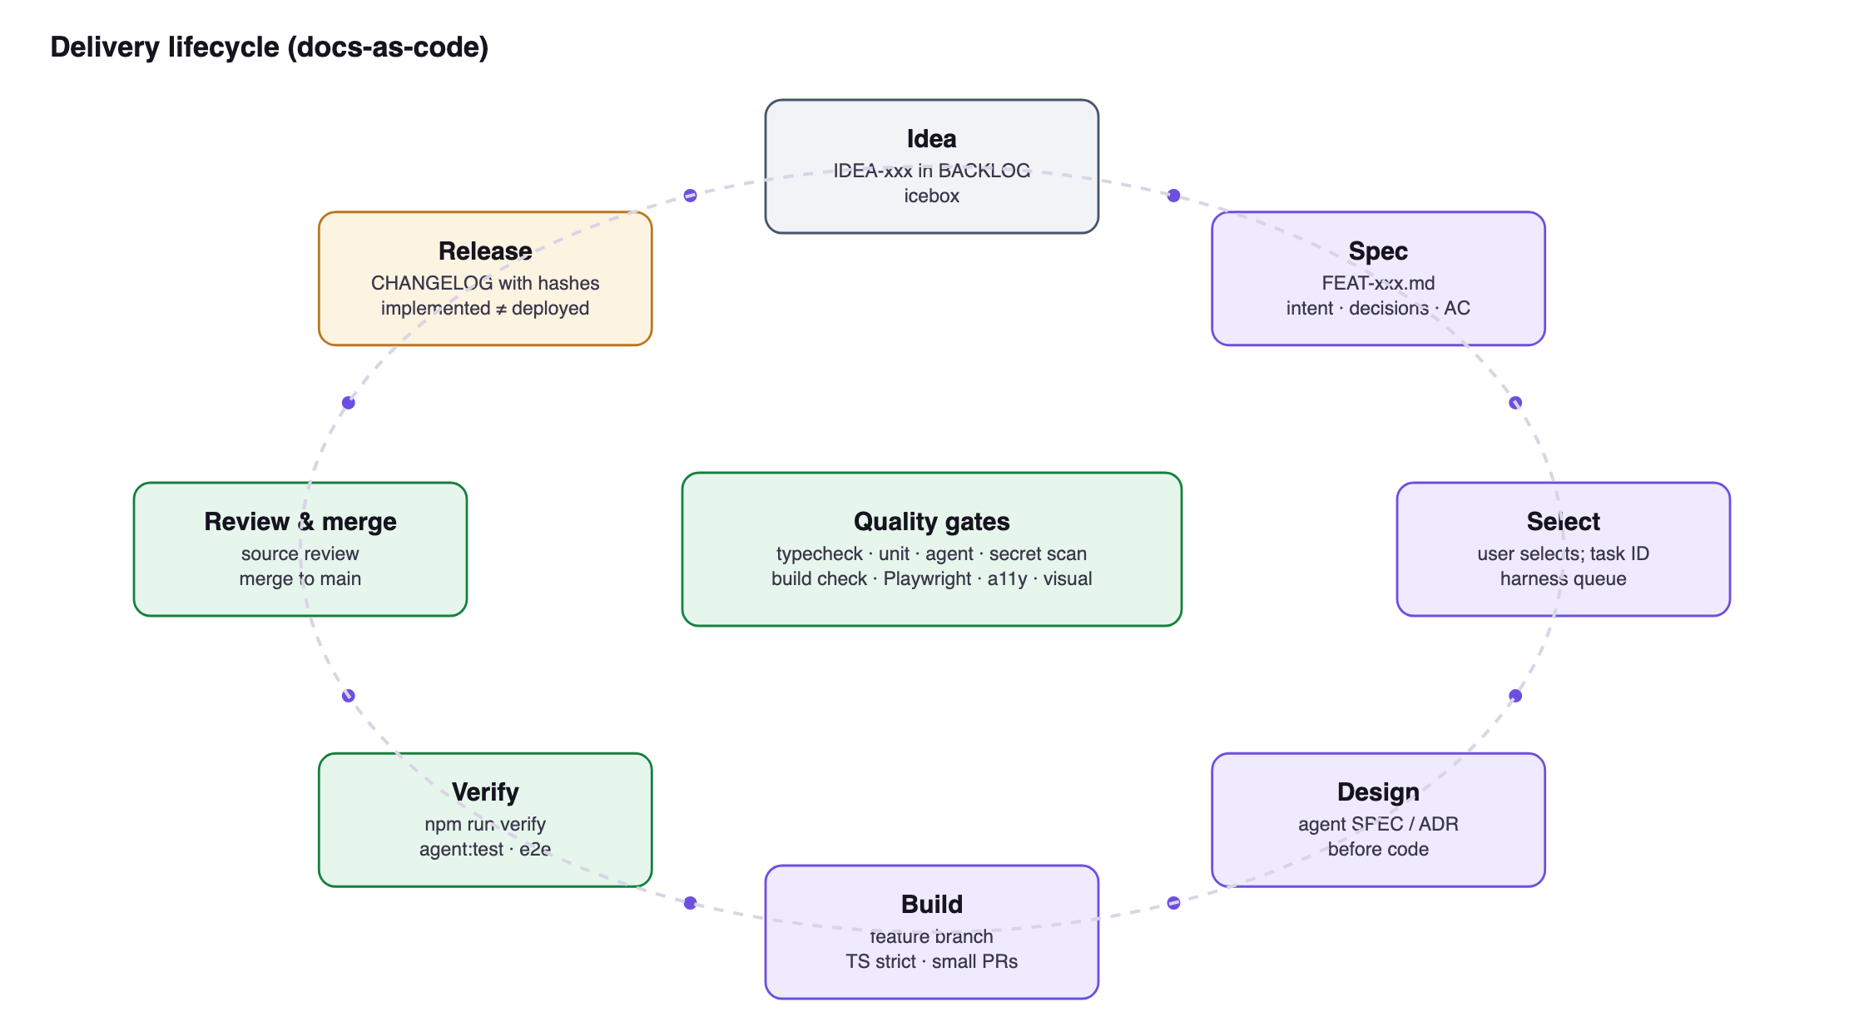
Figure 16 — Delivery lifecycle

26.1 Docs-as-code process
1. Ideas go to the icebox in docs/BACKLOG.md (IDEA-xxx); nothing is built from an idea.
2. Selected work gets a feature spec docs/features/FEAT-xxx-<slug>.md with intent, dated decisions, scope, out of scope and acceptance criteria.
3. Execution is scheduled in the investment-workspace harness (harness/queue.json, task IDs such as PAPER-001); user instructions override queue order.
4. Agent changes start from agent/docs/SPEC.md; contradictions need the user's approval; significant choices get an ADR.
5. Work happens on a feature branch, is verified, reviewed and merged to main.
6. CHANGELOG.md records integrated changes with commit/evidence hashes, distinguishing implemented, verified, merged and deployed.

26.2 Engineering standards
- TypeScript strict; erasable syntax only so Node runs .ts natively.
- Single-responsibility modules; server.ts routes only; pure math in its own modules (returns.ts, portfolio.ts).
- No LLM arithmetic anywhere in the product; deterministic tools own numbers.
- No personal data, keys or records in the repo; secret scan enforced.
- Accessible names match visible text; reduced-motion and keyboard paths for new UI.
- Commits are authored as the owner; small, reviewable changes; visual baselines refreshed deliberately.

26.3 Quality gates
Command | What it checks
npm run typecheck | Web, test and server TypeScript
npm test | Offline unit tests (server + web) with node:test
npm run agent:test | Agent typecheck, tests and secret scan
npm run check:web | Committed bundle matches the source build
npm run e2e | Playwright browser suite (fake market, fake Alpaca, fake agent)
npm run verify | All of the above — required before release

26.4 Engineering gates
Coding agents write features quickly, but speed does not prove a change is correct, secure or operable. Every change passes five gates, each tied to a concrete FinSight check.
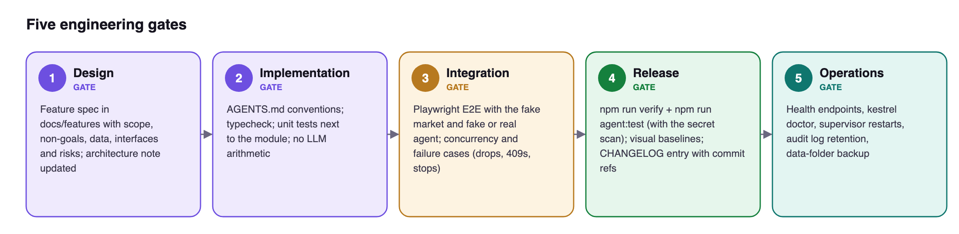
Figure 17 — The five engineering gates and the FinSight checks behind each

26.5 Branching, commits and reviews
Work happens on a feature branch (feat/…, fix/…, mig/<card> for frontend migration cards) in its own worktree, and merges into main with --no-ff after the gates pass. Commits are small, use conventional prefixes (feat, fix, docs, mig) and are authored as the owner. Reviews are done by the owner with AI review tools; visual baselines are refreshed only deliberately.

26.6 Technical debt management
Debt is made visible by scripts: scripts/coupling-inventory.mjs lists legacy couplings that the frontend migration must remove, scripts/css-dead.mjs finds unused CSS, and parity tests (test/publicmath.ts, legacy maths fixtures) keep refactored maths identical to the original.

27. Infrastructure and environments
Domain 15 Infrastructure and cloud
FinSight runs entirely on the owner's computer. There is no cloud infrastructure.

27.1 Topology
Element | Choice
Hosting | The owner's Mac (macOS primary; the terminal also runs on Windows and Linux)
Network exposure | Bound to 127.0.0.1; HOST=0.0.0.0 is an explicit opt-in for LAN access, and only then is the Host check relaxed
Inbound ports | None exposed beyond loopback
Outbound | Market data APIs, model providers, search providers, Alpaca paper
Process management | launchd LaunchAgent (install-autostart.sh / uninstall-autostart.sh); the server supervises the agent
TLS | Not needed on loopback; all outbound calls use HTTPS
Runtime check | Launcher and autostart refuse Node versions below 24

27.2 Run modes
Mode | Command | Port(s) | Data
Personal | node server.ts / autostart (install-autostart.sh) | 8000 · agent 8100 | FINSIGHT_DATA_DIR (e.g. ~/FinSightData)
Standalone (Mac) | double-click start.command | 8002 · agent 8102 | ~/FinSightStandalone
Demo | npm run demo / start-demo.command | 8003 · agent 8103 | ~/FinSightDemo (PIN 2468)
Test / UAT | FINSIGHT_FAKE_MARKET=1 … node server.ts | any | temporary folder

Each environment has its own port and data folder, so demos and tests can never touch real holdings. The test environment uses the fake market and fake broker, so it needs no network.

27.3 Not applicable
Containers, serverless, VPCs, gateways, object storage, infrastructure-as-code and data-residency choices do not apply: nothing is hosted. If FinSight were ever offered to others, this chapter would be the starting point for that design.

28. CI/CD and release engineering
Domain 16 CI/CD and release engineering
FinSight is released by merging to main and restarting the local server. The pipeline runs on the developer's machine.

28.1 Build
- npm run build bundles the React app with esbuild into public/app/ (content-hashed chunks plus a manifest). The output is committed, so users run FinSight without installing build tools.
- npm run check:web rebuilds and fails if the committed bundle differs from the source: a reproducible-build check.
- Lockfiles pin every dependency; the agent installs with npm ci.

28.2 Pipeline
Stage | Command | Blocks release on
Typecheck | npm run typecheck | Any type error in server, web or tests
Unit | npm test | Failing unit test
Agent | npm run agent:test | Agent type error, failing test, or a secret found
Bundle | npm run check:web | Committed bundle out of date
E2E | npm run e2e | Failing browser test or visual diff
All | npm run verify | Any of the above

28.3 Release, rollout and rollback
- Release: merge the verified branch into main, record it in CHANGELOG.md with commit references, restart the server (launchd).
- Progressive enablement: features ship behind switches — KESTREL_COUNCIL for the council, approval mode and limits for paper trading, KESTREL_UI for Intelligent UI views.
- Service worker updates: the shell cache name is bumped when the file set changes so open tabs pick up the new build; the chunk guard reloads safely.
- Database migrations: backed up before applying; a migration refuses to run while another process holds the database.
- Rollback: git revert the merge and restart; restore agent.db.bak-v<N> if a migration must be undone.
- Smoke test after start: /api/health, /api/agent-status and kestrel doctor.

28.4 Planned improvement
A hosted CI workflow (for example GitHub Actions) running npm run verify and npm run agent:test on every push would make the gate independent of the developer's machine. It is the first item on the engineering backlog (§34).

29. Observability and monitoring
Domain 17 Observability and monitoring
Observability in FinSight answers two questions: is the system healthy, and why did Kestrel give this answer?

29.1 Health and status signals
- The top bar shows LIVE or a stale state for market data; panels show their as-of time.
- /api/agent-status exposes the supervisor state (running, crashed, restarting), restart count and last exit; the Kestrel panel turns this into a readable message.
- The paper desk shows the order-stream state ("Order stream live" or reconnecting).

29.2 Agent traces and logs
Every model call, tool call and data request is logged with timing and cost to agent.db and redacted JSONL logs (14-day retention). The UI exposes a per-answer trace; /logs shows recent errors; /cost reports spend by day or month.

29.3 Structured logs and correlation
The agent's audit log writes one JSON line per API request, model request and response, tool call, FinSight call, MCP call and error, in daily files. Each line carries turnId, threadId and request ids propagated with AsyncLocalStorage, so one answer can be traced end to end. Lines are redacted before writing and large fields are capped.

29.4 Business metrics
Cost per answer, per day and per month (/cost), steps, tool calls and latency per turn are recorded in the trace and shown in the UI. Council runs record per-stage status and readiness.

29.5 Not applicable at this scale
Centralised log collection, metrics dashboards, distributed tracing across hosts, real-user monitoring and paging are not needed for one local user. Price alerts are a product feature, not an operational alert.

30. Production operations and support
Domain 18 Production operations and support
The owner is also the operator. This chapter lists what is needed to run, fix and maintain FinSight.

30.1 Configuration
Variable | Purpose
PORT, HOST | Listen port / host (loopback)
FINSIGHT_DATA_DIR | Data folder outside the repo
AGENT_URL, AGENT_AUTOSTART, AGENT_DIR, AGENT_SHELL_ENV | Agent location and supervision
FINSIGHT_FAKE_MARKET | Offline deterministic market + fake Alpaca for tests/demo
FINSIGHT_CACHE_PERSIST | Persist market cache to disk
LOCK_IDLE_MIN | Idle auto-lock minutes
NOTIFY, ALERT_INTERVAL | Desktop notifications and alert polling
ALPACA_PAPER_KEY_ID, ALPACA_PAPER_SECRET_KEY | Paper keys via environment (alternative to UI)
DEEPSEEK_API_KEY, ANTHROPIC_API_KEY, TAVILY_API_KEY | Model and search keys (prefer Keychain)
KESTREL_UI | Intelligent UI views setting

30.2 Runbook
Task | How
Install agent | npm run agent:install
Health | node agent/src/cli.ts doctor; /api/agent-status
Logs | agent.log, agent/logs/*.jsonl; /logs in Kestrel
Reset PIN | Delete auth.json in the data folder (holdings kept)
Reset demo | npm run demo:reset
Port clash | PORT=9000 node server.ts
Backup | Copy the data folder; portfolio.json + undo.json + agent/agent.db
Register MCP | claude mcp add finsight -- node <finsight>/agent/src/cli.ts mcp

30.3 Incident handling
Symptom | First check | Fix
Kestrel panel says offline | /api/agent-status, agent.log | npm run agent:install; check keys with kestrel doctor
Panels stale | Top bar status, panel as-of time | Usually a source outage; data refreshes when it returns
Paper stream not live | Desk account strip | Reconnect, or Disconnect and Connect paper again
Port in use | Error at start | Start on another port (PORT=9000 node server.ts)
Forgotten PIN | — | Delete auth.json in the data folder
Bad data after a change | Undo, .corrupt.json, backups | Undo (25 steps) or restore the data folder

30.4 Patching and upgrades
Dependencies are upgraded deliberately, one change at a time, with the full gate. Node 24 or newer is enforced by the launcher. After an upgrade the service worker picks up the new shell automatically.

30.5 Support
The interactive guide (docs/guide/finsight-guide.html) includes a troubleshooting scene; /help and /logs in Kestrel show capabilities and recent errors.
PART F
Business, governance and sustainability
Domains 19–23: cost, privacy and compliance, documentation, analytics, maintainability

31. Cost engineering and FinOps
Domain 19 Cost engineering and FinOps
FinSight's infrastructure cost is zero: it runs locally and uses free, keyless data. The only variable cost is AI model usage, which is engineered to be small, visible and capped.

31.1 Cost model
Cost | Amount | Control
Hosting, compute, storage | US$0 (owner's machine) | —
Market and macro data | US$0 (public sources) | Cache to stay within rate limits
Paper broker | US$0 (Alpaca paper) | —
Model tokens | ≈ US$0.0003–0.0008 per simple DeepSeek turn | Per-turn and per-day caps
Web search | Provider pricing (Tavily, Brave) | Searches per turn limit

31.2 Budgets and caps
Limit | Default | Editable
US$ per reply | 0.25 | Yes (/limits or the Today spend)
US$ per day | 5 | Yes
Council research calls | 8 | Yes; optional council turn ceiling
Steps / seconds per reply | 25 / 300 | Yes
Searches / pages per reply | 20 / 25 | Yes

Limits are changed only by the owner; Kestrel's token cannot change them.

31.3 Cost control mechanics
- Reservation before every billable call, reconciled after, with a persisted daily ledger, so parallel calls (for example council specialists) cannot overshoot a cap.
- Prompt caching lowers repeat input cost (FEAT-005).
- Model choice by cost tier: cheap default, stronger models on demand.
- Attribution: cost is recorded per answer and per thread and summarised by day and month (/cost).

32. Privacy, legal and compliance
Domain 20 Privacy, legal and compliance · Domain 22 Product analytics and experiments
Privacy is a product goal (G3). FinSight keeps financial data on the owner's machine and sends out only what each feature needs.

32.1 What data goes where
Data | Stays local | Leaves the machine
Holdings, trades, cash, records | Yes, in the 0600 data folder | Only as tool results inside a Kestrel question, to the chosen model provider
Symbols | — | Sent to public market APIs to fetch quotes
Paper orders | Mirror book local | Sent to Alpaca paper
Web research queries | — | Sent to the chosen search provider
Keys and PIN | Yes (Keychain, 0600 files, scrypt hash) | Never

32.2 Principles applied
- Data minimisation: no account, no telemetry, no cloud sync.
- Purpose limitation: data is used only to answer the owner's questions and run the owner's book.
- Retention and deletion: chats can be deleted; logs expire after 14 days by default; the owner can delete the data folder at any time.
- Repository hygiene: AGENTS.md forbids personal data, keys and records in the repo; broker exports (*.csv) are git-ignored; demo and test data are synthetic.

32.3 Regulation and terms
- Singapore's PDPA governs organisations; an individual managing their own data in a personal capacity is outside its scope. If FinSight were offered to other users, consent, access and correction workflows and cross-border transfer terms would apply.
- Data-source terms: Forex Factory's feed is for personal use and is not redistributed; Yahoo endpoints are unofficial and used for personal analysis only.
- FinSight is MIT-licensed; dependency licences are permissive.
- Not investment advice: FinSight and the council state this in the product.

32.4 Product analytics and experimentation
Domain 22 was evaluated and is intentionally not implemented: product analytics would mean telemetry, which conflicts with G3. Quality is measured offline instead — council evaluation metrics (council-metrics.ts), per-turn cost and latency traces, and UAT results. If FinSight ever had other users, analytics would be opt-in and privacy-preserving.

33. Documentation and knowledge management
Domain 21 Documentation and knowledge
Documentation lives with the code and changes in the same commit as the behaviour it describes.

33.1 Document set
Concern | Where it lives
Product requirements | docs/product/PRD.md; §5–§9 of this document
Architecture | docs/architecture/SYSTEM.md, finsight-architecture.md, kestrel-architecture.md; §10
Decision records | agent/docs/ADR-THINKING-EFFORT.md; decisions inside feature specs; §10
Agent specification | agent/docs/SPEC.md, COUNCIL.md, INTELLIGENT-UI.md, UI-QUALIFICATION.md
Data model | §14; agent/docs/SPEC.md
API | §15; DOCS.md
Security | §20; agent/docs/SPEC.md §10
Test plan | §24, §25; web/e2e/COVERAGE.md
Deployment and operations | §27–§30; README.md, START-HERE.md
Roadmap | docs/BACKLOG.md; docs/features/FEAT-001…013; §34
Rules for coding agents | AGENTS.md
User guide and demo | docs/guide/finsight-guide.html

33.2 Onboarding
START-HERE.md and README.md take a new user from download to a running terminal; npm run demo gives a safe sandbox. A new contributor or coding agent reads AGENTS.md, this document, then the feature spec for the work at hand.

33.3 Ownership and versioning
The owner maintains all documents. This master document is generated from docs/master/src (content, diagrams and screenshots) so the PDF and Word versions never drift, and it states the code baseline it reflects.

33.4 Repository structure
finsight/
├── server.ts Node HTTP server: routes, headers, session gate, proxies
├── lib/ Domain modules (portfolio, market, macro, paper, auth, cache…)
├── web/ React 19 + TS source
│ ├── src/features/ one folder per panel (positions, kestrel, paper, discover…)
│ ├── src/shell/ boot, layout, chart hooks
│ └── e2e/ Playwright specs, fake agent, fixtures
├── public/ served as-is: index.html, app/ bundle, chart.js, styles, sw.js
├── agent/ ↗ Kestrel (TypeScript)
│ ├── src/ api, chat, brains, tools, store, sandbox, mcp, obs
│ ├── skills/ bundled playbooks
│ ├── plugins/brains/ one manifest per model
│ └── docs/ SPEC, COUNCIL, INTELLIGENT-UI, ADRs
├── shared/ contracts shared by server/agent/web (council lenses)
├── scripts/ build-web, demo, checks
├── test/ node:test unit suites and fixtures
├── docs/ BACKLOG, features (FEAT-xxx), architecture, product PRD, guide, master
└── AGENTS.md rules for coding agents

34. Maintainability and future evolution
Domain 23 Maintainability and evolution
FinSight is built to be changed safely by one owner working with coding agents.

34.1 Modularity and separation of concerns
- Pure maths in lib/ modules with unit and parity tests; server.ts only routes.
- UI panels as independent islands; shared primitives in web/src/ui.
- One agent tool registry used by Kestrel, the council and MCP.
- Contracts shared between server, agent and web in shared/.

34.2 Extensibility
Brains, skills, strategies and search providers are plugins with manifests. Adding a model or a playbook does not change the core; the registry is reloaded as an immutable snapshot.

34.3 Ongoing evolution
- Frontend migration: legacy panels are being moved to React islands card by card, with a coupling inventory, parity tests and visual baselines (docs/frontend-migration).
- Backward compatibility: data files are upgraded on load; the agent API is versioned; council contracts are versioned.
- Data portability: CSV export of holdings, ledger and journal; data files are plain JSON and SQLite.
- Handover: this document, AGENTS.md and the guide reduce the risk of single-owner knowledge.

34.4 Feature status
Spec | Feature | Status (2026-11-01)
CORE-001 | Kestrel research agent core | Integrated 2026-10-24
IUI-001 / START-001 | Intelligent UI views; briefing start screen | Integrated 2026-10-26
FEAT-002 | Investment lenses & council mode | Merged, verified, personally activated; quality work open (COUNCILQUALITY-001)
FEAT-003 | Chat deletion, /delete, /clear, bulk clear | Merged — verified
FEAT-005 | Prompt-cache optimisation | Merged — verified
FEAT-006 / 007 / 008 | New-symbol trades; account transfers; IBKR fill import | Merged — verified
FEAT-009 | Kestrel terminal redesign (panel states, light mode, council views) | Merged (PR #1)
FEAT-010 | Market Discover: movers, US movers, IPO calendar | Merged locally; not deployed
FEAT-012 | Paper trading, trade desk, Kestrel paper orders and limits | Merged to main (aa373b7); live run with real paper keys pending
FEAT-013 | Agentic trading cycle | Plan, not selected
FEAT-001 / 011 | IBKR MCP live sync; agent data sources | Deferred
IDEA-001…004 | PDF memo export, ETF look-through, multi-broker, voice input | Icebox

34.5 Engineering backlog
Priority | Item | Domain
P1 | Hosted CI running npm run verify and npm run agent:test on every push | CI/CD
P1 | Strict Content-Security-Policy header | Security
P2 | Dependency audit in the release gate | Security
P2 | Documented and rehearsed data-folder backup and restore | Data, reliability
P3 | docs/adr/ with the key past decisions | Architecture, documentation
P3 | OpenAPI description of /api and /v1 | APIs, documentation

35. Risks, assumptions and constraints
Type | Item | Mitigation / note
Risk | Unofficial Yahoo endpoint changes or rate-limits | Cache, backoff, stale flags; sources isolated in market.ts
Risk | Model hallucination or overconfidence | Tool-only numbers, citations, council gaps, figure flags, user decides
Risk | Prompt injection via web/docs | Untrusted wrapping; no write tools on the real book
Risk | Agent over-trading paper | Ask mode default, limits, PIN-only settings
Risk | Provider cost spikes | Turn and daily caps with reservation
Assumption | Single trusted user on a personal machine | Controls target other processes/pages, not other users
Assumption | FinSight running when the agent needs facts | Agent degrades with FINSIGHT_DOWN
Constraint | Forex Factory feed personal-use only; no redistribution | Local use only; disclaimer in README
Constraint | US-only market movers and IPOs | SG/HK deferred
Constraint | No ETF look-through yet | Exposure answers must say so

Disclaimer
FinSight is a personal tool and not investment advice. It is not affiliated with Bloomberg, Yahoo, Interactive Brokers, Alpaca, Forex Factory or the Federal Reserve. Data is provided as-is.

FINSIGHT
Appendices

Appendix A — Glossary
Term | Meaning
Base currency | Currency all totals are reported in (default SGD)
Stock P&L / FX P&L | Part of unrealized gain from the price move / from the exchange-rate move
Blended entry | Weighted-average exchange rate paid for foreign holdings
TWR / XIRR | Time-weighted return (ignores cash-flow timing) / money-weighted personal return
VaR | Value at risk; here 1-week, 1σ and 95% from recent FX volatility
Lot | One purchase with quantity, price, FX and time
Brain | Model plugin used by Kestrel for a turn
Tool | Function the model can request; executed by deterministic code
Skill | Playbook in SKILL.md format invoked with /name
Context pack | Dated snapshot of the user's situation built by code for each turn
Lens | Analytical emphasis for the council (Balanced, Growth, Speculative, Hedge Fund, Macro)
Ticket | A Kestrel paper order waiting for Approve/Reject
UNPEEK | Privacy mode that blanks money figures
MCP | Model Context Protocol; exposes tools to external AI clients

Appendix B — Terminal commands
Command | Effect
ADD SYM QTY PRICE [DATE] | Buy/add (averages in); optional date fetches historical FX
SELL SYM QTY [PRICE] | Sell; realized P&L recorded
DEL SYM | Stop tracking
CASH CCY AMOUNT | Set cash
UNDO | Undo last change
LEDGER | Open trades ledger
Q SYM / SYM | Load symbol detail
WATCH / UNWATCH SYM | Watchlist
ALERT SYM > | < PRICE | Price alert
NEWS SYM | News
WHT MKT PCT | Withholding rate
MKT · HELP | Refresh markets · help

Appendix C — Kestrel commands
Command | Effect
/new · /clear · /delete | New chat · fresh chat keeping history · delete (asks first)
/model <id> | Switch brain (e.g. deepseek-pro)
/cost [month] | Spend
/limits | Spending and tool limits
/strategies · /skills · /logs · /help | Library · installed skills · recent errors · capabilities
/committee <question> | Run the council once
/pre-trade-check · /position-review · /earnings-review · /why-did-it-move · /strategy-scan | Skills
⌘/ · ⌘⇧/ · ⌘. · Esc | Toggle panel · full page · council view · stop

Appendix D — Traceability matrix
Story | Functional requirements | Automated evidence | UAT
US-A1/A2 | FR-ACC-1…4 | lock, session, PAPER specs | UAT-01, 02, 21, 30
US-A3/A4 | FR-ACC-5 | startup, demo safety | UAT-03
US-B1/B2 | FR-PF-1, FR-PF-2 | portfolio unit tests, summary visual | UAT-07
US-B3/B4/B5 | FR-PF-3…7 | add-sell, import-export, trades, ledger, OPENFEATURES | UAT-04, 05, 06
US-B6/B7/B8 | FR-AN-1…3 | returns/performance units, panels spec | UAT-09
US-C1…C5 | FR-MD-1/2, FR-DS-1, FR-MC-1, FR-AL-1 | chart, DISCOVER, F-specs, visual | UAT-08, 10, 11, 12, 13
US-D1…D8 | FR-K-1…11 | G.agent, KESTRELUX, CHATDELETE, LIMITS, IUI, agent tests | UAT-14…18
US-E1…E4 | FR-C-1…6 | COUNCIL.agent, COUNCIL.motion, council real-backend | UAT-19, 20
US-F1…F4 | FR-P-1…7 | PAPER.spec, paper unit tests vs fake broker | UAT-21…29

Appendix E — References
- README.md, DOCS.md, AGENTS.md — overview, developer/API reference, agent rules
- docs/architecture/SYSTEM.md, finsight-architecture.md, kestrel-architecture.md
- agent/docs/SPEC.md (SRS), COUNCIL.md, INTELLIGENT-UI.md, ADR-THINKING-EFFORT.md
- docs/product/PRD.md, docs/BACKLOG.md, docs/features/FEAT-001…013
- docs/guide/finsight-guide.html — interactive demo guide and user manual
- web/e2e/COVERAGE.md — browser test coverage map

