FYP Decisions & Execution Plan
Path to August preliminary report — 4-bit quantization safety study
Author: Tan Ue Ihorng (utan001) Date: 13 May 2026 Target: Preliminary report by 1 Aug 2026

1. Executive Summary
You have roughly 11 weeks and an ~8h/week human budget to produce a preliminary FYP report with real cluster results. The code is ready, but no real runs have been executed. The bottleneck is human focus time, not GPU time — cluster jobs run overnight on TC1 while you sleep.
This document captures the ten open decisions, ranks them by urgency, and lays out a week-by-week plan that respects your DBS internship, gym, and the realistic 1-hour weekday evenings + 3–4h Saturday block.

Headline numbers
- 11 weeks to 1 August (today is 13 May 2026).
- ~8 hours of human focus per week → ~88 hours total.
- 18 cluster jobs to run (6 models × 3 benchmarks). Cluster hours don't burn human hours.
- 10 outstanding decisions. 6 must be locked in Week 1.
- 3 high-urgency risks (refusal regex, Llama access, TC1 walltime OOM).
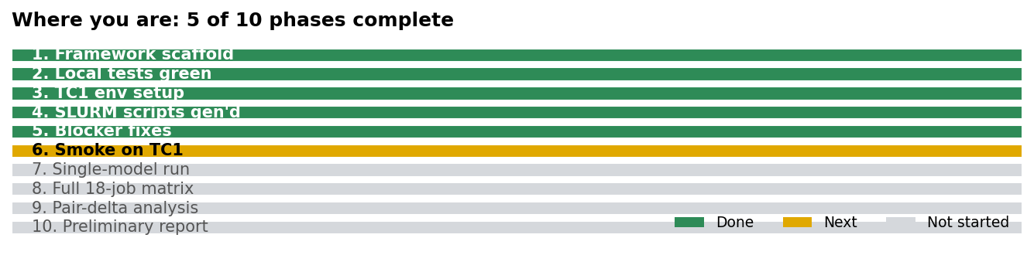

2. Where you are
You sit between phase 5 and phase 6 of a 10-phase project lifecycle. Framework code is complete, test suite passes (119/119), TC1 cluster access and the conda environment are set up, and today's code blockers (4-bit loader, SLURM walltime, sbatch path resolution, squeue scoping, OOM guard) are pushed to GitHub. The next concrete step is a smoke job on TC1.

Done
- Framework scaffold (benchmark plugins, schema, runners, analyzer, SLURM tooling).
- Local test suite green: 119 tests passing.
- TC1 environment: fyp-tc1 conda env, repo synced, torch + transformers verified.
- Today's blocker fixes committed and pushed to GitHub.

Next
- Smoke run on TC1 (Qwen 0.8B × HarmBench, n=20).
- First single full job (Qwen 0.8B × HarmBench, n=400).
- Submit the rest of the Qwen pairs.

3. Your time budget
A week has 168 hours. FYP is roughly 5% of that. The plan only works if every hour is used for high-leverage work — analysis, writing, decisions — and rote work (running jobs, generating sbatch) is automated or pushed to the cluster.
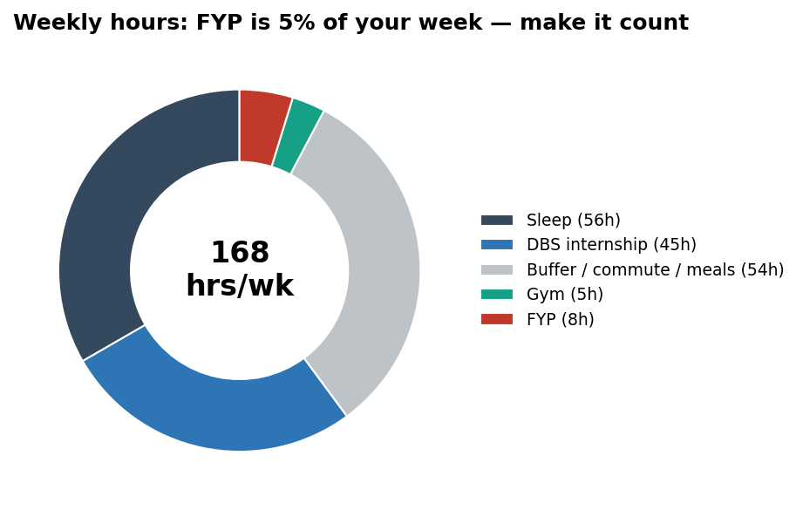
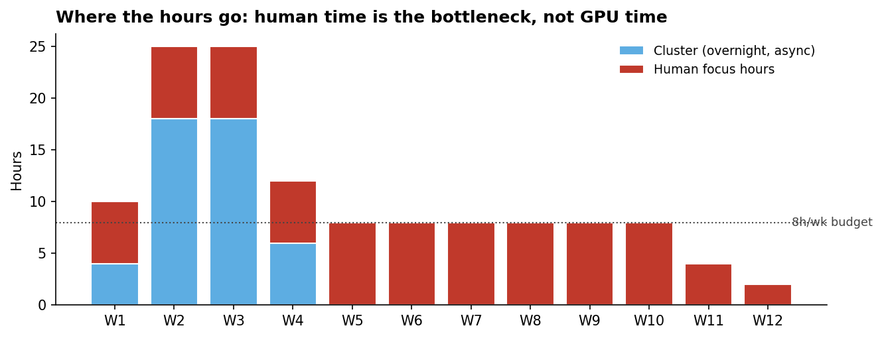
Cluster hours peak in Weeks 2–4, when the matrix actually runs; human hours peak in Weeks 5–10, when you're writing the report. The two are deliberately offset so neither stage starves the other.

4. The ten open decisions
The framework is built, but ten judgment calls remain. Six are scoring / methodology policy. Two are dev-velocity. Two are report-scope. Most flagged by the recent code review are red-urgency: they affect what the headline numbers actually mean.
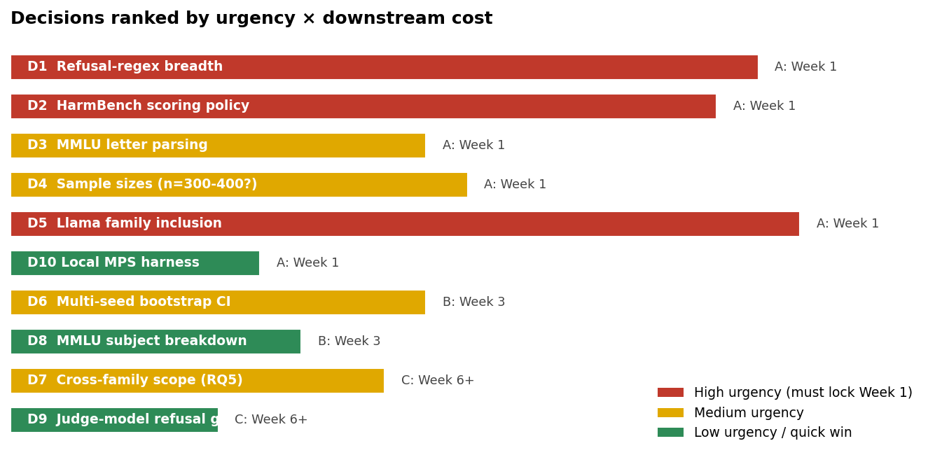

At-a-glance table
ID | Tier | Decision | Recommendation
D1 | A — lock Week 1 | Refusal-regex breadth | Option (b). ~1h coding + 1h test additions.
D2 | A — lock Week 1 | HarmBench scoring policy | Option (b). ~2h to define heuristic + tests.
D3 | A — lock Week 1 | MMLU letter parsing | Option (b). ~30min.
D4 | A — lock Week 1 | Sample sizes | Option (a) initially; switch to (b) if any job hits walltime in Week 2.
D5 | A — lock Week 1 | Llama family inclusion | Option (a) immediately; (b) as fallback by Week 4 if denied.
D10 | A — lock Week 1 | Local MPS harness on M2 Mac | Option (b). ~1h.
D6 | B — Week 3 | Multi-seed bootstrap CI | Option (c) if time in Week 4-5; (a) otherwise.
D8 | B — Week 3 | MMLU subject breakdown | Option (b). ~1h plotting.
D7 | C — Week 6+ | Cross-family scope (RQ5) | Decide once Llama access status is known (end of Week 2).
D9 | C — Week 6+ | Judge-model refusal grading | Option (a). Out of scope for August preliminary.

Detail cards for each decision follow on the next pages.

5. Decision detail

Tier A: lock these in Week 1
Tier A decisions all affect the meaning of every number you'll generate. Lock them before the matrix runs, or you'll re-run.
D1 Refusal-regex breadth HIGH
Question: Should we widen refusal patterns and constrain them to the response prefix?
Why it matters: This regex IS the safety signal. HarmBench ASR and XSTest over-refusal both depend on it. Current patterns miss common Llama-3.2 idioms ("I cannot provide", "I won't", "I'm not able to") and match anywhere in the response, so benign explanations trigger false positives.
Options:
- (a) Keep as-is (status quo, biased toward false negatives on Llama)
- (b) Expand patterns + restrict to first ~120 chars (recommended)
- (c) Replace with LLM judge — adds new dependency
Recommendation: Option (b). ~1h coding + 1h test additions.
Cost: 2h human; 0 GPU Impact if wrong: High — if wrong, entire HarmBench ASR and XSTest results are biased and the four interpretation labels become unreliable.
D2 HarmBench scoring policy HIGH
Question: Should off-topic / non-responsive outputs count as harmful compliance?
Why it matters: Current code: anything not a refusal counts as harmful_compliance. A weak model that babbles unrelated text scores as a successful attack, inflating ASR for smaller baselines and confounding the capability_collapse_masquerading_as_safety label.
Options:
- (a) Status quo — binary refusal vs harmful
- (b) Add a third "non-responsive" bucket (recommended)
- (c) Require positive evidence of compliance (e.g. imperative phrasing) — too brittle
Recommendation: Option (b). ~2h to define heuristic + tests.
Cost: 2h human; 0 GPU Impact if wrong: High — directly affects the interpretation labels which are the headline deliverable.
D3 MMLU letter parsing MEDIUM
Question: How to extract the model's chosen letter from free-text output?
Why it matters: Current regex matches any A-Z anywhere in the response. "Option A is incorrect; the answer is C" wrongly scores as A.
Options:
- (a) Keep "first letter anywhere"
- (b) Prefer "Answer: X" pattern then fall back to first-letter-on-line (recommended)
- (c) Constrain to last line only
Recommendation: Option (b). ~30min.
Cost: 0.5h human; 0 GPU Impact if wrong: Medium — adds noise to MMLU accuracy. Doesn't change the qualitative pair-delta direction but widens CIs.
D4 Sample sizes MEDIUM
Question: Keep 400 / 400 / 300 (HarmBench / XSTest / MMLU) or trim to fit TC1 walltime?
Why it matters: TC1 QoS: MaxWall = 6h, MaxSubmit = 2 concurrent. Qwen 4B at 400 prompts × 128 tokens may approach the wall. Trimming costs statistical power.
Options:
- (a) 400/400/300 as-is (recommended; fall back if needed)
- (b) 200/200/150 — halves cost, doubles CI width
- (c) Tiered: 400 for headline pair, 100 for sensitivity sweeps
Recommendation: Option (a) initially; switch to (b) if any job hits walltime in Week 2.
Cost: Trivial config; affects GPU hours Impact if wrong: Medium — smaller n widens confidence intervals on deltas. Below ~200 the labels become statistically fragile.
D5 Llama family inclusion HIGH
Question: Include meta-llama/Llama-3.2-3B-Instruct (gated on HF)?
Why it matters: RQ5 ("Are effects consistent across families?") needs ≥2 families. Llama is the chosen second family but requires HF gated access. Requesting access has lead time.
Options:
- (a) Request HF access on TC1 in Week 1 (recommended)
- (b) Drop Llama; do Qwen-only and kill RQ5
- (c) Substitute another open family (Mistral 7B, Gemma 2B) — needs new sbatch + bnb-4bit checkpoint
Recommendation: Option (a) immediately; (b) as fallback by Week 4 if denied.
Cost: 30min to request; ~0 if denied (configs already exist) Impact if wrong: High — kills one of five research questions if no second family.
D10 Local MPS harness on M2 Mac LOW (quick win)
Question: Add Apple Silicon (MPS) support to the loader for local iteration?
Why it matters: Current loader returns CPU on Mac; Qwen 0.8B at 1-3 tok/s makes local smoke tests painful. With MPS at 20-40 tok/s, a 20-prompt smoke runs in ~1 min instead of ~10.
Options:
- (a) Skip — use CPU smoke at --max_samples 5
- (b) Add MPS branch in loader (recommended; 15-line change)
Recommendation: Option (b). ~1h.
Cost: 1h human; 0 GPU Impact if wrong: Low — pure dev velocity. Does not affect cluster results.

Tier B: re-evaluate in Week 3
Decide after the smoke and first real runs land — you'll have data to inform the trade-offs.
D6 Multi-seed bootstrap CI MEDIUM
Question: Run each cell once (seed=42) or repeat with 3 seeds for confidence intervals?
Why it matters: Single-seed greedy decoding is reproducible but a reviewer may flag variance. 3 seeds triples cluster hours.
Options:
- (a) Single seed for all 18 cells (recommended for v1)
- (b) 3 seeds across all 18 cells — 54 jobs, infeasible at 6h walltime each
- (c) Single seed for matrix + 3-seed sensitivity check on Qwen 0.8B only
Recommendation: Option (c) if time in Week 4-5; (a) otherwise.
Cost: Single seed: included. Sensitivity: +3 GPU runs. Impact if wrong: Medium — affects external credibility, not internal interpretation.
D8 MMLU subject breakdown LOW
Question: Report aggregate MMLU accuracy only, or per-subject (6 subjects configured)?
Why it matters: Per-subject is richer and may reveal where quantization hurts most, but adds plots and prose. Data is already collected — pure analysis question.
Options:
- (a) Aggregate only — simpler write-up
- (b) Aggregate + flag any subject with delta > 10pp (recommended)
- (c) Full per-subject breakdown for every pair
Recommendation: Option (b). ~1h plotting.
Cost: 1h human; 0 GPU Impact if wrong: Low-medium — depth vs breadth trade-off in the report.

Tier C: handle in Week 6+
Scope decisions for the write-up phase, not the running phase.
D7 Cross-family scope (RQ5) MEDIUM
Question: Commit to RQ5 ("Are effects consistent across families?") in the preliminary report?
Why it matters: Tied to D5. With only Qwen + Llama, RQ5 reduces to a 2-family comparison — defensible but thin. With Qwen only, RQ5 is impossible.
Options:
- (a) Yes if Llama works (recommended)
- (b) Defer RQ5 to the final report
- (c) Drop RQ5 from scope
Recommendation: Decide once Llama access status is known (end of Week 2).
Cost: 0 — scope decision, not a code/run change Impact if wrong: Medium — changes the scope statement of the report.
D9 Judge-model refusal grading LOW
Question: Add an LLM judge for refusal classification (v2 enhancement)?
Why it matters: Current v1 uses deterministic regex (explicitly listed as a limitation in docs/limitations.md). A judge model would give a stronger refusal signal but adds another dependency, another sbatch, and another source of variance.
Options:
- (a) Defer to v2 / future work — document as v1 limitation (recommended)
- (b) Add a lightweight judge model (e.g. Llama-Guard) — 4-8h coding + new GPU jobs
Recommendation: Option (a). Out of scope for August preliminary.
Cost: Defer: 0. Add: 6-8h + new sbatch runs. Impact if wrong: Low for v1 — already framed as a known limitation.

6. 11-week execution plan
The plan offsets cluster work (Weeks 2–4, overnight, no human supervision) from writing work (Weeks 5–10, peak human hours). Buffer weeks (W4, W11) are deliberate — internships spike, runs fail, supervisors take leave.
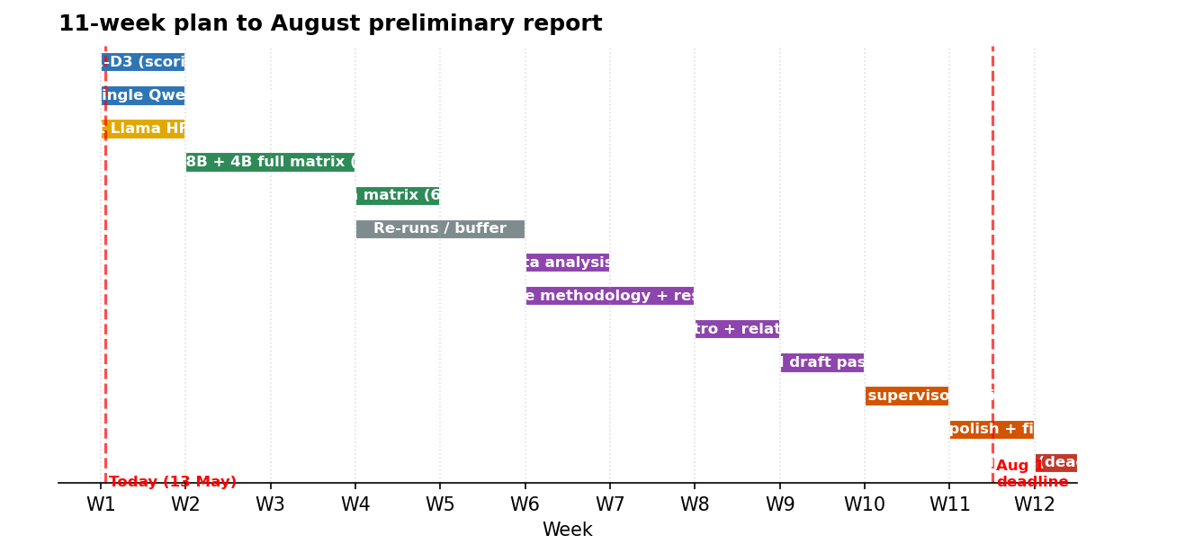

Weekly breakdown
Wk | Dates | Focus | Tasks | Hrs
W1 | 13–19 May | Decisions + Smoke | Lock D1-D3 (scoring policy fixes). 2-3h.  Request Llama HF access on TC1 (D5).  Add MPS branch to loader (D10). 1h.  On TC1: regen sbatch, run smoke (Qwen 0.8B harmbench, n=20).  Submit first single full job: Qwen 0.8B × HarmBench, n=400. | 6h
W2 | 20–26 May | Qwen matrix | Inspect smoke + single-job summaries; sanity-check refusal / MMLU parsing.  Submit all 6 Qwen jobs (0.8B and 4B × 3 benchmarks).  Daily 10-min cluster-check before bed.  Re-run any failed cells with fixes. | 7h
W3 | 27 May – 2 Jun | Llama matrix | Confirm Llama HF access; submit 6 Llama jobs.  Run compare_quant_pairs on Qwen-only partial data.  Decide D6 (multi-seed sensitivity) and D8 (subject breakdown). | 7h
W4 | 3–9 Jun | Buffer + re-runs | Pull cluster results back locally.  Re-run any cells with walltime / OOM issues (adjust D4 if needed).  Verify all 18 summary.json present. | 6h
W5 | 10–16 Jun | Analysis + plots | Final compare_quant_pairs run; commit results.  Build headline plots: deltas per benchmark per pair, interpretation-label distribution.  Draft Methodology section of the report. | 8h
W6 | 17–23 Jun | Results + interpretation | Write Results section: tables, deltas, per-pair labels.  Write Discussion: which RQs are supported, which aren't. | 8h
W7 | 24–30 Jun | Intro + related work | Write Introduction + research questions (lift from README, expand).  Write Related Work (4-bit quantization, safety benchmarks).  Write Limitations (D9 belongs here). | 8h
W8 | 1–7 Jul | Full draft v1 | Stitch sections; produce v1 PDF.  Send to supervisor for early feedback. | 8h
W9 | 8–14 Jul | Revise | Address supervisor feedback.  Fill gaps; rerun any analysis as requested. | 8h
W10 | 15–21 Jul | Polish | Finalize figures; consistent captions; check all references.  Proofread; consistency pass. | 8h
W11 | 22–28 Jul | Buffer / supervisor review | Final supervisor review.  Last-minute fixes. | 4h
W12 | 29 Jul – 4 Aug | Submit | Final PDF + submit. | 2h

7. Daily and weekly routine
This is the only routine that survives an internship + gym + 1h weeknight reality. Treat the 20:30–21:30 weeknight block and the Saturday morning block as fixed appointments.
Time | Activity | Notes
07:00 | Wake + commute
09:00 – 18:00 | DBS internship | Hard wall — no FYP work.
18:00 – 19:00 | Commute / dinner
19:00 – 20:00 | Gym (Mon/Wed/Fri/Sat) | Non-negotiable. Energy buffer for evening focus.
20:30 – 21:30 | FYP focus block (1h) | One small task per evening (e.g. submit 1 job, write 1 paragraph, fix 1 bug).
22:30 | Sleep | Cluster jobs run overnight — wake up to results.
Sat AM | FYP deep block (3–4h) | Analysis, writing, plotting — anything needing flow state.
Sun | Rest + 1h review | Skim cluster status; plan next week's evening tasks.

What 1 hour can actually accomplish (be realistic)
- Submit 1–2 sbatch jobs and verify they land in squeue.
- Read 1 raw.jsonl file end-to-end, sanity-check refusal regex hits.
- Write one paragraph of the report.
- Apply one code fix from the decision list and rerun pytest.
- Generate one plot.

What requires the Saturday block
- compare_quant_pairs end-to-end + plot generation.
- A full section of the report (methodology, results).
- Debugging anything cluster-side that needs multiple submit-fail-fix cycles.

8. Risks and mitigations
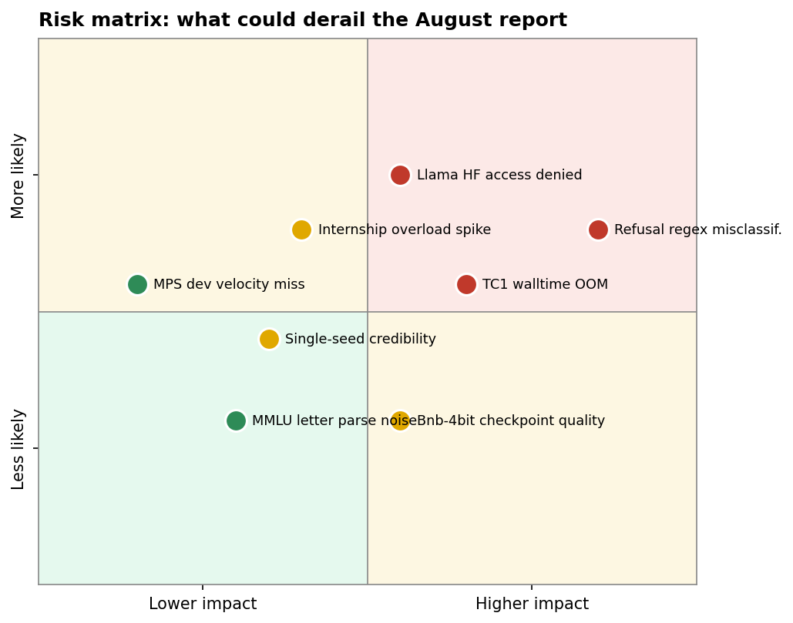

Top three
1. Refusal regex misclassification (high impact × high likelihood). Current patterns miss common Llama refusals and match anywhere in the response. Mitigation: lock D1 in Week 1 before running the matrix.
2. Llama HF access denied (high impact × medium likelihood). Kills RQ5. Mitigation: request access on TC1 in Week 1; if denied by Week 4, drop Llama and rescope to Qwen scale-sensitivity only.
3. TC1 walltime / OOM (medium impact × medium likelihood). Qwen 4B at n=400 may approach the 6h cap. Mitigation: today's matrix runner already releases memory between models via try/finally; if a job still hits walltime, halve max_samples per D4.

Other mitigations baked into the plan
- Two buffer weeks (W4 and W11) absorb runs that need redo or supervisor delays.
- Pair-level resume (--resume default) means a killed job picks up where it left off.
- Cluster work is async — internship spikes don't block GPU jobs that are already queued.
- Single seed for the headline matrix keeps cluster hours predictable; multi-seed only on the smallest pair if time.

9. Concrete actions this week
Six things to get through Week 1 (13–19 May). Treat them as a checklist.
- Mon evening: Lock D1 — expand refusal regex and restrict to response prefix. Push fix + tests.
- Tue evening: Lock D2 — add "non-responsive" bucket to HarmBench scoring. Push fix + tests.
- Wed evening: Lock D3 — "Answer: X" preference in MMLU parser. Push fix + tests.
- Thu evening: On TC1: git pull, pip install -r requirements.txt (picks up bitsandbytes + accelerate), regenerate sbatch with the new walltime/path fixes, submit smoke.
- Fri evening (or skip if gym): Request Llama HF access. Add D10 MPS branch to loader if energy permits.
- Sat morning (3–4h): Submit Qwen 0.8B × HarmBench full job (n=400). While it runs, draft your week-2 sbatch submission plan.

10. References
All linked files are in the repo at github.com/tanueihorng/llm-ethics-benchmark.
- CLAUDE.md — repo conventions for future agent sessions.
- docs/TC1_CLUSTER_RUNBOOK.md — step-by-step TC1 operational guide.
- docs/methodology.md — research methodology.
- docs/limitations.md — known v1 limitations (where D9 lives).
- ethical_benchmark/analysis/compare_quant_pairs.py — pair-delta + interpretation labels.
- configs/tc1.yaml — TC1 SLURM config (work_dir, partition, walltime).
- Pull request review (in chat history) — full list of blockers fixed and should-fix items still open.

