CODEX BUILDERS MEETUP · FIELD REPORT & TALKING POINTS
Building a repo-native agent harness
for real research work
How a dual-agent setup — OpenAI Codex and Claude Code, sharing one repository — runs a final-year LLM safety study without losing track of state, leaking data, or corrupting evidence. A grounded tour of the harness, the memory model, the workflow, and what it teaches about agent engineering in 2026.
Project CCDS25-1136 (LLM safety × 4-bit quantization) Agents Codex + Claude Code
Surface one Git repo as shared memory June 2026

The short version, before the detail: most people use a coding agent. This project engineers the environment the agents run in — the rules, the memory, the guardrails, and the verification gate — so that two different agents from two different vendors can pick up the same research project, days apart, and not break it. Everything below is grounded in real files in the repository; nothing is aspirational.

Contents

1 A primer on agent & harness engineering
A shared vocabulary first, so the rest of the report lands. If you already live in this world, skim — the one idea that matters is the ladder from prompt → context → harness.

The three eras of getting useful work out of a model
The industry has moved through three phases of practice. Each one didn’t replace the last — it wrapped it.
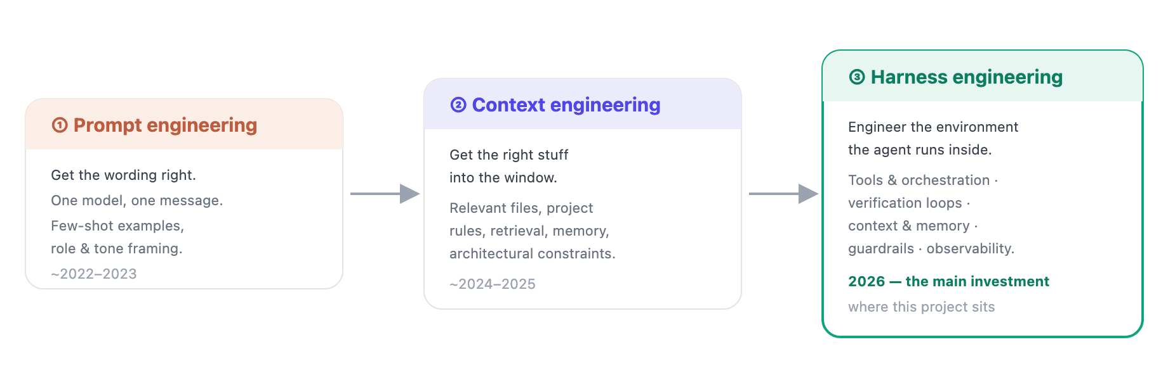
Figure 1. The maturity ladder. Harness engineering is the discipline of designing the environment, constraints and feedback loops that make a coding agent reliable at scale — the field’s primary engineering focus in 2026. This project is an example of it applied to research, not production code.

What a “harness” actually is
A production-grade agent harness is usually described as five layers. Keep these in mind — Section 4 shows that this repository implements all five, by hand, in plain files:
- Tool orchestration — what the agent can do, and how calls are routed and sequenced.
- Verification loops — plan → execute → verify. Deterministic checks and review gates before a change is trusted.
- Context & memory — what persists between turns and sessions, and where the source of truth lives.
- Guardrails — what the agent must never do: privacy, safety, integrity boundaries.
- Observability — a trail of what happened, so a human (or the next agent) can audit it.
THE POINT
Reliability comes from the harness, not from a smarter prompt. The model is a component; the harness is the system.

The primitives every modern coding agent now shares
Codex, Claude Code, Cursor, Gemini CLI and ~30 others have converged on the same handful of building blocks. This convergence is why a dual-agent setup is even possible — the two agents speak the same dialect.
PRIMITIVE | WHAT IT IS | WHERE IT LIVES
Instruction file | A “README for agents” — house rules, conventions, where to look. | AGENTS.md / CLAUDE.md
Skills | On-demand procedures the agent loads only when a task matches — keeps the base prompt small. | SKILL.md files
Subagents | Specialised, context-isolated helpers spawned for a sub-task (explore, audit, review). | TOML / config files
Hooks | Code that fires on lifecycle events (before a tool runs, before compaction, on stop). | hooks.json / config.toml
MCP | Model Context Protocol — a standard socket for plugging external tools/data into any agent. | server configs

THE THESIS OF THIS REPORT
This project doesn’t just use these primitives — it assembles them into a coherent harness whose job is research integrity: never mutate raw experimental data, never leak harmful prompt text, never let two agents drift out of sync, and never trust a claim that the repo can’t verify.

2 The Codex landscape (2025 → 2026)
Since the meetup is hosted by the Codex team, here is the lay of the land — accurate as of mid-2026 — and exactly which Codex features this repo leans on.

Codex, the short history
WHEN | MILESTONE
Apr 2025 | Codex CLI launches — an agentic coding agent in the terminal: reads the repo, edits files, runs tests, commits.
May 2025 | Codex Cloud research preview, powered by codex-1 (an o3 variant tuned for software engineering).
Dec 2025 | Skills land — a SKILL.md file under ~/.agents/skills/, auto-loaded when a task matches.
Mar 2026 | 2M+ weekly active users; Codex Security ships; positioned as an enterprise agent platform.

Codex now runs across one continuous surface — the ChatGPT web app, the CLI, a desktop app (macOS/Windows), IDE integrations, and the cloud — with limits shared across all of them. That “same agent, many doorways” model matters here: work can start in the CLI on a laptop and continue in the cloud, against the same repo.
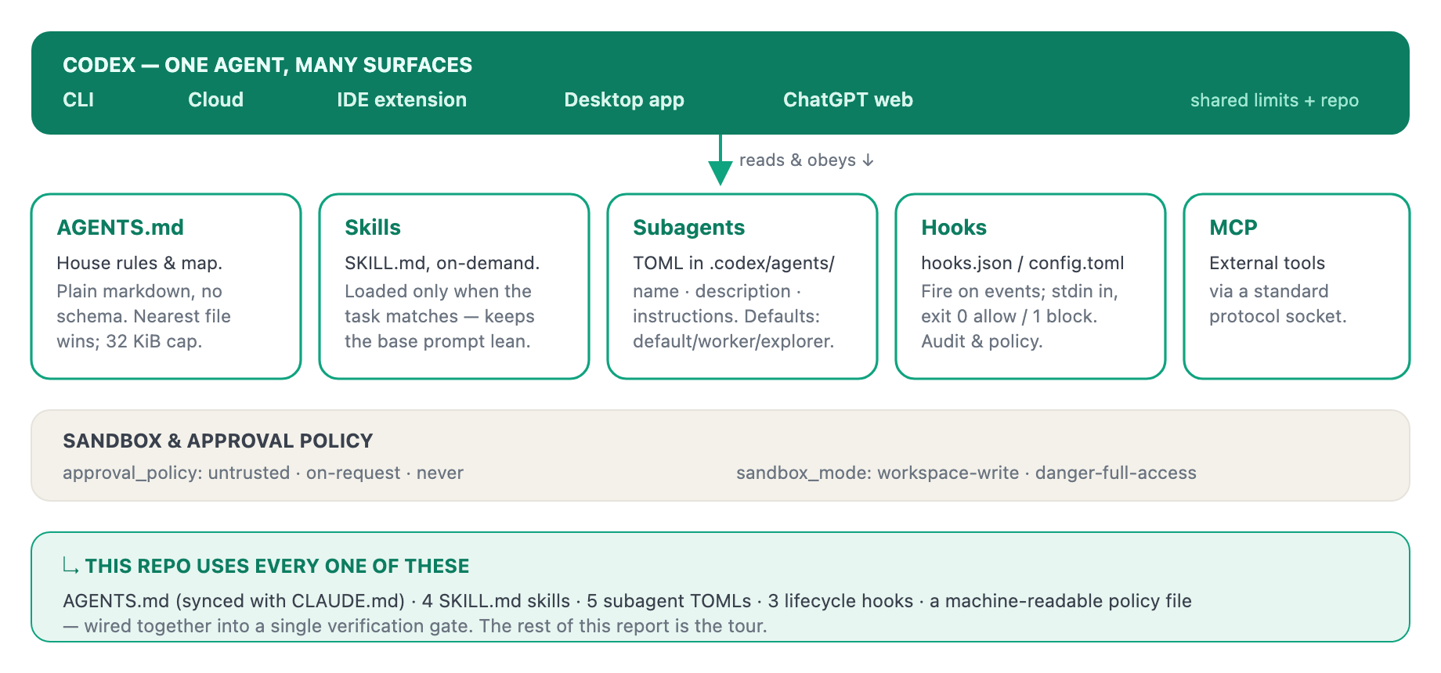
Figure 2. Codex’s extension primitives and how the repository adopts each. The instruction file, skills, subagents and hooks are exactly the surfaces this harness is built on.

AGENTS.md — the open standard underneath it all
AGENTS.md was released by OpenAI in August 2025, then handed to the Linux Foundation’s Agentic AI Foundation in late 2025. By May 2026 it was in 60,000+ repositories and read by 30+ agents (Codex, Claude Code, Copilot, Cursor, Gemini CLI, Aider, Zed, Windsurf, Devin…). It is deliberately boring: plain markdown, no required fields, no front-matter. In a monorepo the nearest file to the edited file wins.
WHY THIS MATTERS FOR A DUAL-AGENT SETUP
Because AGENTS.md is a shared standard, Codex and Claude Code read the same house rules. This repo keeps a CLAUDE.md for Claude and an AGENTS.md for Codex that are byte-identical below the title line — and the harness fails the build if they ever drift apart. One source of rules, two readers.

Codex subagents & hooks — the exact mechanisms used here
Subagents .codex/agents/*.toml — each TOML file defines one custom agent with name, description, developer_instructions. Codex spawns them in parallel, isolates their context, and collects results into one answer. Global knobs: max_threads (default 6) and max_depth (default 1 — no deep nesting). Trade-off: more tokens, bought for cleaner separation.
Hooks .codex/hooks.json — lifecycle handlers configured per-repo. A hook declares a matcher and a command; it receives data on stdin and signals via exit code (0 allow, 1 block). Used for audit logging and policy enforcement.
// .codex/hooks.json — the real shape of a Codex hook
{
"PreToolUse": [{ "matcher": "Bash|Edit|Write|apply_patch",
"hooks": [{ "type": "command",
"command": "python3 .codex/hooks/guard_artifact_paths.py" }] }],
"PreCompact": [ /* refresh the handoff before compaction */ ],
"Stop": [ /* run a lightweight finish check on turn end */ ]
}

That is precisely the set of three hooks this project ships. They are reminders, not blockers — the authoritative gate is a separate command (Section 4). Hooks nudge; the gate decides.

3 The research project this harness serves
You can’t appreciate the harness without knowing what it protects. The agents aren’t writing a web app — they’re running a controlled scientific experiment where the data must stay trustworthy.
When you shrink a language model to 4-bit to make it cheap to run, does it become less safe — or just less capable? And can you even tell the two apart?
That is the research question of CCDS25-1136, a final-year project at NTU’s College of Computing and Data Science. The study takes three small instruction-tuned models, makes a 4-bit (NF4) copy of each from identical weights, and measures both copies along three axes — then asks whether any safety change is real alignment movement or just collateral capability loss.
MODEL PAIR | BASELINE → 4-BIT | HARMBENCH (SAFETY) | XSTEST | MMLU (CAPABILITY)
Qwen 1.7B | Qwen3-1.7B → NF4 | harmful compliance (ASR) | benign refusal | 6-subject accuracy
Qwen 4B | Qwen3-4B → NF4 | ASR | refusal | accuracy
Llama 3.2 3B | Llama-3.2-3B-Instruct → NF4 | ASR | refusal | accuracy
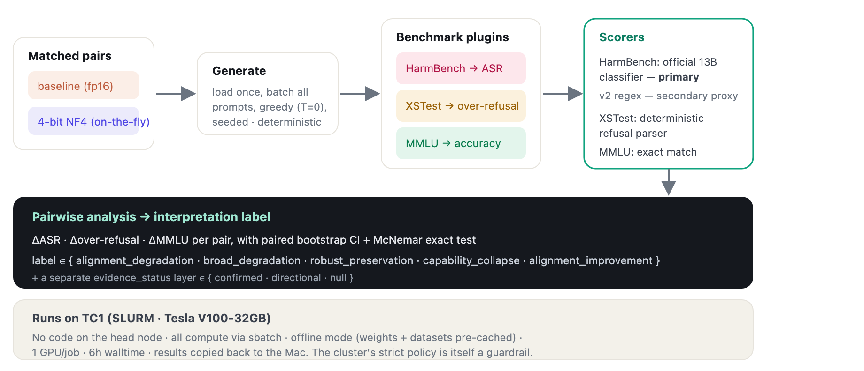
Figure 3. The experimental pipeline. Each model is loaded once and run through three benchmark plugins; the HarmBench scorer is the official 13B classifier (primary), with a fast regex kept as a secondary proxy. Deltas between a pair feed a labelled interpretation plus a separate evidence-strength layer.

The finding — and why it’s the harness’s best demo
The project’s headline result is also the cleanest illustration of why the harness exists. The first-pass HarmBench scorer was a fast regex. Validating it against the official 13B HarmBench classifier (run as a judge model on the cluster) showed the regex over-counts attack success — agreement was poor on the Qwen pairs (Cohen’s κ ≈ 0.19–0.37) and only moderate on Llama (κ ≈ 0.69–0.79).
DECISION D16 · THE MOMENT THE HARNESS EARNED ITS KEEP
Switching to the judge as the primary scorer moved the study’s only statistically significant safety regression from Qwen 4B (under the regex) to Qwen 1.7B (under the judge). Under the judge, 4-bit quantization never reduces harmful compliance in any pair. A scoring layer changed the conclusion — but because raw model outputs are immutable evidence, nothing had to be re-run. The correction was a new sidecar, not a mutation.

The authoritative results (judge-primary)
PAIR | ΔASR (JUDGE) | EVIDENCE | ΔMMLU | LABEL
Qwen 1.7B | +0.055 ↑ harm | confirmed · McNemar p=0.027 | −0.087 ↓ cap | broad_degradation
Qwen 4B | +0.025 | directional · n.s. (p=0.18) | −0.003 | alignment_degradation
Llama 3.2 3B | ≈ 0.000 | null | −0.043 ↓ cap | broad_degradation
The label is never altered by significance; a second “evidence_status” layer carries statistical confidence separately (Decision D19). That separation is itself a guardrail against over-claiming.

4 The repo-native harness, layer by layer
This is the centrepiece. Everything an agent needs to work safely on this project is a file in the repo — versioned, diffable, reviewable. The harness turns the project’s prose rules into machine-checkable contracts.

The repository at a glance
Before the control plane, here is the whole project laid out by role — four zones: the agent operating system (the harness itself), the research core (the science), the inputs & compute, and the evidence & deliverables. The harness governs the left; experimental evidence flows one-way into the right and is never mutated.
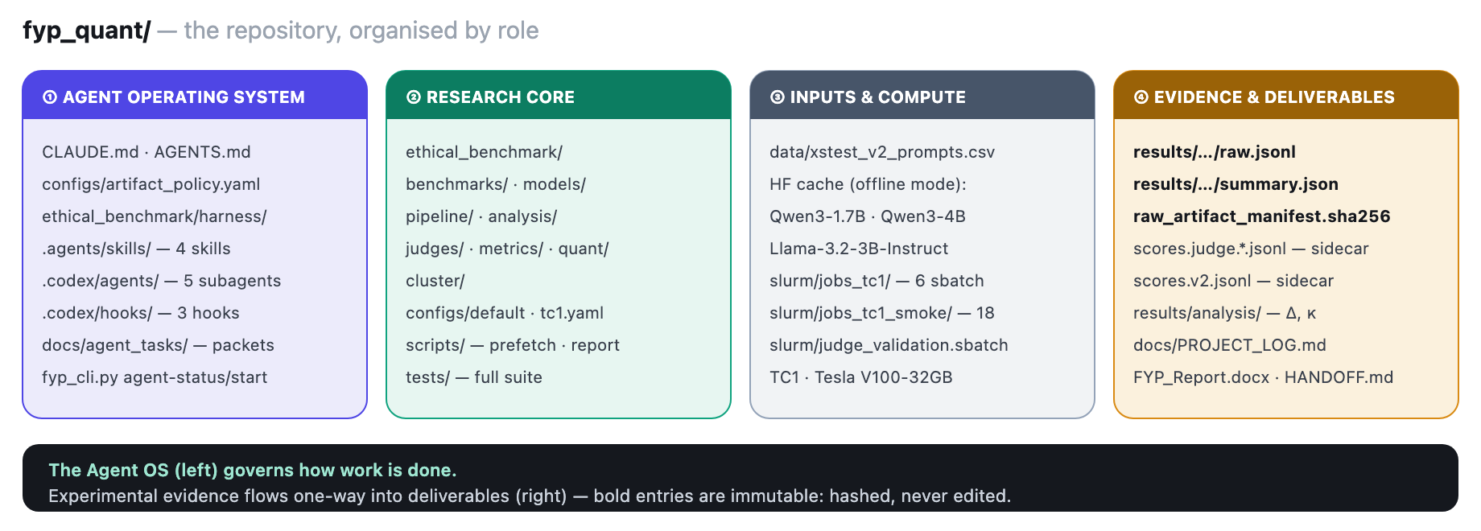
Figure 4. The repository, by role. Four functional zones, every entry a real path. The agent operating system (harness) wraps the research core; raw outputs in the evidence zone are hashed and immutable, and corrections are written as additive sidecars rather than edits.

The harness control plane
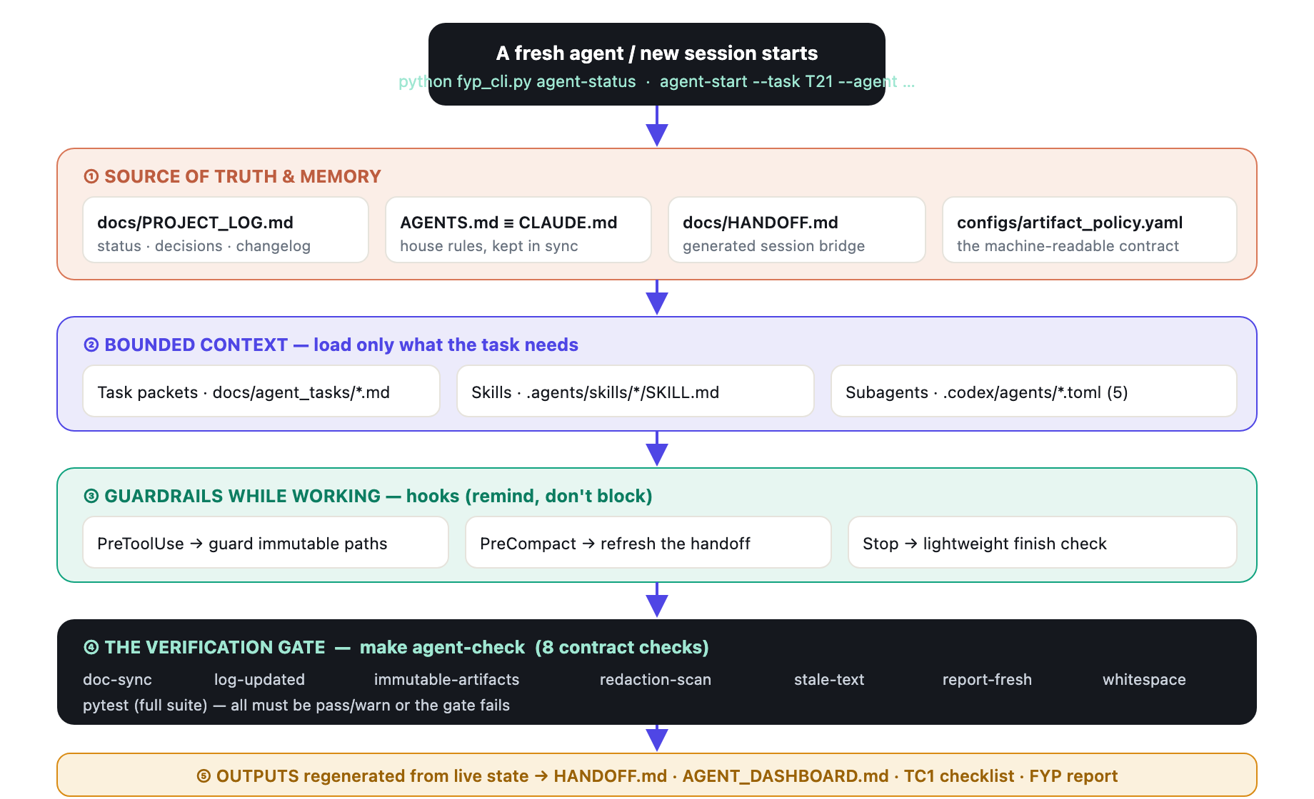
Figure 5. The harness control plane. A session flows top-to-bottom: orient from the source of truth, pull in only the bounded context the task needs, work under hook-level reminders, then pass through one authoritative verification gate before regenerating the hand-off artifacts. Every box is a real file or command.

Layer ① — One source of truth, enforced
The rule the whole project hangs on: docs/PROJECT_LOG.md is the only file that records “what’s happening now.” Every other doc is reference or archive. Every change to the repo appends one row to its changelog — When | Files | Change | Why | Report? | Who — newest first. The Who column is literally how you see the dual-agent split (Section 6). This is the harness’s observability layer.

Layer ② — Bounded context instead of a giant prompt
Rather than one bloated instruction file, the harness keeps the base lean and pulls in detail on demand:
MECHANISM | FILE | PURPOSE
Task packet | docs/agent_tasks/T21-…md | A small, self-contained brief for one task: objective, likely files, what’s allowed, what’s forbidden, done-criteria.
Skill | .agents/skills/…/SKILL.md | A reusable procedure loaded only when the work matches — auditing report claims, adding a second judge, etc.
Startup packet | agent-start --task --agent | Assembles live status + the chosen task packet + the chosen subagent profile into one focused briefing.

Four skills exist today — fyp-harness-maintenance, fyp-report-audit, fyp-second-judge, fyp-meetup-brief — each with a clear scope, start step, guardrails, and finish step.

Five context-isolated subagents
The five .codex/agents/*.toml profiles are all read-only reviewers by design — they audit, they don’t mutate, and the main agent runs the gate:
- fyp-artifact-guardian — evidence-chain auditor: raw-artifact immutability, the SHA-256 manifest, redaction leaks.
- fyp-judge-reviewer — reviews the HarmBench judge layer; confirms the official classifier stays primary.
- fyp-report-auditor — reviews report prose for stale claims, judge-vs-regex mistakes, missing verification.
- fyp-tc1-ops — cluster-safety reviewer: compute routed via sbatch, offline env vars preserved.
- fyp-meetup-story — turns repo evidence into a human-readable workflow narrative.
WHY ISOLATE THEM?
An auditor with a clean, narrow context gives a sharper second opinion than the same model carrying the whole working session in its head.

Layer ④ — The gate: make agent-check
This is the verification loop made concrete. Eight checks, each reading the same artifact_policy.yaml. Any fail stops the build:
CHECK | FAILS WHEN…
doc-sync | AGENTS.md and CLAUDE.md drift apart below the title line.
log-updated | The repo has changes but PROJECT_LOG.md isn’t among them — no silent edits.
immutable-artifacts | A raw raw.jsonl/summary.json hash no longer matches the manifest (tolerates absent files in fresh clones, fails on mutation).
redaction-scan | Raw prompt/response/behavior text leaks into any doc, hook, or agent profile.
stale-text | Outdated claims survive (e.g. “results pending”, an old scorer still called primary).
report-fresh | A report-worthy source changed but the report docx wasn’t regenerated.
whitespace | git diff --check finds trailing-whitespace noise.
pytest | Any test in the full suite fails.

THE DETAIL THAT SELLS IT
There’s a test that the harness itself works (make harness-eval): it builds a tiny throwaway repo, deliberately breaks each rule — mutates a raw artifact, drifts the two instruction files, plants a redaction leak — and asserts the gate catches each one. The guardrails are themselves under test.

5 Memory: state lives in the repo, not the chat
The single biggest idea to communicate at the meetup. Chat history is volatile and private to one agent. This project pushes durable state out of the conversation and into versioned files any agent can read.
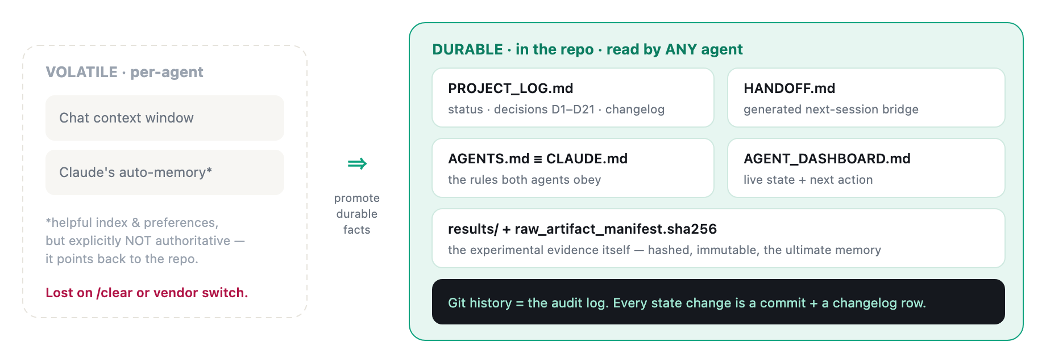
Figure 6. Two tiers of memory. Conversation context and an agent’s private memory are convenient but volatile and vendor-specific. Everything that must survive a /clear, a new machine, or a switch between Codex and Claude is promoted into versioned repo files — with the experimental results, hashed and immutable, as the deepest layer.

How the auto-memory and the repo cooperate
The agent does keep a small private memory (user preferences, a project-state snapshot, file pointers). But it is deliberately framed as an index, not an authority: it carries warnings like “the source of truth is always the repo — don’t trust memory numbers.” If a memory note names a file or a result, the rule is to verify it against the repo before acting. The harness even scans for stale prose so out-of-date claims can’t quietly persist.
THE ONE-LINER FOR THE MEETUP
“My agents’ memory isn’t in the chat — it’s in the repository. PROJECT_LOG.md is the brain, Git is the audit log, and a hashed manifest makes the raw data tamper-evident. A brand-new session — even on a different vendor’s agent — reads four files and is fully oriented.”

6 The dual-agent workflow (Codex & Claude)
Two agents, two vendors, one repo. They don’t talk to each other directly — they collaborate through the repository, the same way two humans collaborate through a shared codebase and a changelog.
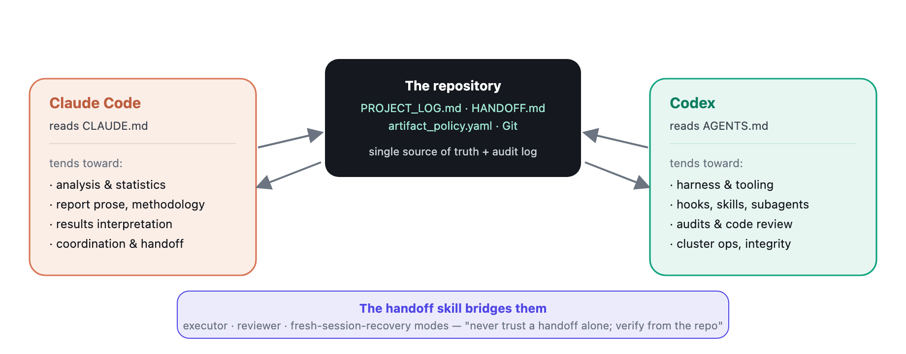
Figure 7. Collaboration through the repo, not through a channel. Each agent reads its own instruction file (kept identical), does the kind of work it’s best placed for, and records every change in the shared changelog. The Who column makes the division of labour visible and auditable.

How the labour actually divided — from the changelog
This isn’t a theory; it’s visible in the Who column of the changelog:
CLAUDE — THE ANALYST & WRITER | CODEX — THE HARNESS BUILDER & AUDITOR
Judge-validation analysis and the McNemar/CI evidence layer; the two-layer reporting scheme; report prose; drafting the supervisor email; refreshing handoffs; landing and verifying Codex’s uncommitted work before committing it. | The entire on-demand agentic layer (skills, subagents, hooks); the architecture diagrams; converting in-place rescoring into immutable sidecars after a near-miss; pre-push hardening audits; recording cluster submissions and the QoS concurrency discovery.

A REAL HANDOFF, CAPTURED IN ONE CHANGELOG ROW
On one occasion Claude committed Codex’s uncommitted work for it — syncing AGENTS.md/CLAUDE.md, applying a report appendix edit, regenerating the docx — but only after verifying the diffs matched what Codex’s own changelog row claimed. One agent implements, the other reviews against the recorded intent and merges. Trust, but verify from the repo.

Why split by vendor at all?
Two honest reasons, both worth saying out loud: (1) different agents have different strengths and quotas, and routing work to the better-suited one is just good economics; (2) a second agent is a second pair of eyes — a reviewer that didn’t write the code catches what the author misses. The harness is what makes the split safe: because all state is in the repo and the gate is vendor-neutral, it genuinely doesn’t matter which agent picks up the work next.

7 A session, start to finish
Concretely: what happens between an agent opening this repo and closing it cleanly. This is the demo you’d run live.
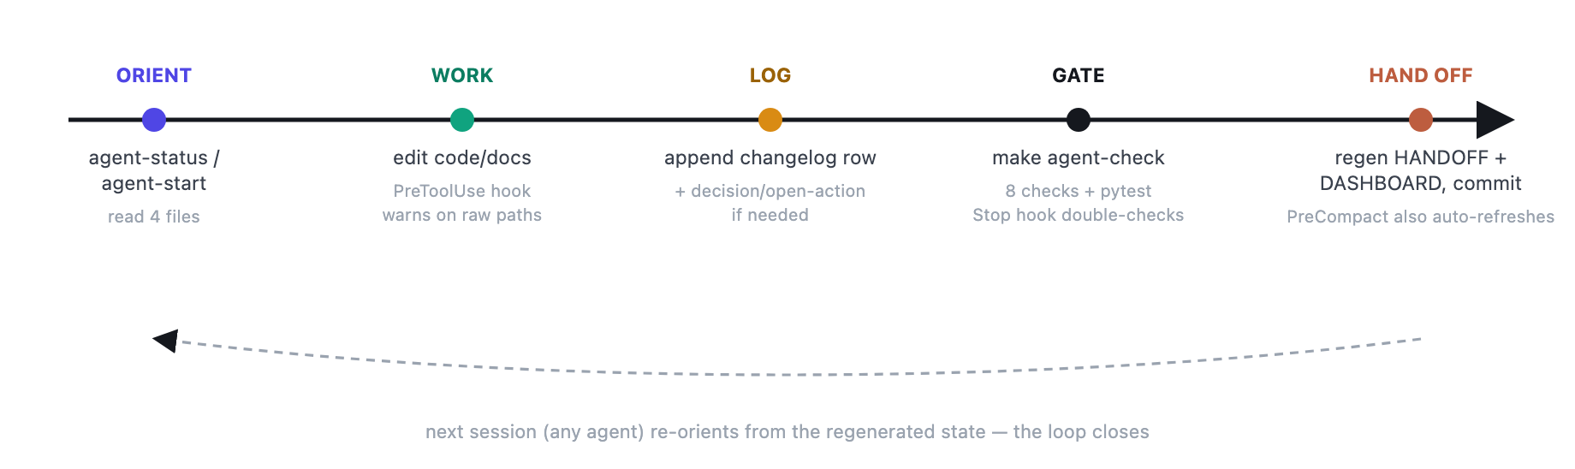
Figure 8. The session loop. Orient → work (under hook reminders) → log → pass the gate → hand off. The outputs of one session are the inputs of the next, which is what lets a different agent resume cleanly.

The immutable-evidence rule, illustrated
The strongest single story in this whole system is how it handled changing the answer without corrupting the data:
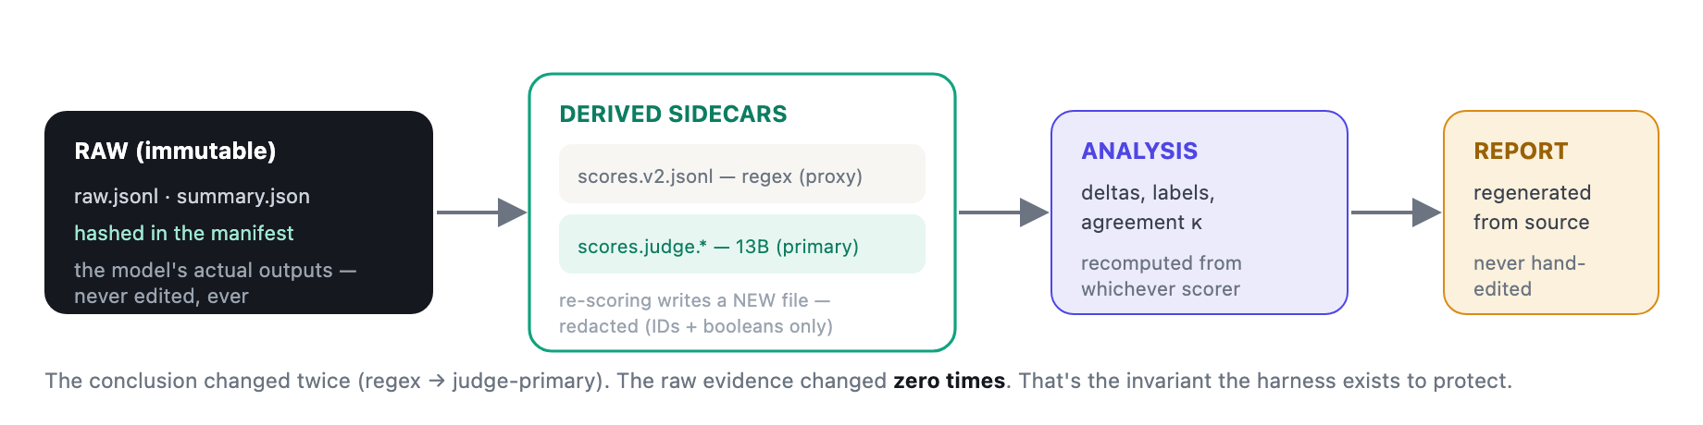
Figure 9. Immutable evidence, mutable interpretation. Raw model outputs are hashed and frozen. Every scoring change is an additive, redacted sidecar; analysis and the report are always regenerated from sources. You can revise the answer as many times as the science demands without ever touching — or being able to silently corrupt — the data.

8 How to explain it to peers
Ready-to-use framing for the room. Lead with the idea, back it with one concrete file, and let people pull on the thread.

The 30-second version
SAY THIS
“I run two coding agents — Codex and Claude Code — on the same research repo. Instead of trusting either one’s memory, I made the repository the memory: one log file is the source of truth, the raw experimental data is hashed and immutable, and there’s a single make agent-check gate that fails if the two agents drift, if data gets mutated, or if a harmful prompt leaks into a doc. It’s harness engineering applied to research integrity — built entirely out of Codex’s own primitives: AGENTS.md, skills, subagents, and hooks.”

Five talking points, each with a concrete hook
- Memory lives in the repo. “A new session reads four files and is oriented.” → open PROJECT_LOG.md and HANDOFF.md.
- Rules are executable, not just prose. “Prose rules rot. I compiled mine into checks.” → run make agent-check; show artifact_policy.yaml.
- Two vendors, one standard. “AGENTS.md ≡ CLAUDE.md, enforced by a drift check.” → show doc-sync failing on a deliberate edit.
- Evidence is immutable. “I changed the conclusion twice and never touched the data.” → show the sidecar files + the SHA manifest.
- The guardrails are tested. “My harness has a test suite that proves it catches bad states.” → run make harness-eval.

A 3-minute live demo, if you get a laptop
- python fyp_cli.py agent-status — show how the repo introduces itself.
- Open PROJECT_LOG.md §4 changelog — point at the Who column alternating between Claude and Codex.
- Make a deliberate bad edit (drift CLAUDE.md, or add “RESULTS PENDING”) → run make agent-check → watch the relevant check go red.
- Show .codex/hooks.json and one subagent TOML — “stock Codex features; I just composed them.”
- Close with the Figure 9 story: the judge correction that moved the headline result without re-running a single experiment.

Anticipated questions — and honest answers
THEY’LL ASK | ANSWER
“Isn’t this over-engineering for a student project?” | The over-engineering is the risk control: it’s scientific data. The harness is small (a policy file, a check script, a few generated docs) and it has already caught a real near-miss (in-place rescoring) and a scorer error that changed the headline finding.
“Why two agents instead of one good one?” | Different strengths and quotas, plus a genuine second reviewer. The harness makes the choice of agent irrelevant to correctness — that’s the point.
“Do the hooks enforce anything?” | No — hooks are reminders by design. The authoritative gate is make agent-check, run explicitly. Keeping enforcement in one visible place is deliberate.
“How is this different from a good README + CI?” | It largely is that — which is the point. The novel part is treating agents as first-class repo citizens: bounded task packets, context-isolated reviewer subagents, an immutable-evidence contract, and a vendor-neutral instruction standard, all checked together.

9 Appendix: command & file map
The cheat-sheet to keep open during the event.

The harness commands
COMMAND | DOES
python fyp_cli.py agent-status | Live repo status for a fresh agent — git state, log freshness, open actions, next step.
agent-start --task T21 --agent … | Assemble a focused startup packet for one task + one subagent.
make agent-check | The verification gate — 8 contract checks + full pytest.
make harness-eval | Prove the harness itself catches broken states.
make agent-handoff | Regenerate HANDOFF.md / AGENT_DASHBOARD.md from live state.
make report | Rebuild the FYP report docx from its build script (never hand-edited).

Where everything lives
PATH | ROLE
docs/PROJECT_LOG.md | Single source of truth — status, decisions, changelog.
CLAUDE.md · AGENTS.md | Synced house rules (Claude / Codex & others).
configs/artifact_policy.yaml | Machine-readable contract behind every check.
.agents/skills/*/SKILL.md | Four on-demand skills.
.codex/agents/*.toml | Five context-isolated reviewer subagents.
.codex/hooks.json + hooks/*.py | Three lifecycle hooks (PreToolUse / PreCompact / Stop).
docs/agent_tasks/*.md | Bounded task packets.
ethical_benchmark/harness/agent.py | The harness engine — status, checks, doc generation.
results/…/raw.jsonl + manifest | Immutable evidence + its hash ledger.
results/…/scores.judge.*.jsonl | Redacted derived sidecars (the primary HarmBench scorer).

The vocabulary, one line each
TERM | MEANING
Harness | The engineered environment around an agent: tools, verification, memory, guardrails, observability.
AGENTS.md | Open, markdown instruction standard read by 30+ agents; OpenAI-originated, now Linux-Foundation governed.
Skill | A SKILL.md procedure loaded on demand when a task matches.
Subagent | A context-isolated specialist spawned for a sub-task; defined in TOML for Codex.
Hook | Code fired on a lifecycle event (pre-tool, pre-compact, stop) for policy and logging.
MCP | Model Context Protocol — a standard way to attach external tools/data to an agent.
Immutable artifact | Raw experimental output that may never be edited; corrections go to additive sidecars.
Verification gate | One explicit command that must pass before work is trusted.

10 Sources
External facts about Codex, AGENTS.md and harness engineering are drawn from the following; project facts are drawn directly from the repository.
- OpenAI Developers — Codex Subagents (developers.openai.com/codex/subagents)
- OpenAI Developers — Codex Advanced Configuration: hooks, sandbox, config.toml
- OpenAI — Introducing the Codex app
- Wikipedia — Codex (AI agent): timeline, surfaces, skills, user numbers
- AGENTS.md — official site
- Morph — AGENTS.md spec guide (2026): format, governance, adoption
- Simon Willison — Use subagents and custom agents in Codex
- Faros AI — Harness Engineering: Making AI Coding Agents Work in 2026
- Augment Code — Harness Engineering for AI Coding Agents
Project repository — docs/PROJECT_LOG.md CLAUDE.md / AGENTS.md configs/artifact_policy.yaml ethical_benchmark/harness/agent.py .codex/ .agents/skills/ docs/AGENTIC_WORKFLOW.md.

