1. Write a program to style content using different CSS selectors?

<!DOCTYPE html>

<html lang="en">

<head>

<meta charset="UTF-8">

<meta name="viewport" content="width=device-width, initial-scale=1.0">

<title>Document</title>

<style>

h1 {

color: blue;

}

p.intro {

font-style: bold;

}

#my-paragraph {

font-style: italic;

color: grey;

}

ul li:nth-child(odd) {

background-color: lightgrey;

}

ul li:nth-child(even) {

background-color: white;

}

</style>

</head>

<body>

<h1>This is a heading</h1>

<p class="intro">This ia a paragraph with the class "intro"</p>

<p id="my-paragraph">This is a paragrapgh with the id "my-paragraph".</p>

<ul>

<li>Item 1</li>

<li>Item 2</li>

<li>Item 3</li>

</ul>

</body>

</html>

**Output :**

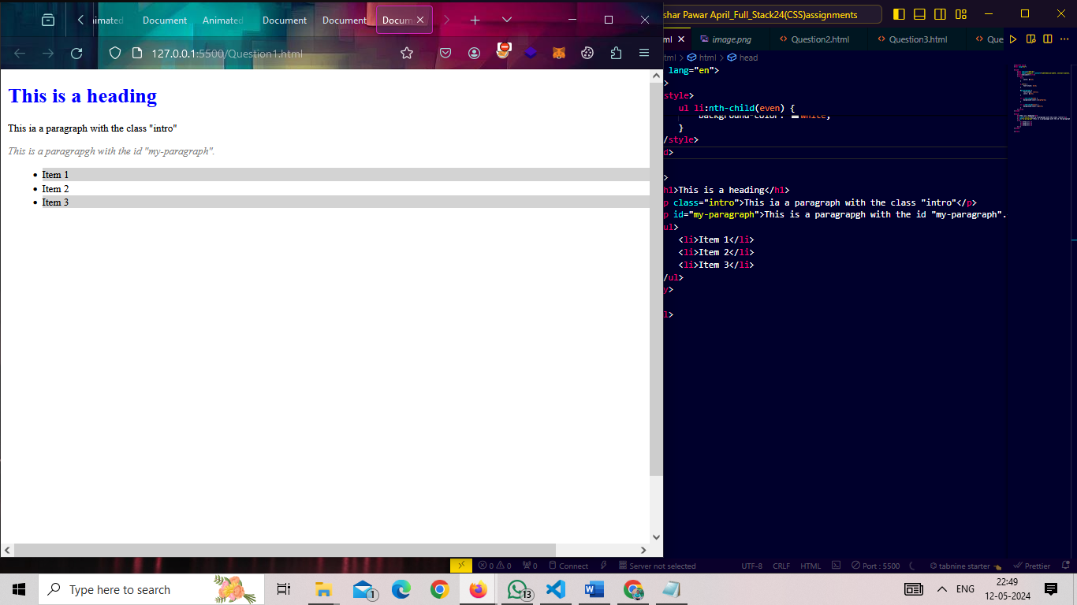

1. Write a program to show different background properties and display course information using different font properties in css?

<!DOCTYPE html>

<html lang="en">

<head>

<meta charset="UTF-8">

<meta name="viewport" content="width=device-width, initial-scale=1.0">

<title>Document</title>

<style>

h1.color {

background-color: yellow;

}

h1.image {

background-image: url('image.png');

}

h1.gradient {

background-image: linear-gradient(to right, red, yellow);

}

h1.repeat {

background-image: url('pattern.jpg');

background-repeat: repeat;

}

h1.position {

background-image: url('image.png');

background-position: center;

}

</style>

</head>

<body>

<h1 class="color">Background Color</h1>

<h1 class="image">Background Image</h1>

<h1 class="gradient">Background Gradient</h1>

<h1 class="repeat">Background Repeat</h1>

<h1 class="position">Background Position </h1>

<br>

<div>

<h1><u>Introduction to CSS</u>

</h1>

<p>Instructor: john smith</p>

<p>Duration:4 weeks</p>

<p>Level: Begineer</p>

<pre>This course provide an introduction to CSS, covering basic syntax,selectors, and styling properties.</pre>

</div>

</body>

</html>

**Output :**

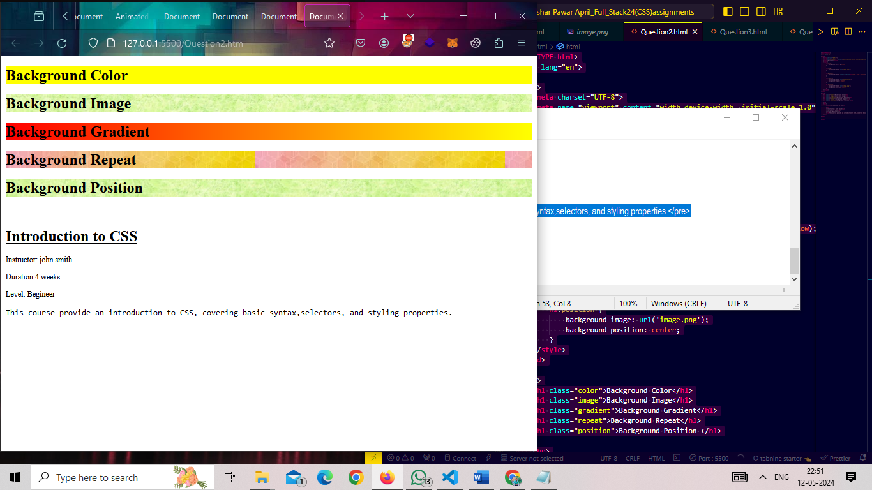

1. Write a program to display courses in a tile using flexbox?

<!DOCTYPE html>

<html lang="en">

<head>

<meta charset="UTF-8">

<meta name="viewport" content="width=device-width, initial-scale=1.0">

<title>Document</title>

<style>

.courses {

background-color: white;

display: flex;

align-items: stretch;

margin: 20px;

}

.course {

background-color: #f7f5f5;

align-items: stretch;

margin: 10px;

padding: 20px;

height: 200px;

width: 350px;

font-family: Arial;

}

p {

color: rgb(126, 126, 126);

}

</style>

</head>

<body>

<div class="courses">

<div class="course">

<h2>HTML</h2>

<p>The HyperText Markup Language or HTML is the standard markup language for documents deigned to be displayed in a web browser.It defines the meaning and structure of web conetnt.</p>

</div>

<div class="course">

<h2>CSS</h2>

<p>Cascading Style Sheets(CSS) is a style sheets language used for descriping the presentation of a document written in a markup language such as HTML or XML.</p>

</div>

<div class="course">

<h2>Bootstrap</h2>

<p>Bootstrap is an HTML, CSS and JS library that focuses on simplifying the development of informative web pages (as opposed to web applications).</p>

</div>

<div class="course">

<h2>JavaScript</h2>

<p>JavaScript is a high-level, often just-in-time compiled language that conforms to hteECMAScript standard. It has dynamic typing, prototype-based object-orientation, and first-class function.</p>

</div>

</div>

</body>

</html>

**Output:** 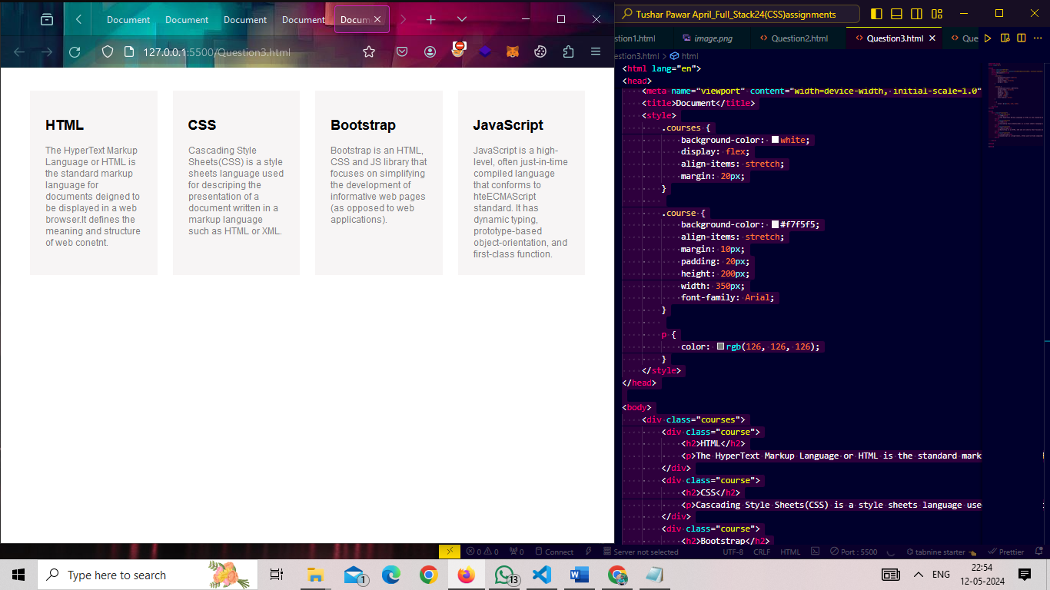

1. Write a program to design standard web layout using GRID?

<!DOCTYPE html>

<html lang="en">

<head>

<meta charset="UTF-8">

<meta name="viewport" content="width=device-width, initial-scale=1.0">

<title>Grid Layout</title>

<style>

body {

margin: 0;

font-family: Arial, sans-serif;

}

.container {

display: grid;

grid-template-columns: 1fr 3fr 3fr;

grid-template-rows: auto;

gap: 20px;

padding: 20px;

}

.sidebar {

background-color: #f0f0f0;

padding: 20px;

}

.content {

background-color: #fff;

padding: 20px;

}

header,

footer {

grid-column: 1;

background-color: #333;

color: #fff;

padding: 10px 20px;

}

</style>

</head>

<body>

<header>

<h1>ExcelR FullStack APR 2024</h1>

</header>

<div class="container">

<div class="sidebar">

<h2>Sidebar</h2>

<p> full-stack developer </p>

</div>

<div class="content">

<h2>Front End Developer</h2>

<p>Full-stack developers may be creative, graphically inclined, internet- and tech-savvy, and have excellent attention to detail. Front-end development is the process of creating the interface of a website. It entails coding details like drop-down

menus, fonts, colors, and page layouts. Full-stack developers should also know how to work with front-end technologies like HTML, CSS, and scripting languages such as JavaScript to make websites and applications visually viable and appealing.

</p>

</div>

<div class="sidebar">

<h2>Sidebar</h2>

<p>Back-end development skills entail using back-end programming languages like Python, PHP, Ruby on Rails, and CakePHP and understanding how algorithms and business logic work.Database management skills are required for full-stack developers,

though it is part of the skills needed for back-end web development. </p>

</div>

</div>

<footer>

<p>© 2024</p>

</footer>

</body>

</html>

**Output :**

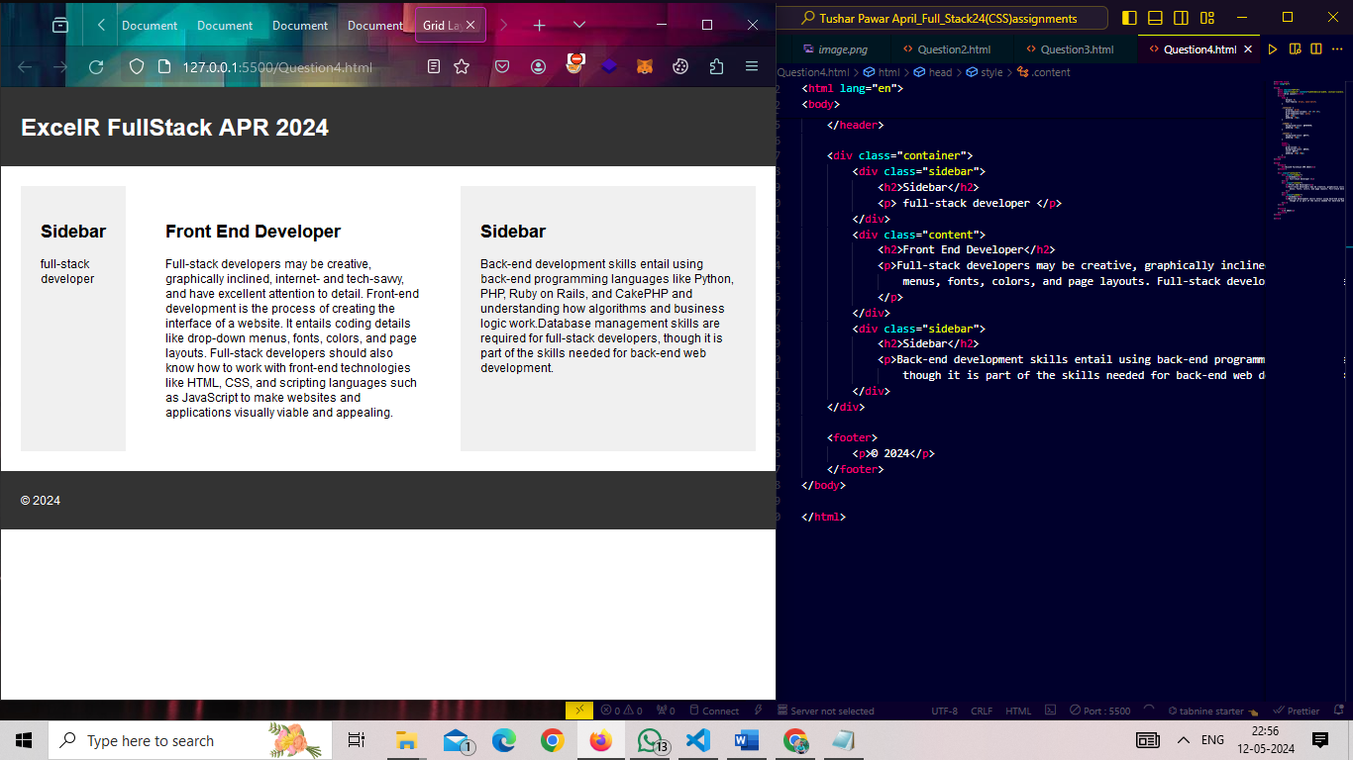

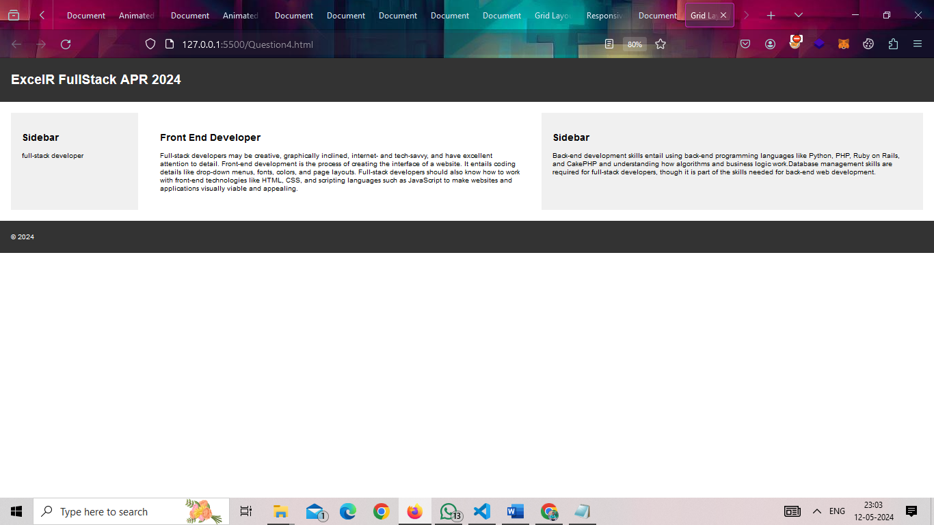

1. Write a program to create responsive menu using media queries css?

<!DOCTYPE html>

<html lang="en">

<head>

<meta charset="UTF-8">

<meta name="viewport" content="width=device-width, initial-scale=1.0">

<title>Responsive Menu</title>

<style>

.menu {

display: flex;

justify-content: space-between;

background-color: #333;

color: #fff;

padding: 10px;

font-family: Arial, sans-serif;

}

.menu ul {

list-style-type: none;

margin: 0;

padding: 0;

display: flex;

}

.menu li {

margin-right: 20px;

}

.menu a {

text-decoration: none;

color: #fff;

padding: 5px 10px;

transition: background-color 0.3s;

}

.content {

background-color: rgb(221, 220, 220);

height: 700px;

}

@media screen and (max-width: 768px) {

.menu {

flex-direction: column;

}

.menu ul {

flex-direction: column;

align-items: center;

}

.menu li {

margin-right: 0;

margin-bottom: 10px;

}

}

</style>

</head>

<body>

<div class="menu">

<div class="logo">Logo</div>

<ul>

<li><a href="#">Home</a></li>

<li><a href="#">About</a></li>

<li><a href="#">Services</a></li>

<li><a href="#">Contact</a></li>

</ul>

</div>

<div class="content">

<h1></h1>

</div>

</body>

</html>

**Output:**

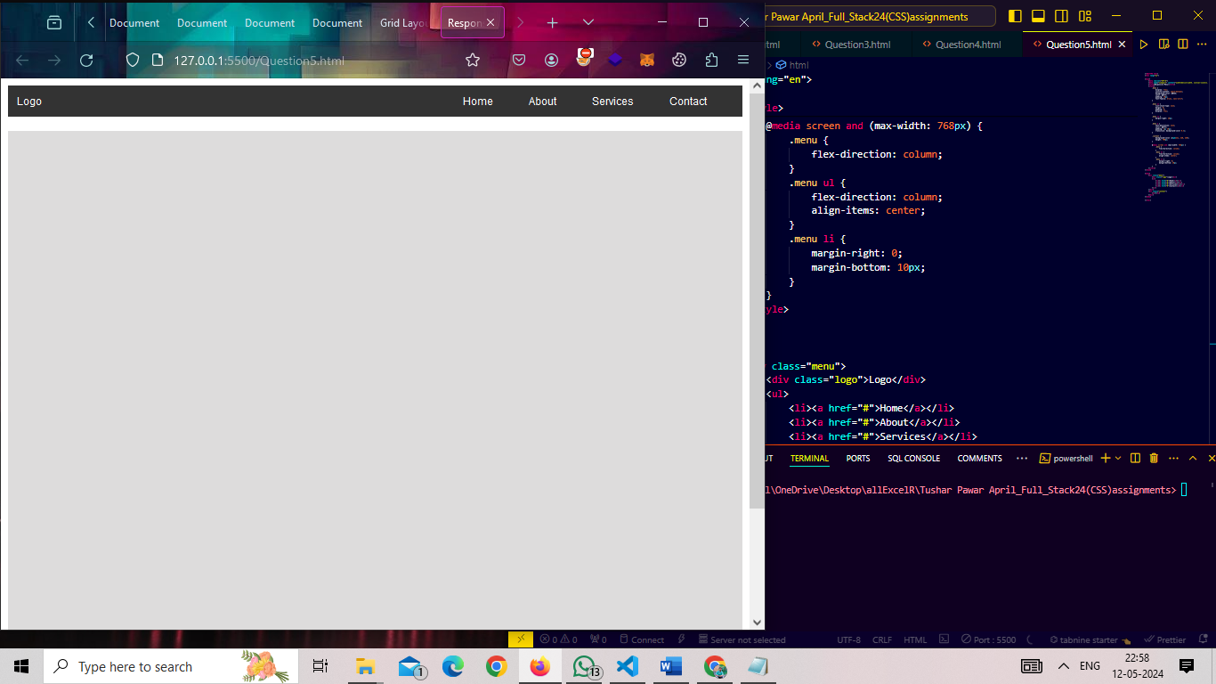

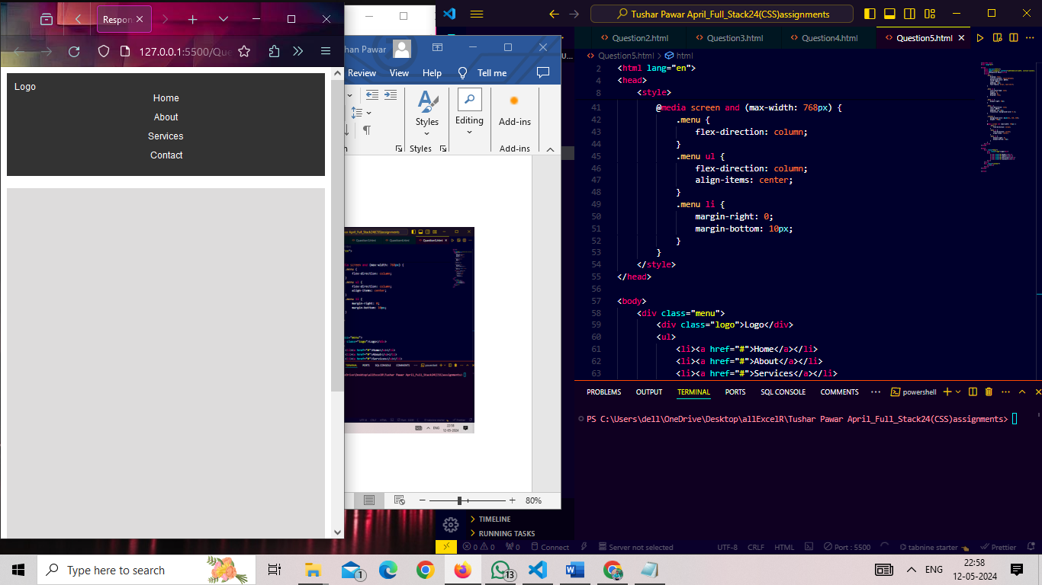

1. Write a program to animate a tile in CSS?

<!DOCTYPE html>

<html lang="en">

<head>

<meta charset="UTF-8">

<meta name="viewport" content="width=device-width, initial-scale=1.0">

<title>Document</title>

<style>

div {

width: 100px;

height: 150px;

background-color: aqua;

font-weight: bold;

position: relative;

animation-name: demo;

animation-duration: 10s;

animation-fill-mode: forward;

margin-left: 500px;

animation: demo 5s linear 2s infininte alternate;

}

@keyframes demo {

from {

left: -500px;

}

to {

left: 300px;

}

0% {

background-color: aqua

}

25% {

background-color: blue

}

50% {

background-color: violet

}

100% {

background-color: black

}

}

#linear {

animation-timing-function: linear;

}

#ease {

animation-timing-function: ease;

}

#easein {

animation-timing-function: ease-in;

}

#easeout {

animation-timing-function: ease-out;

}

#easeinout {

animation-timing-function: ease-in-out;

}

</style>

</head>

<body>

<div id="linear">

Linear

</div>

<div id="ease">Ease</div>

<div id="easein">Ease-in</div>

<div id="easeourt">ease-out</div>

<div id="easeinout">ease-in-out</div>

</body>

</html>

**Output :**

