* Perform the following data visualization operations using Tableau on Adult and Iris datasets.
  1. 1D (Linear) Data visualization.
  2. 2D (Planar) Data Visualization.
  3. 3D (Volumetric) Data Visualization.
  4. Temporal Data Visualization.
  5. Multidimensional Data Visualization.
  6. Tree/ Hierarchical Data visualization.
  7. Network Data visualization.

Connect to Dataset.

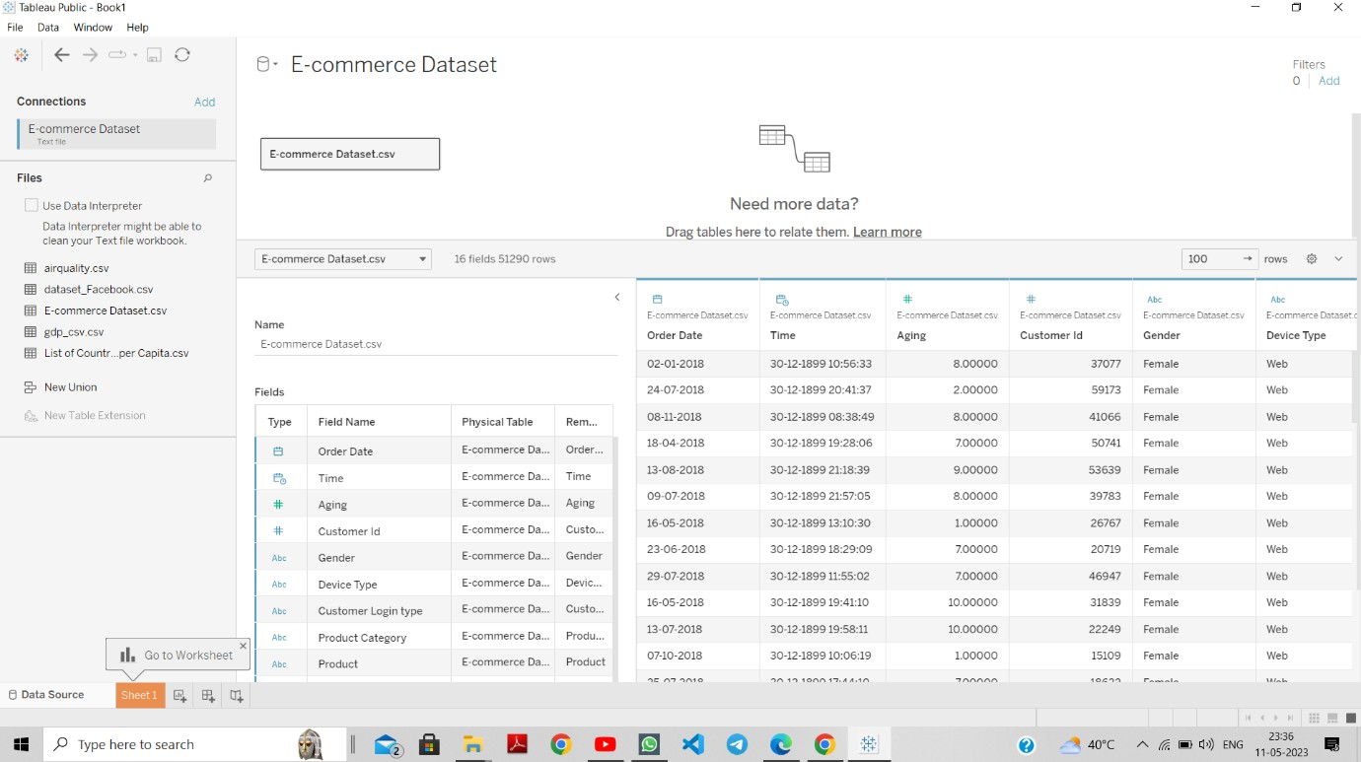

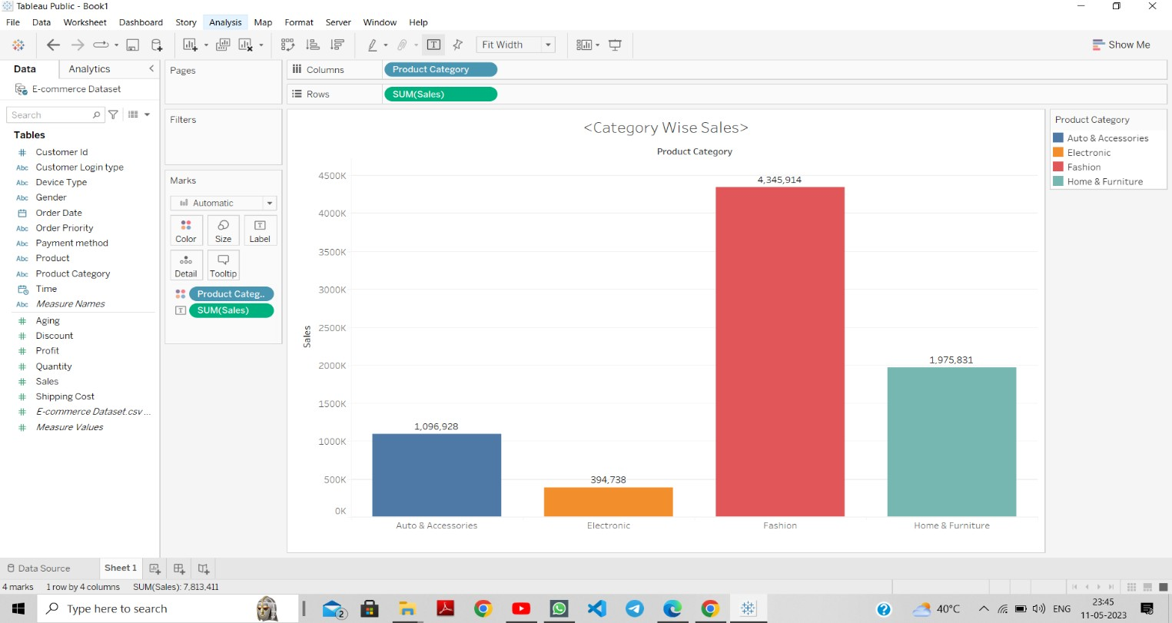

b. 2D (Planar) Data Visualization.

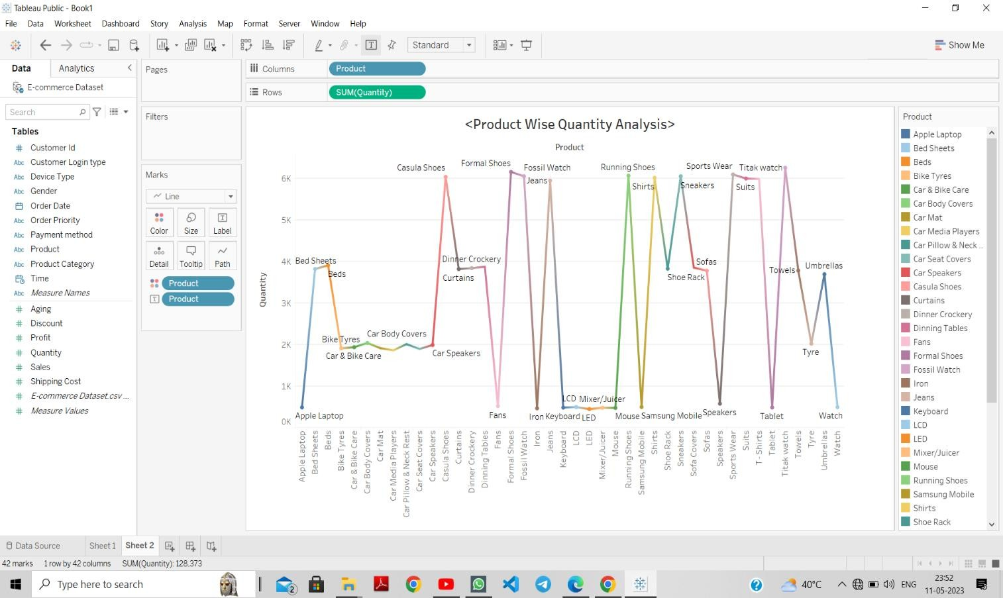

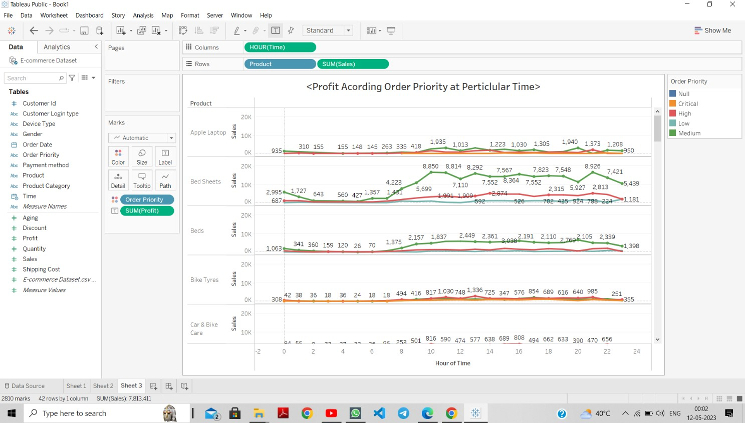

d. Temporal Data Visualization.

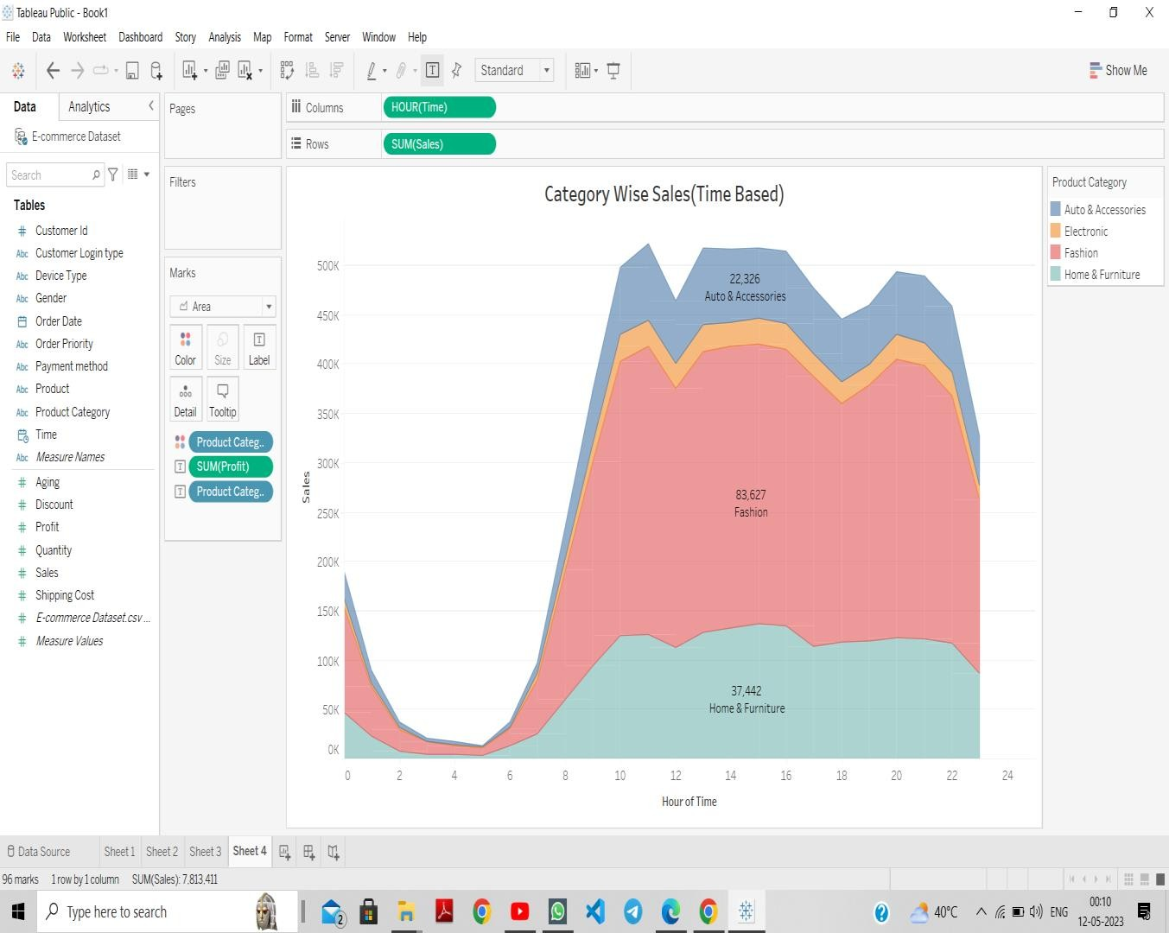

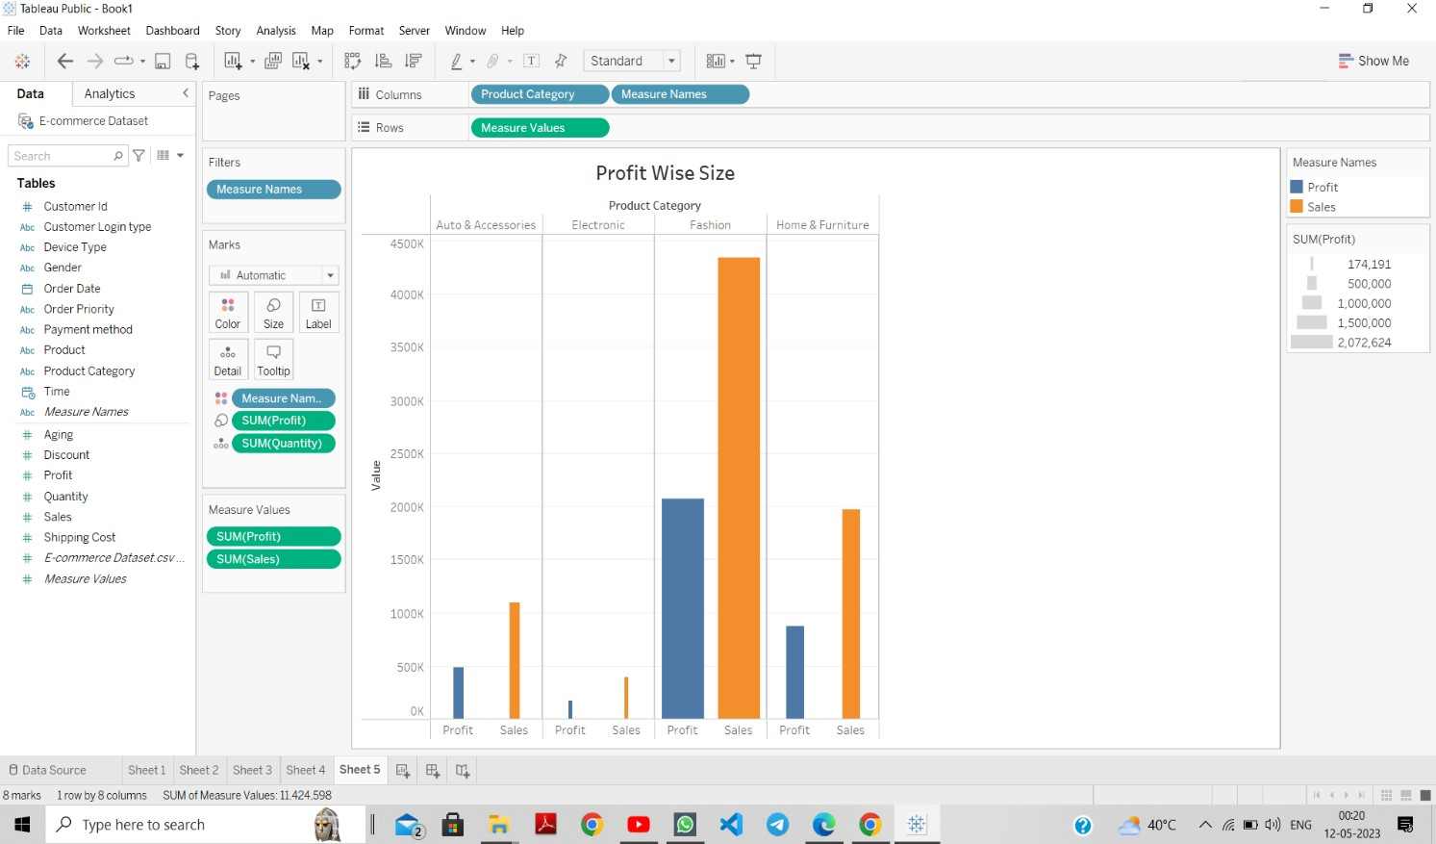

f. Tree/ Hierarchical Data visualization.

