Break

The break Statement

With the break statement we can stop the loop even if the while condition is true:

Example:

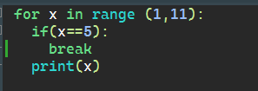

Output:

