Continue

The continue Statement

With the continue statement we can stop the current iteration, and continue with the next:

Example

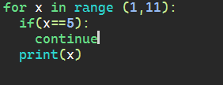

Output:

