Python Dictionaries

Dictionary

Dictionaries are used to store data values in key:value pairs.

A dictionary is a collection which is ordered\*, changeable and do not allow duplicates.

As of Python version 3.7, dictionaries are *ordered*. In Python 3.6 and earlier, dictionaries are *unordered*.

Dictionaries are written with curly brackets, and have keys and values:

Example:

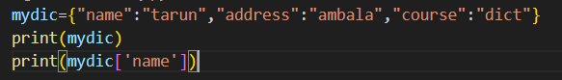

Output:

