Python Functions

A function is a block of code which only runs when it is called.

You can pass data, known as parameters, into a function.

A function can return data as a result.

Creating a Function

In Python a function is defined using the def keyword:

Example

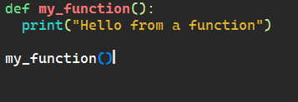

Output:

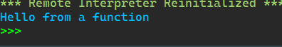

Built in function

Python provides a lot of built-in functions that ease the writing of code. In this article, you will learn about **Python’s built-in functions**, exploring their various applications and highlighting some of the most commonly used ones.

**Python Built-in Functions List**

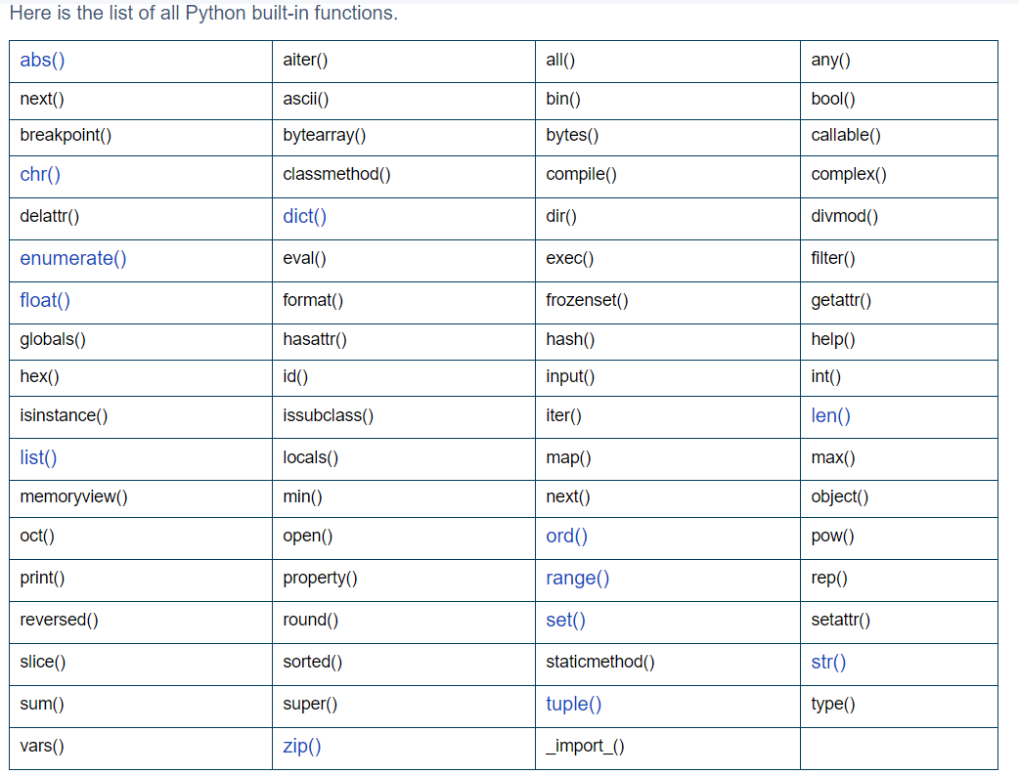

**Example:**

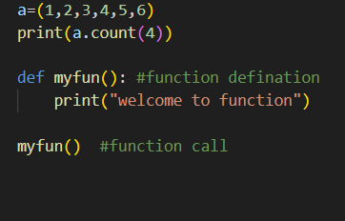

Output

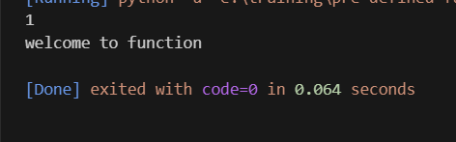

User defined function

Functions that we define ourselves to do certain specific task are referred as user-defined functions. The way in which we define and call [functions in Python](https://www.programiz.com/python-programming/function) are already discussed.

Functions that readily come with Python are called built-in functions. If we use functions written by others in the form of library, it can be termed as library functions.

All the other functions that we write on our own fall under user-defined functions. So, our user-defined function could be a library function to someone else.

Example:

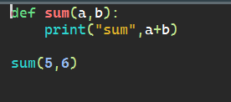

Output:

