Python Lists

List

Lists are used to store multiple items in a single variable.

Lists are one of 4 built-in data types in Python used to store collections of data, the other 3 are [Tuple](https://www.w3schools.com/python/python_tuples.asp), [Set](https://www.w3schools.com/python/python_sets.asp), and [Dictionary](https://www.w3schools.com/python/python_dictionaries.asp), all with different qualities and usage.

Lists are created using square brackets:

Example:

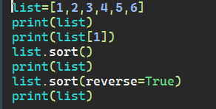

Output:

