Python Strings

Strings

Strings in python are surrounded by either single quotation marks, or double quotation marks.

'hello' is the same as "hello".

You can display a string literal with the print() function:

Example:

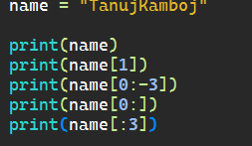

Output:

