Python Tuples

Tuple

Tuples are used to store multiple items in a single variable.

Tuple is one of 4 built-in data types in Python used to store collections of data, the other 3 are [List](https://www.w3schools.com/python/python_lists.asp), [Set](https://www.w3schools.com/python/python_sets.asp), and [Dictionary](https://www.w3schools.com/python/python_dictionaries.asp), all with different qualities and usage.

A tuple is a collection which is ordered and **unchangeable**.

Tuples are written with round brackets.

Example:

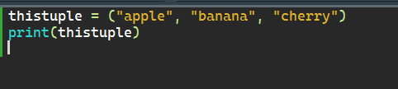

Output:

