Hello,

Here are our given tasks.

(1) Create a Redis cluster with 1 master and 3 slaves * The cluster should have the capability to promote slaves to master automatically in the event of master going down for whatever reason.

(2) Once complete please create a cloud formation template to launch the entire infrastructure and automate the whole process using chef recipes.

(3) Upload code to github and add a README with clear instructions on how to setup etc. Once complete please send us the link.

=> First of all we will create four EC2 Instances and from that 1 will be Master and 3 will be Slave servers.

=> After that we will install Redis Cluster into them and than configure as a master and 3 slave servers by following steps from below link.

Step 1 — Install Redis
Starting with the Droplet that will host our master server, our first step is to install Redis. First we need to add Chris Lea's Redis repository (as always, take extreme caution when adding third party repositories; we are using this one because its maintainer is a reputable figure):
- sudo add-apt-repository ppa:chris-lea/redis-server

Press ENTER to accept the repository.
Run the following command to update our packages:
- sudo apt-get update

Install the Redis server:
- sudo apt-get install redis-server

Check that Redis is up and running:
- redis-benchmark -q -n 1000 -c 10 -P 5

The above command is saying that we want redis-benchmark to run in quiet mode, with 1000 total requests, 10 parallel connections and pipeline 5 requests. For more information on running benchmarks for Redis, typing redis-benchmark --help in your terminal will print useful information with examples.
Let the benchmark run. After it's finished, you should see output similar to the following:
Output
PING_INLINE: 166666.67 requests per second
PING_BULK: 249999.98 requests per second
SET: 249999.98 requests per second
GET: 499999.97 requests per second
INCR: 333333.34 requests per second
LPUSH: 499999.97 requests per second
LPOP: 499999.97 requests per second
SADD: 499999.97 requests per second
SPOP: 499999.97 requests per second
LPUSH (needed to benchmark LRANGE): 499999.97 requests per second
LRANGE_100 (first 100 elements): 111111.12 requests per second
LRANGE_300 (first 300 elements): 27777.78 requests per second
LRANGE_500 (first 450 elements): 8333.33 requests per second
LRANGE_600 (first 600 elements): 6369.43 requests per second
MSET (10 keys): 142857.14 requests per second
Now repeat this section for the Redis slave server. If you are configuring more Droplets, you may set up as many slave servers as necessary.
At this point, Redis is installed and running on our two nodes. If the output of any node is not similar to what is shown above, repeat the setup process carefully and check that all prerequisites are met

Step 2 — Configure Redis Master
Now that Redis is up and running on our two-Droplet cluster, we have to edit their configuration files. As we will see, there are minor differences between configuring the master server and the slave.
Let's first start with our master.
Open /etc/redis/redis.conf with your favorite text editor:
- sudo nano /etc/redis/redis.conf

Edit the following lines.
Set a sensible value to the keepalive timer for TCP:
/etc/redis/redis.conf
tcp-keepalive 60
Make the server accessible to anyone on the web by commenting out this line:
/etc/redis/redis.conf
#bind 127.0.0.1
Given the nature of Redis, and its very high speeds, an attacker may brute force the password without many issues. That is why we recommend uncommenting the requirepass line and adding a complex password (or a complex passphrase, preferably):
/etc/redis/redis.conf
requirepass your_redis_master_password
Depending on your usage scenario, you may change the following line or not. For the purpose of this tutorial, we assume that no key deletion must occur. Uncomment this line and set it as follows:
/etc/redis/redis.conf
maxmemory-policy noeviction
Finally, we want to make the following changes, required for backing up data. Uncomment and/or set these lines as shown:
/etc/redis/redis.conf
appendonly yes
appendfilename redis-staging-ao.aof
Save your changes.
Restart the Redis service to reload our configuration changes:
- sudo service redis-server restart

If you want to go the extra mile, you can add some unique content to the master database by following theRedis Operations sections in this tutorial, so we can later see how it gets replicated to the slave server.
Now that we have the master server ready, let's move on to our slave machine.

Step 3 — Configure Redis Slave
We need to make some changes that allow our slave server to connect to our master instance:
Open /etc/redis/redis.conf with your favorite text editor:
- sudo nano /etc/redis/redis.conf

Edit the following lines; some settings will be similar to the master's.
Make the server accessible to anyone on the web by commenting out this line:
/etc/redis/redis.conf
#bind 127.0.0.1
The slave server needs a password as well so we can give it commands (such as INFO). Uncomment this line and set a server password:
/etc/redis/redis.conf
requirepass your_redis_slave_password
Uncomment this line and indicate the IP address where the master server can be reached, followed by the port set on that machine. By default, the port is 6379:
/etc/redis/redis.conf
slaveof your_redis_master_ip 6379
Uncomment the masterauth line and provide the password/passphrase you set up earlier on the master server:
/etc/redis/redis.conf
masterauth your_redis_master_password
Now save these changes, and exit the file. Next, restart the service like we did on our master server:
- sudo service redis-server restart

This will reinitialize Redis and load our modified files.
Connect to Redis:
- redis-cli -h 127.0.0.1 -p 6379

Authorize with the slave server's password:
- AUTH your_redis_slave_password

At this point we are running a functional master-slave Redis cluster, with both machines properly configured.

Step 4 — Verify the Master-Slave Replication
Testing our setup will allow us to better understand the behavior of our Redis Droplets, once we want to start scripting failover behavior. What we want to do now is make sure that our configuration is working correctly, and our master is talking with the slave Redis instances.
First, we connect to Redis via our terminal, on the master server:
First connect to the local instance, running by default on port 6379. In case you've changed the port, modify the command accordingly.
- redis-cli -h 127.0.0.1 -p 6379

Now authenticate with Redis with the password you set when configuring the master:
- AUTH your_redis_master_password

And you should get an OK as a response. Now, you only have to run:
- INFO

You will see everything you need to know about the master Redis server. We are especially interested in the #Replication section, which should look like the following output:
Output
. . .

# Replication
role:master
connected_slaves:1
slave0:ip=111.111.111.222,port=6379,state=online,offset=407,lag=1
master_repl_offset:407
repl_backlog_active:1
repl_backlog_size:1048576
repl_backlog_first_byte_offset:2
repl_backlog_histlen:406

. . .
Notice the connected_slaves:1 line, which indicates our other instance is talking with the master Droplet. You can also see that we get the slave IP address, along with port, state, and other info.
Let's now take a look at the #Replication section on our slave machine. The process is the same as for our master server. Log in to the Redis instance, issue the INFO command, and view the output:
Output
. . .

# Replication
role:slave
master_host:111.111.111.111
master_port:6379
master_link_status:up
master_last_io_seconds_ago:3
master_sync_in_progress:0
slave_repl_offset:1401
slave_priority:100
slave_read_only:1
connected_slaves:0
master_repl_offset:0
repl_backlog_active:0
repl_backlog_size:1048576
repl_backlog_first_byte_offset:0
repl_backlog_histlen:0

. . .
We can see that this machine has the role of slave, is communicating with the master Redis server, and has no slaves of its own.

Step 5 — Switch to the Slave
Building this architecture means that we also want failures to be handled in such a way that we ensure data integrity and as little downtime as possible for our application. Any slave can be promoted to be a master. First, let's test switching manually.
On a slave machine, we should connect to the Redis instance:
- redis-cli -h 127.0.0.1 -p 6379

Now authenticate with Redis with the password you set when configuring the slave
- AUTH your_redis_slave_password

Turn off slave behavior:
- SLAVEOF NO ONE

The response should be OK. Now type:
- INFO

Look for the # Replication section to find the following output:
Output
. . .

# Replication
role:master
connected_slaves:0
master_repl_offset:1737
repl_backlog_active:0
repl_backlog_size:1048576
repl_backlog_first_byte_offset:0
repl_backlog_histlen:0

. . .
As we expected, the slave has turned into a master, and is now ready to accept connections from other machines (if any). We can use it as a temporary backup while we debug our main master server.

=> Now we will create a CloudFormation template of whole Existing Infrastructure by using CloudFormer tool by following below link.
Go to the AWS Management console and select “CloudFormation service”.
Click on the “Create Stack” button.
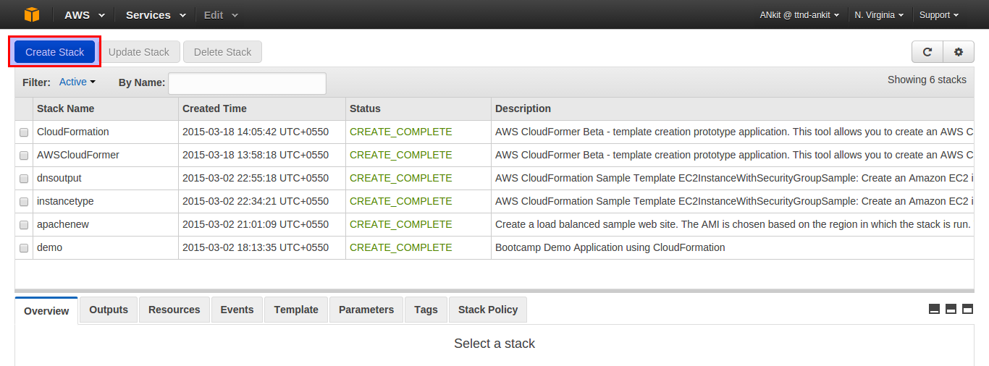
Select the sample template as “CloudFormer”.
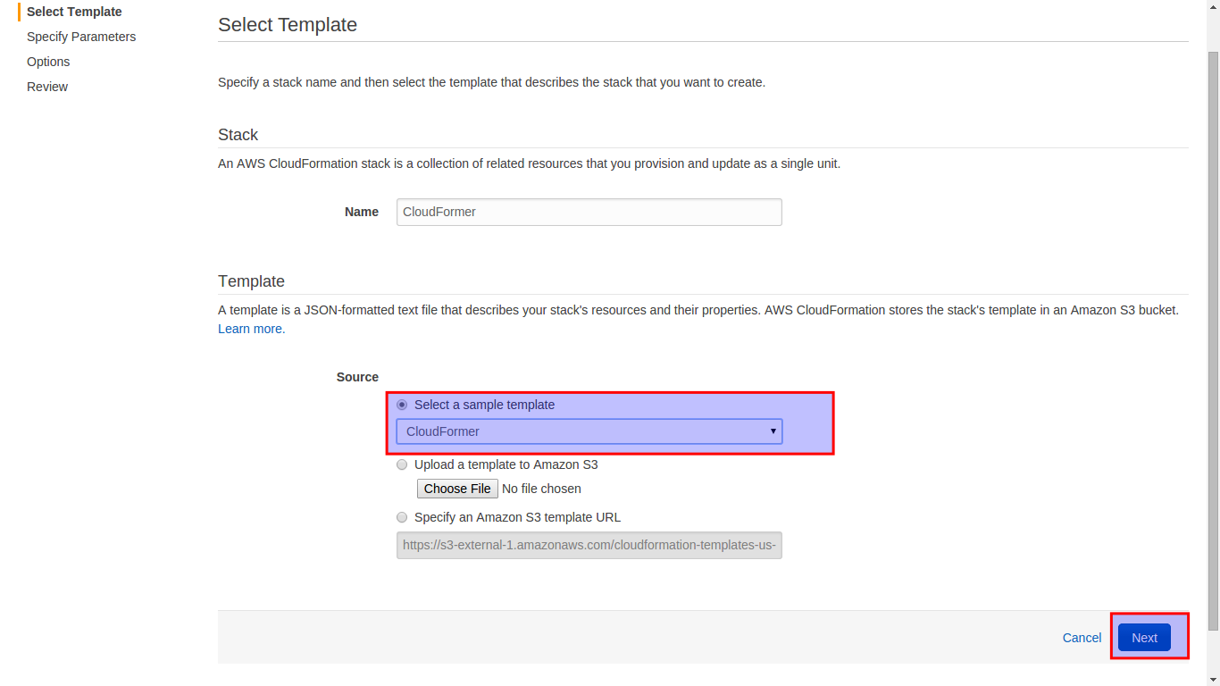
Specify parameters as per requirement.
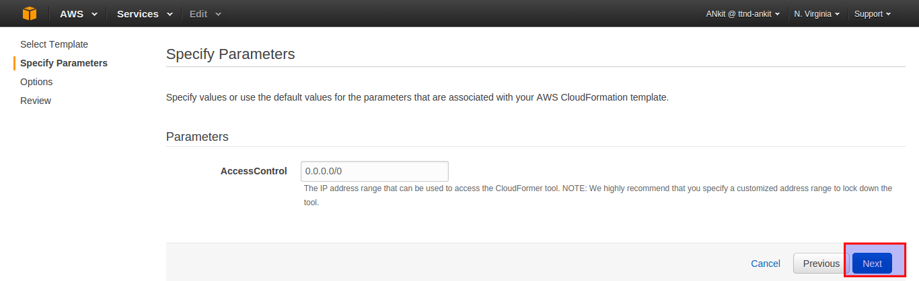

Tag the template with proper naming convention( for ease of use).
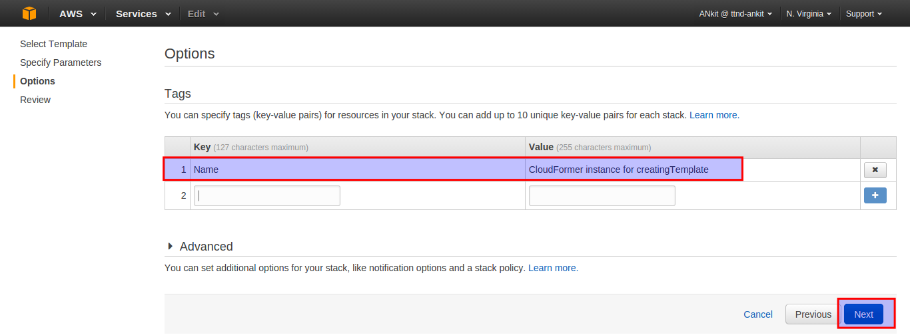

Finally, click on the “create” button & the stack is ready.
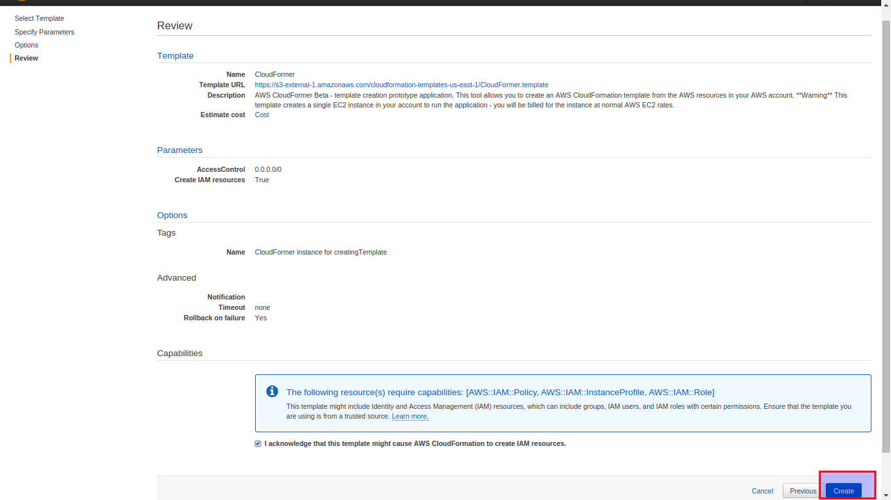

The highlighted Stack is the one which we have just created. The “URL” is the link of the CloudFormer Tool ( it is running on an t1.micro instance in our AWS Account.
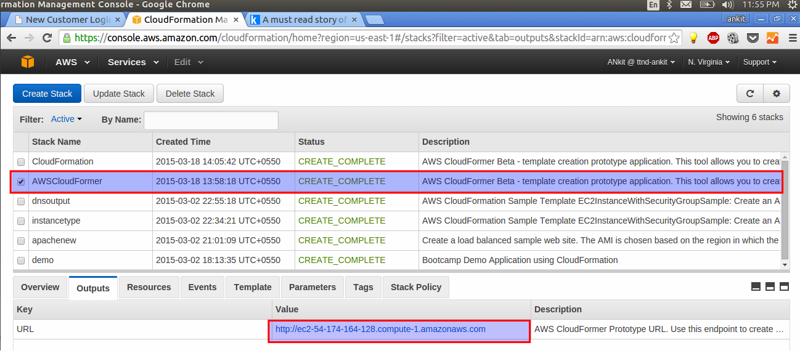

Click on the “create Template button” and proceed further.
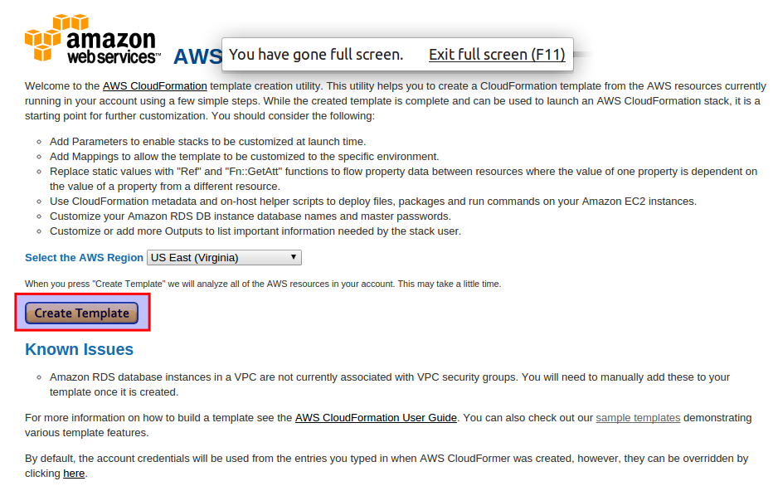

You will see a “Analyzing your account” screen & this step will take some time ( Be patient).

Give the template a Description ( as per your convenience).
* Do not select any resource as of now.
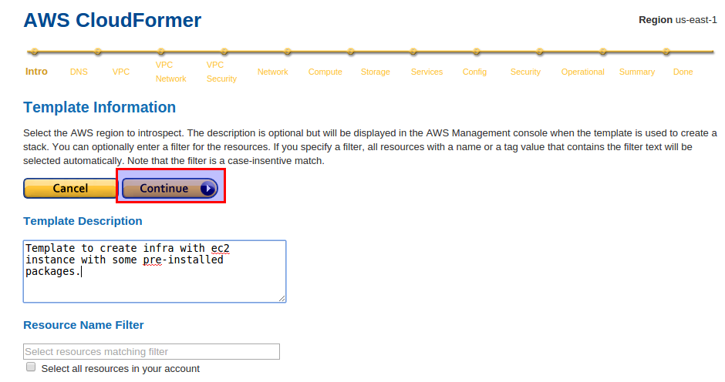
At first, it will ask you to select the VPC. So, all the related subnets, network interface & security group will be automatically selected ( although we can customize it).
1) VPC
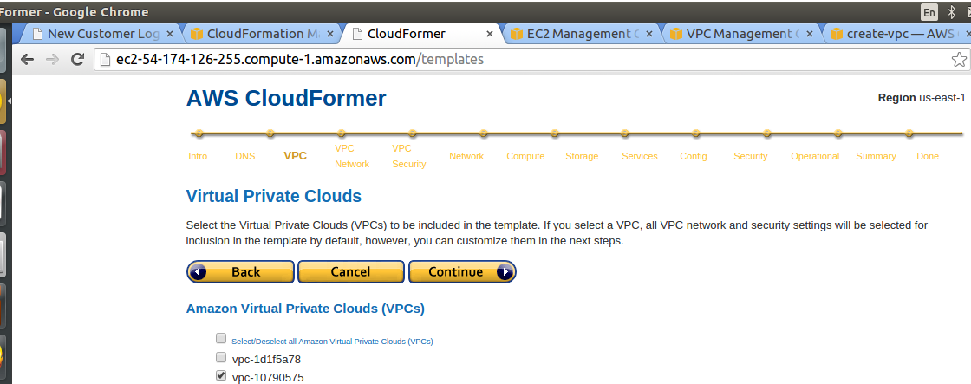
Now just keep clicking on “Continue” button. CloudFormer takes care of the dependencies.
In subsequent steps, it will ask you to select the following:
2) VPC Network (VPC Subnets, Internet Gateways, Customer Gateways, DHCP options)
3) VPC Security (Network ACLs, Rote Tables)
4) Network (ELB, Elastic IP , Network Interfaces)
5) Compute (Auto Scaling Groups, EC2 Instances)
6) Storage (EBS Volumes, RDS Instances, DynamoDB Tables, S3 Buckets)
7) Services (SQS, SNS Topics, SimpleDB Domains)
8) Config (Auto Scaling Launch Configurations, RDS Subnet groups, RDS Parameter Groups)
9) Security (EC2 Security Groups, RDS Security Groups, SQS Queue Policies, SNS Tpic Policies, S3 Bucket Policies)
10)Optional Resources (AutoScaling Policies, CloudWatch Alarms)
At last, you will see a summary page with all your selected setting.
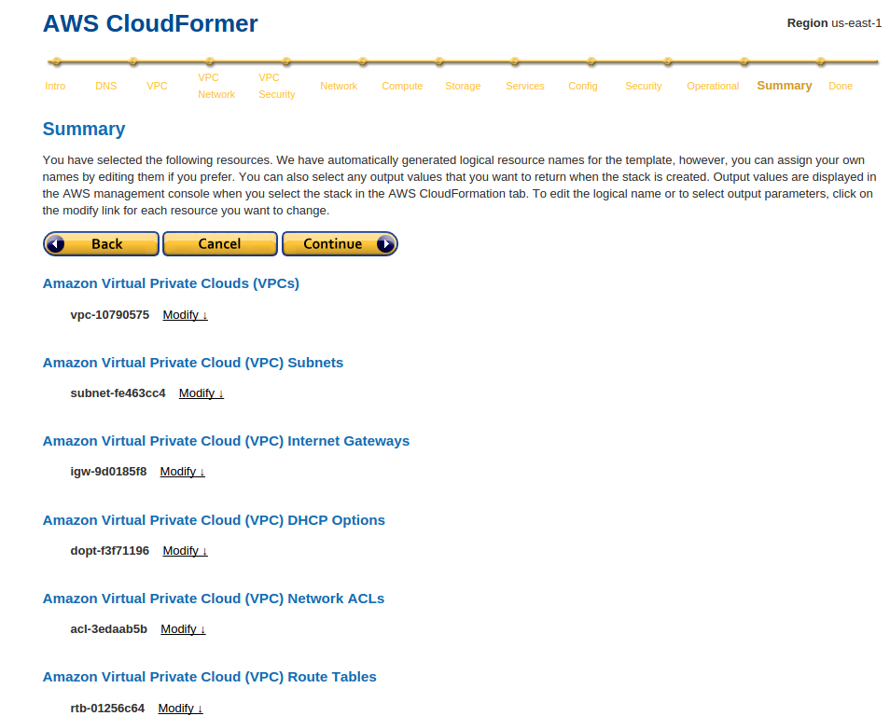
CloudFront will display your template, click on “Save Template”.
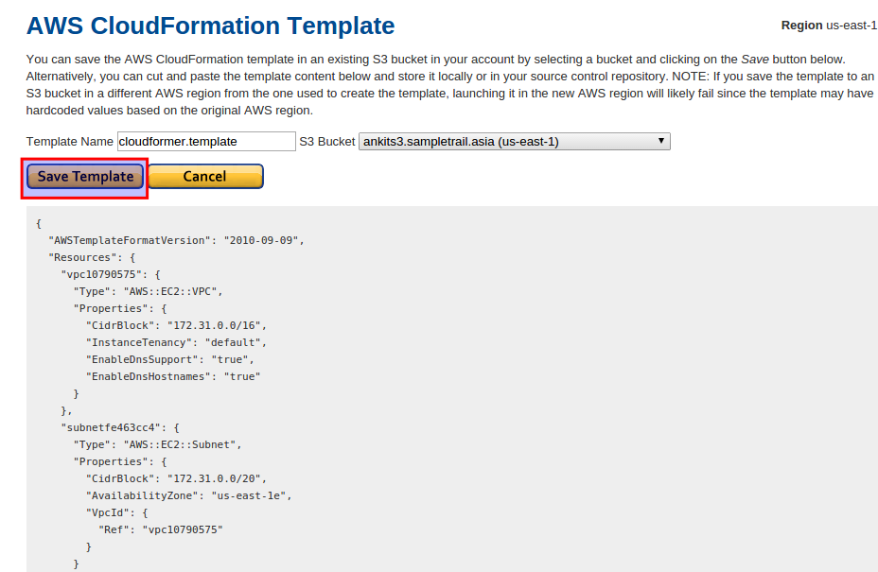
On the next screen you will see,
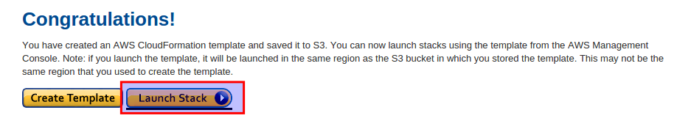

=> Now at the end you will get CloudFormation Template saved in S3 bucket.

=> You have to change the permissions for the template by allocating policy " Anyone " to view/edit. So now anyone with that link can access that template. Here is the link.

https://s3-us-west-2.amazonaws.com/testnclouds/cloudformer.template

=> Now for automating whole process we will write Chef Recipe like below.

