**GREEN MACHINE LEARNING**

**ABSTRACT**

Green machine learning refers to research that is more environmentally friendly and inclusive, not only by producing novel results without increasing the computational cost, but also by ensuring that any researcher with a laptop has the opportunity to perform high-quality research without the need to use expensive cloud servers. This paper is concerned with the development of machine learning algorithms that optimize efficiency rather than only accuracy. This provides a review of the novel contributions to the ESANN 2023 special session on Green Machine Learning and also discusses green AI as a pivotal approach to enhancing the environmental sustainability of AI systems. Described are AI solutions for eco-friendly practices in other fields (green-by AI), strategies for designing energy-efficient machine learning (ML) algorithms and models (green-in AI), and tools for accurately measuring and optimizing energy consumption.

1. **INTRODUCTION**

In the past few years, Artificial Intelligence (AI) and Machine Learning (ML) have changed many industries work. They help things become faster and more accurate in areas like healthcare, finance, transportation, education, and entertainment. To get better results, ML models have become more complex, meaning they need to process more information. But this also means training and using them now require much more energy.

The release of ‘generative AI’ applications, notably the text generator ChatGPT, text-to-image generators like Midjourney, and text-to-video models like Sora have recently brought public attention to the rapidly progressing technological capabilities.

As can be seen in Fig. 1 training modern ML models requires vast amounts of computational resources, and of energy and water for the refrigeration of the data centers.

**CO2 Equivalent Emissions (Tonnes) by Selected Machine Learning Models and Real Life Examples, 2022**

**Fig 1.[1] CO2 equivalent emission training ML, models (blue) and of real-life (violet). In brackets, the billion of parameters adjusted each model.**

The large language model (LLM) behind the popular ChatGPT, reveals that the model size has increased from 1.5 billion to an estimated 1.7 trillion parameters between GPT-2 and GPT-4, an increase by a factor of 1,000 [2][3]. Based on approximations, the energy consumed for the training of GPT models has grown by a factor of 2,000 between the release of GPT-2 and GPT-4 in a time span of just 3.5 years [4], as is displayed in Fig. 2.

As an example, GPT-3 was accessed 590 million times in January 2023, leading to energy consumption equivalent to that of 175,000 persons [6]. Moreover, in inference time, each ChatGPT query consumes energy equivalent to running a 5 W LED bulb for 1hr 20 min, representing 260.42 MWh per day. The newer GPT-4 model is said to be about 10 times bigger than the previous version.

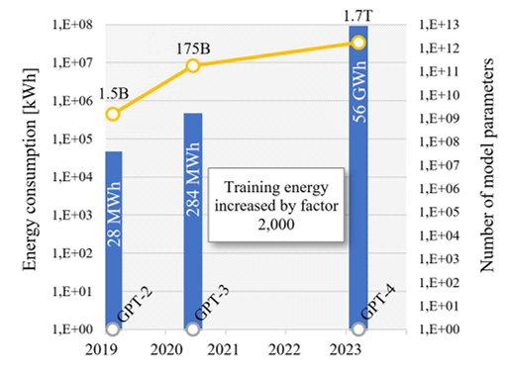

**Fig. 2.[5] Growth in GPT model size and training energy consumption**

The IEA projects the electricity consumption of data centers could reach 1,000 TWh in 2026, roughly equivalent to the electricity consumption of Japan [7].

In the next coming years, this energy consumption is projected to multiply, potentially reaching over 30% of the world’s total energy consumption by 2030. For instance, ChatGPT with GPT-3.5 allegedly consumed 1,287 megawatts and generated 552 metric tons of carbon dioxide emissions during its training, as reported by various sources.

As AI technology grows fast, its impact on the environment also increases, leading to worries about its carbon footprint. Because of this, a new approach called **Green Machine Learning (Green ML)** has been introduced. Green ML aims to make AI more eco-friendly by using sustainable methods in designing, training, and running AI models. The goal is to cut down energy use and reduce the impact of AI on the environment.

Traditional ML uses a lot of computing power and data, leading to high energy use and emissions. Green ML tackles this by improving algorithms, hardware, and data management, creating smaller models, reducing complexity, and ensuring clear decision-making.

Fig. 3shows the economic costs of training modern ML models, e.g., GPT-2 trained with 1.5 billion of parameters in 2019 cost an estimated 50,000 USD, while PaLM trained with 540 billion parameters in 2022 cost 8 million USD; thus, PaLM was 360 times bigger and 160 times more expensive.

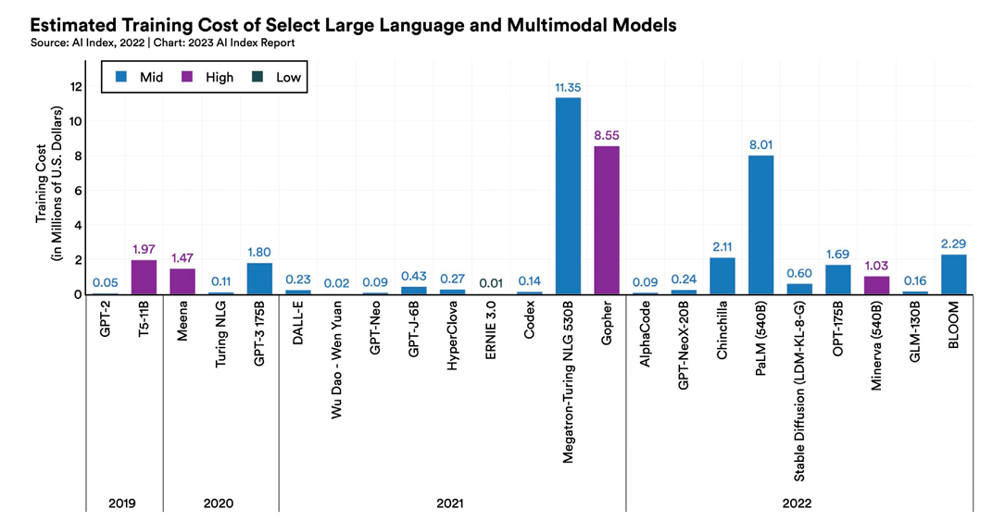

**Fig. 3. [8]Estimated training costs of large language and multimodal models. The colors indicate if estimates are high, mid level, or low.**

This session focuses on Green Machine Learning (Green ML) and how it makes AI more sustainable. We’ll explore key methods like federated and transfer learning that help reduce energy use and carbon emissions while ensuring AI remains ethical and efficient. The adoption of these approaches not only benefits the environment—essential for the future and mandatory in the UE [9]—but also improves cost savings and efficiency without sacrificing performance.

1. **GREEN MACHINE LEARNING**

According to the existing literature [10], green algorithms are usually defined as algorithms ‘‘capable of maximizing the energy efficiency and reducing the environmental impact of AI models, while supporting the use of this technology to respond to different environmental challenges’’.

Artificial intelligence (AI) and the environment are connected in two ways. On one side, AI can help create a greener economy by improving sustainability efforts **("green by AI").** On the other side, AI itself consumes a lot of energy, requiring the development of more efficient algorithms to reduce its environmental impact **("green in AI").**

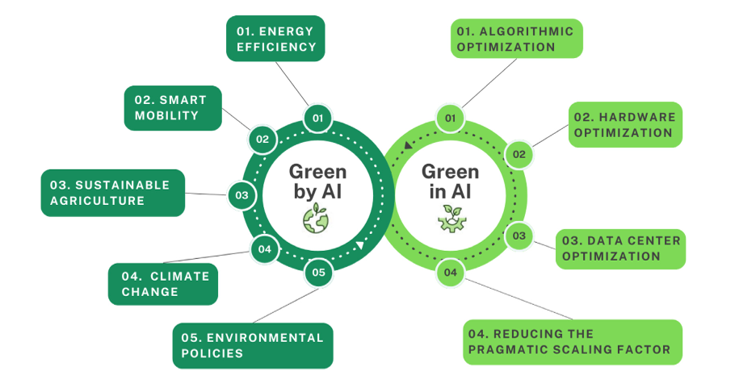

**Fig. 4. Overview of green-in vs green-by algorithms.**

Green algorithms are designed to make AI more energy-efficient and environmentally friendly while also helping tackle global environmental challenges. They generally fall into two categories:

1. **Energy-efficient algorithms** – These are designed to use less power during AI training and operations, making the technology itself more sustainable ("green by design").
2. **Problem-solving algorithms** – These focus on addressing environmental issues, such as those outlined in the Paris Agreement, the United Nations Sustainable Development Goals [11], or the European Green Deal [12].

By combining these approaches, AI can reduce its own impact while actively contributing to a greener future.

The discussion centers on two approaches to AI: **red AI** and **green AI** [13]. A 2018 study [14] found that the computing power needed to train large machine learning models had been doubling every 3.4 months since 2012—much faster than Moore’s Law, which predicts that this should happen close to every two years [15].

In 2020, another paper [16] introduced the idea of **red AI**, where better results are achieved by using massive computational resources. Researchers analyzed over 60 papers from top AI conferences and found that most (between 75% and 90%, depending on the conference) prioritized accuracy over efficiency. This highlights the growing debate about balancing AI performance with sustainability.

Machine learning (ML) consumes a significant amount of energy, but this can be reduced.

There are **different ways to reduce consumption**, which are as follows:

* **Algorithmic Optimization**

Making algorithms more efficient helps them run faster and use less energy. This is a big focus in green computing, where techniques like quantization (simplifying data) and energy-aware pruning [17] (removing unnecessary steps) help cut down power consumption.

* **Hardware Optimization**

Using **energy-efficient GPUs** helps save power. **Parallel computing** spreads tasks across multiple processors, but Anthony et al. [18] found that too many cores can actually **increase emissions** instead of reducing them. With **edge computing**, AI processes data **closer to where it’s collected**, cutting down on cloud use and making things faster and greener. Choosing the right hardware makes AI **more efficient without wasting extra energy**.

* **Choice of Data Center**

The location of a data center plays a huge role in its carbon footprint. Countries like Norway and Switzerland use clean energy, so their data centers have low emissions, while others rely on power sources that produce much more pollution.

* **Reducing the Pragmatic Scaling Factor**

Limiting how many times an algorithm runs, especially complex ones, saves energy. Cutting down on excessive fine-tuning, like spending less time adjusting hyperparameters, also helps reduce unnecessary computing power [19,20,21].

If machine learning keeps growing without considering energy use, it could add to climate change. Large models need a lot of power, but researchers and developers can reduce their carbon footprint by tracking energy consumption.

Beyond algorithmic advances, researchers have also been working on frameworks and tools to assess the environmental impact of ML systems. As reported in a recent analysis [22] that evaluated the carbon footprint of natural language processing (NLP) methods, using existing tools for measuring energy use and carbon emissions.. Different tools give different results because they use different methods, hardware, energy use, software, and electricity sources. Since there is no standard way to measure emissions, comparing results and making reports is hard.

1. **TOOLS USED FOR ESTIMATING CARBON FOOTPRINT**

The most popular tools currently in use for estimating carbon footprint are as follows:

* + **CarbonTracker[23] :**

This tool helps track and study greenhouse gas emissions, mainly carbon dioxide, from different places. It uses atmospheric measurements and statistical modeling to estimate pollution in real time. Researchers, policymakers, and environmental groups use it to understand how AI affects the environment since deep learning needs a lot of energy.

* + **CodeCarbon [24]:**

It is a software tool designed to help developers and organizations track and reduce the carbon footprint of their code. It monitors the energy consumption of software applications and analyzes their environmental impact. Once integrated into the development pipeline, it provides insights and recommendations to lower emissions, making software development more sustainable.

* + **Green algorithms [25] :**

This project aims to make computing more environmentally friendly by using resources efficiently, reducing power consumption, and promoting sustainability. It is especially useful for data centers, supercomputers, and high-performance computing systems, which consume large amounts of energy. Since it requires minimal information and does not interfere with existing code, it can be easily integrated into computational processes without disruptions.

* + **PowerTop [26] :**

This tool helps Linux users save energy and manage power better. Created by Intel, it spots power-draining apps and devices, helping computers use less electricity, extend battery life on laptops, and reduce power use in servers. It shows clear power usage details, making it easy for users to adjust settings, lower their carbon footprint, and make their systems more eco-friendly.

1. **QUANTIFYING SUSTAINABILITY**

To measure the environmental impact of an experiment, the easiest way is to track the number of hours a CPU or GPU is used. This avoids complicated calculations about energy sources and consumption. However, if energy data is available, the footprint can be estimated by multiplying CPU/GPU hours by energy usage per unit and the carbon footprint of the energy mix. Even if the energy source is eco-friendly, using resources still has an impact so minimizing unnecessary computing time helps.

* **MEASURES FOR POST-HOC ANALYSIS**

Evaluating the sustainability of an AutoML approach requires considering both efficiencyand environmental impact. Efficiency refers to how well an approach performs with a given amount of time or resources. Environmental impact measures how much energy an experiment using that approach consumes. Since experiments use different hardware, both factors must be considered together.

* **RUNTIME**

It is the time taken for an experiment to complete. It relates to energy use but does not account for memory usage. Runtime alone does not clearly show the environmental impact. If energy data is available, runtime can help estimate carbon emissions.

* **CPU/GPU HOURS**

It is the number of hours a CPU or GPU is used. A simple way to estimate environmental impact. CPU/GPU hours may include other processes like memory access, making interpretation difficult. If energy usage and energy source details are known, CPU/GPU hours can help calculate carbon footprint.

* **FLOATING POINT OPERATIONS (FPO)**

It is the number of mathematical calculations performed by the system. Often easy to measure. FPO depends on how hardware and software are optimized, making it unreliable for efficiency and footprint calculation. Not ideal for measuring sustainability.

* **ENERGY CONSUMPTION**

It is the amount of electricity used by an experiment. A direct way to measure environmental impact. Tracking energy use is difficult, especially in complex computing setups. If enough data is available, energy usage can help estimate carbon emissions.

* **CO2 EQUIVALENTS**

It is the amount of carbon emissions based on energy usage and energy source. The most accurate way to assess environmental impact is difficult to measure directly and varies depending on location and time. Recording the energy mix helps provide a more precise footprint estimate.

1. **ENVIRONMENT ASSESSMENT OF AI SYSTEM**

AI’s environmental impact is measured using **Life Cycle Assessment (LCA)** and **Product Carbon Footprinting (PCF)**. LCA tracks energy use, waste, and emissions throughout a product’s life. PCF focuses only on carbon emissions, manufacturing (raw material extraction) and usage (power consumption).

For AI systems, the software life cycle includes development, training, and deployment, while the hardware life cycle involves production, operation, and disposal. Both overlap during the use phase, where energy consumption is highest.

To compare environmental effects, researchers use functional units (FU), such as "compute hours" or "tasks per kWh". These help improve AI efficiency and sustainability.

1. **Software Life Cycle :**

Software runs only with computer hardware, so its environmental impact is closely linked to the hardware it operates on. To assess AI’s environmental footprint, researchers must consider the entire system including computers and networks that support AI services.

The development of AI models determines how much computational power is needed for training and inference, which directly affects energy usage. AI’s processing demand is measured using FLOPS (floating-point operations per second), processor utilization, and compute hours [27].

Research indicates that training and re-training models, such as hyperparameter tuning are the biggest energy-consuming stages [28].

This highlights that software design plays a critical role in AI’s carbon footprint. Efficient designs can help reduce energy consumption by optimizing compute power usage and hardware efficiency.

**B. Hardware Life Cycle**

AI hardware goes through two key stages manufacturing and usage , both impact the environment. In manufacturing, creating processors, memory chips, and circuit boards requires high energy and resources, generating carbon emissions [29]. Factors like technology generation, production methods, and energy sources influence this footprint.

During the use phase, AI systems consume more power as computing demands grow. High-performance CPUs and GPUs now use 500–700W, increasing energy use [30]. Data centers also contribute, depending on energy efficiency and whether they use renewable power.

**C. Exemplary Carbon Footprint of Server Hardware**

This section estimates the carbon footprint of server hardware, focusing on how technical and operational factors contribute to energy consumption.

A CPU-based system is used as an example, with calculations based on processor type, memory size, and board components. The manufacturing footprint of an Intel Xeon 8468 CPU, is estimated at 1,200 kg CO2e , mainly due to integrated circuits and memory chips . If used for five years, the annual footprint is 240 kg CO2e .

During use, the CPU consumes 350W, and DRAM adds 205W, bringing total system power to 555W. With 75% active usage and 25% idle time, the annual electricity consumption is 4,084 kWh , leading to 1,634 kg CO2e emissions. This means 87% of the system’s footprint comes from energy use rather than manufacturing .

Switching to renewable energy significantly reduces the carbon footprint—from 1,634 kg CO2e to just 204 kg CO2e annually. The trend applies not only to CPUs but also GPUs and TPUs, emphasizing the role of memory configuration in environmental impact.

**D. Comparison of CPU and GPU Systems**

A GPU system , like the NVIDIA H100 , has 80 GB of high-bandwidth memory (HBM) and consumes 700W , while a CPU system , such as the Intel Xeon 8468 , has 4 TB of DRAM and uses 350W . Despite GPUs having smaller boards and lower memory capacity , they are widely used in AI/ML for their parallel processing power .

1. **RESEARCH INITIATIVES**

To make AI more sustainable, it's important to encourage research in Green AutoML . There are a few ways to do this.

* **Competitions That Push Efficiency**

AI challenges help drive innovation by limiting computing time, forcing researchers to find smarter, more efficient solutions . For example, in the AutoML challenge (2015-2018) , participants had only 20 minutes to build a model, leading to techniques like PoSH , which later became part of auto-sklearn 2.0 . Similar challenges continue, focusing on deep learning and few-shot learning.

* **Funding for Sustainable AI**

Organizations that fund AI research can support sustainable AI by considering a project's environmental impact. The German Research Foundation (DFG) is one example—they now allow researchers to offset emissions from travel.

* **Recognizing Green AI in Conferences**

Academic conferences and journals can promote Green AutoML by featuring special topics and awards for sustainability-focused research. The AAAI introduced a sustainability track in 2013 , and the first Sustainable AI conference happened in 2021. The AutoML conference in 2022 even asked researchers to consider sustainability in their submissions.

* **Moving Forward**

By supporting competitions , funding sustainable projects , and highlighting eco-friendly AI at conferences , we can push AI research towards smarter and greener solutions **.**

1. **FINDINGS**

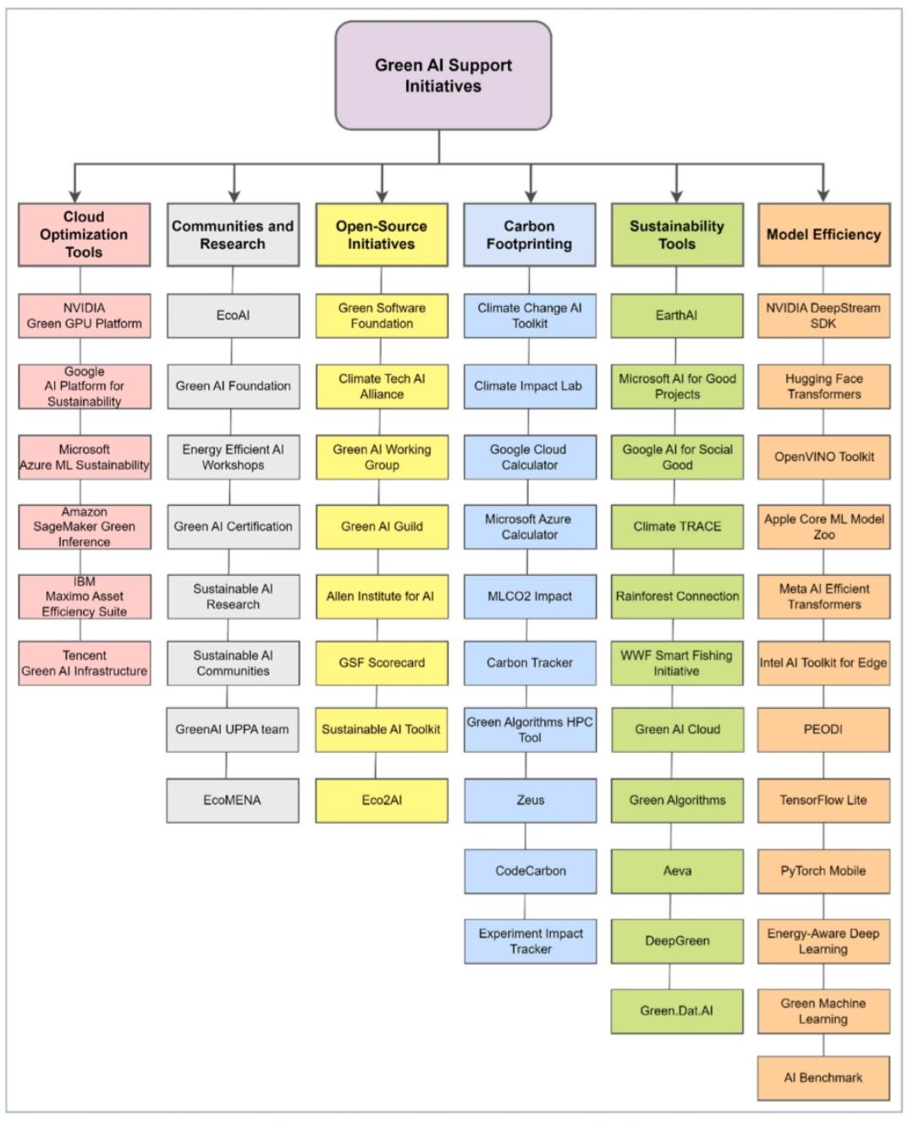The paper Categorizes the identified 55 green AI initiatives into six distinct categories visually represented in Fig. 5.

**Fig. 5[31]. Summary of green AI initiatives.**

1. **Cloud Optimization**– Some companies provide special tools that help AI systems use less electricity when running in the cloud. This helps reduce the environmental impact of AI. Examples: NVIDIA Green GPU Platform, Google AI Platform for Sustainability, Amazon SageMaker Green Inference.
2. **Model Efficiency** – AI models can be adjusted to work smarter, using fewer computer resources while still being effective. Some tools help make AI models smaller and faster without losing accuracy. Examples: Hugging Face Transformers, OpenVINO Toolkit, TensorFlow Lite, PyTorch Mobile.
3. **Carbon Footprinting–** Certain tools measure how much pollution (carbon emissions) AI models create when they run. These measurements help companies find ways to reduce their environmental impact. Examples: MLCO2 Impact, Google Cloud Sustainability Calculator, Carbon Tracker.
4. **Sustainability-Focused** AI – AI can be used to solve environmental problems, like tracking deforestation, improving farming methods, and predicting energy needs. Some projects specifically focus on using AI for sustainability. Examples: Climate TRACE, EarthAI, Microsoft AI for Good Projects, WWF Smart Fishing Initiative.
5. **Open-Source Initiatives** – There are groups that provide free resources and tools to help develop AI that is more environmentally friendly. These tools allow people around the world to work together on green AI solutions. Examples: Green Software Foundation, Eco2AI, Green AI Guild.
6. **Green AI Research & Community**– Researchers and organizations study AI’s environmental impact and share knowledge about how to make AI more eco-friendly. Examples: EcoAI, Energy-Efficient AI Workshops, Green AI Foundation.
7. **RECENT CONTRIBUTIONS TO GREEN MACHINE LEARNING**

Green Machine Learning has seen significant advancements in recent years, with researchers focusing on several key areas:

* **Environmental Impact of Machine Learning**

Recent research highlights the significant energy and resource consumption of machine learning systems. Yigitcanlar et al. [32] found that **Bitcoin mining** uses around **130 terawatt hours (TWh)** of energy yearly—about **0.6% of global electricity consumption**, comparable to the emissions of small countries like Sri Lanka or Jordan.

In **Natural Language Processing (NLP)**, Strubell et al. [33] discovered that training a popular AI model emitted as much **CO2 as five cars over their lifetime**. More recently, George et al. [34] reported that training models like **GPT-3** [35] or **ChatGPT** required **over 700,000 liters of water**—the same amount an average American household uses in **20 years**.

These findings emphasize the urgent need for **energy-efficient AI solutions** to reduce environmental impact.

* **Energy-Efficient Models**

Researchers are developing techniques to reduce the energy demand of ML models, such as **sparse training** [36,37,38], **quantization** [39,40,41], and **low-precision arithmetic** [42,43], which help decrease computational complexity.

* **Hardware Acceleration**

Specialized chips like **GPUs and TPUs** [44] have been optimized for ML tasks, reducing energy consumption. Additionally, **edge computing** [45,46] allows for data processing closer to the source, saving power and improving privacy.

* **Data Center Optimization**

Algorithms now dynamically **manage server loads** [47,48], optimize **cooling systems** [49,50], and improve **resource allocation** [51] to cut down on unnecessary energy use.

* **Energy-Efficient Structures**

ML is helping **smart buildings** and **smart cities** optimize **HVAC systems, lighting, and energy use** , leading to significant carbon savings.

Green ML is also being applied in fields like **climate change** [52], **sustainable agriculture** [53,54], **renewable energy forecasting** [55, 56], and **waste management** [57], expanding its impact on environmental sustainability.

* **Smarter Feature Selection**

Garćıa-Castillo et al. [58] created a **faster way to pick important features** in machine learning without wasting extra computing power. Their method, **Mutual Information Maximization (MIM)**, skips unnecessary steps, making it more efficient.

* **Railway Maintenance Made Greener**

Lourenço et al. [59] built an **anomaly detection system** using **locality-sensitive hashing** and **Apache Spark** to help railways **monitor train wheels** more efficiently. Their system **analyzes data faster** while using less energy.

* **Better AI for Agriculture**

Shumska et al. [60] worked on **smart image processing** for farming, helping AI **identify crop health** using multispectral images. Their method reduces the **computational workload** while still giving accurate results.

1. **REFERENCES**
2. <https://analytics.textify.ai/view/67861e2d60a57045923106be>
3. S. Bollaart, “The Environmental Cost of LLMs: A Call for Efficiency”, Medium, published 31st May 2023.
4. Z. Huang, P.K. Damalapati, E. Wu, “Data Ambiguity Strikes Back: How Documentation arXiv:2310.18742, 2023. Improves GPT's Text-to-SQL”, arXiv:2310.18742, 2023.
5. K.G.A. Ludvigsen, “The carbon footprint of GPT-4”, Towards Data Science, published 19th July 2023.
6. <https://www.researchgate.net/figure/Growth-in-GPT-model-size-and-training-energy-consumption_fig2_382271242>
7. <https://towardsdatascience.com/chatgpts-electricity-consumption-7873483feac4/>
8. International Energy Agency (IEA), “Electricity 2024 - Analysis and forecast to 2026”, 2024.
9. <https://gigazine.net/gsc_news/en/20230405-artificial-intelligence-index-report/>
10. European Union. Proposal for a regulation of the European Parliament and of the Council laying down harmonised rules on artificial intelligence (Artificial Intelligence Act) and amending certain union legislative acts, 2021.
11. L. Lannelongue, J. Grealey, M. Inouye, Green algorithms: quantifying the carbon footprint of computation, Adv. Sci. 8 (12) (2021) 2100707.
12. <https://sdgs.un.org/goals>
13. <https://commission.europa.eu/strategy-and-policy/priorities-2019-2024/european-green-deal_en>
14. Payal Dhar. The carbon impact of artificial intelligence. Nat. Mach. Intell., 2(8):423–425, 2020.
15. <https://openai.com/research/ai-and-compute>
16. C. Renggli, S. Ashkboos, M. Aghagolzadeh, D. Alistarh, T. Hoefler, SparCML: High-performance sparse communication for machine learning, in: Proceedings of the International Conference for High Performance Computing, Networking, Storage and Analysis, 2019, pp. 1–15.
17. Roy Schwartz, Jesse Dodge, Noah A Smith, and Oren Etzioni. Green ai. Communications of the ACM, 63(12):54–63, 2020.
18. Tien-Ju Yang, Yu-Hsin Chen, and Vivienne Sze. Designing energy-efficient convolutional neural networks using energy-aware pruning. In Proceedings of the IEEE conference on computer vision and pattern recognition, pages 5687–5695, 2017.
19. Lasse F Wolff Anthony, Benjamin Kanding, and Raghavendra Selvan. Carbontracker: Tracking and predicting the carbon footprint of training deep learning models. arXiv preprint arXiv:2007.03051, 2020.
20. James Bergstra and Yoshua Bengio. Random search for hyper-parameter optimization. Journal of machine learning research, 13(2), 2012.
21. Jasper Snoek, Hugo Larochelle, and Ryan P Adams. Practical bayesian optimization of machine learning algorithms. Advances in neural information processing systems, 25, 2012.
22. Lisha Li, Kevin Jamieson, Giulia DeSalvo, Afshin Rostamizadeh, and Ameet Talwalkar. Hyperband: A novel bandit-based approach to hyperparameter optimization. The Journal of Machine Learning Research, 18(1):6765–6816, 2017.
23. N. Bannour, S. Ghannay, A. Névéol, A.-L. Ligozat, Evaluating the carbon footprint of NLP methods: a survey and analysis of existing tools, in: Proceedings of the Second Workshop on Simple and Efficient Natural Language Processing, 2021, pp. 11–21.
24. <https://carbontracker.org>
25. <https://codecarbon.io/>
26. <http://www.green-algorithms.org>
27. <https://github.com/fenrus75/powertop>
28. P. Henderson, J. Hu, J. Romoff, E. Brunskill, D. Jurafsky, and J. Pineau, “Towards the Systematic Reporting of the Energy and Carbon Footprints of Machine Learning”, Journal of Machine Learning Research 21, 248 (2020), 1–43, 2020.
29. R. Verdecchia, J, Sallou, and L. Cruz, “A systematic review of Green AI”, WIREs Data Mining and Knowledge Discovery, 13(4), e1507, 2023
30. M. Proske, D. Sánchez, C. Clemm, S.-J. Baur, “Life cycle assessment of the Fairphone 3”, 2020.
31. A. C. Elster and T. A. Haugdahl, "Nvidia Hopper GPU and Grace CPU Highlights," in Computing in Science & Engineering, vol. 24, no. 2, pp. 95-100, 1 March-April 2022.
32. https://www.sciencedirect.com/science/article/pii/S0959652624025393
33. Tan Yigitcanlar, Rashid Mehmood, and Juan M Corchado. Green artificial intelligence:Towards an efficient, sustainable and equitable technology for smart cities and futures.Sustainability, 13(16):8952, 2021.
34. Emma Strubell, Ananya Ganesh, and Andrew McCallum. Energy and policy consid-Erations for deep learning in nlp. In Proceedings of the 57th Annual Meeting of theAssociation for Computational Linguistics, pages 3645–3650, 2019T.
35. A Shaji George, AS Hovan George, and AS Gabrio Martin. The environmental impact of ai: A case study of water consumption by chat gpt. Partners Universal International Innovation Journal, 1(2):97-104, 2023.
36. Tom Brown, Benjamin Mann, Nick Ryder, Melanie Subbiah, Jared D Kaplan, Prafulla Dhariwal, Arvind Neelakantan, Pranav Shyam, Girish Sastry, Amanda Askell, et al. Lan guage models are few-shot learners. Advances in neural information processing systems, 33:1877–1901, 2020.
37. C` edric Renggli, Saleh Ashkboos, Mehdi Aghagolzadeh, Dan Alistarh, and Torsten Hoefler. Sparcml: High-performance sparse communication for machine learning. In Proceedings of the International Conference for High Performance Computing, Networking, Storage and Analysis, pages 1–15, 2019.
38. Yi Tay, Dara Bahri, Liu Yang, Donald Metzler, and Da-Cheng Juan. Sparse sinkhorn attention. In International Conference on Machine Learning, pages 9438–9447. PMLR, 2020.
39. Sameer Bibikar, Haris Vikalo, Zhangyang Wang, and Xiaohan Chen. Federated dynamic sparse training: Computing less, communicating less, yet learning better. In Proceedings of the AAAI Conference on Artificial Intelligence, volume 36, pages 6080–6088, 2022.
40. Anis Elgabli, Jihong Park, Amrit Singh Bedi, Chaouki Ben Issaid, Mehdi Bennis, and Vaneet Aggarwal. Q-gadmm: Quantized group admm for communication efficient de centralized machine learning. IEEE Transactions on Communications, 69(1):164–181, 2020.
41. Sarit Khirirat, Sindri Magn´ usson, Arda Aytekin, and Mikael Johansson. A flexible frame work for communication-efficient machine learning. In Proceedings of the AAAI Confer ence on Artificial Intelligence, volume 35, pages 8101–8109, 2021.
42. Guangxuan Xiao, Ji Lin, Mickael Seznec, Hao Wu, Julien Demouth, and Song Han. Smoothquant: Accurate and efficient post-training quantization for large language mod els. In International Conference on Machine Learning, pages 38087–38099. PMLR, 2023.
43. Ofir Zafrir, Guy Boudoukh, Peter Izsak, and Moshe Wasserblat. Q8bert: Quantized 8bit bert. In 2019 Fifth Workshop on Energy Efficient Machine Learning and Cognitive Computing-NeurIPS Edition (EMC2-NIPS), pages 36–39. IEEE, 2019.
44. Zhenhua Liu, Yunhe Wang, Kai Han, Wei Zhang, Siwei Ma, and Wen Gao. Post-training quantization for vision transformer. Advances in Neural Information Processing Systems, 34:28092–28103, 2021.
45. Norm Jouppi, George Kurian, Sheng Li, Peter Ma, Rahul Nagarajan, Lifeng Nai, Nishant Patil, Suvinay Subramanian, Andy Swing, Brian Towles, et al. Tpu v4: An optically re configurable supercomputer for machine learning with hardware support for embeddings. In Proceedings of the 50th Annual International Symposium on Computer Architecture, pages 1–14, 2023
46. Shivani Singh, Razia Sulthana, Tanvi Shewale, Vinay Chamola, Abderrahim Benslimane, and Biplab Sikdar. Machine-learning-assisted security and privacy provisioning for edge computing: A survey. IEEE Internet of Things Journal, 9(1):236–260, 2021.
47. Yichen Wan, Youyang Qu, Longxiang Gao, and Yong Xiang. Privacy-preserving blockchain-enabled federated learning for b5g-driven edge computing. Computer Net works, 204:108671, 2022.
48. Arezoo Ghasemi and Abolfazl Toroghi Haghighat. A multi-objective load balancing al gorithm for virtual machine placement in cloud data centers based on machine learning. Computing, 102:2049–2072, 2020.
49. Haiwei Dong, Ali Munir, Hanine Tout, and Yashar Ganjali. Next-generation data center network enabled by machine learning: Review, challenges, and opportunities. IEEE Access, 9:136459–136475, 2021.
50. Yuanlong Li, Yonggang Wen, Dacheng Tao, and Kyle Guan. Transforming cooling op timization for green data center via deep reinforcement learning. IEEE transactions on cybernetics, 50(5):2002–2013, 2019.
51. Zhiwei Cao, Xin Zhou, Han Hu, Zhi Wang, and Yonggang Wen. Toward a systematic survey for carbon neutral data centers. IEEE Communications Surveys & Tutorials, 24(2):895–936, 2022.
52. Rafael Moreno-Vozmediano, Rub´ en S Montero, Eduardo Huedo, and Ignacio M Llorente. Efficient resource provisioning for elastic cloud services based on machine learning tech niques. Journal of Cloud Computing, 8(1):1–18, 2019.
53. David Rolnick, Priya L Donti, Lynn H Kaack, Kelly Kochanski, Alexandre Lacoste, Kris Sankaran, Andrew Slavin Ross, Nikola Milojevic-Dupont, Natasha Jaques, Anna Waldman-Brown, et al. Tackling climate change with machine learning. ACM Comput ing Surveys (CSUR), 55(2):1–96, 2022.
54. Ruhollah Taghizadeh-Mehrjardi, Kamal Nabiollahi, Leila Rasoli, Ruth Kerry, and Thomas Scholten. Land suitability assessment and agricultural production sustainability using machine learning models. Agronomy, 10(4):573, 2020.
55. Balsher Singh Sidhu, Zia Mehrabi, Navin Ramankutty, and Milind Kandlikar. How can machine learning help in understanding the impact of climate change on crop yields? Environmental Research Letters, 18(2):024008, 2023.
56. Sheraz Aslam, Herodotos Herodotou, Syed Muhammad Mohsin, Nadeem Javaid, Nouman Ashraf, and Shahzad Aslam. A survey on deep learning methods for power load and renewable energy forecasting in smart microgrids. Renewable and Sustainable Energy Reviews, 144:110992, 2021.
57. Monika Sandelic, Saeed Peyghami, Ariya Sangwongwanich, and Frede Blaabjerg. Reli ability aspects in microgrid design and planning: Status and power electronics-induced challenges. Renewable and Sustainable Energy Reviews, 159:112127, 2022.
58. Wanjun Xia, Yanping Jiang, Xiaohong Chen, and Rui Zhao. Application of machine learn ing algorithms in municipal solid waste management: A mini review. Waste Management & Research, 40(6):609–624, 2022.
59. Guillermo Castillo-Garc´ ıa, Laura Mor´ an-Fern´ andez, and Ver´ onica Bol´ on-Canedo. Effi cient feature selection for domain adaptation using mutual information maximization. In European Symposium on Artificial Neural Networks, Computational Intelligence and Machine Learning, 2023.
60. Afonso Louren¸co, Carolina Ferraz, Jorge Meira, Goreti Marreiros, Ver´ onica Bol´on Canedo, and Amparo Alonso-Betanzos. Automated green machine learning for condition based maintenance. In European Symposium on Artificial Neural Networks, Computa tional Intelligence and Machine Learning, 2023.
61. Mariya Shumska and Kerstin Bunte. Multispectral texture classification in agriculture. In European Symposium on Artificial Neural Networks, Computational Intelligence and Machine Learning, 2023