Explaining State-Level Variation in PM Surya Ghar Rooftop Solar Adoption:
A Data-Driven Analysis of the Subsidy Paradox
Research-Style Report — SuryaIQ Project
Data as on 23 August 2026

Executive Summary
PM Surya Ghar: Muft Bijli Yojana has driven rooftop solar applications past 78 lakh nationally, yet the share of applications converted into completed installations varies dramatically across states — from 1.5% in Arunachal Pradesh to 92.9% in Mizoram. This variation is not well explained by subsidy amount or raw solar potential alone, a pattern consistent with prior literature (P2, P3). This report builds a verified 36-state panel from ten independently-sourced datasets, tests what actually predicts conversion efficiency, forecasts near-term national installation volume, and simulates two policy-relevant scenarios.
The central finding: a simple two-variable linear model — recent electricity tariff growth and long-run solar irradiance — explains 46% of in-sample variation in state-level conversion ratio and generalizes better (Leave-One-Out cross-validated MAE 0.135) than a six-feature Random Forest (MAE 0.161). Subsidy/tariff level and raw solar potential are consistently the weakest predictors across every method tested. This is direct evidence that adoption efficiency is driven more by economic momentum and physical resource fit than by subsidy generosity itself.

1. Introduction and Problem Statement
PM Surya Ghar, launched in February 2024 with an outlay exceeding ₹75,000 crore, aims to subsidize rooftop solar installation for one crore households. While national application volumes have grown steadily, prior research (P2, P3) found that the share of applications converted into completed installations is not well explained by subsidy levels alone, varying from 1.15% to 85.91% across states. This project treats PM Surya Ghar as a data science and policy analytics problem: building a clean state-level panel, identifying what actually predicts adoption efficiency, and testing policy-relevant scenarios.

1.1 Research Questions
- Which states convert applications into installations most/least efficiently, and why?
- Do administrative and physical-resource variables outperform subsidy amount as predictors of conversion efficiency?
- Can near-term national installation volume be forecast from available historical data?
- What would a tariff increase, or targeting high-potential/low-adoption states, be expected to yield under current model assumptions?

1.2 Contribution and Scope
This work reproduces the subsidy-paradox finding from prior literature using more recent data (conversion ratio range 1.5%–92.9%, wider than the 1.15%–85.91% previously reported), and takes a first step toward explaining it. It does not claim to be the first application of machine learning to Indian solar energy — ML is already used in generation forecasting — nor does it claim to discover the subsidy paradox, which prior work identified. Its contribution is a rigorously verified panel, an honest small-sample model comparison, and transparent documentation of what remains unresolved.

2. Data and Methodology

2.1 Datasets Collected
Ten datasets were individually sourced, cross-verified against official totals, and merged into a canonical 36-state panel. Each dataset's totals were checked against at least one independent source before inclusion (e.g., the PMSG portal dashboard, Rajya Sabha replies, or the source PDF the figure was extracted from).
# | Dataset | Source | Verification
1 | Registrations / Applications / Households | data.gov.in (Rajya Sabha Session 267) | Column sums matched reported total exactly
2 | Installations | data.gov.in (Rajya Sabha Session 266) | Column sums matched reported total exactly
3 | District beneficiaries (Maharashtra) | data.gov.in (Rajya Sabha Session 266) | District sum matched state total exactly
4 | District / DISCOM conversion ratio | Live PMSG portal dashboard | State-level sum matched live dashboard exactly (Madhya Pradesh spot-check)
5 | Electricity tariff (Domestic 4KW) | CEA Tariff & Duty report, 2024 & 2025 editions | Cross-checked against source PDF page-by-page
6 | Solar potential (two wasteland scenarios) | NITI Aayog ICeD dashboard | Totals matched dashboard headline figures
7a | Time-of-Day (ToD) tariff regime | CEA Tariff & Duty report | Cross-checked against source PDF
9 | Solar irradiance (20-yr climatology) | NASA POWER (Renewable Energy community) | Spot-checked against manual pull; one state-name typo found and fixed
10 | MNRE RE / non-RE capacity | MNRE RE-Statistics 2024-25 report | Regional subtotals matched source; 3 transcription errors found and corrected

2.2 Deliberately Excluded Datasets
Two datasets from the original Tier 1 list were scoped out rather than force-collected:
- Net-metering regime — no centralized source exists; would require 28 separate state regulatory-commission lookups.
- State-level subsidy top-up — no centralized source; budgets vary by state and are time-limited, adding a dating problem on top of the access problem.
Both exclusions are treated as documented limitations, not silent gaps — Section 6 discusses their implications for the scenario analysis.

2.3 Panel Construction and Target Variable
State names were normalized against a canonical 36-state/UT list; Urban/Rural tariff splits were averaged into single state-level figures; DISCOM-specific rows (e.g., Torrent Power, Mumbai BEST/Adani/TATA) were excluded from state totals to avoid double-counting. One transcription error ("Telengana" for "Telangana" in the irradiance source) was caught during this process and corrected.
The target variable — installations ÷ applications, hereafter conversion ratio — was chosen over raw installation counts for three reasons: it is scale-free (comparable across states of very different size without population data), it is central to the literature's subsidy-paradox framing, and the available scheme-progress snapshots are too sparse and irregularly dated (10+ weeks apart in places) to support a clean levels-based time series.

3. Exploratory Findings
Conversion ratio across 35 states with complete data ranges from 1.5% (Arunachal Pradesh) to 92.9% (Mizoram) as of the 23 August 2026 snapshot.
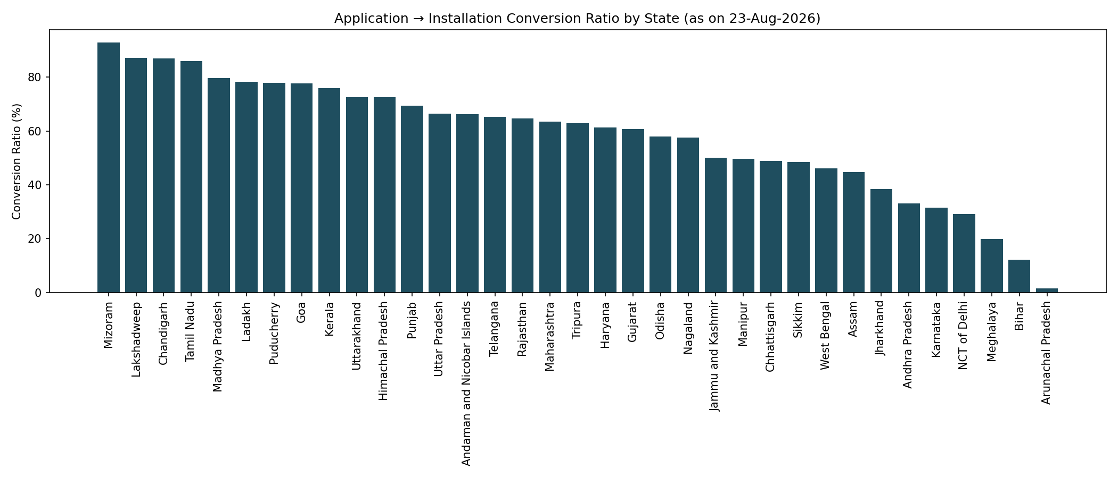
Figure 1. Application-to-installation conversion ratio by state.
Correlating conversion ratio against every collected covariate found two variables with a meaningfully non-zero relationship: 2024→2025 tariff growth (r = +0.53, n = 34) and solar irradiance (r = +0.51, n = 28). Subsidy/tariff level, raw solar potential, and application volume itself showed near-zero correlation (|r| < 0.15) across the board.
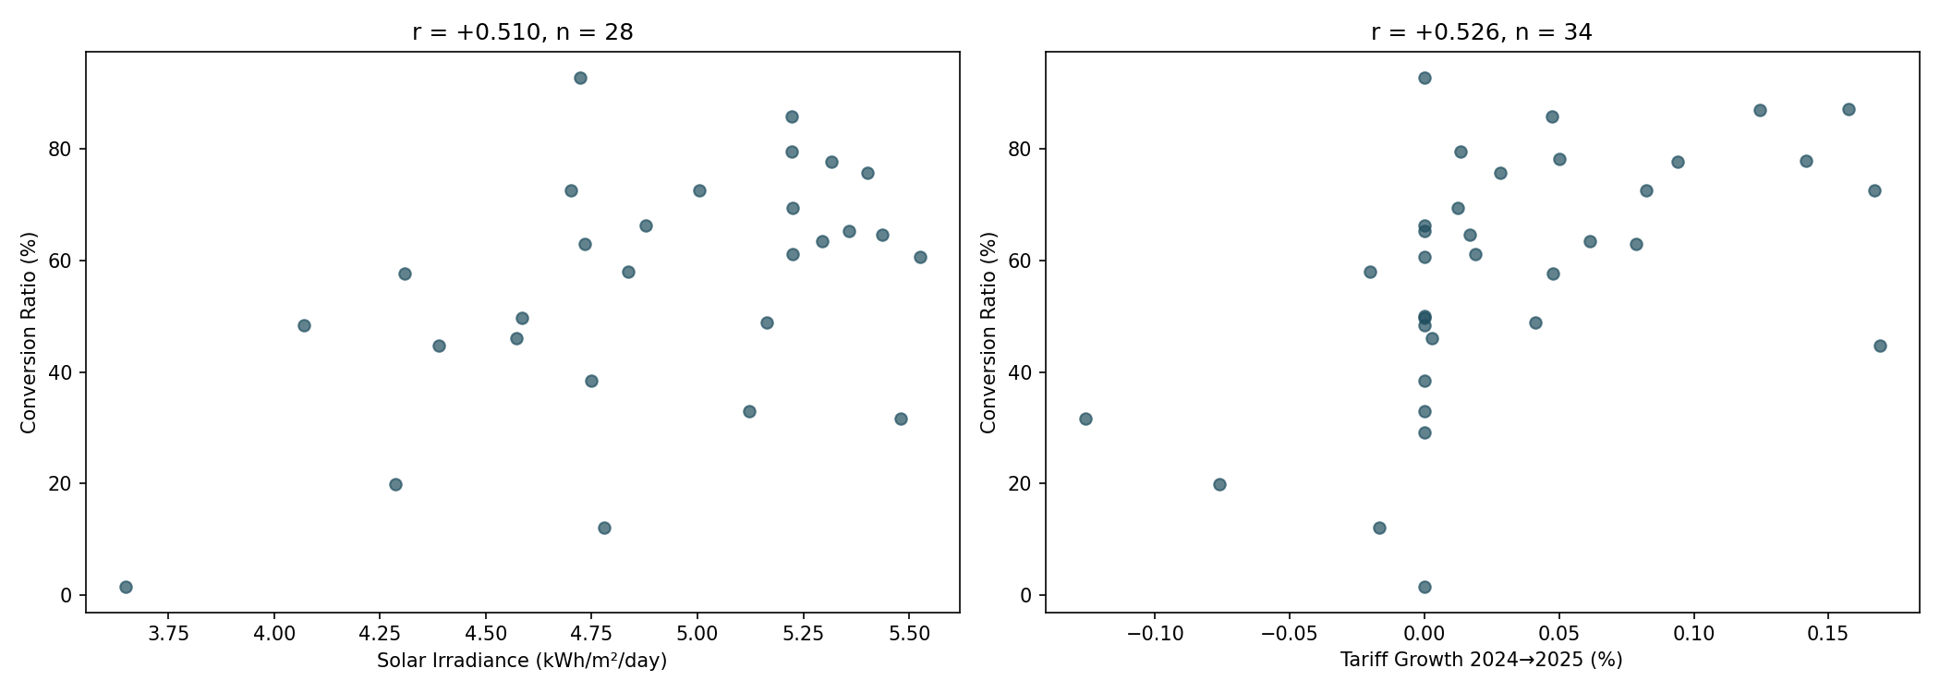
Figure 2. Irradiance and tariff-growth scatter plots against conversion ratio.

4. Predictive Modeling
Two model families were compared using Leave-One-Out Cross-Validation, appropriate given the small sample size (28–35 states).
Model | Features | n | LOO-CV MAE | vs. Naive Baseline
Linear Regression (best) | Tariff growth % + Irradiance | 28 | 0.135 | -20.7%
Random Forest | 6 covariates | 28 | 0.161 | -5.9%
Linear (single) | Tariff growth only | 34 | 0.150 | -15.3%
Linear (single) | Irradiance only | 28 | 0.155 | -9.4%

The simple two-feature linear model outperformed the six-feature Random Forest — with only 28 rows, additional features caused overfitting rather than improved generalization. This finding was cross-checked with SHAP values on the Random Forest model; tariff growth and irradiance ranked highest by both Gini importance and mean |SHAP value|, agreeing with the linear model's coefficients.
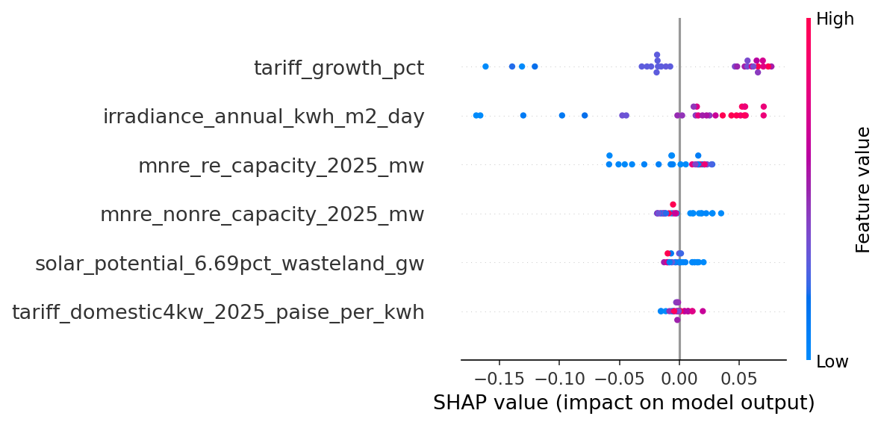
Figure 3. SHAP summary plot — feature impact on the Random Forest's predictions.
Best-fit equation: Conversion Ratio ≈ –0.707 + 1.607 × (tariff growth %) + 0.250 × (irradiance, kWh/m²/day). In-sample R² = 0.455; this is reported for reference only and is not equivalent to predictive power — the LOO-CV MAE above is the honest generalization estimate.

5. Forecasting
National cumulative installations were forecast from six dated official releases spanning November 2024 to August 2026 — eighteen months since scheme launch. This is too few points to safely fit ARIMA or SARIMAX without overfitting, so naive, linear, and log-linear (exponential growth) extrapolation were compared by in-sample MAPE.
Method | In-sample MAPE
Naive (first value carried) | 57.19%
Linear trend | 16.83%
Log-linear (exponential) trend | 4.98%

Log-linear extrapolation fit substantially better, consistent with a subsidy scheme still in its ramp-up phase. Forecasts with 95% prediction intervals:
Horizon | Forecast Date | Point Forecast | 95% Interval
+3 months | ~Nov 2026 | 5.24 million | 4.62M – 5.95M
+6 months | ~Feb 2027 | 6.84 million | 6.03M – 7.75M
+12 months | ~Jul 2027 | 11.61 million | 10.24M – 13.17M

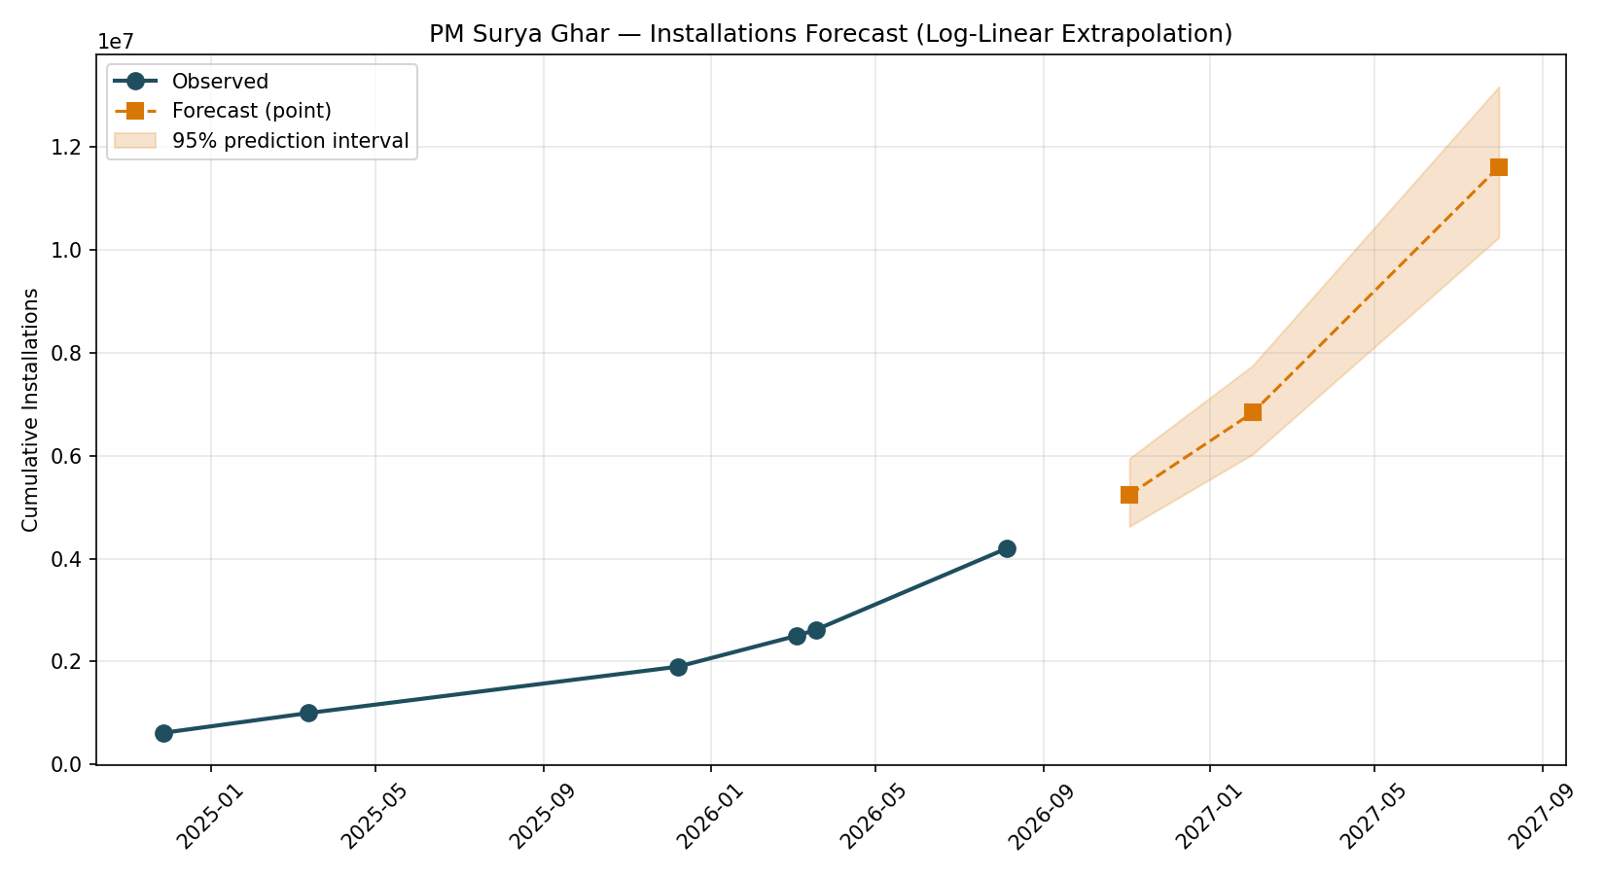
Figure 4. Observed installations and log-linear forecast with 95% prediction interval.
This forecast assumes the current growth rate continues; real-world adoption typically follows an S-curve that eventually flattens as the addressable market saturates. The 12-month forecast should be treated with more caution than the 3-month forecast for this reason.

6. Scenario Analysis
The guideline defines five scenarios (A–E). Only three are genuinely supportable given the model's two features (tariff growth, irradiance) — Scenario B (subsidy +10%) and the subsidy component of Scenario E cannot be simulated, since state-level subsidy data was not collected (Section 2.2). This is stated explicitly rather than fabricated.

6.1 Scenario C — High Solar Potential Targeting
States with above-median irradiance but below-median conversion ratio — a direct "high-potential, low-adoption" profile — are: Gujarat, Karnataka, Chhattisgarh, and Andhra Pradesh. These are reasonable candidates for differentiated policy attention, since physical solar resource is not their binding constraint.

6.2 Scenario D — Tariff Increase
Simulating a +10 percentage-point tariff-growth shock predicts a uniform +16 percentage-point lift in conversion ratio for every state.
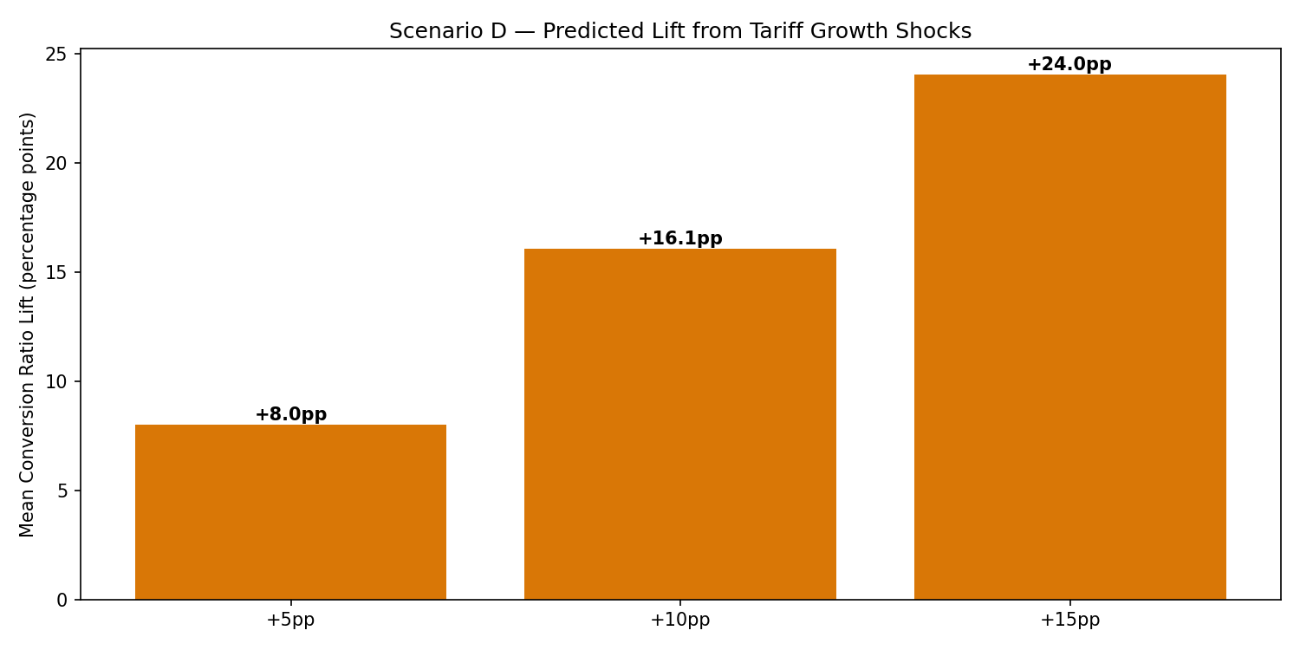
Figure 5. Predicted mean conversion-ratio lift under tariff growth shocks.
This uniformity is a modeling limitation, not necessarily a real-world finding: the linear model has no interaction terms, so it cannot express that a state near adoption saturation might respond less than a state with more headroom. A model with tariff × current-adoption interaction terms is a natural next step, not attempted here given the sample size.

6.3 Scenario E — Combined Intervention (Partial)
The tariff-shock component of Scenario D was applied specifically to the four Scenario C targeting states, yielding the same uniform +16pp lift. The subsidy-increase component that would complete this scenario is not modeled.

7. Limitations
- Small sample size: 28–35 states is limited for a six-feature model; the Random Forest result should be read as a caution against overfitting, not a strong finding in its own right.
- Cross-sectional, not longitudinal: all modeling uses a single dated snapshot (23 August 2026). Whether the tariff-growth/irradiance relationship holds requires a second aligned cross-section at a future date.
- Correlational, not causal: none of the reported relationships should be interpreted causally without a proper identification strategy (difference-in-differences, instrumental variables, or synthetic control), none of which was attempted here.
- Limited historical depth: PM Surya Ghar launched in February 2024; only six dated national installation figures exist across eighteen months, constraining the forecasting methodology to simple extrapolation.
- Missing subsidy and net-metering data: two Tier 1 datasets were deliberately not collected due to the absence of a centralized source, limiting Scenario B and part of Scenario E.
- Source disagreement: official releases occasionally disagree on the same metric for close dates (e.g., a household count differing by roughly 38,000 between two releases one day apart in early August 2026) — the more granular, traceable source was preferred in each case, and the discrepancy is logged rather than silently resolved.
- No population normalization: state population data was not collected, so per-capita installation rates are not reported here.

8. Conclusion and Future Work
This project set out to explain why PM Surya Ghar conversion efficiency varies so widely across Indian states. The strongest, most consistent finding across correlation analysis, linear regression, Random Forest importance, and SHAP values is that tariff growth and solar irradiance predict conversion efficiency meaningfully better than subsidy level or raw solar potential — direct evidence against a "subsidy amount alone" explanation, and a concrete first step toward resolving the subsidy paradox identified in prior literature.
Future work should prioritize, in order: (1) collecting state-level subsidy top-up data to properly test Scenario B; (2) obtaining a second aligned cross-section to test whether the tariff-growth/irradiance relationship is stable over time, which would meaningfully strengthen the causal plausibility of these findings; (3) adding interaction terms to the model to capture state-specific responsiveness to tariff changes; and (4) sourcing state population data to enable per-capita normalized analysis.

Data Sources
- data.gov.in — PM Surya Ghar registrations, applications, households, installations (Rajya Sabha Sessions 266 & 267)
- PM Surya Ghar National Portal (pmsuryaghar.gov.in) — live district/DISCOM dashboard, 23 August 2026
- Central Electricity Authority — "Electricity Tariff & Duty and Average Rates of Electricity Supply in India," March 2024 and March 2025 editions
- NITI Aayog India Climate & Energy Dashboard (ICeD) — state-wise solar potential
- NASA POWER — solar irradiance climatology (2001–2020), Renewable Energy community
- Ministry of New and Renewable Energy — RE-Statistics 2024-25 report
- Rajya Sabha written replies and PIB press releases, November 2024 – August 2026 (national installation time series)

