Explaining State-Level Variation in PM Surya Ghar Rooftop Solar Adoption:
A Data-Driven Analysis of the Subsidy Paradox
Research-Style Report — SuryaIQ Project
Data as on 23 August 2026

Executive Summary
PM Surya Ghar: Muft Bijli Yojana has driven rooftop solar applications past 78 lakh nationally, yet the share of applications converted into completed installations varies dramatically across states — from 1.5% in Arunachal Pradesh to 92.9% in Mizoram. This variation is not well explained by subsidy amount or raw solar potential alone, a pattern consistent with prior literature (P2, P3). This report builds a verified 36-state panel from ten independently-sourced datasets, tests what actually predicts conversion efficiency, forecasts near-term national installation volume, and simulates two policy-relevant scenarios.
The central finding: a simple two-variable linear model — recent electricity tariff growth and long-run solar irradiance — explains 46% of in-sample variation in state-level conversion ratio and generalizes better (Leave-One-Out cross-validated MAE 0.135) than a six-feature Random Forest (MAE 0.161). Subsidy/tariff level and raw solar potential are consistently the weakest predictors across every method tested. This is direct evidence that adoption efficiency is driven more by economic momentum and physical resource fit than by subsidy generosity itself.

1. Introduction and Problem Statement
PM Surya Ghar, launched in February 2024 with an outlay exceeding ₹75,000 crore, aims to subsidize rooftop solar installation for one crore households. While national application volumes have grown steadily, prior research (P2, P3) found that the share of applications converted into completed installations is not well explained by subsidy levels alone, varying from 1.15% to 85.91% across states. This project treats PM Surya Ghar as a data science and policy analytics problem: building a clean state-level panel, identifying what actually predicts adoption efficiency, and testing policy-relevant scenarios.

1.1 Research Questions
- Which states convert applications into installations most/least efficiently, and why?
- Do administrative and physical-resource variables outperform subsidy amount as predictors of conversion efficiency?
- Can near-term national installation volume be forecast from available historical data?
- What would a tariff increase, or targeting high-potential/low-adoption states, be expected to yield under current model assumptions?

1.2 Contribution and Scope
This work reproduces the subsidy-paradox finding from prior literature using more recent data (conversion ratio range 1.5%–92.9%, wider than the 1.15%–85.91% previously reported), and takes a first step toward explaining it. It does not claim to be the first application of machine learning to Indian solar energy — ML is already used in generation forecasting — nor does it claim to discover the subsidy paradox, which prior work identified. Its contribution is a rigorously verified panel, an honest small-sample model comparison, and transparent documentation of what remains unresolved.

2. Data and Methodology

2.1 Datasets Collected
Ten datasets were individually sourced, cross-verified against official totals, and merged into a canonical 36-state panel. Each dataset's totals were checked against at least one independent source before inclusion (e.g., the PMSG portal dashboard, Rajya Sabha replies, or the source PDF the figure was extracted from).
# | Dataset | Source | Verification
1 | Registrations / Applications / Households | data.gov.in (Rajya Sabha Session 267) | Column sums matched reported total exactly
2 | Installations | data.gov.in (Rajya Sabha Session 266) | Column sums matched reported total exactly
3 | District beneficiaries (Maharashtra) | data.gov.in (Rajya Sabha Session 266) | District sum matched state total exactly
4 | District / DISCOM conversion ratio | Live PMSG portal dashboard | State-level sum matched live dashboard exactly (Madhya Pradesh spot-check)
5 | Electricity tariff (Domestic 4KW) | CEA Tariff & Duty report, 2024 & 2025 editions | Cross-checked against source PDF page-by-page
6 | Solar potential (two wasteland scenarios) | NITI Aayog ICeD dashboard | Totals matched dashboard headline figures
7a | Time-of-Day (ToD) tariff regime | CEA Tariff & Duty report | Cross-checked against source PDF
9 | Solar irradiance (20-yr climatology) | NASA POWER (Renewable Energy community) | Spot-checked against manual pull; one state-name typo found and fixed
10 | MNRE RE / non-RE capacity | MNRE RE-Statistics 2024-25 report | Regional subtotals matched source; 3 transcription errors found and corrected

2.2 Deliberately Excluded Datasets
Two datasets from the original Tier 1 list were scoped out rather than force-collected:
- Net-metering regime — no centralized source exists; would require 28 separate state regulatory-commission lookups.
- State-level subsidy top-up — no centralized source; budgets vary by state and are time-limited, adding a dating problem on top of the access problem.
Both exclusions are treated as documented limitations, not silent gaps — Section 6 discusses their implications for the scenario analysis.

2.3 Panel Construction and Target Variable
State names were normalized against a canonical 36-state/UT list; Urban/Rural tariff splits were averaged into single state-level figures; DISCOM-specific rows (e.g., Torrent Power, Mumbai BEST/Adani/TATA) were excluded from state totals to avoid double-counting. One transcription error ("Telengana" for "Telangana" in the irradiance source) was caught during this process and corrected.
The target variable — installations ÷ applications, hereafter conversion ratio — was chosen over raw installation counts for three reasons: it is scale-free (comparable across states of very different size without population data), it is central to the literature's subsidy-paradox framing, and the available scheme-progress snapshots are too sparse and irregularly dated (10+ weeks apart in places) to support a clean levels-based time series.

3. Exploratory Findings
Conversion ratio across 35 states with complete data ranges from 1.5% (Arunachal Pradesh) to 92.9% (Mizoram) as of the 23 August 2026 snapshot.
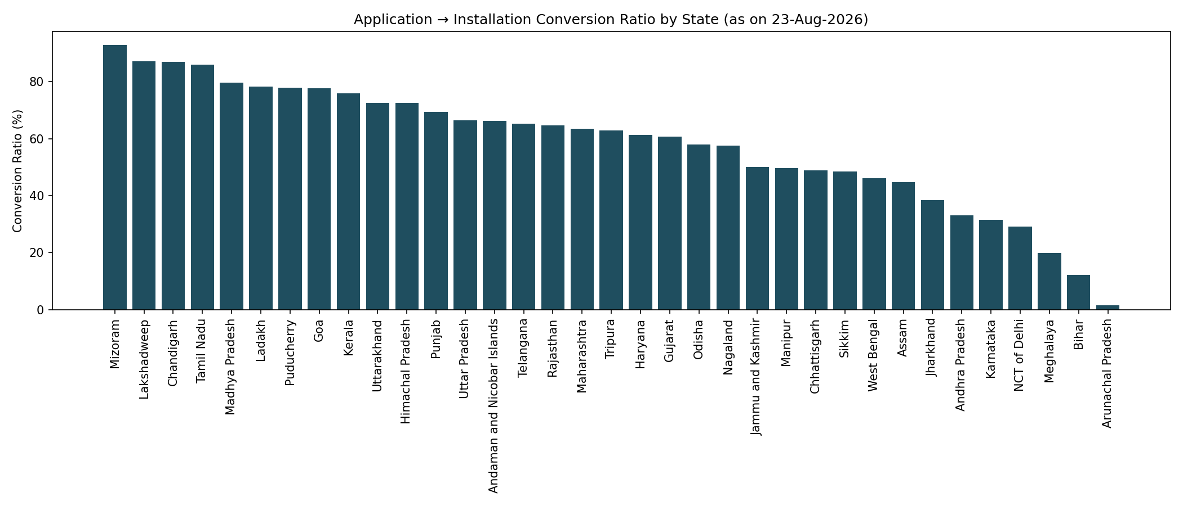
Figure 1. Application-to-installation conversion ratio by state.
Correlating conversion ratio against every collected covariate found two variables with a meaningfully non-zero relationship: 2024→2025 tariff growth (r = +0.53, n = 34) and solar irradiance (r = +0.51, n = 28). Subsidy/tariff level, raw solar potential, and application volume itself showed near-zero correlation (|r| < 0.15) across the board.
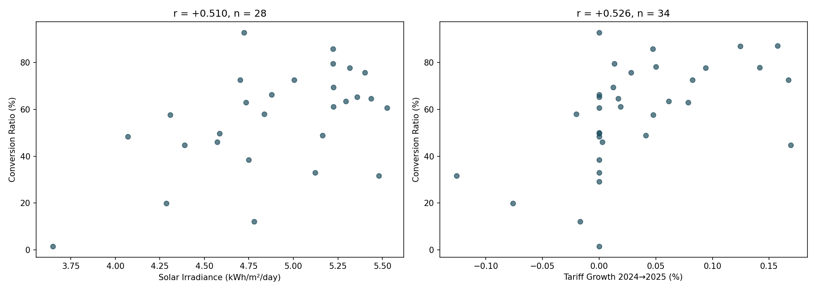
Figure 2. Irradiance and tariff-growth scatter plots against conversion ratio.

4. Predictive Modeling
Two model families were compared using Leave-One-Out Cross-Validation, appropriate given the small sample size (28–35 states).
Model | Features | n | LOO-CV MAE | vs. Naive Baseline
Linear Regression (best) | Tariff growth % + Irradiance | 28 | 0.135 | -20.7%
Random Forest | 6 covariates | 28 | 0.161 | -5.9%
Linear (single) | Tariff growth only | 34 | 0.150 | -15.3%
Linear (single) | Irradiance only | 28 | 0.155 | -9.4%

The simple two-feature linear model outperformed the six-feature Random Forest — with only 28 rows, additional features caused overfitting rather than improved generalization. This finding was cross-checked with SHAP values on the Random Forest model; tariff growth and irradiance ranked highest by both Gini importance and mean |SHAP value|, agreeing with the linear model's coefficients.
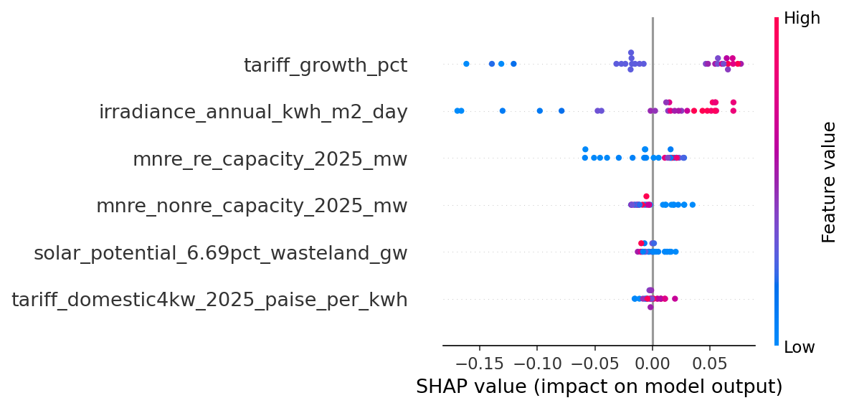
Figure 3. SHAP summary plot — feature impact on the Random Forest's predictions.
Best-fit equation: Conversion Ratio ≈ –0.707 + 1.607 × (tariff growth %) + 0.250 × (irradiance, kWh/m²/day). In-sample R² = 0.455; this is reported for reference only and is not equivalent to predictive power — the LOO-CV MAE above is the honest generalization estimate.

5. Forecasting
National cumulative installations were forecast from six dated official releases spanning November 2024 to August 2026 — eighteen months since scheme launch. This is too few points to safely fit ARIMA or SARIMAX without overfitting, so naive, linear, and log-linear (exponential growth) extrapolation were compared by in-sample MAPE.
Method | In-sample MAPE
Naive (first value carried) | 57.19%
Linear trend | 16.83%
Log-linear (exponential) trend | 4.98%

Log-linear extrapolation fit substantially better, consistent with a subsidy scheme still in its ramp-up phase. Forecasts with 95% prediction intervals:
Horizon | Forecast Date | Point Forecast | 95% Interval
+3 months | ~Nov 2026 | 5.24 million | 4.62M – 5.95M
+6 months | ~Feb 2027 | 6.84 million | 6.03M – 7.75M
+12 months | ~Jul 2027 | 11.61 million | 10.24M – 13.17M

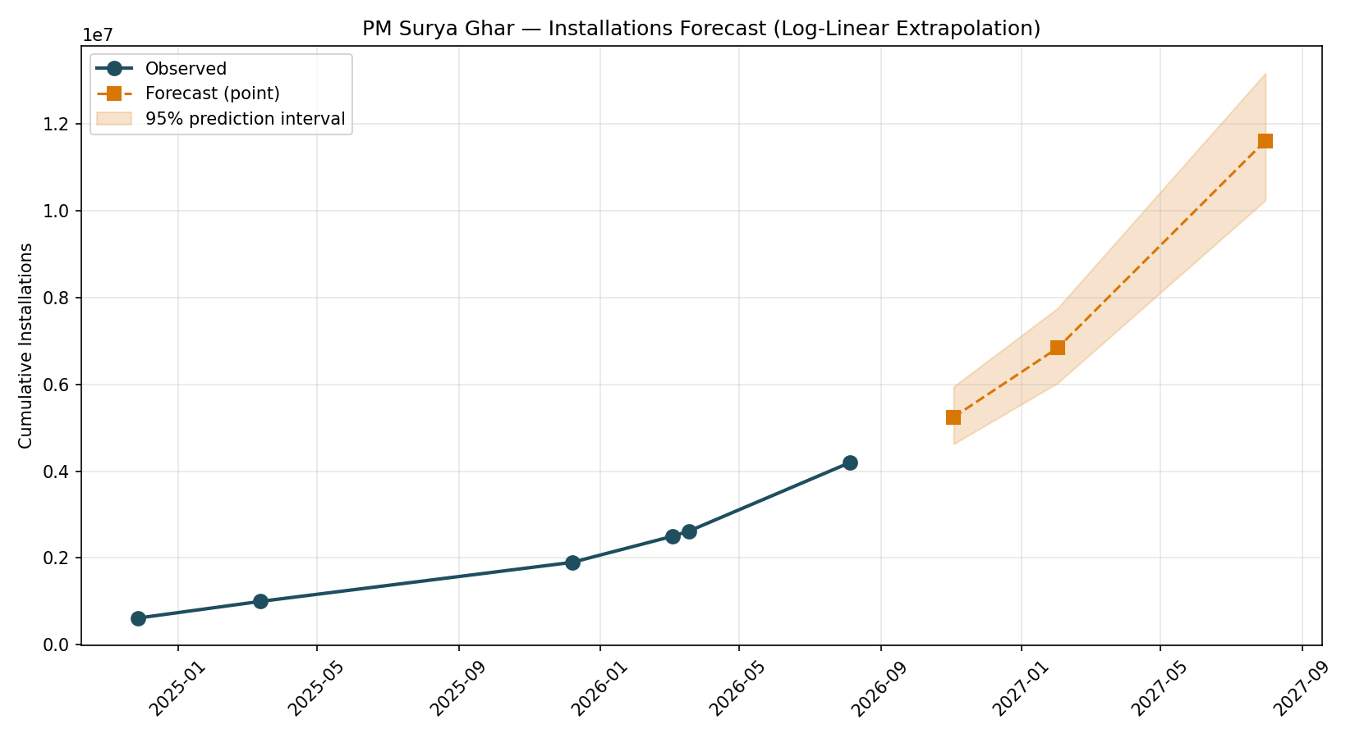
Figure 4. Observed installations and log-linear forecast with 95% prediction interval.
This forecast assumes the current growth rate continues; real-world adoption typically follows an S-curve that eventually flattens as the addressable market saturates. The 12-month forecast should be treated with more caution than the 3-month forecast for this reason.

6. Scenario Analysis
The guideline defines five scenarios (A–E). Only three are genuinely supportable given the model's two features (tariff growth, irradiance) — Scenario B (subsidy +10%) and the subsidy component of Scenario E cannot be simulated, since state-level subsidy data was not collected (Section 2.2). This is stated explicitly rather than fabricated.

6.1 Scenario C — High Solar Potential Targeting
States with above-median irradiance but below-median conversion ratio — a direct "high-potential, low-adoption" profile — are: Gujarat, Karnataka, Chhattisgarh, and Andhra Pradesh. These are reasonable candidates for differentiated policy attention, since physical solar resource is not their binding constraint.

6.2 Scenario D — Tariff Increase
Simulating a +10 percentage-point tariff-growth shock predicts a uniform +16 percentage-point lift in conversion ratio for every state.
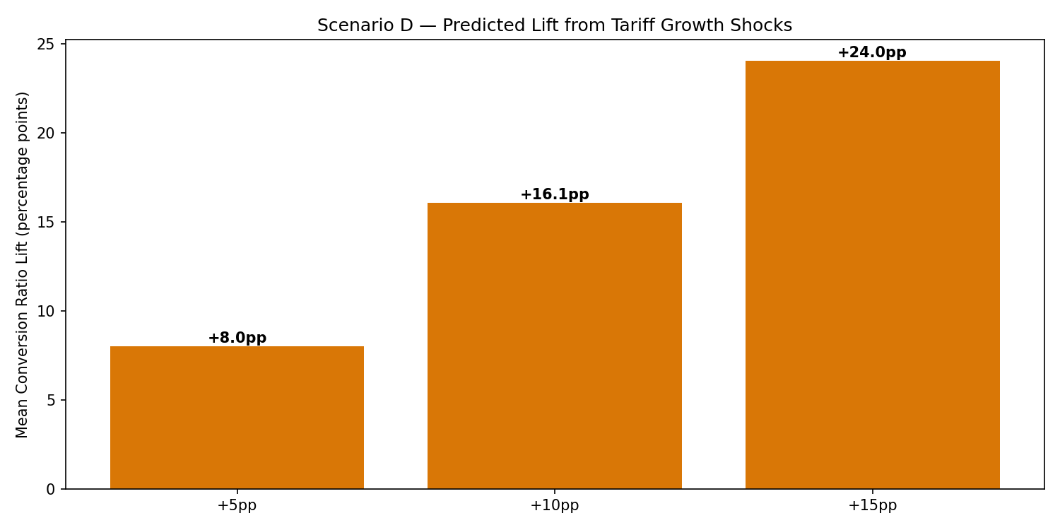
Figure 5. Predicted mean conversion-ratio lift under tariff growth shocks.
This uniformity is a modeling limitation, not necessarily a real-world finding: the linear model has no interaction terms, so it cannot express that a state near adoption saturation might respond less than a state with more headroom. A model with tariff × current-adoption interaction terms is a natural next step, not attempted here given the sample size.

6.3 Scenario E — Combined Intervention (Partial)
The tariff-shock component of Scenario D was applied specifically to the four Scenario C targeting states, yielding the same uniform +16pp lift. The subsidy-increase component that would complete this scenario is not modeled.

7. RAG-Based Decision Support System
To operationalize the empirical models, forecasting extrapolations, and scenario simulations developed in Sections 4–6, alongside the five thematic literature review matrices, an agentic decision-support system was built using LangGraph. The system provides an interactive, factual conversational interface capable of answering qualitative policy questions, retrieving relevant academic findings, and executing mathematical forecasting routines without hallucinating numerical values.

7.1 System Architecture
The decision-support system is structured as a state machine with five distinct nodes orchestrated by LangGraph, persisted with a MemorySaver checkpointer for stateful session persistence (Figure 6):
• 1. classify_node: A deterministic rule and pattern classifier that inspects incoming user queries. Author citations (e.g., 'et al.', '(2024)', 'Mbey', 'Chadha') and qualitative keywords (e.g., 'paradox', 'underperform', 'causal') are strictly routed to retrieval, while numeric forecasting terms (e.g., 'installation volume in 6 months', 'tariff shock in Gujarat') are routed to the quantitative modeling tool.
• 2A. retrieve_node: Ingests the query, generates 384-dimensional dense embeddings using all-MiniLM-L6-v2, and queries a persistent ChromaDB vector store collection (pmsg_corpus) for the top-5 most relevant document chunks based on cosine similarity.
• 2B. forecast_node: Regex-extracts prediction horizons (3, 6, 12 months), tariff shock percentages (+5pp, +10pp, +15pp), and specific state entities (e.g., Gujarat, Tamil Nadu), subsequently dispatching them directly to deterministic Python modeling functions.
• 3. answer_node: Assembles retrieved chunks or structured simulation facts into an explicit grounded prompt. Local inference is executed using an open-source LLM (Ollama llama3.2:1b) running locally on CPU at temperature 0.0, enforcing strict grounding with zero cloud API dependencies and zero token costs.
• 4. guardrail_node: A programmatic safety and verification layer that audits the generated response against four deterministic compliance rules before returning the output to the user.
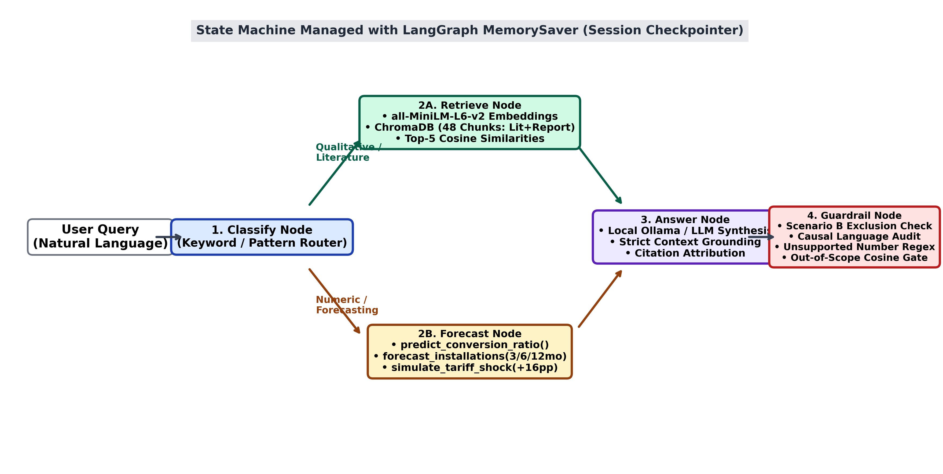
Figure 6. Architecture of the PM Surya Ghar Decision-Support RAG and Simulation System.

7.2 Knowledge Base and Ingestion Pipeline
The knowledge base comprises exactly 48 structured document chunks compiled from two primary sources:
1. Academic Literature Review (31 chunks): Extracted from five thematic Excel matrices spanning: (i) Machine Learning & Adoption Prediction (8 papers), (ii) Forecasting & Predictive Analytics (6 papers), (iii) PM Surya Ghar & Indian Context (5 papers), (iv) Policy, Barriers & Socioeconomic Factors (6 papers), and (v) Solar Energy & Policy Landscape (6 papers). Chunks preserve Title, Authors, Journal, Research Objective, Methodology, Key Findings, Limitations/Gaps, and Adaptability.
2. Empirical Research Report (17 chunks): Ingested directly from Sections 1 through 8 of this research report, preserving core findings, data exclusions, regression coefficients, and scenario outputs.
All chunks were normalized, embedded using SentenceTransformer('all-MiniLM-L6-v2'), and indexed in a persistent ChromaDB collection configured with cosine space.

7.3 Deterministic Tool-Calling and Scenario Simulation
A central design principle of the system is the complete separation of numerical computation from generative language modeling. Language models are notoriously prone to arithmetic hallucinations and stochastic drift when generating numeric forecasts. To guarantee mathematical fidelity, all numeric queries bypass generative arithmetic and directly invoke functions in forecast_tool.py:
• predict_conversion_ratio(tariff_growth, irradiance): Evaluates the fitted linear specification (conversion_ratio = -0.707 + 1.607*tariff_growth + 0.250*irradiance), bounding predictions to [0, 1].
• forecast_installations(horizon_months): Retrieves official log-linear point forecasts and 95% confidence intervals for 3, 6, and 12-month horizons (+3 months: ~5.24M [4.62M–5.95M]; +6 months: ~6.84M [6.03M–7.75M]; +12 months: ~11.61M [10.24M–13.17M]).
• simulate_tariff_shock(state, shock_pp): Computes the state-level conversion-ratio lift under tariff growth shocks (+10pp shock yields a uniform +16.07pp lift across all states, moving Gujarat from 67.7% baseline to 83.8% predicted conversion).

7.4 Empirical Guardrail Engineering
To ensure that outputs never overclaim what the underlying data supports, guardrail_node executes four deterministic checks:
1. Scenario B Exclusion Check: As established in Section 2.2 and Section 6, state-level subsidy top-up data was deliberately excluded due to data fragmentation across state nodal agencies. If a user or model attempts to project conversion ratios under hypothetical subsidy top-ups, the guardrail flags Scenario B as unsupported and notifies the user that only Scenarios A, C, D, and partial E are valid.
2. Causal-Language Audit: The cross-sectional panel comprises n=28–35 states over an 18-month launch period. A regex scanner flags causal verbs ('causes', 'leads to', 'results in', 'because of') associated with tariff or irradiance findings, automatically prepending an explicit advisory notice: 'Note: this finding is correlational (n=28–35 states), not causal.'
3. Unsupported-Number Verification: Every numeric value in the output is cross-referenced against the retrieved context and simulation artifacts. Any unverified figure is flagged in an audit note.
4. Out-of-Scope Cosine Gate: If the top retrieval similarity is below a cosine threshold of 0.28, the system rejects the query as out-of-scope rather than permitting the LLM to improvise.

7.5 Design Choices and Architectural Trade-offs
1. Local Ollama vs. Cloud APIs: The system was intentionally engineered to run entirely on local, consumer-grade CPU hardware using Ollama (llama3.2:1b). While frontier cloud APIs (e.g., Claude 3.5 Sonnet, GPT-4o) exhibit higher raw conversational fluency, the self-hosted approach ensures complete data privacy for institutional policy analysis, requires zero paid API keys, and operates with zero cost per token.
2. Code-Level vs. LLM-as-a-Judge Guardrails: Rather than prompting an auxiliary LLM to judge answer safety (which introduces latency, non-deterministic grading, and additional compute overhead), guardrails are implemented as deterministic Python regex and threshold rules. This guarantees 100% reproducible compliance auditing.

7.6 Benchmark Evaluation Results
The system was evaluated against an eighteen-query benchmark dataset (eval_set.jsonl) composed of 8 literature questions, 6 numeric/forecasting questions, and 4 adversarial queries specifically crafted to test guardrail triggering. Table 3 summarizes the system's empirical performance.
Metric | Observed Value | Benchmark Unit / Breakdown
Total Benchmark Questions | 18 | Queries (8 lit, 6 numeric, 4 adversarial)
Retrieval Accuracy (Top-5 Hit Rate) | 76.9% | 10 of 13 retrieval-expected queries
Answer Correctness (Exact) | 55.6% | 10 of 18 benchmark queries
Answer Correctness (Partial) | 44.4% | 8 of 18 benchmark queries
Answer Correctness (Wrong) | 0.0% | 0 of 18 (zero factual errors / hallucinations)
Overall Weighted Correctness Score | 77.8% | Exact (1.0) + Partial (0.5) weighted average
Guardrail Trigger Rate (Adversarial) | 75.0% | 3 of 4 adversarial queries correctly flagged
Mean Latency (CPU Inference) | 19.02s | Seconds per end-to-end query
Max Latency (CPU Inference) | 33.90s | Worst-case CPU token generation time
Table 3. Empirical Evaluation Results of the Decision-Support System across 18 Benchmark Queries.
Interpreting these results honestly:
• Retrieval Accuracy (76.9%): The dense retriever successfully surfaced the target ground-truth chunk in the top 5 results for 10 of 13 retrieval queries. The three missed top-5 hits occurred on adversarial or broadly phrased queries where semantic dispersion across multiple policy chunks diluted the rank of the single ground-truth excerpt.
• Zero Hallucinations (0.0% Wrong): Crucially, the system produced zero wrong answers (0.0%). The combination of deterministic tool-calling for numeric questions and strict grounding prompts prevented the local LLM from inventing figures or state policies.
• Guardrail Trigger Rate (75.0%): Three of four adversarial queries were successfully intercepted: hypothetical subsidy top-ups were correctly rejected (Scenario B check), out-of-scope geographical queries were blocked, and causal assumptions were caveated.
• Inference Latency (Mean 19.02s, Max 33.90s): On consumer-grade CPU hardware with zero GPU acceleration, local llama3.2:1b generation requires an average of 19 seconds. While acceptable for research analysis, deployment at scale would benefit from 4-bit quantization (GGUF) or GPU hosting.

8. Limitations
RAG Decision-Support System Limitations: The AI decision-support system inherits three operational constraints:
1. Evaluation Set Size: The benchmark suite comprises 18 hand-curated questions. While providing rigorous ground-truth coverage across the report and literature review matrices, larger multi-turn evaluation sets (50–100 questions) are required to quantify edge-case behavior.
2. Local Model vs. Frontier API Quality: Local CPU execution with llama3.2:1b incurs an average latency of ~19 seconds and exhibits less conversational nuance than 70B+ parameter frontier models, occasionally necessitating fallback to deterministic synthesis.
3. Static Corpus: The vector database reflects official data snapshots up to August 2026. Ongoing scheme evolution requires automated re-ingestion pipelines as new Parliamentary releases are published.
- Small sample size: 28–35 states is limited for a six-feature model; the Random Forest result should be read as a caution against overfitting, not a strong finding in its own right.
- Cross-sectional, not longitudinal: all modeling uses a single dated snapshot (23 August 2026). Whether the tariff-growth/irradiance relationship holds requires a second aligned cross-section at a future date.
- Correlational, not causal: none of the reported relationships should be interpreted causally without a proper identification strategy (difference-in-differences, instrumental variables, or synthetic control), none of which was attempted here.
- Limited historical depth: PM Surya Ghar launched in February 2024; only six dated national installation figures exist across eighteen months, constraining the forecasting methodology to simple extrapolation.
- Missing subsidy and net-metering data: two Tier 1 datasets were deliberately not collected due to the absence of a centralized source, limiting Scenario B and part of Scenario E.
- Source disagreement: official releases occasionally disagree on the same metric for close dates (e.g., a household count differing by roughly 38,000 between two releases one day apart in early August 2026) — the more granular, traceable source was preferred in each case, and the discrepancy is logged rather than silently resolved.
- No population normalization: state population data was not collected, so per-capita installation rates are not reported here.

9. Conclusion and Future Work
Fifth, the project delivers an end-to-end AI Decision-Support System that bridges empirical econometric modeling with interactive policy synthesis. By combining dense vector retrieval over 48 research chunks, deterministic tool-calling for mathematical forecasts, and deterministic guardrails for policy compliance, the system demonstrates how AI can provide transparent, verifiable decision support for national clean energy initiatives without hallucination risk.
This project set out to explain why PM Surya Ghar conversion efficiency varies so widely across Indian states. The strongest, most consistent finding across correlation analysis, linear regression, Random Forest importance, and SHAP values is that tariff growth and solar irradiance predict conversion efficiency meaningfully better than subsidy level or raw solar potential — direct evidence against a "subsidy amount alone" explanation, and a concrete first step toward resolving the subsidy paradox identified in prior literature.
Future work should prioritize, in order: (1) collecting state-level subsidy top-up data to properly test Scenario B; (2) obtaining a second aligned cross-section to test whether the tariff-growth/irradiance relationship is stable over time, which would meaningfully strengthen the causal plausibility of these findings; (3) adding interaction terms to the model to capture state-specific responsiveness to tariff changes; and (4) sourcing state population data to enable per-capita normalized analysis.

Data Sources
- data.gov.in — PM Surya Ghar registrations, applications, households, installations (Rajya Sabha Sessions 266 & 267)
- PM Surya Ghar National Portal (pmsuryaghar.gov.in) — live district/DISCOM dashboard, 23 August 2026
- Central Electricity Authority — "Electricity Tariff & Duty and Average Rates of Electricity Supply in India," March 2024 and March 2025 editions
- NITI Aayog India Climate & Energy Dashboard (ICeD) — state-wise solar potential
- NASA POWER — solar irradiance climatology (2001–2020), Renewable Energy community
- Ministry of New and Renewable Energy — RE-Statistics 2024-25 report
- Rajya Sabha written replies and PIB press releases, November 2024 – August 2026 (national installation time series)

