1)
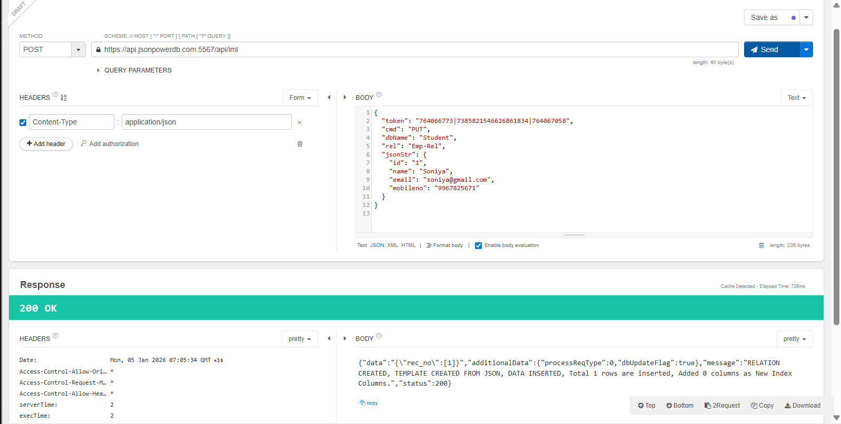
This screenshot shows successful execution of a POST (PUT) request to JsonPowerDB using an API testing tool.
It confirms that the record was inserted successfully with a 200 OK response during CRUD operation practice.

2)

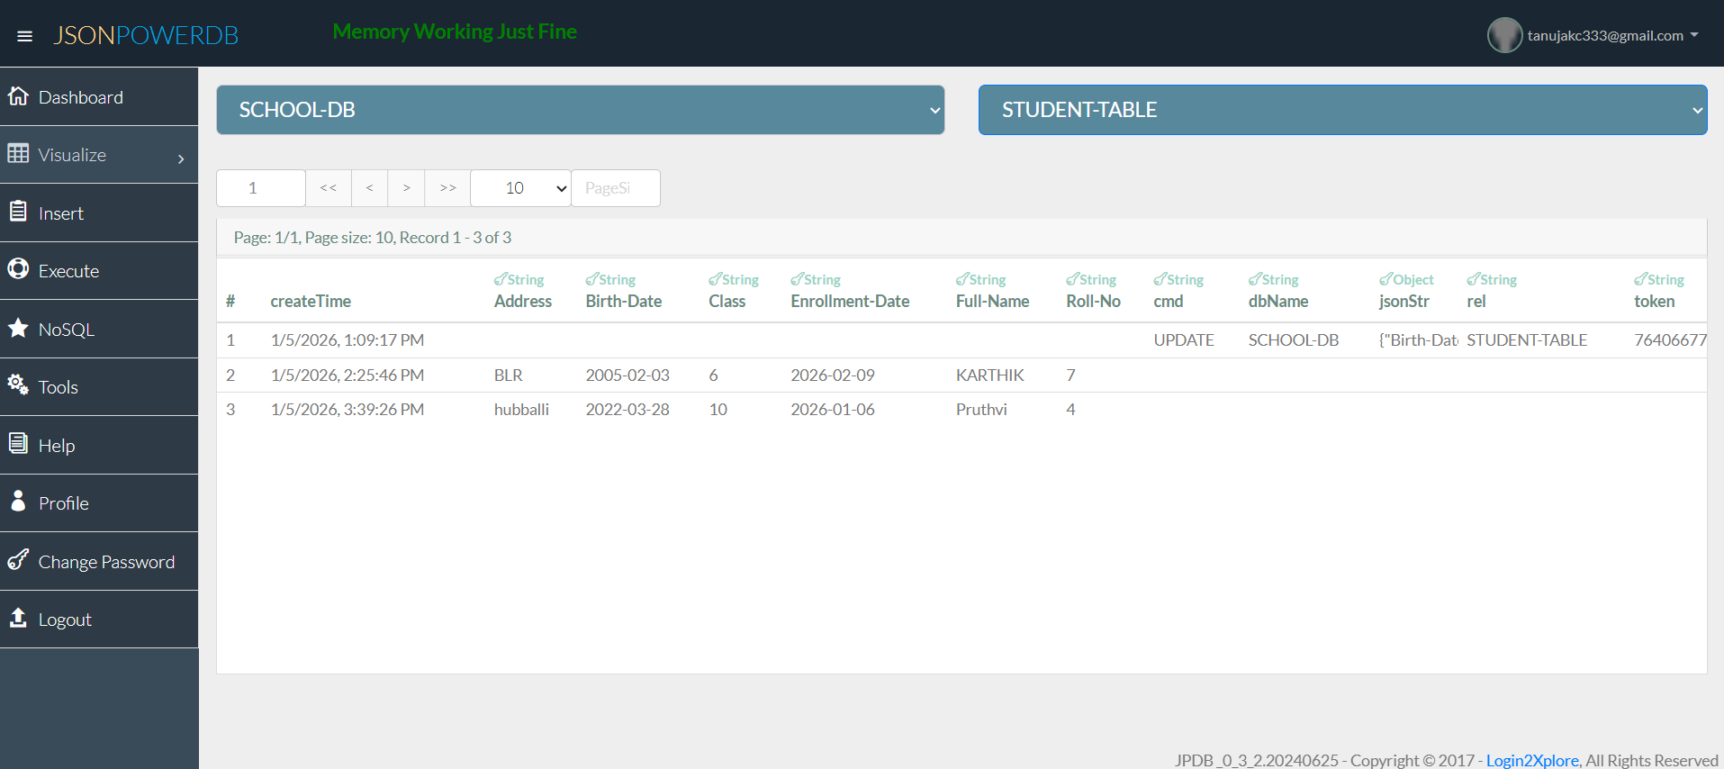
Database Records View
This screenshot shows the records stored in JsonPowerDB under the SCHOOL-DB database and STUDENT-TABLE relation.
It confirms successful Save and Update operations performed through the Student Enrollment Form.

