**Write a program to print Hello World.**

org 100h

jmp lab1

msg: db "Hello, World!", 0Dh,0Ah, 24h

lab1: mov dx, msg

mov ah, 09h

int 21h

mov ah, 0

int 16h

ret

**OUTPUT:**

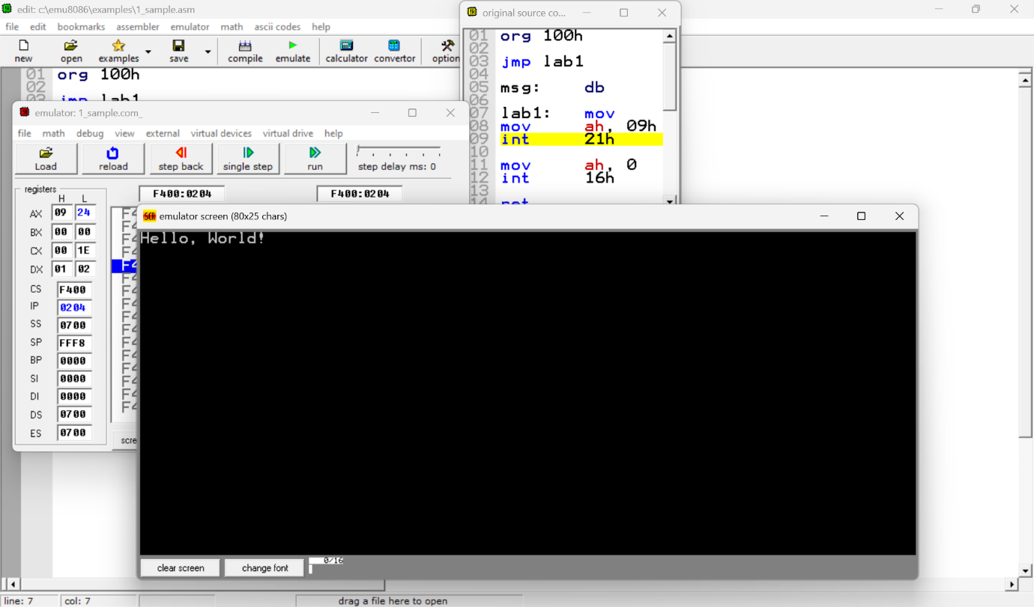

**Write a program to print your name.**

org 100h

jmp intro

msg: db "Myself Tanuja Chakka", 0Dh,0Ah, 24h

intro: mov dx, msg

mov ah, 09h

int 21h

mov ah, 0

int 16h

ret

**OUTPUT:**

