1. Define the Bayesian interpretation of probability.

Ans:  It is also considered for the case of [conditional probability](https://byjus.com/maths/conditional-probability-and-conditional-probability-examples/).

P(A|B)=P(B|A)P(A)/P(B)

Where P(A|B) is the probability of condition when event A is occurring while event B has already occurred.  [posterior probability](https://en.wikipedia.org/wiki/Posterior_probability) of �A given �B,P(B|A)= the probability of event �B occurring given that �A is true.

1. Define probability of a union of two events with equation.

Ans: The probability of the union of two events, denoted by P (A ∪ B), is the probability that at least one of the two events occurs. It is calculated as:**P (A ∪ B) = P (A) + P (B) − P (A ∩ B)**

1. What is joint probability? What is its formula?

Ans: Let A and B be the two events, joint probability is the probability of event B occurring at the same time that event A occurs. P (A⋂B)

where,A, B= Two eventsP(A and B),P(AB)=The joint probability of A and B

1. What is chain rule of probability?

Ans: The chain rule is used when you have [multiple trials](https://www.houseofmath.com/encyclopedia/statistics-and-probability/probability-and-combinatorics/basic-probability/probability-of-success-on-multiple-ordered-trials), meaning that you want to measure several [events](https://www.houseofmath.com/encyclopedia/statistics-and-probability/probability-and-combinatorics/what-is-probability/how-probability-is-used-in-real-life) one after another. In these cases you need to multiply the [probability](https://www.houseofmath.com/encyclopedia/statistics-and-probability/probability-and-combinatorics/what-is-probability) of the first event by the probability of the second event. It’s important to pay attention to whether the events are [independent](https://www.houseofmath.com/encyclopedia/statistics-and-probability/probability-and-combinatorics/rules-of-probability/what-are-dependent-and-independent-events-in-math) of each other or not.

The chain rule for independent events P (A⋂B)=P(A) P(B)

The chain rule for dependent events P (A⋂B)=P(A) P(B|A)

1. What is conditional probability means? What is the formula of it?

Ans: **Conditional probability** is known as the possibility of an event or outcome happening, based on the existence of a previous event or outcome. It is calculated by multiplying the probability of the preceding event by the renewed probability of the succeeding, or conditional, event. The probability of occurrence of any event A when another event B in relation to A has already occurred is known as conditional probability. It is depicted by P(A|B).

1. What are continuous random variables?

Ans: [Continuous random variables are **random variables that can take on any value in an interval, either finite or infinite**](https://www.bing.com/ck/a?!&&p=a0f3a8c91a7f90d0JmltdHM9MTY4MzQxNzYwMCZpZ3VpZD0yMjc0ZWY0My05NzBjLTZkMzAtMTg0My1mZmU5OTY5NzZjZTAmaW5zaWQ9NTc0NA&ptn=3&hsh=3&fclid=2274ef43-970c-6d30-1843-ffe996976ce0&psq=What+are+continuous+random+variables%3f&u=a1aHR0cHM6Ly93d3cuY3VlbWF0aC5jb20vZGF0YS9jb250aW51b3VzLXJhbmRvbS12YXJpYWJsZS8&ntb=1). [They have a probability density function that replaces the probability mass function of discrete random variables](https://www.bing.com/ck/a?!&&p=a4b3f2c84cfefa69JmltdHM9MTY4MzQxNzYwMCZpZ3VpZD0yMjc0ZWY0My05NzBjLTZkMzAtMTg0My1mZmU5OTY5NzZjZTAmaW5zaWQ9NTc1MQ&ptn=3&hsh=3&fclid=2274ef43-970c-6d30-1843-ffe996976ce0&psq=What+are+continuous+random+variables%3f&u=a1aHR0cHM6Ly9tYXRoc3RhdC5zbHUuZWR1L35zcGVlZ2xlL19ib29rL2NvbnRpbnVvdXNyYW5kb212YXJpYWJsZXMuaHRtbA&ntb=1)[2](https://www.bing.com/ck/a?!&&p=c921fde20394aedfJmltdHM9MTY4MzQxNzYwMCZpZ3VpZD0yMjc0ZWY0My05NzBjLTZkMzAtMTg0My1mZmU5OTY5NzZjZTAmaW5zaWQ9NTc1Mg&ptn=3&hsh=3&fclid=2274ef43-970c-6d30-1843-ffe996976ce0&psq=What+are+continuous+random+variables%3f&u=a1aHR0cHM6Ly9tYXRoc3RhdC5zbHUuZWR1L35zcGVlZ2xlL19ib29rL2NvbnRpbnVvdXNyYW5kb212YXJpYWJsZXMuaHRtbA&ntb=1). [Their statistical distribution is continuous](https://www.bing.com/ck/a?!&&p=c6909eca4c91bd76JmltdHM9MTY4MzQxNzYwMCZpZ3VpZD0yMjc0ZWY0My05NzBjLTZkMzAtMTg0My1mZmU5OTY5NzZjZTAmaW5zaWQ9NTc1Mw&ptn=3&hsh=3&fclid=2274ef43-970c-6d30-1843-ffe996976ce0&psq=What+are+continuous+random+variables%3f&u=a1aHR0cHM6Ly9icmlsbGlhbnQub3JnL3dpa2kvY29udGludW91cy1yYW5kb20tdmFyaWFibGVzLWRlZmluaXRpb24v&ntb=1).

1. What are Bernoulli distributions? What is the formula of it?

Ans: Bernoulli Distribution is a type of discrete probability distribution where every experiment conducted asks a question that can be answered only in yes or no. The formula for pmf, f, associated with a Bernoulli random variable over possible outcomes 'x' is given as follows:

PMF = f(x, p) = { p if x=1

1−p if x=0

The cumulative distribution function of a Bernoulli random variable X when evaluated at x is defined as the probability that X will take a value lesser than or equal to x. The formula is given as follows:

CDF = F(x, p) = 0 if x<0

1−p if 0≤x<1

1 x≥1

1. What is binomial distribution? What is the formula?

Ans:  the **binomial distribution** is the discrete probability distribution that gives only two possible results in an experiment, either **Success or Failure**.

P(x:n,p) = nCx px (1-p)n-x

Or

P(x:n,p) = nCx px (q)n-x

Where,

n = the number of experiments

x = 0, 1, 2, 3, 4, …

p = Probability of Success in a single experiment

q = Probability of Failure in a single experiment = 1 – p

1. What is Poisson distribution? What is the formula?

Ans:  It is used for calculating the possibilities for an event with the average rate of value. Poisson distribution is a discrete [probability distribution](https://byjus.com/maths/probability-distribution/)

The formula for the Poisson distribution function is given by:

**f(x) =(e– λ λx)/x!**

Where,

e is the base of the logarithm

x is a Poisson random variable

λ is an average rate of value

1. Define covariance.

## Ans: **Covariance** is a measure of the relationship between two random variables and to what extent, they change together. Types of Covariance

Covariance can have both positive and negative values. Based on this, it has two types:

1. Positive Covariance
2. Negative Covariance

**Positive Covariance**

If the covariance for any two variables is positive, that means, both the variables move in the same direction. Here, the variables show similar behaviour. That means, if the values (greater or lesser) of one variable corresponds to the values of another variable, then they are said to be in positive covariance.

**Negative Covariance**

If the covariance for any two variables is negative, that means, both the variables move in the opposite direction. It is the opposite case of positive covariance, where greater values of one variable correspond to lesser values of another variable and vice-versa.

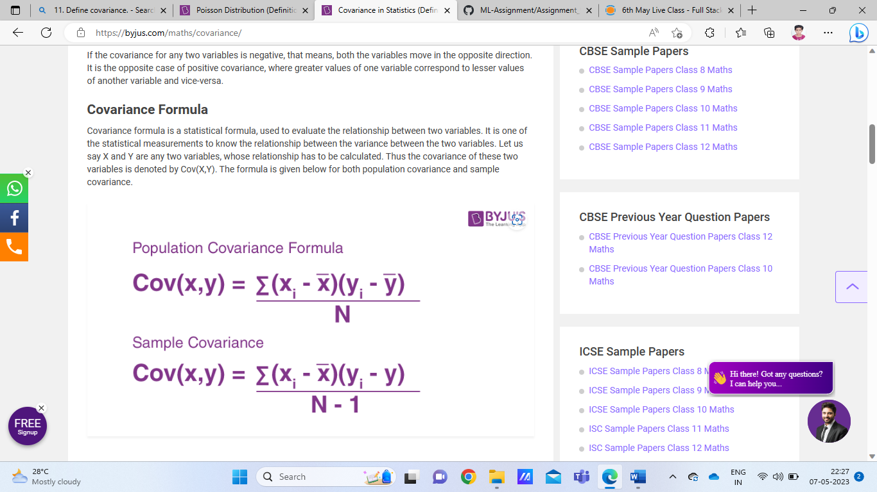

1. Define correlation.

Ans: **Correlation** refers to a process for establishing the relationships between two variables. Correlation studies and measures the direction and extent of relationship among variables, so the correlation measures co-variation, The correlation coefficient is scaled so that it is always between -1 and +1. When r is close to 0 this means that there is little relationship between the variables and the farther away from 0 r is, in either the positive or negative direction, the greater the relationship between the two variables. Where n = Quantity of Information

Σx = Total of the First Variable Value

Σy = Total of the Second Variable Value

Σxy = Sum of the Product of first & Second Value

Σx2 = Sum of the Squares of the First Value

Σy2 = Sum of the Squares of the Second Value

1. Define sampling with replacement. Give example.

Ans: With replacement refers to a sampling method where each time an item is drawn from a population, it is replaced back into the population before the next item is drawn. This means that each item in the population has the same chance of being selected at each draw, and the population size remains unchanged after each draw. For example, if you are drawing cards from a deck of playing cards with replacement, after each draw, the card is returned to the deck before the next draw, and the deck remains unchanged.

Example: Suppose you have a bag with 5 red marbles and 3 blue marbles. You want to draw 2 marbles from the bag.

Sampling with replacement: If you draw a marble from the bag, record its color, and then put it back into the bag before drawing the next marble, you are sampling with replacement. The probability of drawing a red marble on the first draw is 5/8, and the probability of drawing a blue marble on the first draw is 3/8. After putting the first marble back into the bag, the probabilities for the second draw remain the same, 5/8 for red and 3/8 for blue, because the population size (total number of marbles in the bag) remains unchanged.

1. What is sampling without replacement? Give example.

Ans: In sampling without replacement, the probability of selecting each item changes with each draw, as the population size decreases. This can have an impact on the outcomes and probabilities of events of interest, such as in calculating the probability of drawing a certain combination of items from a population, or in estimating population parameters from a sample.Example: Suppose you have a bag with 5 red marbles and 3 blue marbles. You want to draw 2 marbles from the bag.

* Sampling without replacement: If you draw a marble from the bag, record its color, and then do not put it back into the bag before drawing the next marble, you are sampling without replacement. The probability of drawing a red marble on the first draw is 5/8, but after drawing a red marble, the population size decreases by 1, so the probability of drawing a red marble on the second draw changes to 4/7. Similarly, the probability of drawing a blue marble on the first draw is 3/8, but after drawing a blue marble, the population size decreases by 1, so the probability of drawing a blue marble on the second draw changes to 2/7.

1. What is hypothesis? Give example.

Ans: A hypothesis is an assumption that is made based on some evidence. This is the initial point of any investigation that translates the research questions into predictions. It includes components like variables, population and the relation between the variables. A research hypothesis is a hypothesis that is used to test the relationship between two or more variables.

**Characteristics of Hypothesis**

Following are the characteristics of the hypothesis:

* The hypothesis should be clear and precise to consider it to be reliable.
* If the hypothesis is a relational hypothesis, then it should be stating the relationship between variables.
* The hypothesis must be specific and should have scope for conducting more tests.
* The way of explanation of the hypothesis must be very simple and it should also be understood that the simplicity of the hypothesis is not related to its significance.

**Examples of Hypothesis**

* The resemblance between the phenomenon.
* Observations from past studies, present-day experiences and from the competitors.
* Scientific theories.
* General patterns that influence the thinking process of people.