Merge Sort=
#include <stdio.h>
#include <stdlib.h>
#include <time.h>

void merge(int arr[], int left, int mid, int right) {
int i, j, k;
int n1 = mid - left + 1;
int n2 = right - mid;

int L[n1], R[n2];

for (i = 0; i < n1; i++)
L[i] = arr[left + i];
for (j = 0; j < n2; j++)
R[j] = arr[mid + 1 + j];

i = 0;
j = 0;
k = left;

while (i < n1 && j < n2) {
if (L[i] <= R[j]) {
arr[k] = L[i];
i++;
} else {
arr[k] = R[j];
j++;
}
k++;
}

while (i < n1) {
arr[k] = L[i];
i++;
k++;
}

while (j < n2) {
arr[k] = R[j];
j++;
k++;
}
}

void mergeSort(int arr[], int left, int right) {
if (left < right) {
int mid = left + (right - left) / 2;

mergeSort(arr, left, mid);
mergeSort(arr, mid + 1, right);

merge(arr, left, mid, right);
}
}

int main() {
int n, i;
clock_t start, end;
double cpu_time_used;

printf("Enter number of elements: ");
scanf("%d", &n);

int arr[n];

// Generating random numbers
for (i = 0; i < n; i++) {
arr[i] = rand() % 10000;
}

start = clock();

mergeSort(arr, 0, n - 1);

end = clock();

cpu_time_used = ((double)(end - start)) / CLOCKS_PER_SEC;

printf("Time taken to sort %d elements: %f seconds\n", n, cpu_time_used);

return 0;
}
Output=
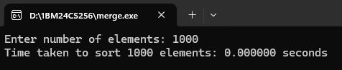
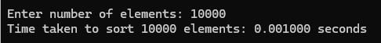
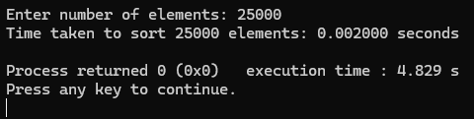
Graph=
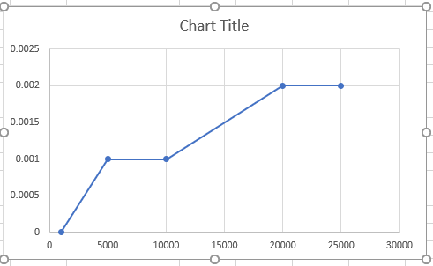
Quick Sort=
#include <stdio.h>
#include <stdlib.h>
#include <time.h>

void quicksort(int a[], int low, int high);
int partition(int a[], int low, int high);

void quicksort(int a[], int low, int high)
{
int j;

if (low < high)
{
j = partition(a, low, high);

quicksort(a, low, j - 1);
quicksort(a, j + 1, high);
}
}

int partition(int a[], int low, int high)
{
int i, j, pivot, temp;

pivot = a[low];
i = low;
j = high + 1;

while (i < j)
{
do
{
i++;
} while (i <= high && a[i] <= pivot);

do
{
j--;
} while (a[j] > pivot);

if (i < j)
{
temp = a[i];
a[i] = a[j];
a[j] = temp;
}
}

temp = a[low];
a[low] = a[j];
a[j] = temp;

return j;
}

int main()
{
int *a, n, i;
clock_t start, end;
double time_taken;

printf("Enter number of elements: ");
scanf("%d", &n);

a = (int *)malloc(n * sizeof(int));
for (i = 0; i < n; i++)
{
a[i] = rand() % 10000;
}

start = clock();

quicksort(a, 0, n - 1);

end = clock();

time_taken = ((double)(end - start)) / CLOCKS_PER_SEC;

printf("Time taken: %f seconds\n", time_taken);

free(a);

return 0;
}
Output=
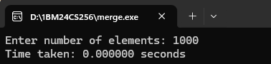
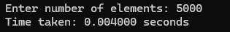
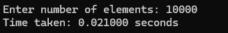
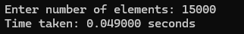
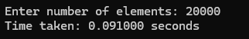
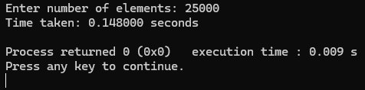
Graph=
