Heap Sort (Top-Down-Approach)=
#include <stdio.h>
#include <time.h>
#define MAX 100000

int heap[MAX];
int n;

void insert(int item, int loc)
{
int parent;

while(loc > 0)
{
parent = (loc - 1) / 2;

if(item <= heap[parent])
break;

heap[loc] = heap[parent];
loc = parent;
}

heap[loc] = item;
}
int deleteHeap(int size)
{
int item, temp, parent, child;

item = heap[0];
temp = heap[size - 1];

parent = 0;
child = 1;

while(child < size - 1)
{
if(child + 1 < size - 1 && heap[child + 1] > heap[child])
child++;

if(temp >= heap[child])
break;

heap[parent] = heap[child];
parent = child;
child = 2 * parent + 1;
}

heap[parent] = temp;

return item;
}
int main()
{
int i, item;
clock_t start, end;
double cpu_time;

printf("Enter number of elements: ");
scanf("%d", &n);

printf("Enter elements:\n");

start = clock();
for(i = 0; i < n; i++)
{
scanf("%d", &item);
insert(item, i);
}
for(i = n - 1; i >= 0; i--)
heap[i] = deleteHeap(i + 1);

end = clock();
printf("\nSorted elements:\n");
for(i = 0; i < n; i++)
printf("%d ", heap[i]);

cpu_time = ((double)(end - start)) / CLOCKS_PER_SEC;

printf("\n\nTime taken (Top-Down): %f seconds\n", cpu_time);

return 0;
}
Output=
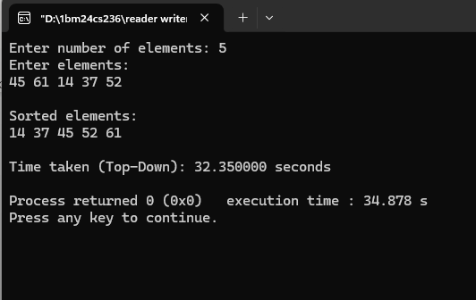
Heap Sort (Bottom-Up-Approach)=
#include <stdio.h>
#include <time.h>
#define MAX 100000

int arr[MAX];
int n;

void heapify(int arr[], int n, int i)
{
int largest = i;
int left = 2 * i + 1;
int right = 2 * i + 2;
int temp;

if(left < n && arr[left] > arr[largest])
largest = left;

if(right < n && arr[right] > arr[largest])
largest = right;

if(largest != i)
{
temp = arr[i];
arr[i] = arr[largest];
arr[largest] = temp;

heapify(arr, n, largest);
}
}
void heapSort(int arr[], int n)
{
int i, temp;
for(i = n / 2 - 1; i >= 0; i--)
heapify(arr, n, i);
for(i = n - 1; i > 0; i--)
{
temp = arr[0];
arr[0] = arr[i];
arr[i] = temp;

heapify(arr, i, 0);
}
}
int main()
{
int i;
clock_t start, end;
double cpu_time;

printf("Enter number of elements: ");
scanf("%d", &n);

printf("Enter elements:\n");

for(i = 0; i < n; i++)
scanf("%d", &arr[i]);

start = clock();

heapSort(arr, n);

end = clock();

printf("\nSorted elements:\n");
for(i = 0; i < n; i++)
printf("%d ", arr[i]);

cpu_time = ((double)(end - start)) / CLOCKS_PER_SEC;

printf("\n\nTime taken (Bottom-Up): %f seconds\n", cpu_time);

return 0;
}
Output=
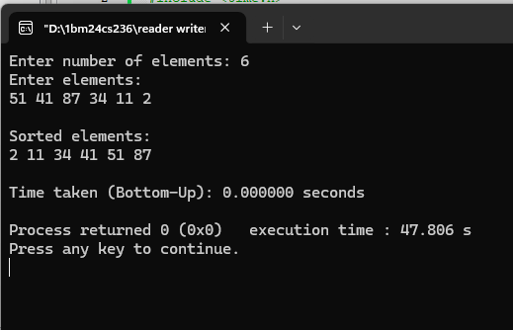
Min Heap Sort (Descending Order)=
#include <stdio.h>
#include <time.h>
#define MAX 100000

int arr[MAX];
int n;
void minHeapify(int arr[], int n, int i)
{
int smallest = i;
int left = 2 * i + 1;
int right = 2 * i + 2;
int temp;
if(left < n && arr[left] < arr[smallest])
smallest = left;

if(right < n && arr[right] < arr[smallest])
smallest = right;
if(smallest != i)
{
temp = arr[i];
arr[i] = arr[smallest];
arr[smallest] = temp;

minHeapify(arr, n, smallest);
}
}
void heapSortDescending(int arr[], int n)
{
int i, temp;
for(i = n / 2 - 1; i >= 0; i--)
minHeapify(arr, n, i);
for(i = n - 1; i > 0; i--)
{
temp = arr[0];
arr[0] = arr[i];
arr[i] = temp;
minHeapify(arr, i, 0);
}
}
int main()
{
int i;
clock_t start, end;
double cpu_time;

printf("Enter number of elements: ");
scanf("%d", &n);

printf("Enter elements:\n");

for(i = 0; i < n; i++)
scanf("%d", &arr[i]);

start = clock();

heapSortDescending(arr, n);

end = clock();

printf("\nElements sorted in Descending Order:\n");

for(i = 0; i < n; i++)
printf("%d ", arr[i]);

cpu_time = ((double)(end - start)) / CLOCKS_PER_SEC;

printf("\n\nTime taken: %f seconds\n", cpu_time);

return 0;
}
Output=
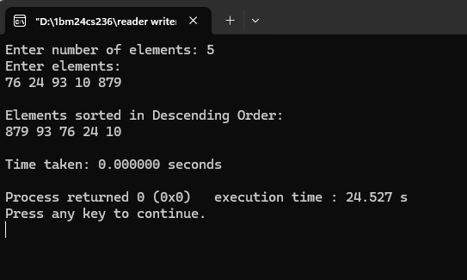
Horner’s Rule for Ploynomial Evaluation=
#include <stdio.h>

int main()
{
int n, i;
float x, result;
float a[100];

printf("Enter degree of polynomial: ");
scanf("%d", &n);

printf("Enter coefficients:\n");
printf("(From highest degree to constant term)\n");

for(i = 0; i <= n; i++)
{
scanf("%f", &a[i]);
}
printf("Enter value of x: ");
scanf("%f", &x);
result = a[0];

for(i = 1; i <= n; i++)
{
result = result * x + a[i];
}

printf("\nValue of Polynomial = %.2f\n", result);

return 0;
}
Output=
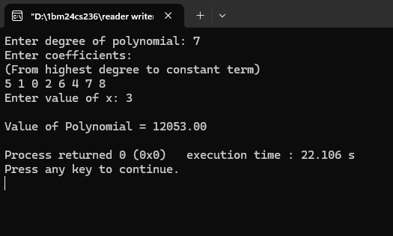
Mode Value (Presorting)=
#include <stdio.h>

void sort(int arr[], int n)
{
int i, j, temp;
for(i = 0; i < n - 1; i++)
{
for(j = 0; j < n - i - 1; j++)
{
if(arr[j] > arr[j + 1])
{
temp = arr[j];
arr[j] = arr[j + 1];
arr[j + 1] = temp;
}
}
}
}
int main()
{
int arr[100], n;
int i;
int mode, maxCount = 0;
int currentCount = 1;
printf("Enter number of elements: ");
scanf("%d", &n);
printf("Enter elements:\n");

for(i = 0; i < n; i++)
scanf("%d", &arr[i]);
sort(arr, n);
mode = arr[0];

for(i = 1; i < n; i++)
{
if(arr[i] == arr[i - 1])
{
currentCount++;
}
else
{
currentCount = 1;
}

if(currentCount > maxCount)
{
maxCount = currentCount;
mode = arr[i];
}
}
printf("\nSorted Array:\n");
for(i = 0; i < n; i++)
printf("%d ", arr[i]);

printf("\n\nMode = %d", mode);
printf("\nFrequency = %d\n", maxCount);

return 0;
}
Output=
