“N-Queens Problem” using Backtracking =
#include<stdio.h>
#include<stdlib.h>

int canplace(int r, int c[])
{
int i;
for(i=0;i<r;i++)
{
if(c[i]==c[r] || abs(c[i]-c[r])==abs(i-r))
return 0;
}
return 1;
}

void display(int c[], int n)
{
int i,j;

for(i=0;i<n;i++)
{
for(j=0;j<n;j++)
{
if(c[i]==j)
printf("Q ");
else
printf("- ");
}
printf("\n");
}
printf("\n");
}

void nqueen(int n)
{
int c[50];
int r=0;

c[0]=-1;

while(r>=0)
{
c[r]++;

while(c[r]<n && !canplace(r,c))
c[r]++;

if(c[r]<n)
{
if(r==n-1)
{
display(c,n);
}
else
{
r++;
c[r]=-1;
}
}
else
{
r--;
}
}
}

int main()
{
int n;

printf("Enter number of queens: ");
scanf("%d",&n);

nqueen(n);

return 0;
}
Output=
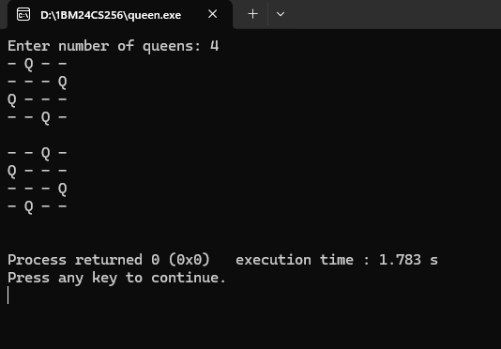
Sum of Subsets using Backtracking=
#include<stdio.h>

void subset(int n,int d,int w[])
{
int s,k,i,x[10];

for(i=1;i<=n;i++)
x[i]=0;

s=0;
k=1;
x[k]=1;

while(1)
{
if(k<=n && x[k]==1)
{
if(s+w[k]==d)
{
printf("Solution: ");

for(i=1;i<=n;i++)
{
if(x[i]==1)
printf("%d ",w[i]);
}

printf("\n");
x[k]=0;
}
else if(s+w[k]<d)
{
s=s+w[k];
}
else
{
x[k]=0;
}
}
else
{
k--;

while(k>0 && x[k]==0)
k--;

if(k==0)
break;

x[k]=0;
s=s-w[k];
}

k++;
x[k]=1;
}
}

int main()
{
int n,d,i,w[10];

printf("Enter number of elements: ");
scanf("%d",&n);

printf("Enter elements in ascending order:\n");

for(i=1;i<=n;i++)
scanf("%d",&w[i]);

printf("Enter required sum: ");
scanf("%d",&d);

subset(n,d,w);

return 0;
}
Output=
