Lab 01 = 25/09/2026
Vaccum Cleaner Agent =
rooms = {
'A': 'Dirty',
'B': 'Dirty'
}

position = input("Enter vacuum position (A/B): ").upper()

while True:
print("\nCurrent position:", position)
print("Room A:", rooms['A'])
print("Room B:", rooms['B'])

if rooms[position] == 'Dirty':
print("Action: SUCK")
rooms[position] = 'Clean'

elif rooms['A'] == 'Clean' and rooms['B'] == 'Clean':
print("Goal achieved! Both rooms are clean.")
break

else:
if position == 'A':
position = 'B'
print("Action: MOVE RIGHT")
else:
position = 'A'
print("Action: MOVE LEFT")

Output=

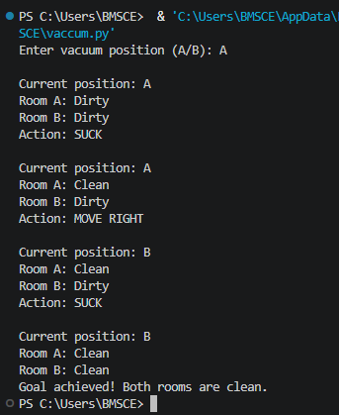
TIC – TAC – TOE=
import random

board = [' ' for _ in range(9)]

def display():
print(board[0], '|', board[1], '|', board[2])
print('--+---+--')
print(board[3], '|', board[4], '|', board[5])
print('--+---+--')
print(board[6], '|', board[7], '|', board[8])

def check_winner(symbol):
wins = [
(0, 1, 2), (3, 4, 5), (6, 7, 8),
(0, 3, 6), (1, 4, 7), (2, 5, 8),
(0, 4, 8), (2, 4, 6)
]

for a, b, c in wins:
if board[a] == board[b] == board[c] == symbol:
return True
return False

def full():
return ' ' not in board

print("TIC-TAC-TOE")
print("You = X, Computer = O")
print("Positions are 1 to 9")

while True:
display()

pos = int(input("Enter your position: ")) - 1

if pos < 0 or pos > 8 or board[pos] != ' ':
print("Invalid position!")
continue

board[pos] = 'X'

if check_winner('X'):
display()
print("You win!")
break

if full():
display()
print("Draw!")
break

empty = [i for i in range(9) if board[i] == ' ']
computer = random.choice(empty)
board[computer] = 'O'

print("Computer selected:", computer + 1)

if check_winner('O'):
display()
print("Computer wins!")
break

if full():
display()
print("Draw!")
break

Output=

