Fire TV stick HD
with Alexa Voice Remote
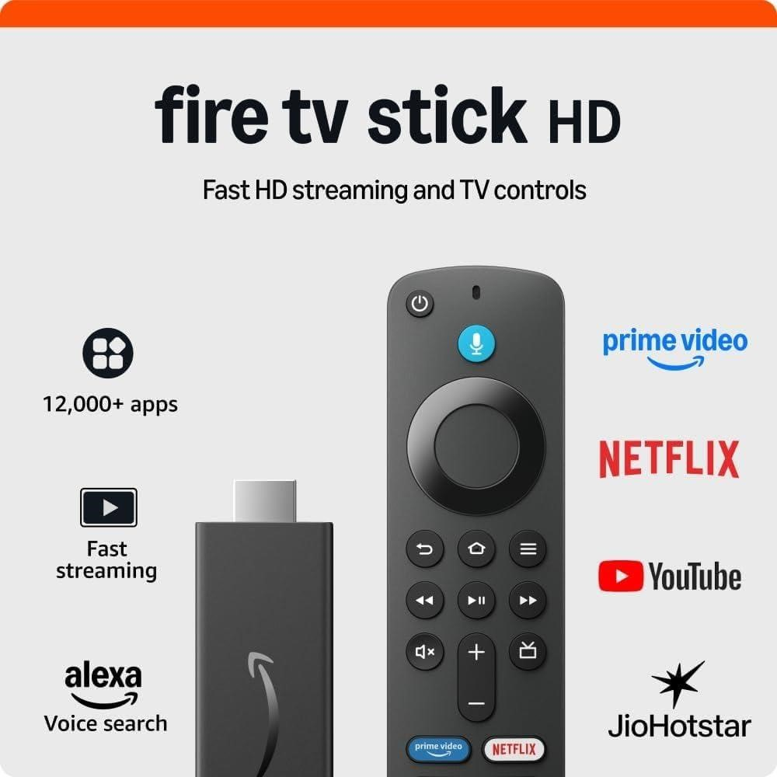
Upgrade your TV, instantly.
Sales Kit
Fire TV stick HD
Compact, Colorful, Affordable smart speaker with full sound
The Fire TV Stick HD is a Full HD streaming device that be plugged into the HDMI port of the TV and connected to Internet to stream content on your TV. Use the Alexa Voice Remote to voice search and launch content and manage the power and audio of your TV.
 Full HD Streaming: Supported by powerful 1.7Ghz Quad Core Processor and optimised streaming
 TV Controls: Power on/off and adjust volume using Alexa Voice Remote
 Alexa Voice Search: Search, play, pause, rewind, or forward using your voice
 Immersive sound by Dolby Atmos, Dolby Digital, Dolby Digital+ Surround sound.
 Endless Entertainment: Access thousands of movies and shows across top apps.
How FireTV makes the Smart TV experience better
Smart TVs today often run different versions of Android, each customized by the device manufacturer. This leads to fragmented app availability (for example, Apple TV+ missing on some models), inconsistent updates, and sluggish user experiences as the software grows heavier than the TV’s limited hardware can handle. Over time, the result is a patchy, frustrating TV experience.
Fire TV stick HD fixes this.
With a dedicated 1.7 GHz Quad-Core processor, 8 GB DDR4 RAM, and dual-channel MIMO Wi-Fi, Fire TV is built purely for streaming—unlike Smart TVs, where resources are split with other functions. Features like ASAP streaming technology ensure buffer-free viewing. Because Amazon designs both the hardware and software, the two work seamlessly together.
Beyond performance, Fire TV adds what most Smart TVs miss:
Integrated voice search that’s more interactive and responsive. Alexa integration to play songs, fetch news, control smart home
Subscriptions apply for apps like Amazon Prime, Netflix, Hotstar, Apple TV and other OTT channels.
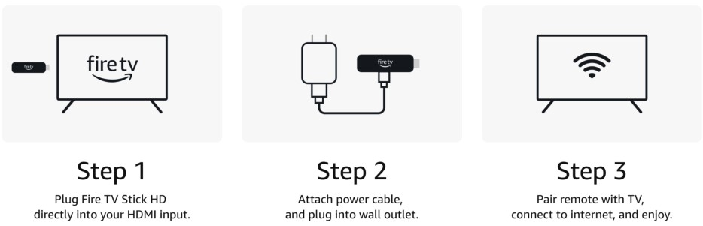
 Free Streaming: Watch free content on YouTube, MXPlayer.
 Live TV Access: Stream live news, sports, and TV - apps like SonyLIV, Hotstar, Zee5, and JioCinema
 Smart Home Control : Use Alexa to control lights, cameras, and more
devices, and more.

