**PROJECT REPORT**

ON

**AIRLINES SEAT RESERVATION**

describes the bonafide work done by

**SWATI GOEL**

**University Roll no: 2507330**

for the project training

held in the company

**Bytech India Pvt. Ltd.(ISO 9001:2000 Company)**

**511, Arunachal Building, Barakhamba Road, Cannaught Place**

in partial fulfillment of the requirements

for the award of the degree of

**BACHELOR OF TECHNOLOGY**

from

**UNIVERSITY INSTITUTE OF ENGINEERING AND TECHNOLOGY**

**KURUKSHETRA UNIVERSITY, KURUKSHETRA.**

**1**

**ACKNOWLEDGEMENT**

My thanks to **Bytech India Pvt Ltd**. and its CEO **Mr. T**. **Shrinivasan** for giving me the opportunity and providing facilities to complete the project and my guide **Mr. Vishal** who gave me full support without which it would have been difficult to pursue the project.

I shall also mention the name of my project leader **Mr. Prashant Bahera** who showed me the way to achieve a desired goal.

**2**

**CANDIDATE’S DECLARATION**

I hereby declare that the work which is being presented in this project work entitled **“AIRLINES SEAT RESERVATION”** in partial fulfillment of the requirements for the award of the degree of **Bachelor of Technology** from **Kurukshetra University, Kurukshetra,** is an authentic record of my own work carried out during the period 1st July to 15th August 2009 under the supervision and guidance of **Mr.Vishal**.

I have not submitted the matter embodied in this project work anywhere for the award of any degree.

**3**

**Contents**

**S.No Description**

**1 Abstract**

**2 Company Profile**

**3 System analysis**

**3.1 Problem Definition**

**3.2 Findings**

**3.3 Feasibility study**

**3.3.1 Economic Feasibility**

**3.3.2 Technical Feasibility**

**3.3.3 Behavioral Feasibility**

**3.4 System functions**

**3.5 Project description**

**3.5.1 Data requirements**

**3.5.2 Process flow**

**4 System requirement specifications**

**4.1 Introduction**

**4.1.1 Purpose**

**4.1.2 Scope**

**4.1.3 Overview**

**4.2 General description**

**4.2.1 Product function**

**4.2.2 User characteristics**

**4.3 Specific requirements**

**4.3.1 Functional Requirements**

**4.4 Data flow Diagram**

**5 High level Design**

**5.1 Process Hierarchy Chart**

**6 Low level Design**

**6.1 Flow Chart**

**6.2 Database Design**

**4**

**6.3 User interface design**

**7 Unit test case**

**8 Conclusion**

**9 Bibliography**

**5**



**1. Abstract**

The software aims at automating the existing manual systems and providing secure, cheaper and quicker communication within an organization. As this is a well designed and easy-to-use communication system will certainly give the organization an edge over the other organizations with outdated and manual communication system, with manpower doing the bulk of data transfer in the form of files and paper documents.

It provides centralized reservation system with any number of users. The project gives the user an easy-to-use graphical interface that can be easily used by a novice.

**Features of the project are as follows:**

* Automation of existing airlines reservation & information systems.
* Reduction of manual processing.
* Keep track of number of seats reserved daily.
* Increase in processing and transfer speeds of information over the network.
* Reduction of errors and viruses due to non requirement of the internet.
* Fast retrieval of all type of information
* Multimedia data communication.

**6**

**2. COMPANY PROFILE**

**Bytech India Pvt Ltd**, now on its 20th year of operation, is an Information Technology solution Provider, located in the heart of India’s capital New Delhi.

**Bytech** operates as a high- end Software Business Development Center. It has its offices at Bangalore, Singapore, London and Dubai.

**Bytech** works with major Multi-Nationals to bring -in custom- built solutions.

Over years **Bytech** has earned the coveted reputation of ‘Much Sought After ‘IT Solution provider by its customer. Today**, Bytech** specializes in both package and customized software business commanding an impressive repertoire of skills that need to be employed in the service of its clients.

**Bytech’s** core competence theme is to “Design, Build, Implement and Support Information Technology Solutions”.

**Bytech Specializes in:**

* E- Commerce (Web, Internet, E-Solutions).
* Business Solutions (Commercial, Industrial, Finance).
* Web-Enabled Client/Server Application.
* Data Ware –housing and Data-Mining.
* Enterprise System for Techno –Commercial Apps.

**Customer Centered Service:**

Committed to quality, user orientation and usage of the most relevant technology has been the backbone of **Bytech’s** success and emergence as a strong provider of IT solutions in areas of its operations. The steady progress that followed was the result of Bytech’s uncompromising dedication to customer satisfaction, the rigid standards set and met, the trust deserved and earned the tradition of high quality service.

**Bytech** over the past few years has its objectives as maximizing customer satisfaction and thus assumes responsibilities of establishing and implementing the software related services.

**Bytech’s** core competence is on building Information Technology solutions and operating of out-sourced processing Services for its clients, majority of them being Multi-Nationals.

**Bytech** has recently been awarded a certificate of commendation for Hewlett-Packard India for a break- through contribution to the development of technology for its supply chain management.

**Bytech’s** products have recently been selected for “best practice “implementation by Hewlett-Packard.

**Partial List of Clientele:**

**Multinationals:**

* M/s Hewlett-Packard India Ltd.
* M/s Agilent Technologies (A Hewlett-Packard Company).
* M/s British Airways Plc.
* Max New York.
* Converges India Services (Wholly Owned Company of Converges Inc, USA).

**7**

**Information Technology Companies:**

* M/s Hewlett- Packard International Software Org.
* M/s Zenith Computers.
* M/s Hindustan Computers Limited (HCL).
* M/s International Computers Indian Manufacture Ltd-Fujitsu.

**Banks:**

* ANZ Grind lays Bank.
* Standard Chartered Bank.
* PNB Housing Finance Ltd.
* Indian Overseas Bank.
* Bank of America.

**Government Undertakings:**

* M/s Bharat Electronics Limited.
* M/s D.L.W. Varanasi.
* M/s Delhi Transport Corporation

**Private Sector:**

* M/s Hindustan Motors Ltd.
* M/s Thapar Group (KCT and Bros Ltd.).
* M/s RPG Paging Services Ltd.
* M/s Data cons Pvt. Ltd.

**Overseas Clients:**

* M/s Lindar Ltd., HONG KONG.
* M/s Infoserve International Inc., New York, USA.
* M/s Hewlett-Packard –Asia Pacific, Singapore.
* M/s Data Square Inc, Stanford, USA.
* Ulysses Group LLC, Irwin, USA.

**8**

**3.**  **SYSTEM ANALYSIS**

**3.1 Problem:**

The software aims at automating the existing manual systems and providing secure, cheaper and quicker communication within an organization. As this is a well designed and easy-to-use communication system will certainly give the organization an edge over the other organizations with outdated and manual communication system, with manpower doing the bulk of data transfer in the form of files and paper documents.

**3.2 Findings:**

To overcome the problem of duplication in the seat reservation, software made is airlines seat reservation in which seats already booked can’t be booked again. And the database manipulation is done through the efficient use of MS Access.

**3.3 Feasibility:**

Feasibility study describes and evaluates candidate systems and provides for the selection of the best candidate system that meets the system performance requirements. Three key considerations are involved in the feasibility analysis.

**3.3.1 Economic Feasibility:**

By introducing the AIRLINES SEAT RESERVATION tool, the human work and time is highly reduced. The tool has been efficiently developed using the existing resources. By considering the overall benefits of speed and the system is developed without requirement of any new resources we conclude that the system is highly economically feasible.

**3.3.2** **Technical Feasibility:**

Technical Feasibility centers on the existing system and to what extent it can support the proposed system. In this part of feasibility analysis we determined the technical possibilities for the implementation of the system. Two major benefits are:

* Improving the performance
* Minimizing the cost of processing

The performance category emphasis improvements in the accuracy and access to the information. It also makes easier to access the system by the authorized users.

**3.3.3 Behavioral Feasibility:** Behavioral feasibility estimates the reaction of the User staff towards the development of the computerized system. For the successful implementation of any system, the users must be impressed that the new system is for his benefit. So, the behavioral feasibility plays a very important role in the development of new system It reveals that whether the system is acceptable by user or not. If the user does not ready to use it, then it doesn’t matter how best the system is or how much effort you are putting in its development.

**9**

**3.4 System Functions:**

* The Travel Reservation Service examines the incoming client itinerary and processes the itinerary to completion.
* If the client itinerary does not contain a pre-existing airline reservation, the Travel Reservation Service passes the itinerary on to its partner service, the Airline Reservation Service, to add the airline reservation.
* The Airline Reservation Service passes back the modified itinerary to the Travel Reservation Service.
* The Travel Reservation Service conducts similar logic for both vehicle and hotel reservations. In each case it will delegate the actual provisioning of the reservation to the Vehicle Reservation Service and the Hotel Reservation Service.
* Finally, the Travel Reservation Service passes the completed itinerary back to the original client, completing the process.

**3.5 Process Description:**

**3.5.1 Data Requirements:** The ‘Airplane Reservation System’ is designed for accepting request from the client and updating changes requested by him in the database.

The following type of data is required:

* End user request
* Access file containing reservation details

**3.5.2 Process Flow:**

The wholeprocess is divided into following steps:

* Initially a GUI window is used from where we enter into the details of flights by entering a username & password and clicking on ‘OK’ button.
* Then we come across a GUI window on which we have to select flight no and date of flight.
* Then a window is displayed in which flight seats are there. If they are red, then seats are vacant otherwise filled.
* After clicking on seat no (filled) we get details of the passengers.
* After clicking on the black seatno (vacant) user enter the details of the passengers and clicking on confirm button confirms his seat.
* If the user wants to cancel his seat, clicking on the cancel button will cancel his seat.
* The database is updated according to whether cancellation or reservation has occurred.

**10**

**4. System Requirement Specifications**

**4.1 Introduction:**

**4.1.1 Purpose:**

The “AIRPLANE RESERVATION” project is a system to manage and maintain information related to users who have their seat reserved in this system. The main purpose of this system is to accept request from the user regarding the seat number and category in which he/she wants to reserve his seat and insert his/her reservation details in the database and hence reserve the seat.

**4.1.2 Scope:**

Project scope covers the following tasks:

* Study of the system.
* Modification of the system will be carried out as per user requirements.
* Existing database is used and two tables are created.

**4.1.3 Overview:**

The Airline reservation system is a reservation system that is intended to provide

information needed to reserve seat(s) on certain flights. It is intended:

To capture request from the client.

* To reserve the seat as per client’s request.
* To update record as per request from the client.
* To get the details of clients whose seats have been reserved, whenever needed.

**4.2 General Description:**

The product is not a complete system. It is a part of the system. The choice of seats will depend will depend on the database created. The system will accept client request and reserve his seat accordingly.

**4.2.1 Product Functions:**

* The system is meant to accept requests from the client.
* The system shall reserve seats as per the request.
* The system shall update database after allocating the seat to client.
* The system shall display details of passengers whenever needed.

**4.2.2 User Characteristics:**

The intended users of the system “AIRPLANE RESERVATION” shall be expected to have basic knowledge of computers and basic troubleshooting of computers. No technical expertise or formal qualification s are needed to use the system.

**11**

**4.3 Specific Requirements:**

**4.3.1 Functional Requirements:**

While performing the required functions following are the basic requirements:

* Each flight has a limited number of available seats. There are number of flights that go from/to different cities at different dates.
* The airline employee shall maintain a table where each row within the table has the following fields: Flight number, date of flight, seat number (that has been reserved), Customer Name, Customer Age and Customer ID.

The new values within this table will be created when the user makes a

Reservation

* For the user interface, you have to give an option for flight number
* For the user interface, you have to give an option for date of flight.
* Once the user makes the selection for flight number and date of flight and clicks the OK button, next panel will be displayed. Empty seats are labeled green and reserved seats are labeled black. It will be seen if there are seats on such flights on the selected date, available in the database and if there are, user will be asked to enter his details in order to reserve the seat. Within this panel, there are a number of buttons:
* If the user selects the Submit button invalid information (if any) entered by the user (e.g. numbers in the name field) will automatically be corrected.
* If the user selects the Enter button then a dialog box will be displayed that will alert the user that if he continues, information entered by him cannot be changed.

* If the user selects the OK button, the information entered will be inserted in the database.
* If the client presses the BACK button, previous panel will be displayed.
* If the client presses the CANCEL button, the reservation will be cancelled (of seat no whose ID is entered by employee).

**12 4.4** **Data Flow Diagram:**

A DFD also known as a “bubble chart,” has the purpose of clarifying system requirements. This is supported to explain the logical diagram of the system. A DFD consists of a series of bubbles joined by lines. The bubbles represent data transformations and the lines represent data flow in the system.

**Level 0 DFD:**

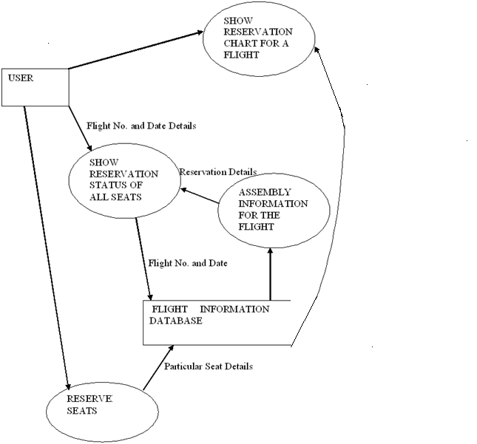

**13**

**Level1 DFD:**

**Getting flight no and date details swati3**

**Maintaining records Information details Read access file**

**14**

**5.** **HIGH LEVEL DESIGN**

**5.1 Process Hierarchy Chart:**

**UPDATING RESERVATION DATA**

**RETRIEVING AND DISPLAYING FLIGHT DATA**

**CANCEL RESERVATION**

**ACCEPT NEW RESERVATION INFORMATION**

**ACCEPT FLIGHT INFORMATION**

**CLIENT INTERACTION**

**DATABASE PROCESSING**

**MAIN MENU**

**6. LOW LEVEL DESIGN**

**6.1 Flow Chart:**

**SHOW RESERVATION DETAILS**  **NEXT**

**CHECK RESERVATION TYPE**

**NEXT FORM IS DISPLAYED**

**TABLE SHOWING DETAILS IS DISPLAYED**

**CHECK BUTTONPRESSED**

**SELECT FLIGHT NO AND DATE**

**USERNAME AND PASSWORD ACCEPTED**

**FIRST CLASS** **COACH** **BLACK**  **GREEN**

**ENTER RESERVATION DETAILS**

**SHOW DETAILS OF SELECTED SEAT**

**CHECK BUTTON COLOUR**

**SEATS 5-12 ARE ENABLED**

**SEATS 1-4 ARE ENABLED**

**CONFIRM CANCEL 6.2 Database Design:**

**CANCEL SEAT RESERVATION**

**CONFIRM SEAT RESERVATION**

**CHECK BUTTON PRESSED**

**Microsoft Access D****escription:** Microsoft Access is a powerful program to create and manage your databases. It has many built in features to assist you in constructing and viewing your information. Access is much more involved and is a more genuine database application than other programs such as Microsoft Works.

**Database Name: database6**

1.Table2:

**Purpose:** Contains details of passengers

**Primary keys:** seatno, dof, flightno

Table name: Table2

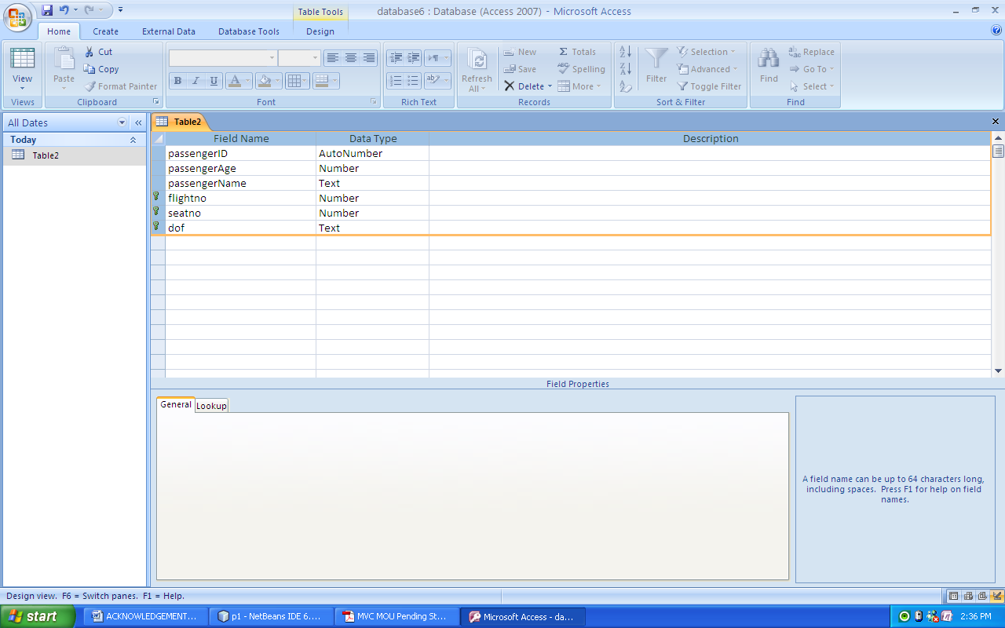

**Database name: database5**

2.Table1

**Purpose:** Contains Password and Username

Table Name: Table1

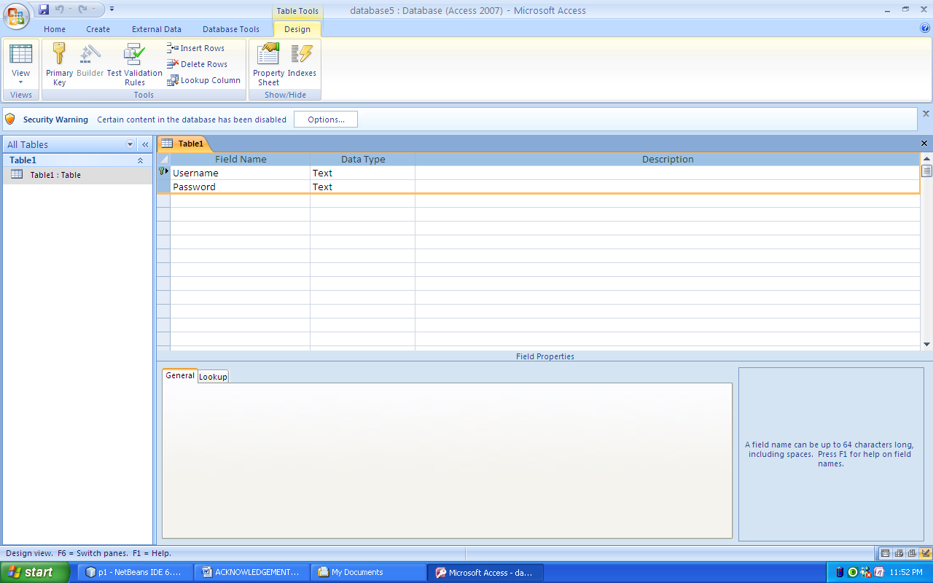

**17**

**6.3 User Interface Design:**

The following screens have been designed for user interface:

**Login Screen:** The User login form is loaded. This looks as follows:

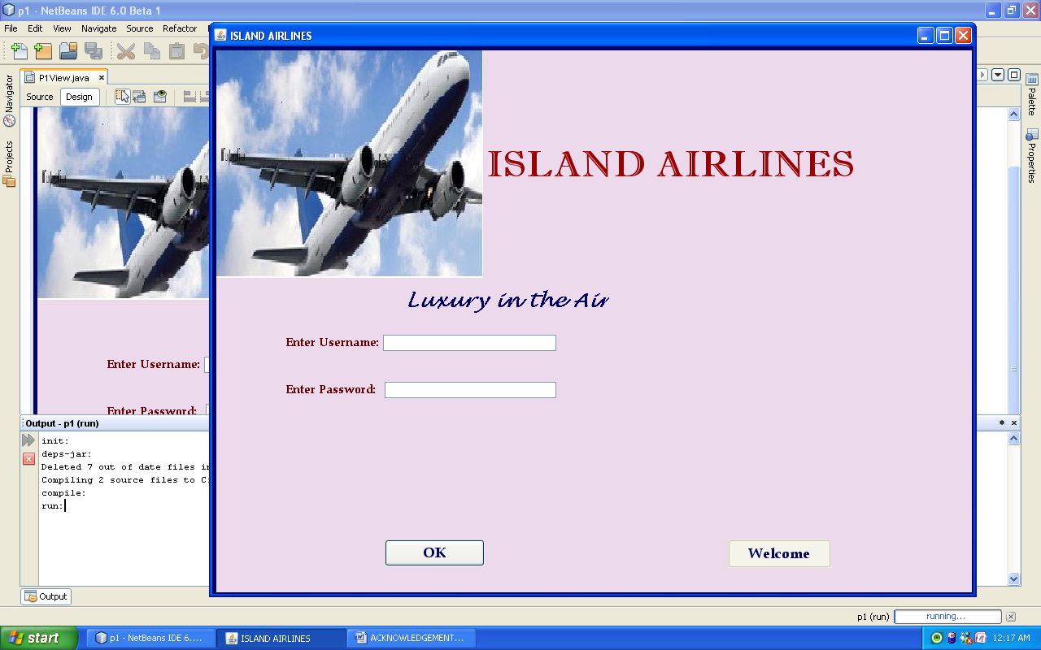

When the user enters the Username and Password, the user login form checks for the validity of the user and correct password. If it is valid, ‘Welcome’ button is activated and next screen, which is our main screen is displayed.

**Main form:**

After user authentication main screen is loaded.

It looks as follows: 18

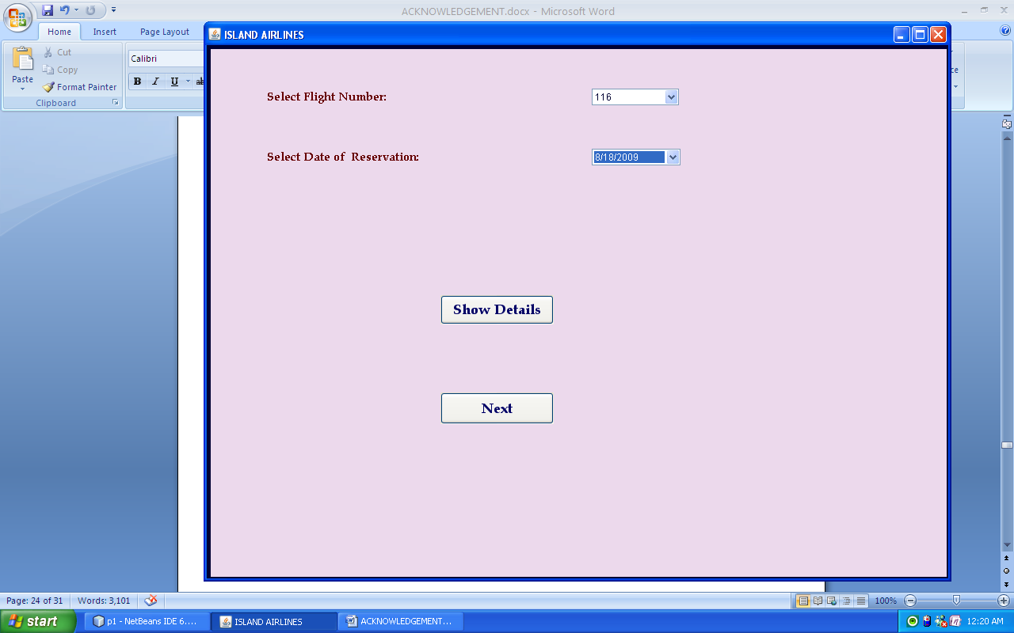

The user selects the flight number of the flight in which he wants to reserve his seat from first combo box and the date on which he wants his reservation from second combo box.

If the user wants to see the details of all the passengers on the selected date and flight he need to press the ‘Show Details’ button. A panel containing table displaying the details is displayed.

Window will look as follows:

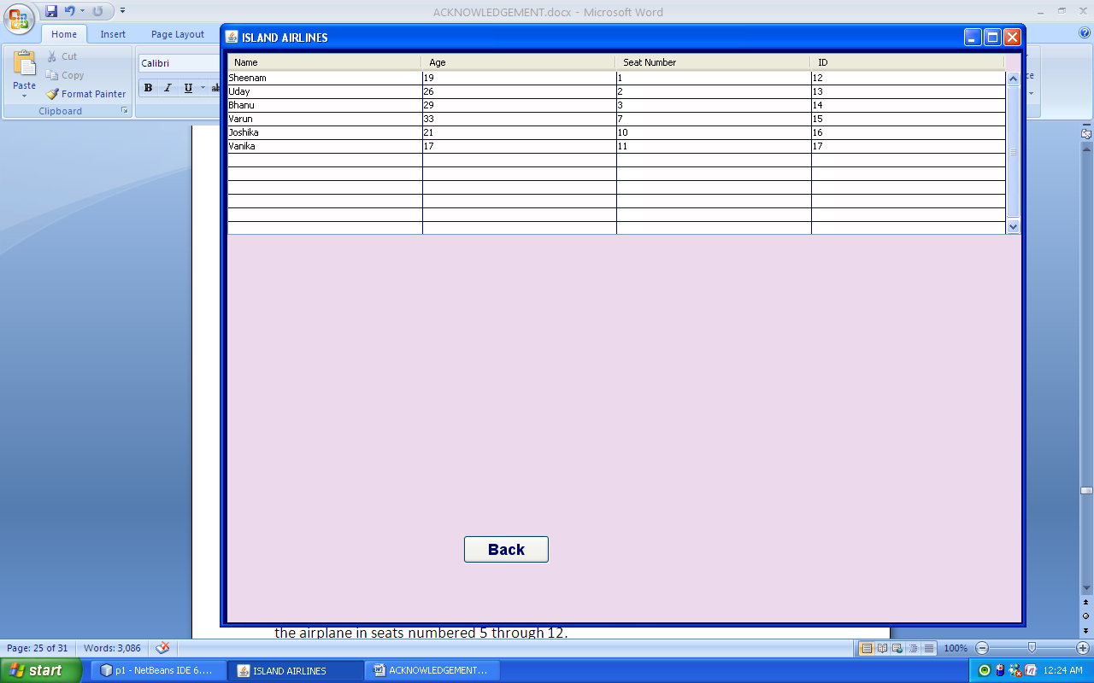

Back button brings the user back to the previous panel.

When the user presses the ‘Next’ button Reservation form is loaded.

19

**Reservation Form:**

After the selection of flight number and date of flight, reservation form is loaded.

Each airplane seats 12 passengers. Each row has two seats, with an aisle between them. Odd-numbered seats are on the left (starboard) side of the airplane. Even-numbered seats are on the right (port) side of the airplane.

First-class passengers go in the first two rows in the front section of the airplane in seats numbered 1 through 4. Coach-class passengers go in the rear section of the airplane in seats numbered 5 through 12.

Initially, the window should look like this:

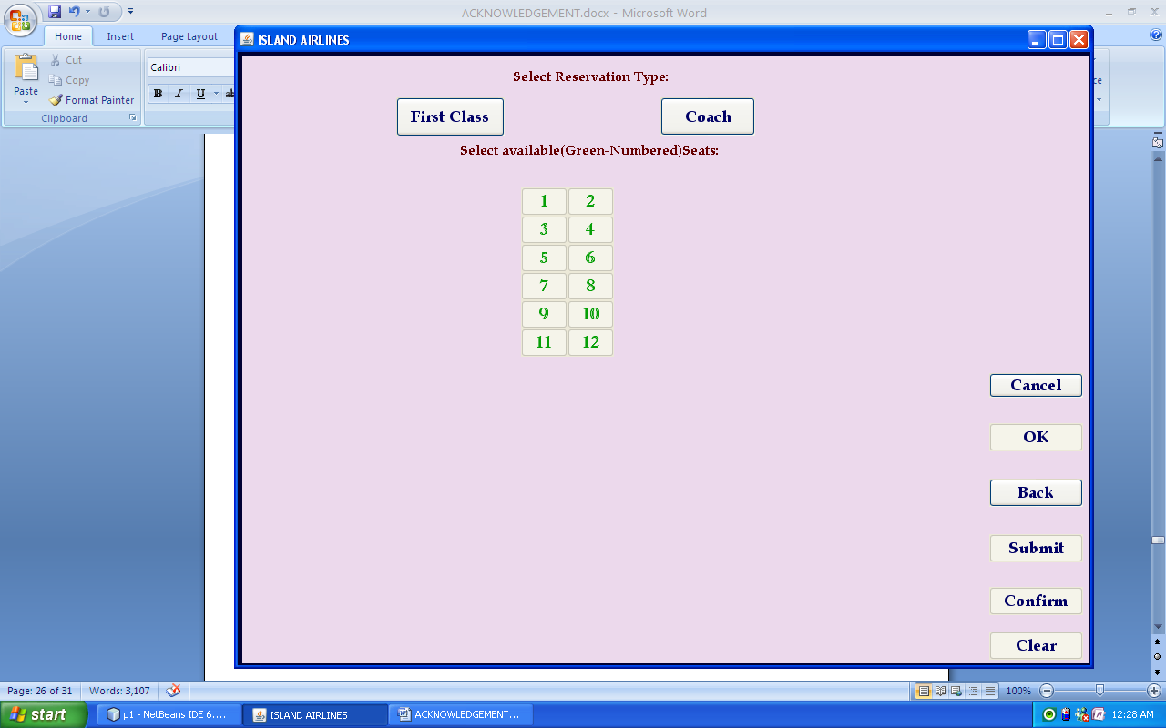

If the user tries to click on any of the seat buttons at this time, nothing will happen. The user is supposed to first click the first class button or the coach button. Then, depending on which of these two buttons is clicked, buttons of the numbers of all seats in that section of the plane will be activated. the screen will look like this;

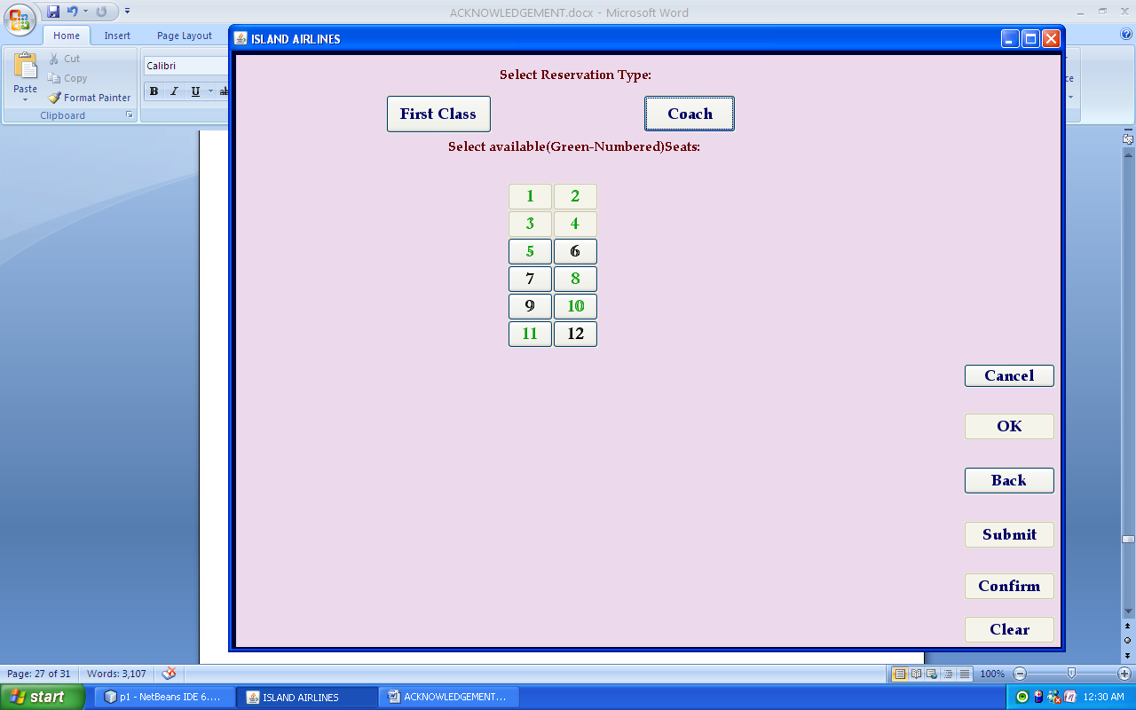

20

If the user clicks any of the black numbers, details of passengers who have already reserved their seats will be displayed in the non-editable text fields. But if the user clicks one of the green-numbered buttons, the screen will change to this:

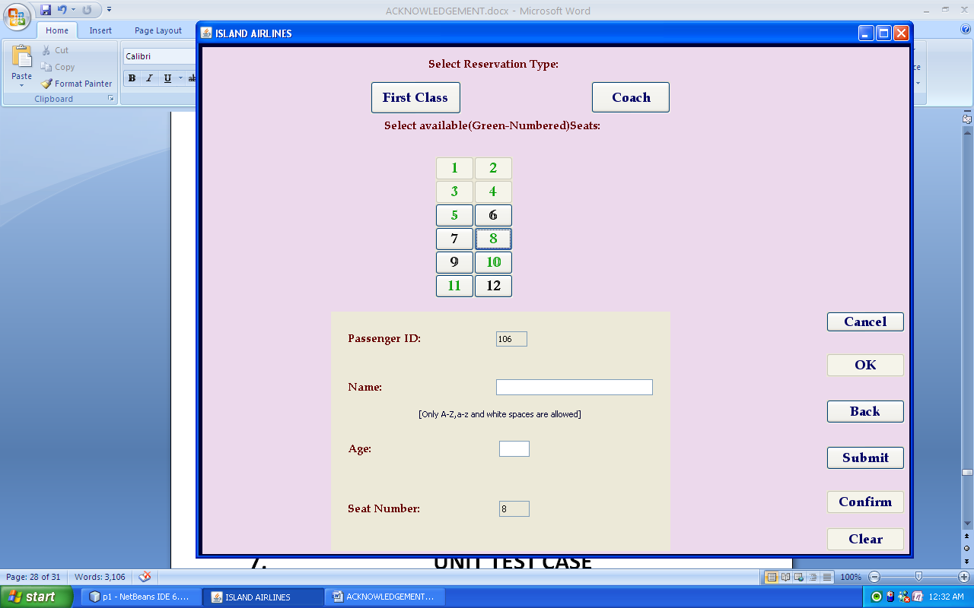

Then the user is supposed to enter his or her name in the text box that appears after Name:, and his or her age in the text box that appears after Age:. When the user presses Submit, text fields becomes non-editable. Pressing CLEAR will clear the text fields and hence editable and pressing ENTER will not allow passengers to edit their details and user will be asked to confirm reservation by displaying a dialog box. If the user presses yes, OK will be activated and passenger seat assignment confirmation occurs.

A black label for the button associated with the confirmed seat will be displayed.

21

The Screen will look like this:

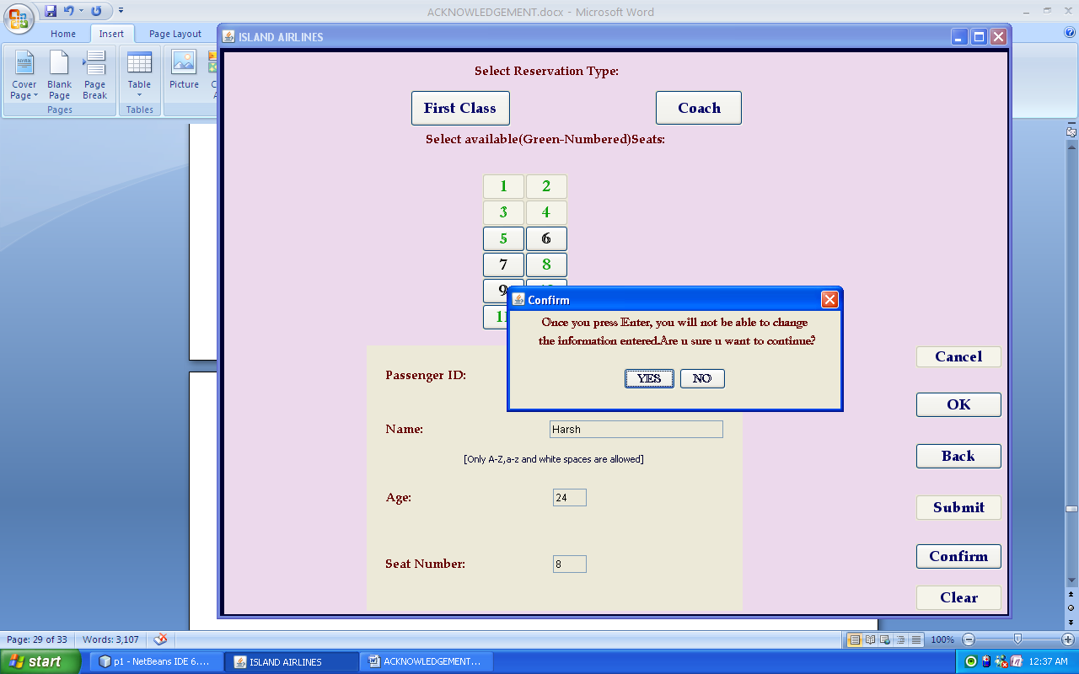

If the user wants to cancel his seat, he needs to press ‘Cancel’ button.

22

**7. UNIT TEST CASE**

All data in the database are for f lights for 18/8/2009 and 19/9/2009. To test the system we have to select the dates from among these only.

**7.1** **Unit Test Case of Panel P1View:**

|  |  |  |  |  |
| --- | --- | --- | --- | --- |
| **TCID** | **Steps to Test** | **Expected Result** | **Actual Result** | **Remarks** |
| 1. | Click on OK button | It should enable Welcome button | It enables Welcome button | Pass |
| 2. | Click on Welcome button | It should display panel p2 | It displays panel p2 | Pass |

**7.2** **Unit Test Case of Panel p2:**

|  |  |  |  |  |
| --- | --- | --- | --- | --- |
| **TCID** | **Steps to Test** | **Expected Result** | **Actual Result** | **Remarks** |
| 1. | Click on Show Reservation Details button | It should display p6 frame | It displays p6 frame | Pass |
| 2. | Click on Next button | It should display panel p3 | It displays panel p3 | Pass |

**7.3 Unit Test Case of Frame p6:**

|  |  |  |  |  |
| --- | --- | --- | --- | --- |
| **TCID** | **Steps to Test** | **Expected Result** | **Actual Result** | **Remarks** |
| 1. | Click on Back button | It should display panel p2 | It displays panel p2 | Pass |

23

**7.4 Unit Test Case of p3 panel**

|  |  |  |  |  |
| --- | --- | --- | --- | --- |
| **TCID** | **Steps to Test** | **Expected Result** | **Actual Result** | **Remarks** |
| 1. | Click on First Class button | It should enable buttons numbered 1-4, disable buttons numbered 5-12 and display their labels as black or green | It enables buttons numbered 1-4, disables buttons numbered 5-12 and displays their labels as black or green | Pass |
| 2. | Click on Coach button | It should enable buttons numbered 5-12,disable buttons numbered 1-4 and display their labels as black or green | It enables buttons numbered 5-12 ,disables buttons numbered 1-4 and displays their labels as black or green | Pass |
| 3. | Click on any button colored green | It should display a panel asking the user to enter his reservation details | It displays a panel asking the user to enter his reservation details | Pass |
| 4. | Click on any button colored Black | It should display a panel displaying the reservation details of the passenger | It displays a panel displaying the reservation details of the passenger | Pass |
| 5. | Click on Submit button | Only correct data should be accepted. Clear and Confirm buttons should be enabled, Submit button should be disabled. Text fields should become non-editable.  If age entered is less than 3 years a dialog box should be displayed | Only correct data is accepted. Clear and Confirm buttons are enabled, Submit button is disabled. Text fields becomes non-editable  If age entered is less than 3 years a dialog box is displayed | Pass |
| 6. | Click on Clear button | Name and Age text fields should be cleared and become editable. Submit button should be enabled. | Name and Age text fields are cleared and becomes editable. Submit button is enabled. | Pass |
| 7. | Click on Confirm button | A dialog box with two buttons :Yes and No should be displayed | A dialog box with two buttons :Yes and No is displayed | Pass |
| 8. | Click on OK button | Reservation details of the passenger should be inserted in the database. All the buttons should be disabled except the Cancel button. | Reservation details of the passenger are inserted in the database.  All the buttons are disabled except the Cancel button | Pass |
| 9. | Click on Cancel button | Reservation of the passenger should be cancelled i.e. his details should be removed from the database and all the text fields should be cleared. Submit button should be enabled. | Reservation of the passenger is cancelled i.e. his details are removed from the database and all the text fields are cleared.. Submit button is enabled. | Pass |

**8. CONCLUSION**

**8.1 Advantages of the System:**

The main advantages of the Airplane Reservation System are:

* The system displays details of passengers of the selected flight on the selected date on a single click.
* It allows the user to update the database efficiently after user confirmation.

**9. BIBLIOGRAPHY**

1. Complete Reference in Core Java
2. [www.javaguru.com](http://www.javaguru.com)
3. www.java.sun.com

25