RESUME

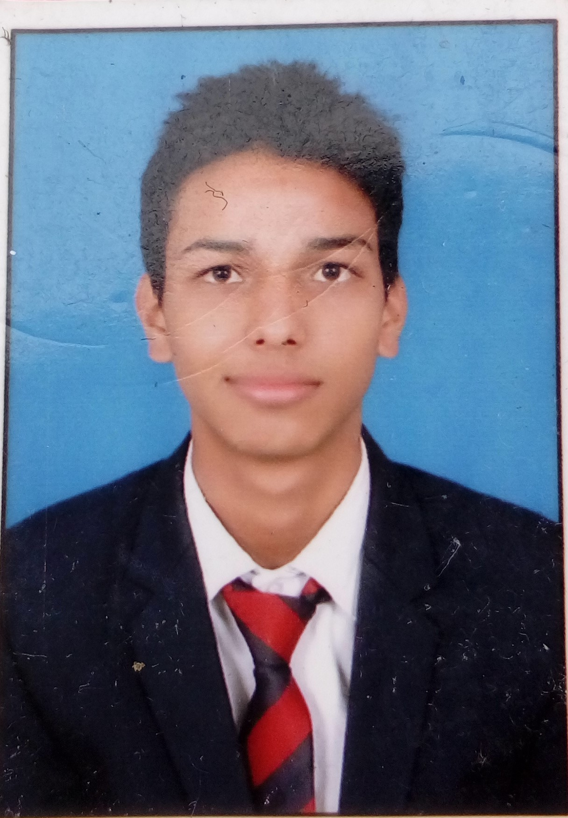

Tanuj joshi

Contact No: -9634775456

E-mail:- tanujjoshi43@gmail.com

CARRIER OBJECTIVE

- To be a part of dynamic and growing organization and to reach on good level of satisfaction and success through my hard work, creative ideas and team work.
WORK EXPERIENCE
- Six month of experience in tech Mahindra Pvt limited.
- Six month of experience in Exl pvt limited
- Designation : Back office Executive.

EDUCATIONAL QUALIFICATION

- 10th passed from Uk Board
- 12th passed from Uk Board
- BCA from Amrpali Group of Institute Haldwani.

HOBBIES

- Listening music
- Swimming
- Web Browsing

STRENGTH

- Positive Attitude & Soft behavior.
- Ability to work and learn with a team.
- Disciplined.

PERSONAL DETAILS

Father’s Name : Urva datt joshi Permanent Address : Khnna farm teenpani talli haldwani
Dist-Nainital (uttarakhand)
Marital Status : Unmarried
Language Known : Hindi & English
Nationality : Indian

DECLARATION

I hereby state that all the information mentioned above by me is correct & true to the best of my knowledge.

Date :

Place :
(Tanuj joshi )

