Tanuj Ojha

*FullStack Developer(MERN)*

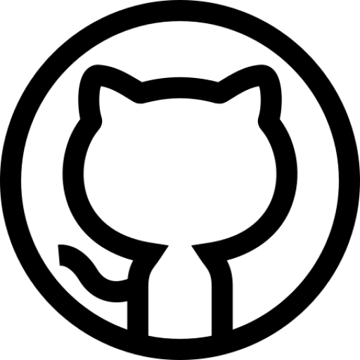

[*tanujojha2042@gmail.com*](mailto:tanujojha2042@gmail.com)

*8755955263*

[*tanujojha.netlify.app*](https://tanujojha.netlify.app/)

[*github.com/tanujojha*](https://github.com/tanujojha)

# Work Experience

## MERN Stack Developer @ [MNB Soft Solution Pvt. Ltd](https://mnbsoft.com).

*July 2023 - Present // Noida, India*

▹ Develop, maintain and ship high-quality and robust production code for a diverse

array of client and internal projects by leveraging the power of MERN stack.

▹ Collaborate with designers, project managers to transform creative concept into

production realities.

▹ Implemented seamless chat functionality using Socket.io to facilitate communication among administrators, employees and clients within the MNB Project Management system.

▹ Design and implement RESTful APIs, optimizing data retrieval and manipulation through well-structured endpoints and query parameters.

# Projects

## [TaskFlier](https://taskflier.com/)

*A Single Unified Platform for all the Management Needs*

Developed a comprehensive SaaS project management platform with a multi-tenant architecture for client isolation. The platform utilizes role-based access control with dedicated admin, employee, and client dashboards.

**Key Features:**  
**Project & Task Management:** Streamlined project tracking with task creation, assignment, and progress monitoring.

**Communication & Collaboration:** Integrated chat system for real-time communication.

**Performance Tracking:** Employee performance reporting.

**HR Management:** Built-in HRMS functionalities for attendance, leaves and pay slip.

**Tools and Tech:** MERN, JWT, Mongoose, Bootstrap, Socket.io, Multer

## [MNB Mart](https://mnbmart.com)

*A Reliable Online Shopping Platform*

Developed the scalable backend for MNB Mart, a feature-rich multi-vendor Ecommerce platform. Built with Node.js and MongoDB for performance and flexibility. Integrated secure payments (PhonePe) and implemented a real-time order tracking system for enhanced customer experience. MNB Mart boasts a user-friendly interface with comprehensive features, ensuring a seamless and secure shopping experience for customers.

**Tools and Tech:** NodeJS, MongoDB JWT, Mongoose, Multer

# Skills

**Programming Languages** JavaScript (ES6), HTML, CSS, Bash, Python, C++, SQL

## Libraries & Frameworks

jQuery, React, Redux Toolkit, Node.js, Express, Mongoose, MongoDB, Socket.io, Bootstrap, MUI, Tailwind CSS, EJS

## Tools & Platforms

Git, Github, Linux, Netlify, Heroku, Vercel, AWS

# Other Skills

Technical Analysis, Effective Communication, Team Player, Innovative Thinking, Active Listening

# Education

## Bachelor of Technology (CSE)

## Sharda University

*2018 - 2022 // Greate Noida, India*

6.0 CGPA

## Sr Secondary School (CBSE)

## APS Delhi Cantt

*2017 - 2018 // Dehi, India*

74.8 %

# Interests

Swimming, Travelling, Reading, Music, Adventurous Activities