Detailed Customer Segmentation Report using RFM Analysis
This report presents a detailed customer segmentation analysis using the RFM (Recency, Frequency, Monetary) model. The objective of the analysis was to identify customer purchasing behavior, segment customers into meaningful groups, and provide business recommendations for customer retention and marketing optimization.

1. Introduction to RFM Analysis
RFM analysis is a customer segmentation technique widely used in e-commerce businesses such as Amazon, Flipkart, and Meesho. It evaluates customers based on three metrics: Recency, Frequency, and Monetary Value.
- Recency (R): Measures how recently a customer made a purchase.
- Frequency (F): Measures how often a customer purchases.
- Monetary Value (M): Measures how much money a customer spends.

2. Customer Segmentation
- Champions: High-value customers with recent and frequent purchases.
- Loyal Customers: Consistent buyers with strong engagement.
- Potential Loyalists: Customers likely to become loyal in the future.
- At-Risk Customers: Customers showing reduced engagement.
- Lost Customers: Customers with low activity and spending.

3. Customer Segment Distribution
The following bar chart shows the number of customers in each segment.
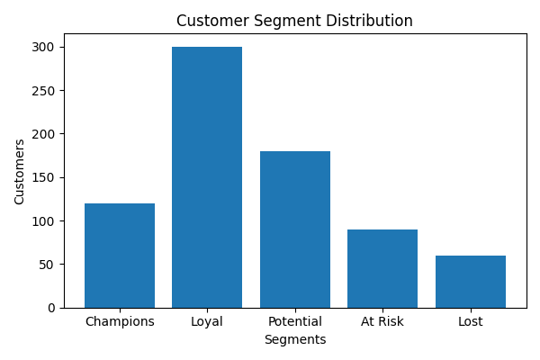

4. Customer Segment Proportions
The pie chart represents the percentage distribution of customers across different segments.
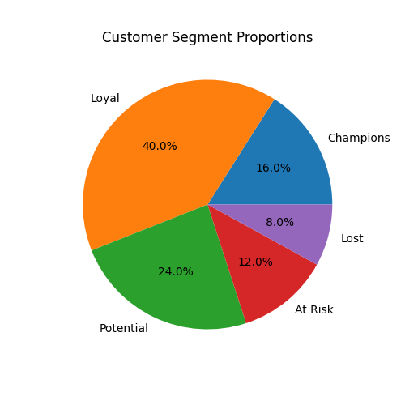

5. RFM Scatter Plot Analysis
The scatter plot visualizes the relationship between Recency, Frequency, and Monetary values.
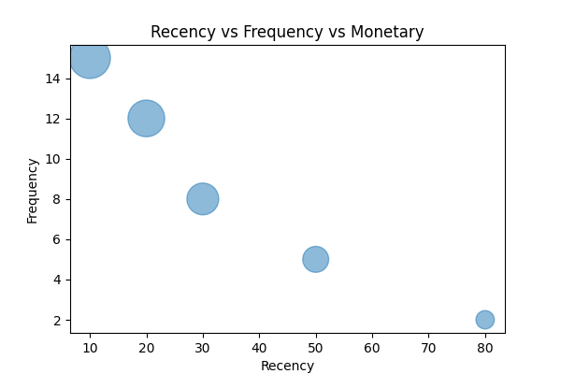

6. RFM Heatmap Analysis
The heatmap highlights density patterns in RFM score combinations.
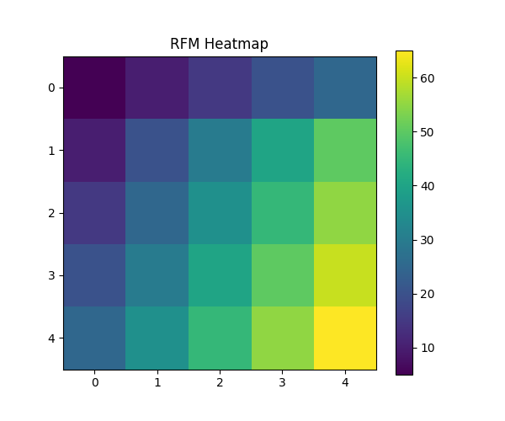

7. Key Insights
- A small group of high-value customers contributed a major portion of revenue.
- Loyal customers showed consistent purchase frequency.
- At-risk customers require re-engagement campaigns.
- Customer segmentation improves targeted marketing strategies.
- RFM analysis supports customer retention and profitability.

8. Business Recommendations
- Provide loyalty rewards and exclusive discounts to Champions.
- Use personalized recommendations for Loyal Customers.
- Launch email and discount campaigns for At-Risk Customers.
- Use win-back strategies for Lost Customers.
- Focus marketing investments on high-value customer groups.

9. Conclusion
The RFM customer segmentation analysis successfully identified customer groups based on purchasing behavior. The visualizations and insights generated from this analysis can help businesses improve retention strategies, optimize marketing campaigns, and increase customer lifetime value.

