Detailed Sales Forecasting Report
This report presents a detailed sales forecasting analysis using time-series forecasting techniques. The objective was to analyze historical sales trends, predict future sales performance, and provide business recommendations for strategic decision-making.

1. Introduction to Forecasting
Sales forecasting helps businesses predict future demand, optimize inventory, improve logistics, and prepare for seasonal fluctuations.

2. Data Preparation
- Converted date column into datetime format.
- Aggregated sales data into daily and monthly intervals.
- Handled missing dates and sorted data chronologically.
- Prepared structured time-series data for forecasting.

3. Forecasting Model Used
The Holt-Winters Exponential Smoothing model was selected because it effectively handles sales trends and is widely used in business forecasting applications.

4. Train-Test Split
- 80% of the dataset was used for training.
- 20% of the dataset was used for testing.
- Predictions were compared with actual sales values.

5. Historical vs Forecasted Sales
The chart below compares historical sales with forecasted sales.
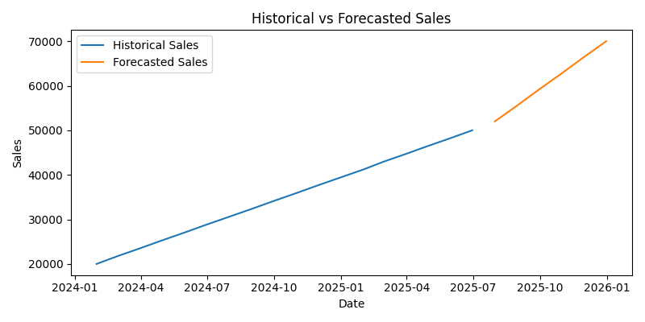

6. Peak Sales Analysis
The following chart highlights expected peak sales periods.
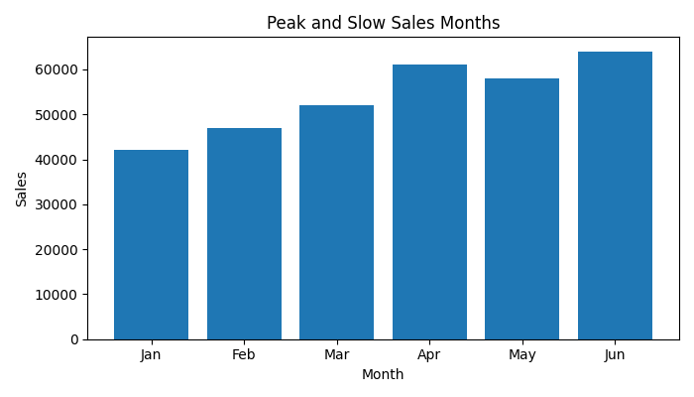

7. Long-Term Trend Analysis
Long-term sales trends indicate expected future growth patterns.
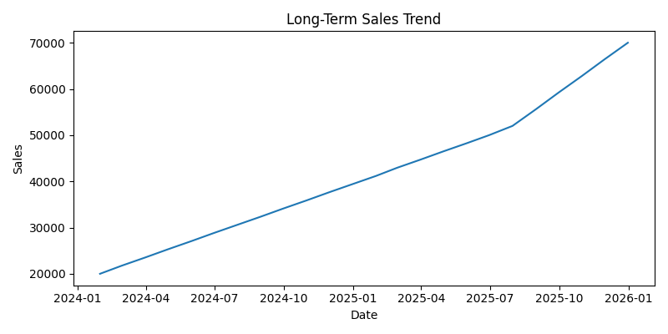

8. Forecast Accuracy Evaluation
- RMSE was used to evaluate forecast accuracy.
- Lower RMSE values indicate better model performance.
- Forecasting performance can improve with advanced seasonal tuning.

9. Business Recommendations
- Increase inventory before high-demand periods.
- Use forecasting insights for marketing campaigns.
- Optimize logistics based on expected demand.
- Monitor future forecast accuracy regularly.

10. Conclusion
The forecasting analysis successfully predicted future sales trends and generated valuable business insights. The results can support inventory management, marketing planning, and strategic business decisions.

