Final E-Commerce Business Analytics Report
Comprehensive Business Analysis, Forecasting, Customer Segmentation, and Strategic Insights

Executive Summary
This report presents a comprehensive e-commerce analytics project covering sales performance analysis, customer segmentation, forecasting, and business opportunity identification. The project aims to support data-driven business decisions for revenue growth and customer retention.

1. Introduction
E-commerce businesses rely on analytics to understand customer behavior, monitor sales trends, forecast demand, and improve business strategies. This project analyzed sales and customer data to generate actionable business insights.

2. Sales Performance Analysis
- Monthly sales trends indicated consistent business growth.
- Technology products generated the highest sales revenue.
- Seasonal fluctuations influenced sales performance.
- Western and Eastern regions contributed the highest revenue.
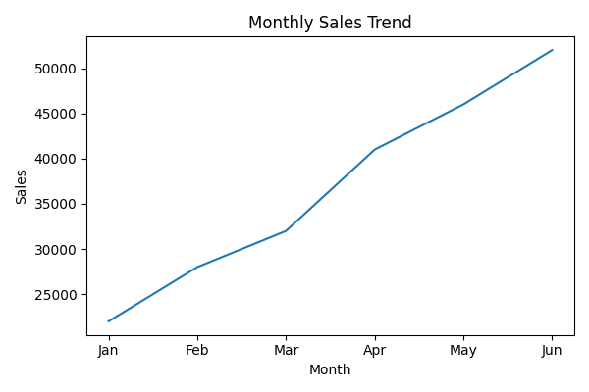
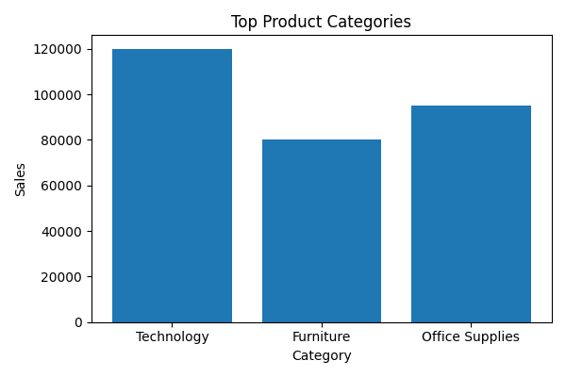
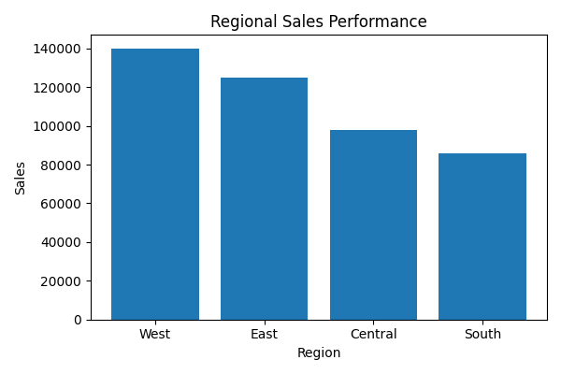

3. Customer Behavior & RFM Analysis
Customers were segmented using RFM (Recency, Frequency, Monetary) analysis.
- Champions represented the highest-value customers.
- Loyal customers contributed repeat purchases.
- At-risk customers required retention strategies.
- Lost customers indicated churn risks.
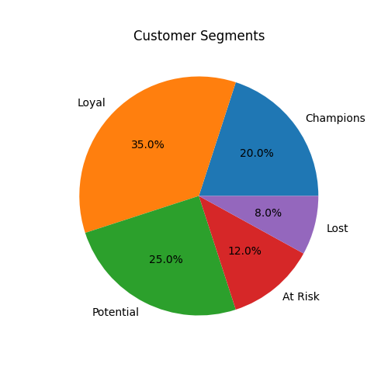

4. Sales Forecasting Analysis
- The Holt-Winters model was used for forecasting future sales.
- Forecasting predicted gradual sales growth.
- Seasonal demand fluctuations were identified.
- Forecasting supports inventory planning and logistics optimization.
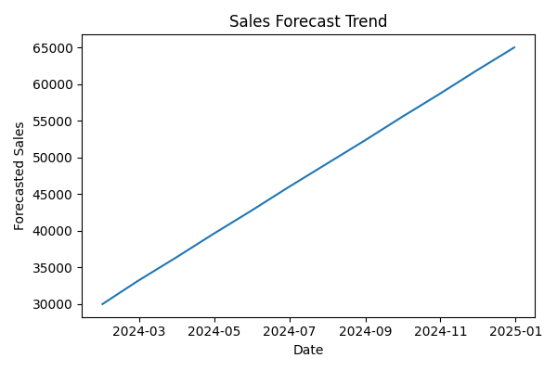

5. Business Opportunities
- Expand inventory for high-demand categories.
- Invest more marketing resources in high-performing regions.
- Implement personalized campaigns for loyal customers.
- Use cross-selling and upselling strategies to improve revenue.
- Develop customer retention programs for at-risk customers.

6. Recommendations & Action Plan
- Introduce loyalty rewards for repeat customers.
- Optimize inventory management using forecasting insights.
- Increase promotional campaigns during low-sales periods.
- Enhance customer engagement using personalized recommendations.
- Monitor forecasting accuracy for continuous improvement.

7. Conclusion
The project successfully analyzed sales performance, customer behavior, and forecasting trends to identify actionable business opportunities. The insights generated can help businesses improve profitability, optimize marketing strategies, and support long-term business growth.

This project focused on analyzing e-commerce sales data to identify business insights, customer behavior patterns, and future sales trends. The analysis included data cleaning, sales trend analysis, product and regional performance analysis, RFM customer segmentation, and time-series forecasting.
Key findings showed that technology products and high-performing regions generated the highest revenue. RFM analysis identified loyal and high-value customers, while forecasting analysis predicted future sales growth and seasonal demand fluctuations. Business opportunities such as personalized marketing, upselling strategies, inventory optimization, and customer retention programs were identified to improve profitability and business growth.
The project demonstrated how data analytics can support strategic decision-making in e-commerce businesses by improving forecasting accuracy, customer engagement, and operational efficiency. The final deliverables include a detailed business report, professional presentation, processed datasets, and forecasting visualizations for future business planning and analysis.

