**AWS_Lambda**

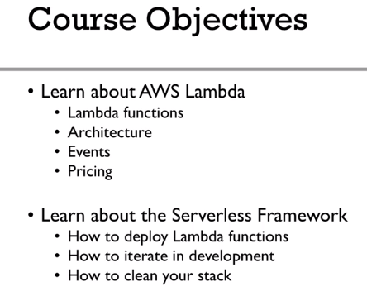

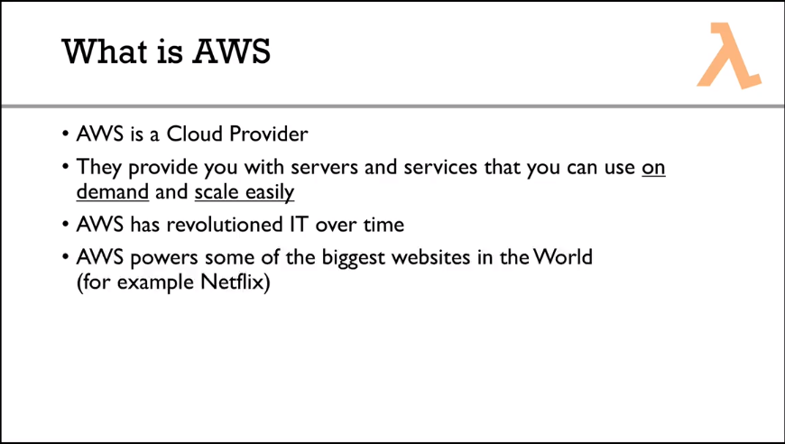

AMAZON EC2 provides you the Servers.

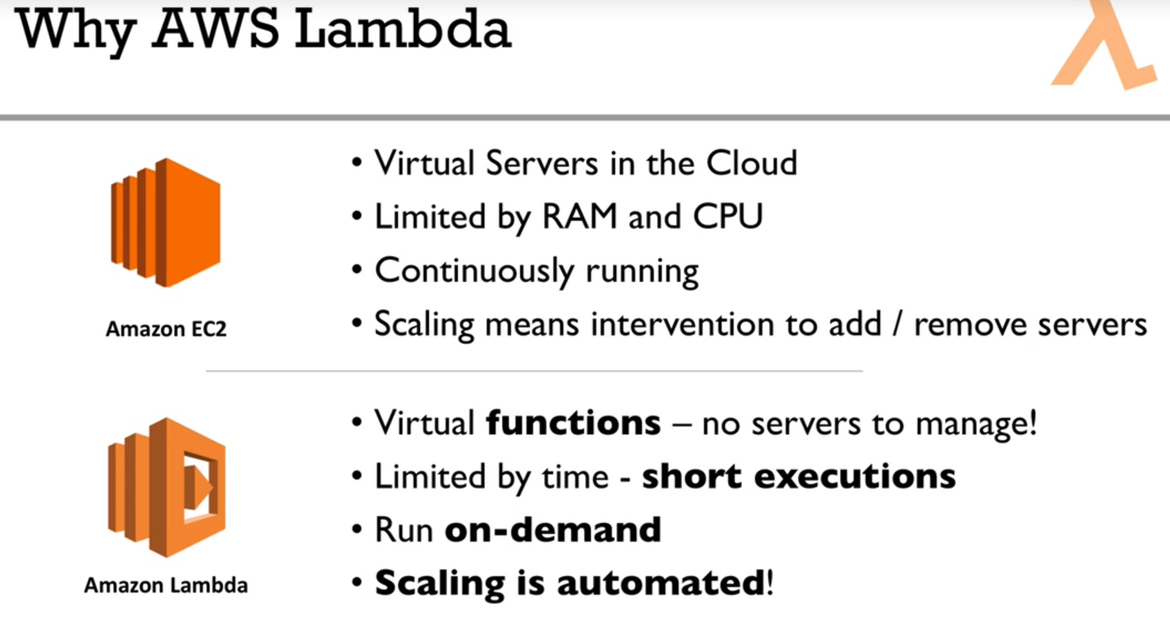

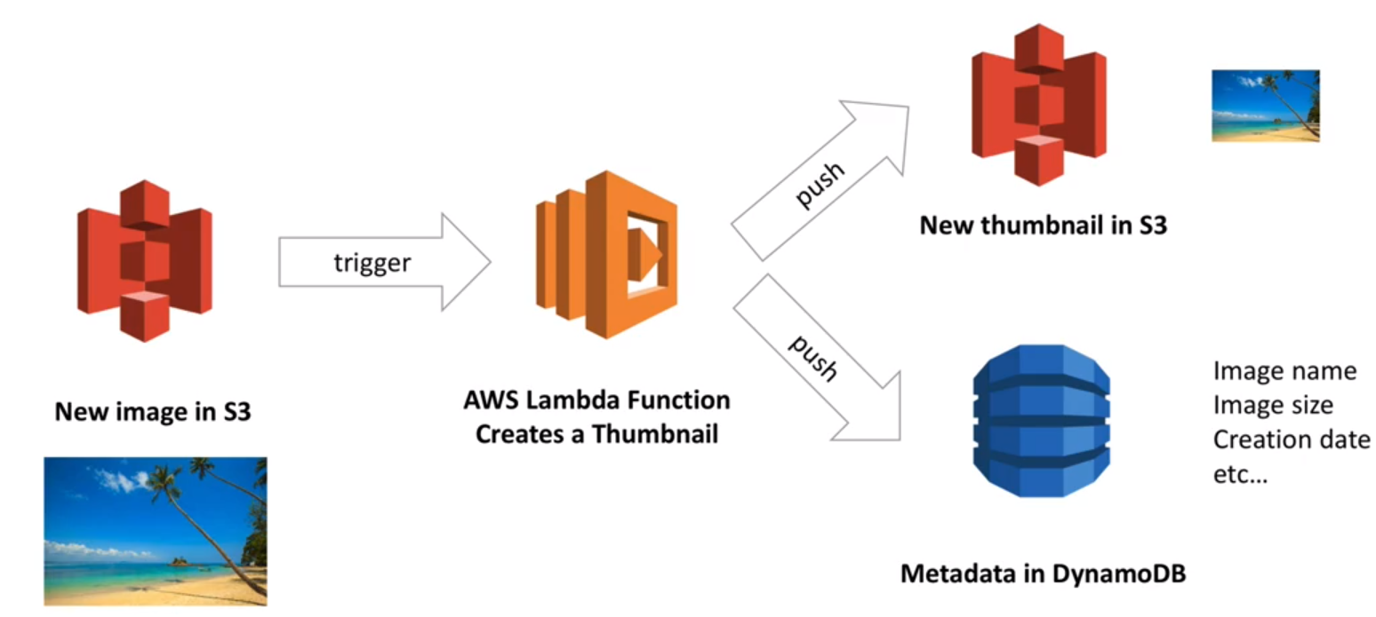

**$** npm install Serverless --save

**$** Serverless config credentials --provider aws --key XXXX --secret XXXX –profiles serverless-admin