**ES6**

ES6: It stands for Ecma script 6.

Ecma script is the standard whereas javascript is an implementation.

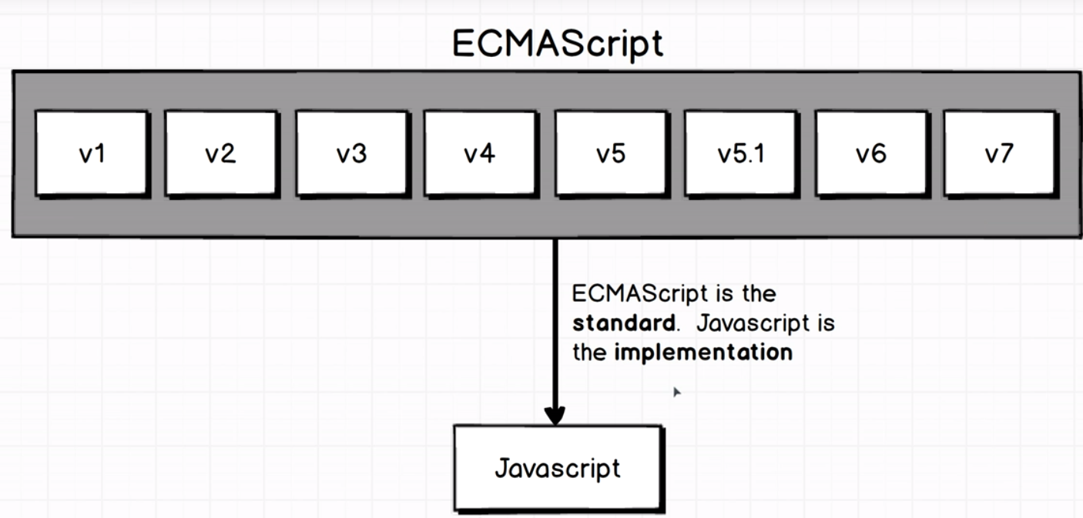

You can say ES6 is a newer version of javascript.

ES6 is not always supported by the every browser right now. ES5 is supported by every browser as it was introduced in 2008. So, to convert (transfiling) ES6 to ES5 Babel is used. So, as the javascript version will keep on upgrading Babel will be used to transfile the newer version to the previous supported version.

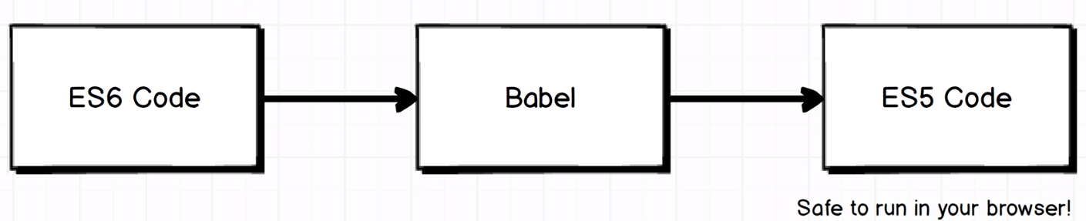

**Array Helper Methods:**

1. forEach
2. map
3. filter
4. find
5. every
6. some
7. reduce

Ui portal XMLGW B2B SDEDS

ESB

IPUB STAA

SIEBEL

SPLUNK

MultiTherading:

The act of stopping one thread and scheduling it in and scheduling it out as well as scheduling another thread is called a context switching.