Message sent from arduino to computer are through: TX->1 (T is Transmitter)

Message sent from computer to arduino are through: RX<-1 (T is Receiver)

we dont have to connect it to our computer as it is already as it is already connected to the chip via USB shown below

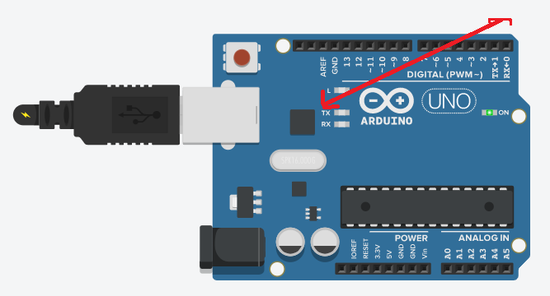

Send from Arduino to Computer (Tx)

void setup()

{

Serial.begin(9600);

}

void loop()

{

Serial.println("Hi");

delay(1000);

}

Ultrasocnic sensore works by sending ultra high frequesncy sound pulse. If that sound pukse hits an object it bounces back.

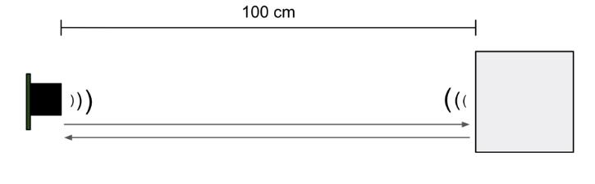

The distance sensor reports the time it takes between sending out a pulse and receivng it. It works best with medium range applications

We have a trigger pin and pulse width pin. Trigger pin sends the sound pulse and we measure the electrical pulse width on the pw pin to determine the distance of an object.

1. Set the trigger pin to HIGH for some specified amount of time. How long it needs to be HIGH depends upon the type of sensor we are using. It can be 3us to 100μs

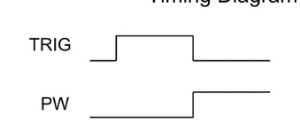

1. As soon as TRIG pin sets to LOW, PW pin is set to HIGH. When the sensor detects its reflected pulse it sets the PW pin to LOW. We need to measure the time in which PW pin remains HIGH

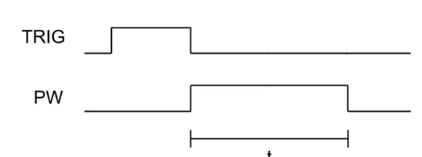

**Speed of sound** = 340m/s = 29.4 μs/cm

**S =d/t**

29.4 μs/cm = 2.d/t

d=t/58.8

so, we can calculate the distance of an object by this formula

**d = t / 58.8**

const int trig_pin = 4;  
 const int pw_pin = 7;  
 const int trig_delay = 25; //microseconds  
  
 void setup(){  
 Serial.begin(9600);  
 }  
  
 void loop(){  
 long duration;  
 float cm;  
  
 //Tell distanse sensor to send out a pulse  
 pinMode(trig_pin, OUTPUT);  
 digitalWrite(trig_pin, LOW);  
 delayMicroseconds(10);  
  
 digitalWrite(trig_pin, HIGH);  
 delayMicroseconds(trig_delay);  
  
 digitalWrite(trig_pin, LOW);  
  
 // Measure time of pulse on PW pin  
 pinMode(pw_pin, INPUT);  
  
 duration = pulseIn(pw_pin, HIGH);  
  
 // convert time to distance  
 cm = duration/58.8;  
  
 }