Select \*from coursefeedback;

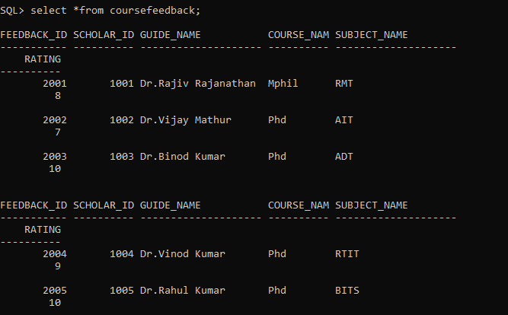

Select\*from scholar;

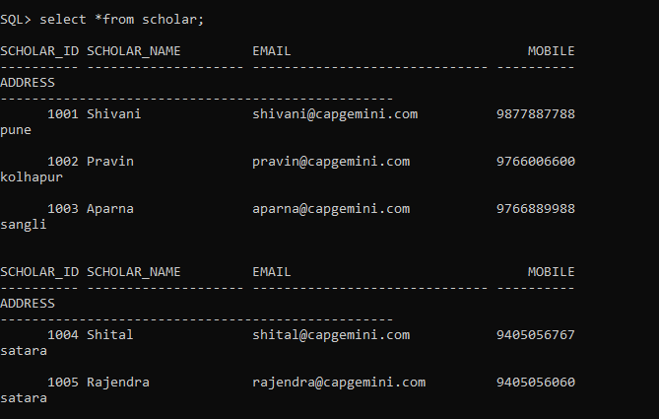

1.a) Retrieve the name of the scholars who all gave 10 ratings.

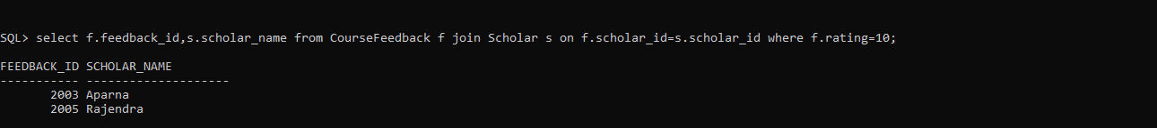

b) Display the count of scholars in Satara

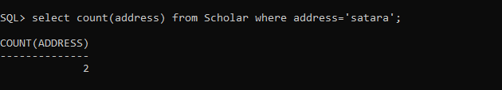

c) Retrieve the name of the scholars who has given feedback for Dr.Binod Kumar



2) Write a SQL query to change the mobile number and address of the scholar whose scholar id is 1001

