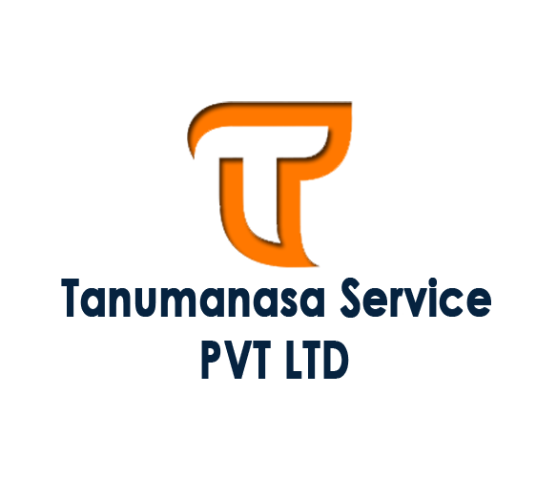

INTERNSHIP & JOBS

Join us to make self- reliance India



# Who are we...

- - - - X- - - -

As our name Tanumanasa i.e the enlightened body and mind being in resonance, we are on a mission to be the tool in bringing the light of wisdom and knowledge in physical form to those who are craving for it in an easier and sustainable way. In the world getting transformed so fast, we are aiming to be the bridge between knowledge and seeker. To be the path breaker who can break the boundaries and borders in fields of education and research. Stigmas to be broken, Trends to be set.



# Mission

- - - - X - - - -

To bring everything associated with research under one umbrella and work in a targeted mission and give our wisdom to generations next in a perfect package.



# Vision

- - - - X - - - -

To bring in all the scattered bricks of knowledge and research, collaborate and interlink them resulting in the upcoming of a tower of collective wisdom.

How to join

( all jobs are available at [www.ncs.gov.in](http://www.ncs.gov.in) )

| Sl No | Job title | Check & Apply |
| --- | --- | --- |
| 1 | Manager | [Click](https://www.ncs.gov.in//Pages/ViewJobDetails.aspx?JSID=Xb1UB3M8AXI%3D) |
| 2 | Accountant | [Click](https://www.ncs.gov.in//Pages/ViewJobDetails.aspx?JSID=4auKxAsK0Kk%3D) |
| 3 | Code Developer | [Click](https://www.ncs.gov.in//Pages/ViewJobDetails.aspx?JSID=B1DGVFuBwPY%3D) |
| 4 | Business Developer | [Click](https://www.ncs.gov.in//Pages/ViewJobDetails.aspx?JSID=Tdul%2BePe6Yc%3D) |
| 5 | Partnership Executive | [Click](https://www.ncs.gov.in//Pages/ViewJobDetails.aspx?JSID=Jl8A3ULjojU%3D) |
| 6 | UX Designer | [Click](https://www.ncs.gov.in//Pages/ViewJobDetails.aspx?JSID=z64NhpXkbSs%3D) |
| 7 | UI Designer | [Click](https://www.ncs.gov.in//Pages/ViewJobDetails.aspx?JSID=ZVMbcSvJWFk%3D) |
| 8 | DTP Operator | [Click](https://www.ncs.gov.in//Pages/ViewJobDetails.aspx?JSID=zaKQUiL1m3c%3D) |
| 9 | Code Developer Internship | [Click](https://www.ncs.gov.in//Pages/ViewJobDetails.aspx?JSID=TAePnS%2FNAwE%3D) |

For Direct Apply -

Mail us your CV. mail:- [archana@tanumanasa.com](mailto:archana@tanumanasa.com)

or call us +91 7008270687

………………………………………………………………………………….....