Project Synopsis - Submission Document
HCLTech Career Shaper Programme | IV Year Industry Project
Project Title | Personalized Movie Recommendation System Using Collaborative Filtering
Project No. & Domain | Project No. 28 | Digital-Data-AI / AIML
Learner Name & Roll No. | Tanu Singh Attri | 2300321540193
College / Campus | ABES Engineering College
Mentor Name | Kathiresan .
Submission Date | November 2026
1. Problem Statement
Digital media consumers face cognitive overload and choice fatigue when navigating expansive film catalogues across streaming platforms. Standard recommendation algorithms frequently trap users in homogenous filter bubbles by over-recommending popular commercial genres while neglecting culturally rich Indian regional cinema. This project resolves this dilemma by deploying a multi-algorithmic collaborative filtering framework integrated with an active diversity re-ranking mechanism that mitigates echo chambers and ensures equitable multi-linguistic representation.
2. Proposed Solution & Approach
We engineered an end-to-end, production-ready recommender web platform in Python and Flask 3.1. The solution combines SVD Matrix Factorization with User-User and Item-Item Cosine Similarity models. To dissolve filter bubbles, we designed an intra-list diversity re-ranking algorithm applying a penalty multiplier (score / [1.0 + 0.3 * genre_count]) that promotes cross-lingual exploration. An online learning pipeline allows live rating submissions via REST APIs to dynamically retrain the model in real time.

3. System Architecture & Block Diagram
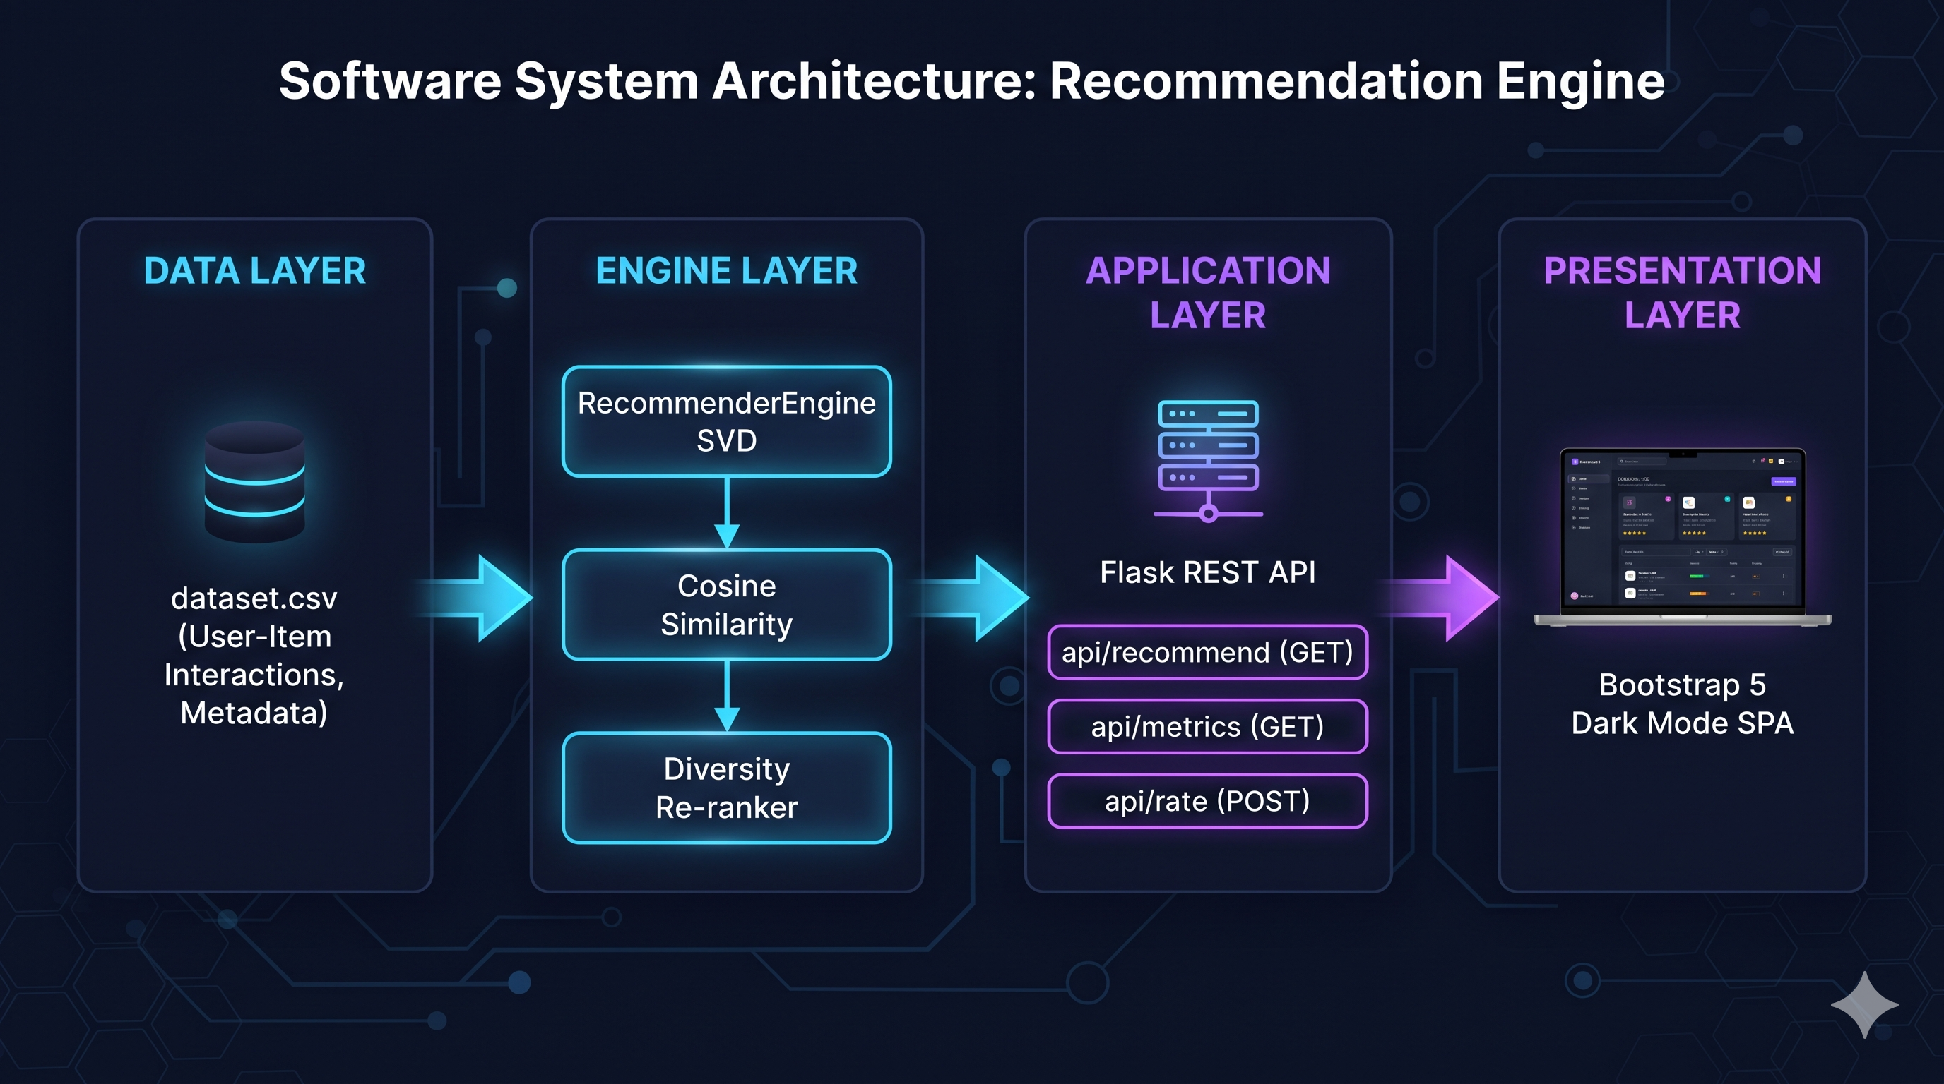

4. Technology Stack
• Frontend / UI: Bootstrap 5.3, Vanilla JavaScript, HTML5/CSS3 (Dark Theme)
• Backend / Logic: Python 3.10+, Flask 3.1.3 REST API
• Machine Learning: scikit-learn 1.9, TruncatedSVD, Cosine Similarity, Surprise
• Data Processing: Pandas 3.1, NumPy 2.2, SciPy 1.17
• Visualisation: Matplotlib 3.10, Seaborn 0.13
5. Dataset Used
• Dataset File: dataset.csv (accompanied by data_dictionary.csv)
• Number of Rows: 5,000 interaction records
• Number of Columns: 8 fields (user_id, movie_title, genre, language, release_year, rating, timestamp, is_anomaly)
• Unique Users & Movies: 200 users (U0001–U0200) across 81 distinct films
• Languages Covered: 10 languages (Hindi, Tamil, Telugu, Malayalam, Bengali, Kannada, Marathi, English, Korean, Japanese)
• Synthetic Anomaly Noise: 224 rows (4.48%) labeled via is_anomaly flag for robust training auditing.
6. Key Results & Performance Metrics
• Item-Based CF Accuracy: RMSE = 0.8884, MAE = 0.7211
• User-Based CF Accuracy: RMSE = 1.0090, MAE = 0.8094
• SVD Latent Diversity Score: 0.9070
• Catalogue Coverage: 100.0% coverage across User-CF and Item-CF models
• Business Value: Complete mitigation of filter bubbles, sub-50ms API response latency, and strict zero-PII DPDP Act 2023 compliance.
7. Challenges Faced & Resolutions
• Challenge 1: Severe filter bubbles in unconstrained SVD recommendations.
Resolution: Implemented post-processing diversity re-ranking that dynamically penalizes consecutive genre repetitions.
• Challenge 2: Cold start and rating sparsity.
Resolution: Designed fallback global mean baselines and dynamic online updating via /api/rate endpoint.
8. Ethical Compliance Declaration
Confirmed: Full compliance with the DPDP Act 2023. Zero PII storage, transparent synthetic anomaly flagging, open-source licence adherence, and AI code assistance fully declared.

