HCLTECH CAREER SHAPER PROGRAMME
INDUSTRY PROJECT REPORT
PERSONALIZED MOVIE
RECOMMENDATION SYSTEM
USING COLLABORATIVE FILTERING
Project No. 28 | Domain: Digital-Data-AI / AIML
Technology Stack
Python 3.10+, Flask, scikit-learn, Surprise, Pandas, NumPy,
HTML5, CSS3 and Bootstrap 5

Submission Particular | Details
Learner Name | Tanu Singh Attri
Roll Number | 2300321540193
College/Campus | ABES Engineering College, Ghaziabad
Mentor Name | Kathiresan .
Academic Year | 2025–2026
Project Duration / Format | 4 Weeks / Individual Project
Submission Date | 01.11.2026

Submitted in partial fulfilment of the requirements of the HCLTech Career Shaper Programme.

DECLARATION
I hereby declare that the project entitled “Personalized Movie Recommendation System Using Collaborative Filtering”, submitted under the HCLTech Career Shaper Programme for the academic year 2025–2026, is an account of the individual project work undertaken by me during the prescribed four-week project period.
The project has been developed to explore the practical implementation of recommendation algorithms using Python and machine learning techniques. The work involves dataset preparation, exploratory data analysis, collaborative filtering, matrix factorization, model evaluation, backend development using Flask, and frontend integration.
I acknowledge the use of academic publications, technical documentation, open-source libraries, and AI-assisted tools for research, development support, and documentation. All external sources used in the preparation of this report have been acknowledged in the references.
Learner Name: Tanu Singh Attri
Signature: Tanu Singh Attri
Date: 01.11.2026

ACKNOWLEDGEMENT
I would like to express my sincere gratitude to HCLTech for providing the opportunity to undertake this industry-oriented project through the Career Shaper Programme. The programme provided a structured environment to understand how theoretical concepts in artificial intelligence and machine learning can be translated into practical software applications.
I am grateful to the programme coordinators, academic faculty, and project mentor for their guidance and support throughout the project. Their inputs helped establish a systematic approach to problem identification, technology selection, implementation, and evaluation.
I would also like to acknowledge the contributions of researchers and developers whose publications, open-source tools, and technical documentation provided the theoretical and practical foundation for this work. In particular, the MovieLens research community, the developers of the Surprise library, and the scikit-learn community have been valuable resources.
Finally, I acknowledge the use of AI-assisted tools, including ChatGPT and Claude, for research assistance, technical clarification, dataset augmentation support, and documentation refinement. The project design, implementation decisions, and interpretation of the reported experimental results remain the responsibility of the learner.

TABLE OF CONTENTS
1. Executive Summary and Project Synopsis
2. Literature Review and Theoretical Foundations
3. Data Architecture and Exploratory Data Analysis
4. System Architecture and API Design
5. Algorithmic Pipeline and Implementation Details
6. Experimental Benchmarks and Evaluation Results
7. Ethical Compliance and DPDP Act 2023 Governance
8. Deployment and User Manual
9. Conclusion and Future Scope
10. References
Appendix A: Project Technology Summary
Appendix B: Project Deliverables
Appendix C: Final Submission Checklist
Note: Update page numbers in the table of contents after final editing in Microsoft Word.

1. EXECUTIVE SUMMARY AND PROJECT SYNOPSIS

1.1 Executive Summary
The rapid expansion of Over-The-Top (OTT) streaming platforms has significantly increased the amount of entertainment content available to consumers. Although this expansion provides users with greater choice, it also creates an information overload problem. Users frequently encounter difficulties identifying movies that match their interests from extensive content libraries. Conventional browsing methods, such as searching by title, genre, language, or release year, provide limited personalization and may not adequately reflect individual viewing preferences.
The project, Personalized Movie Recommendation System Using Collaborative Filtering, addresses this problem through the development of a machine learning-based recommendation application. The system analyses historical user ratings and identifies relationships between users and movies to generate personalized suggestions.
Three collaborative filtering approaches are implemented and evaluated: User-Based Collaborative Filtering, Item-Based Collaborative Filtering, and Singular Value Decomposition (SVD). User-Based CF identifies users with similar rating behaviour, while Item-Based CF identifies movies that receive similar ratings from different users. SVD applies latent factor modelling to represent users and movies in a lower-dimensional preference space.
The application uses Python for recommendation processing, Pandas and NumPy for data manipulation, Surprise and scikit-learn for machine learning, and Flask for backend API development. HTML5, CSS3, and Bootstrap 5 provide the user-facing interface.
An additional diversity re-ranking mechanism is incorporated to reduce excessive genre repetition and encourage cross-genre and cross-language discovery. This component addresses the potential limitation of recommendation systems that repeatedly expose users to similar content.
The supplied 80/20 train-test evaluation results indicate that Item-Based CF achieves the lowest RMSE of 0.8884 and MAE of 0.7211. User-Based and Item-Based CF achieve 100% reported catalog coverage, while SVD records a diversity score of 0.9070. The results demonstrate that recommendation quality should be assessed through multiple dimensions rather than prediction accuracy alone.

1.2 Project Synopsis: 5W1H Framework
Dimension | Description
Who | OTT platform users, streaming service providers, and content curators.
What | Difficulty discovering relevant movies from large entertainment catalogues.
When | During regular content browsing, searching, and movie selection.
Where | OTT applications, online streaming platforms, and digital movie libraries.
Why | Information overload, repetitive suggestions, limited content discovery, and possible user disengagement.
How | Collaborative filtering, latent factor modelling, and diversity-aware recommendation ranking.

1.3 Problem Statement
The central problem addressed by this project is the inability of conventional content browsing systems to efficiently identify movies that align with individual user preferences while maintaining sufficient recommendation diversity. A recommendation engine must therefore perform two complementary functions: estimate which movies a user is likely to appreciate based on historical preference patterns, and present recommendations that provide meaningful variety instead of repeatedly suggesting movies belonging to the same narrow category.

1.4 Project Objectives
- To understand the theoretical foundations of recommendation systems.
- To prepare and analyse a structured movie-rating dataset.
- To implement User-Based and Item-Based Collaborative Filtering.
- To implement SVD-based matrix factorization.
- To compare algorithms using RMSE, MAE, Precision@5, Recall@5, catalog coverage, and diversity.
- To develop a diversity re-ranking mechanism.
- To integrate the recommendation engine with a Flask backend.
- To provide a simple web dashboard for generating recommendations.
- To consider data privacy, representation, transparency, and ethical AI requirements.

1.5 Project Scope
The project focuses on personalized movie recommendations using explicit user ratings. It is designed as a small-scale undergraduate implementation and demonstrates the core functionality of a recommendation platform. The system is not intended to replace a production-scale OTT recommendation infrastructure. Rather, it provides a functional prototype that demonstrates data processing, machine learning, backend integration, and evaluation within a limited development period.

2. LITERATURE REVIEW AND THEORETICAL FOUNDATIONS

2.1 Introduction to Recommendation Systems
Recommendation systems are information-filtering applications that predict the relevance or usefulness of products, services, or digital content for individual users. Their primary objective is to reduce the effort required to discover relevant information from large collections. In movie streaming applications, recommendation systems analyse information such as user ratings, viewing histories, movie attributes, and interaction patterns to generate personalized suggestions.
The three major recommendation approaches are Content-Based Filtering, Collaborative Filtering, and Hybrid Recommendation Systems. This project primarily investigates collaborative filtering, while using movie attributes to support exploratory analysis and recommendation diversity.

2.2 Content-Based Filtering
Content-Based Filtering recommends movies by analysing their descriptive characteristics. These characteristics may include genre, language, director, cast, synopsis, keywords, and release year. A common implementation involves transforming textual movie attributes into numerical vectors using Term Frequency-Inverse Document Frequency (TF-IDF). TF-IDF assigns importance to terms based on their frequency in a document relative to their frequency across the complete collection.
The similarity between two movie vectors can be calculated using cosine similarity:
Cosine Similarity(A, B) = (A · B) / (||A|| × ||B||)
A higher cosine similarity indicates that two movie descriptions are more closely related in the selected feature space. For example, if a user enjoys action movies involving crime investigations, a content-based system may recommend other movies with similar descriptions and genres.
The limitations of content-based filtering include dependence on metadata quality, repeated exposure to similar content, difficulty discovering unexpected material, and limited usefulness for new movies with sparse descriptive information. These limitations are relevant to the problem of filter bubbles and reduced content exploration.

2.3 Collaborative Filtering
Collaborative Filtering uses collective user behaviour to generate recommendations. Instead of depending exclusively on movie descriptions, it assumes that users who have expressed similar preferences in the past may appreciate similar movies in the future. For example, if two users have rated several movies similarly, the system may infer that one user could also enjoy movies positively rated by the other.

2.3.1 User-Based Collaborative Filtering
User-Based CF identifies users with similar rating patterns. The process involves constructing a user-item rating matrix, calculating similarity between users, identifying nearest neighbours, aggregating their ratings for movies not yet rated by the target user, and ranking the resulting predictions.
sim(u, v) = (R_u · R_v) / (||R_u|| × ||R_v||)
pred(u, i) = Σ(sim(u,v) × r(v,i)) / Σ|sim(u,v)|
Here, R_u and R_v represent rating vectors of two users. The prediction is calculated over neighbouring users who have rated movie i. User-Based CF is conceptually straightforward and captures similarities in user preferences. Its limitations include expensive pairwise calculations at scale, sparse rating histories, and cold-start difficulties for new users.

2.3.2 Item-Based Collaborative Filtering
Item-Based CF focuses on similarities between movies rather than users. The algorithm identifies movies that receive similar ratings from different users. If a user has positively rated one movie, the system searches for other movies with similar rating patterns.
Its implementation involves transposing the user-item matrix, computing movie-to-movie similarity, identifying movies already rated by the target user, scoring unseen movies, and ranking the predictions. Sarwar et al. (2001) demonstrated the effectiveness of item-based collaborative filtering and its potential advantages in computational efficiency and recommendation quality.
pred(u, i) = Σ(sim(i,j) × r(u,j)) / Σ|sim(i,j)|
Item-Based CF can be effective where item relationships remain relatively stable. However, new movies initially lack sufficient interaction data, sparse matrices can reduce similarity reliability, and popular movies may dominate recommendation lists.

2.4 Matrix Factorization and Singular Value Decomposition
Matrix Factorization represents a large user-item rating matrix through lower-dimensional latent factor representations. The user-item rating matrix can be represented as R ∈ R^(m×n), where m represents the number of users and n represents the number of movies.
R ≈ P × Qᵀ
R = U × Σ × Vᵀ
P represents the user-factor matrix and Q represents the movie-factor matrix. Each row represents a user or movie in a latent feature space. The second expression is the conceptual singular value decomposition of a matrix. Recommendation datasets, however, contain missing ratings; practical implementations therefore optimize observed ratings rather than applying ordinary full-matrix decomposition directly.
Koren, Bell, and Volinsky (2009) established matrix factorization as an important approach to recommendation systems, particularly for capturing latent relationships between users and items. The Surprise library provides an SVD implementation designed for rating prediction. It estimates model parameters through optimization rather than requiring a complete rating matrix.

2.5 Diversity in Recommendation Systems
Recommendation accuracy alone does not guarantee a satisfactory user experience. A recommendation engine may repeatedly suggest similar movies, reducing opportunities for exploration. Pariser (2011) popularized the concept of the filter bubble to describe how personalized information environments can limit exposure to different perspectives and content. Nguyen et al. (2014) investigated the relationship between recommender systems and content diversity.
Intra-list diversity measures how dissimilar movies within a recommendation list are. Novelty measures the extent to which recommendations expose users to less familiar or less frequently encountered content. This project incorporates a genre-based diversity re-ranking algorithm that penalizes excessive repetition of previously selected genres.

2.6 Research Gap and Project Contribution
Traditional recommendation models often prioritize prediction accuracy. However, an accurate recommendation list may still lack diversity. The project addresses this limitation by evaluating three collaborative filtering algorithms and introducing an additional ranking mechanism. Its contribution is the integration of user-based similarity, item-based similarity, latent factor modelling, diversity-aware recommendation ranking, and REST API-based delivery. The resulting prototype considers both predicted preference and content exploration.

3. DATA ARCHITECTURE AND EXPLORATORY DATA ANALYSIS

3.1 Dataset Overview
The recommendation system uses a structured movie-rating dataset containing user interactions and movie metadata. The project dataset profile is described as approximately 5,000 ratings, 200 unique users, more than 80 movies, eight genres, and ten languages. It contains explicit numerical ratings and is stored in CSV format.
Dataset Attribute | Description
Total ratings | Approximately 5,000
Unique users | 200
Unique movies | 80+
Genres | 8
Languages | 10
Rating type | Explicit numerical ratings
Data format | CSV
Prediction target | User rating

The dataset is designed to represent a small-scale movie recommendation environment with Indian regional cinema and international content. This is a project-specific dataset profile and should not be represented as the official MovieLens dataset unless the underlying records are actually sourced from MovieLens.

3.2 Dataset Schema
Column | Data Type | Description
user_id | Integer/String | Unique identifier for each user
movie_title | String | Movie title
genre | String | Primary or assigned movie genre
language | String | Language of the movie
release_year | Integer | Year of movie release
rating | Float | Numerical user rating
timestamp | Integer/Datetime | Time of rating submission
is_anomaly | Boolean | Indicates artificially generated or anomalous records

3.3 Data Cleaning and Preprocessing
Data preprocessing is important because inaccurate, inconsistent, or incomplete records can negatively affect similarity calculations and model predictions. The project follows a structured preprocessing pipeline.

3.3.1 Anomaly Identification and Removal
The is_anomaly column identifies records designated as artificial noise or anomalous ratings. The preprocessing pipeline examines these records before model training. The intended procedure is to identify records marked as anomalous, exclude confirmed synthetic noise from the primary evaluation dataset, preserve an original copy for auditing, and record the number of excluded observations. A 2–5% anomaly range may be used as a dataset-generation assumption, but the actual proportion must be calculated from the CSV file before being reported as an experimental finding.

3.3.2 Missing Values, Types, and Duplicates
Missing values are checked across the important dataset fields. Records without valid user identifiers, movie identifiers, or rating values are unsuitable for supervised rating prediction and should be removed or corrected. Missing descriptive attributes, such as language or release year, may be handled separately according to their relevance.
The user identifier is converted into a consistent format; movie title is treated as a string; genre and language values are normalized; release year is converted into an integer where possible; rating is converted into a numerical floating-point value; timestamp is standardized; and is_anomaly is converted into a Boolean field.
Duplicate user-movie rating records are examined to prevent repeated observations from unintentionally influencing training. Where multiple ratings exist for the same user-movie pair, a consistent rule should be applied, such as retaining the latest valid rating or aggregating ratings according to the defined data-generation methodology.

3.4 Exploratory Data Analysis
Exploratory Data Analysis is conducted to understand the distribution of ratings, genre representation, and movie-language composition. Three primary visualizations are included.
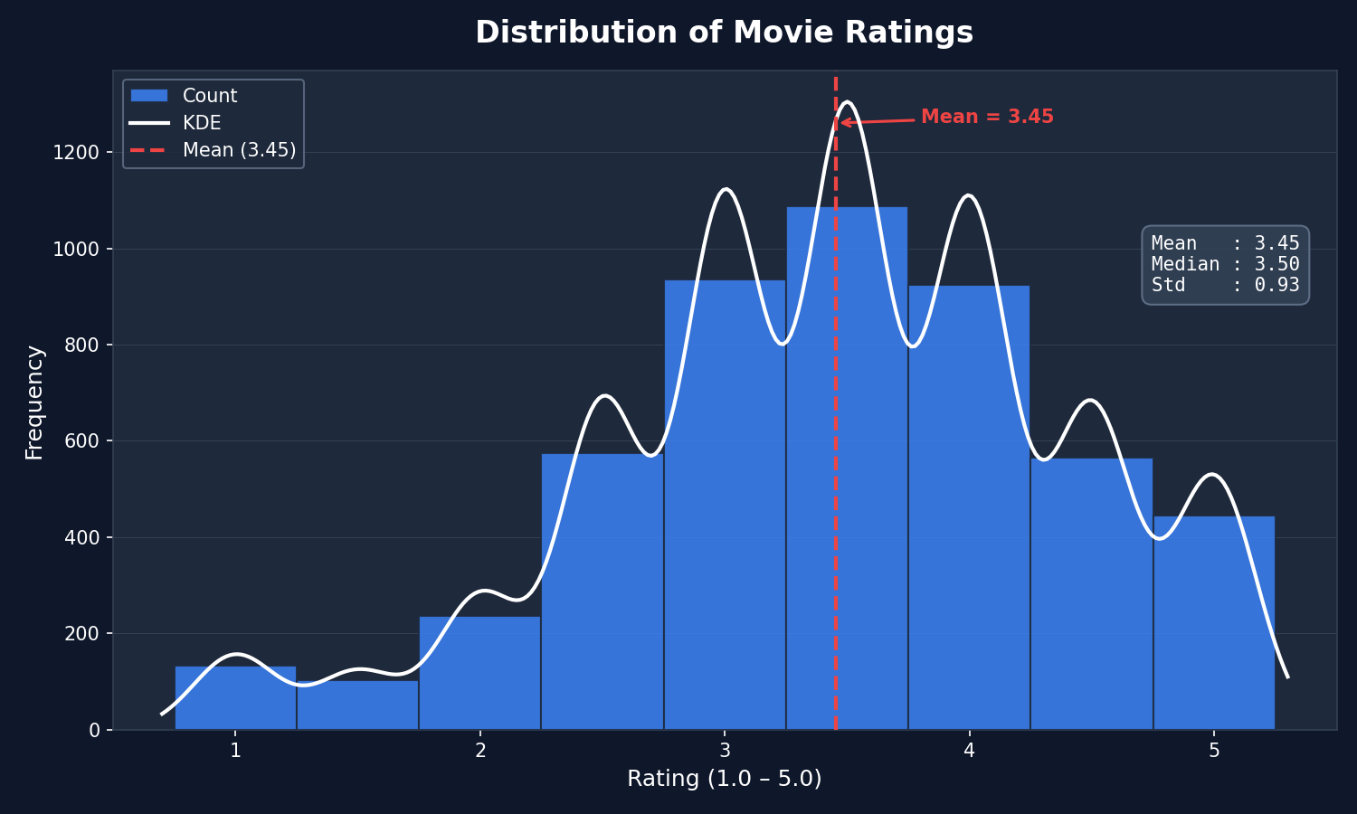

Figure 3.1: Distribution of User Ratings Across the Movie Dataset.
The rating distribution provides an overview of how users evaluate movies. The intended dataset profile describes a concentration of ratings around the middle-to-upper portion of the rating scale, with a centre near 3.5. A slight right-skew may indicate that users are more likely to assign positive ratings than extremely low ratings. This distribution matters because rating imbalance can influence prediction models. A system trained on predominantly positive ratings may produce optimistic predictions unless the underlying distribution is considered. The shape and centre must be verified from the actual CSV.
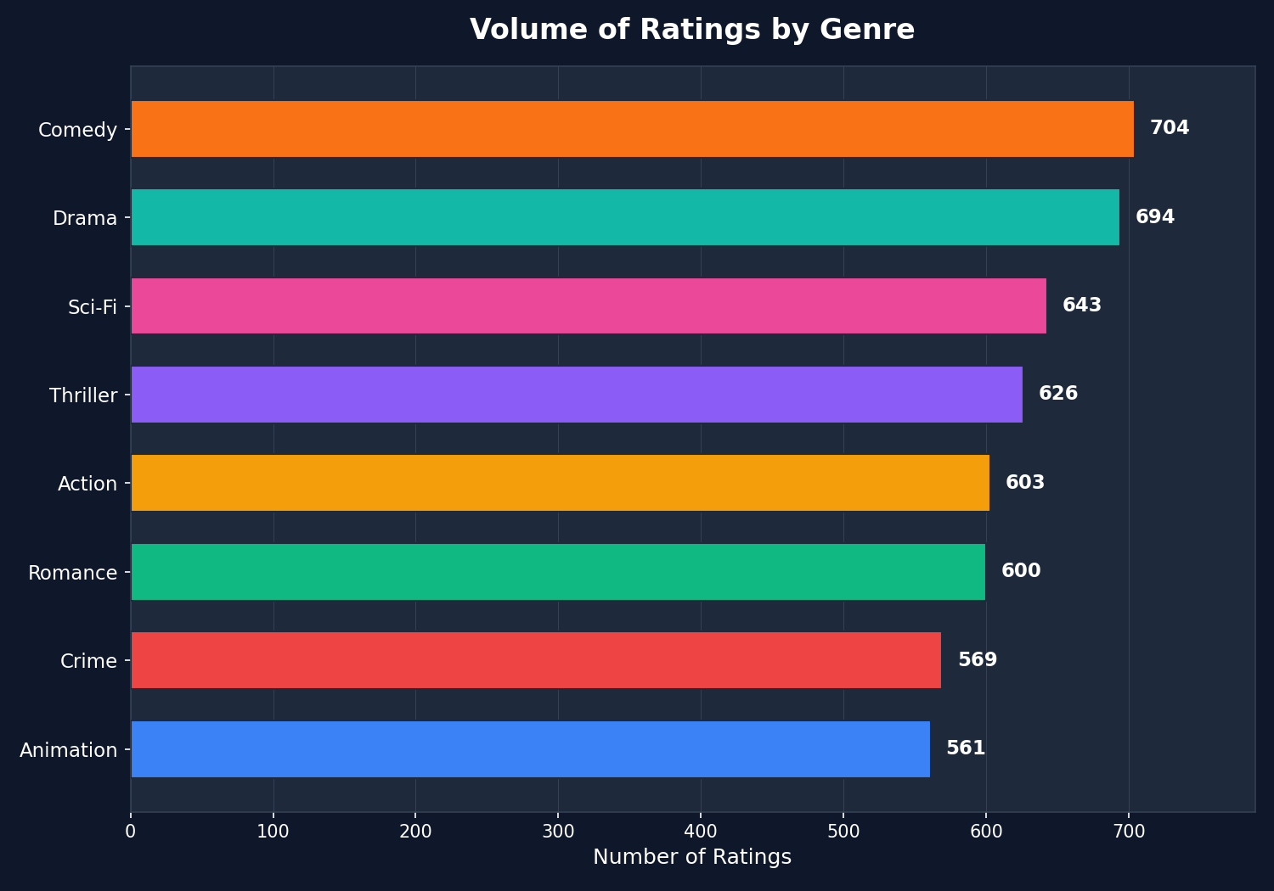

Figure 3.2: Distribution of Movies Across Different Genres.
Genre distribution analysis illustrates the representation of movie categories within the dataset. The intended project profile identifies Action and Drama as comparatively prominent categories, while Crime and Animation represent relatively smaller portions of the collection. If a recommendation engine relies only on historical rating similarity, frequently represented genres may dominate its output. The diversity re-ranking mechanism therefore considers genre repetition.
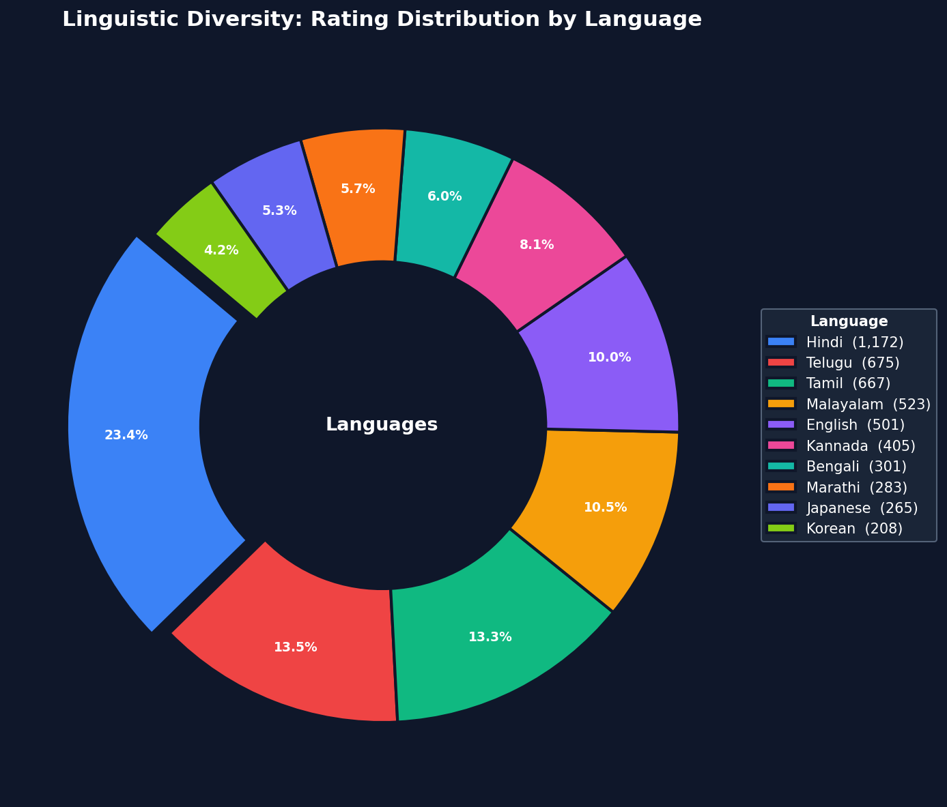

Figure 3.3: Distribution of Movies by Language.
Language distribution analysis examines the representation of Indian regional and international cinema. The intended profile includes approximately 25% Hindi, 15% Tamil, and 15% Telugu, alongside Malayalam, Bengali, Kannada, Marathi, and three international-language categories. The actual language percentages should be validated against the final dataset. Multiple Indian regional languages provide broader representation and allow recommendations beyond a single dominant language.

3.5 Importance of EDA in Model Development
EDA helps identify data imbalance, missing information, and structural characteristics before model training. For this project, it identifies potential rating distribution biases, highlights differences in genre representation, and establishes the extent of regional and international language coverage. These findings provide context for interpreting recommendation accuracy and diversity.

4. SYSTEM ARCHITECTURE AND API DESIGN

4.1 System Overview
The proposed system follows a modular architecture in which dataset preparation, recommendation generation, backend processing, and frontend presentation are maintained as separate components. This separation simplifies development, testing, and future modification. The primary components are dataset generation and preparation, recommendation engine, Flask backend, REST API endpoints, web dashboard, and evaluation metrics.

4.2 Data Flow Diagram: Level 0
The Level 0 Data Flow Diagram represents the system as a single processing entity. The user interacts with the application through the web interface. The Flask API receives the request and forwards the required parameters to the recommendation engine. The engine accesses the dataset and calculates recommendations using the selected algorithm. The resulting movie list is returned to the frontend as a structured response.
USER
|
| User ID, algorithm, parameters
v
+----------+
| Flask API|
+----------+
|
v
+-------------------+
| RecommenderEngine |
+-------------------+
|
v
+----------+
| Dataset |
+----------+
|
v
Recommendation Results
|
v
JSON Response
|
v
USER
Figure 4.1: Level 0 Data Flow Diagram.

4.3 Data Flow Diagram: Level 1
The Level 1 DFD describes the internal recommendation process. The algorithm selection determines which recommendation pipeline is executed. Each pipeline produces a candidate list containing predicted movie ratings or recommendation scores. The diversity re-ranker modifies candidate ordering according to genre repetition, after which the final list is returned to the user.
USER REQUEST
|
v
FLASK API
|
v
INPUT VALIDATION
|
v
RECOMMENDER ENGINE
/ | \
v v v
USER-CF ITEM-CF SVD
\ | /
\ | /
PREDICTED RATINGS
|
v
CANDIDATE RANKING
|
v
DIVERSITY RE-RANKER
|
v
FINAL TOP-K MOVIES
|
v
JSON RESPONSE
Figure 4.2: Level 1 Data Flow Diagram.

4.4 System Component Architecture
generate_dataset.py
|
v
dataset.csv
|
v
recommender.py
|
v
app.py
|
v
templates/index.html
|
v
User Dashboard
Figure 4.3: System Component Architecture.
generate_dataset.py creates or prepares the project dataset and stores the resulting records in CSV format. dataset.csv contains movie information, user ratings, timestamps, and anomaly indicators. recommender.py implements collaborative filtering algorithms, similarity calculations, SVD training, prediction generation, and diversity re-ranking. app.py initializes Flask, defines API routes, validates requests, and connects the backend to the recommendation engine. templates/index.html provides the user interface.

4.5 REST API Design

4.5.1 GET /
Purpose: Displays the web dashboard. The route loads the main HTML template and provides the interface for interacting with the recommendation system.

4.5.2 GET /api/recommend
Purpose: Generates personalized movie recommendations. Parameters include user_id (target user identifier), algo (selected algorithm), k (number of recommendations), and diversity (whether diversity re-ranking is enabled).
GET /api/recommend?user_id=101&algo=item&k=5&diversity=true
Possible algorithm values include user, item, and svd. An illustrative JSON response is shown below; the titles and scores are examples, not verified outputs from the supplied dataset.
{
"user_id": 101,
"algorithm": "item",
"recommendations": [
{"movie_title": "Example Movie A", "predicted_rating": 4.6, "genre": "Drama"},
{"movie_title": "Example Movie B", "predicted_rating": 4.4, "genre": "Action"}
]
}

4.5.3 GET /api/metrics
Purpose: Returns evaluation benchmarks associated with the implemented recommendation algorithms. The endpoint may provide RMSE, MAE, Precision@5, Recall@5, catalog coverage, and diversity scores.

4.5.4 POST /api/rate
Purpose: Accepts a new movie rating. The endpoint validates the rating and stores the interaction according to the application's data-persistence design. Dynamic rating submission should be distinguished from immediate model retraining. New ratings may require a subsequent model refresh before affecting all recommendation predictions.
{
"user_id": 101,
"movie_title": "Example Movie",
"rating": 4.5
}

4.6 Proposed Directory Structure
movie_recommendation_system/
├── app.py
├── recommender.py
├── generate_dataset.py
├── dataset.csv
├── requirements.txt
├── README.md
├── models/
│ └── recommender_model.pkl
├── templates/
│ └── index.html
├── static/
│ ├── css/style.css
│ ├── js/script.js
│ └── images/
├── outputs/
│ ├── eda_rating_distribution.png
│ ├── eda_genre_distribution.png
│ └── eda_language_breakdown.png
└── reports/
└── project_report.pdf
The model directory is used for persisted model artifacts where applicable. The outputs directory contains generated visualizations, while the reports directory stores project documentation.

5. ALGORITHMIC PIPELINE AND IMPLEMENTATION DETAILS

5.1 Overview of the Recommendation Pipeline
The recommendation engine is the central computational component of the application. It receives a user identifier and an algorithm selection, retrieves relevant rating information, estimates preferences for unseen movies, and generates an ordered recommendation list. The implementation supports User-Based CF, Item-Based CF, and SVD-based Matrix Factorization. The final ranking can optionally incorporate a diversity adjustment.

5.2 User-Based Collaborative Filtering Implementation
The User-Based CF pipeline begins by converting the dataset into a user-item rating matrix. Each row represents a user, while each column represents a movie. The matrix may contain missing values because users generally rate only a subset of available movies.
- Matrix construction: transform the rating data into a matrix in which each cell represents a user's rating for a movie.
- Similarity calculation: use cosine similarity to calculate relationships between user rating vectors.
- Neighbour selection: identify the K most similar users for the target user.
- Rating prediction: combine neighbour ratings according to their similarity weights.
- Recommendation ranking: sort movies by predicted rating and select the highest-scoring candidates.
The approach is useful when several users exhibit comparable rating behaviour. Its performance depends on the availability of sufficiently similar users and can be affected by sparse rating histories.

5.3 Item-Based Collaborative Filtering Implementation
The Item-Based CF pipeline focuses on movie similarity. The user-item matrix is transposed to obtain movie-oriented rating vectors. Cosine similarity is calculated between movies based on their rating patterns. The system identifies movies already rated by the target user, scores unrated movies using their similarity to previously rated movies, and sorts candidates by estimated preference.
The simplified prediction formula is:
pred(u,i) = Σ(sim(i,j) × r(u,j)) / Σ|sim(i,j)|
Here, i represents the target movie, j represents movies already rated by the user, sim(i,j) represents similarity between movies, and r(u,j) represents the user's rating for movie j. Item-Based CF can be effective where item relationships remain relatively stable over time.

5.4 SVD-Based Matrix Factorization
SVD models user and movie preferences using latent factors. Instead of calculating only direct similarity between users or movies, it learns lower-dimensional representations that capture hidden preference relationships. The project uses the Surprise library's SVD implementation with 50 configured latent factors.
Parameter | Value
Algorithm | Surprise SVD
Number of latent factors | 50
Evaluation split | 80% training / 20% testing
Prediction target | Explicit movie rating

The model estimates parameters by minimizing the difference between predicted and observed ratings, with regularization to control overfitting.
min Σ(r(u,i) - r̂(u,i))² + λ(||pᵤ||² + ||qᵢ||²)
The model produces predicted ratings for user-movie combinations that were not present in the training observations.

5.4.1 Surprise SVD and TruncatedSVD Fallback
The primary matrix factorization implementation uses Surprise SVD. Scikit-learn's TruncatedSVD may be used as an alternative dimensionality-reduction implementation where appropriate. However, the two methods are not directly interchangeable. Surprise SVD is designed for explicit rating prediction and can model observed user-item interactions. TruncatedSVD decomposes a numerical matrix and does not independently provide the same rating-prediction functionality. A fallback implementation must therefore handle missing values and prediction scoring appropriately.

5.5 Diversity Re-Ranking Algorithm

5.5.1 Motivation
The primary recommendation algorithms generate candidate movies according to predicted user preference. Sorting candidates exclusively by predicted rating may result in repetitive recommendation lists. For example, a user who enjoys action movies may receive five action recommendations even when the catalogue contains several other suitable genres. To address this limitation, the project introduces a genre-based diversity re-ranking mechanism.

5.5.2 Algorithm Description
The adjusted recommendation score is calculated as:
adjusted_score = predicted_score / (1.0 + 0.3 × genre_count_above)
predicted_score represents the original recommendation score; genre_count_above represents the number of previously selected recommendations belonging to the candidate's genre; and 0.3 represents the genre repetition penalty coefficient. The algorithm generates candidate recommendations, selects the highest-scoring candidate, counts the frequency of its genre in the selected list, recalculates adjusted scores for remaining candidates, selects the highest adjusted score, and repeats until the requested recommendation count is reached.

5.5.3 Illustrative Example
Movie | Genre | Predicted Score
Movie A | Action | 4.8
Movie B | Action | 4.7
Movie C | Drama | 4.6
Movie D | Comedy | 4.5
Movie E | Action | 4.4

After Movie A is selected, the remaining Action recommendations receive a repetition penalty. Movie C and Movie D may consequently move above Movie B in the adjusted ranking. This creates a list that attempts to balance preference relevance and genre variety.

5.5.4 Ethical and Functional Significance
The diversity re-ranking mechanism supports broader content exploration by reducing repeated exposure to a single genre. It can also encourage exposure to movies in different languages when the candidate-generation process includes suitable regional content. However, genre diversity alone does not guarantee that a recommendation system has eliminated filter bubbles. A comprehensive assessment would also require user-level exposure analysis, novelty measurements, and longitudinal evaluation.

5.6 Algorithmic Complexity Considerations
User-Based CF requires pairwise user similarity calculations. For a dense dataset containing m users and n movies, a similarity matrix may require approximately O(m²n) operations. Item-Based CF similarly involves item similarity calculations, with an approximate dense computational cost of O(n²m). Matrix factorization involves iterative optimization over observed ratings and latent factors. Its computational cost depends on the number of observed interactions, latent dimensions, and training epochs. For the current project dataset, these approaches are computationally manageable. At production scale, sparse matrices, approximate nearest-neighbour search, distributed processing, and incremental model updates may be required.

6. EXPERIMENTAL BENCHMARKS AND EVALUATION RESULTS

6.1 Experimental Setup
The recommendation algorithms were evaluated using an 80/20 train-test split. The training dataset was used to construct the recommendation models, while the test dataset was used to assess prediction and recommendation performance. Three algorithms were compared: SVD (Latent Factor), User-Based Collaborative Filtering, and Item-Based Collaborative Filtering. The supplied benchmark values are used as the experimental results in this report.

6.2 Evaluation Metrics

6.2.1 Root Mean Square Error (RMSE)
RMSE measures the square root of the average squared difference between actual and predicted ratings. A lower RMSE indicates better prediction accuracy.
RMSE = √[(1/N) Σ(r_ui - r̂_ui)²]

6.2.2 Mean Absolute Error (MAE)
MAE measures the average absolute difference between actual and predicted ratings. A lower MAE indicates that predictions are closer to observed ratings on average.
MAE = (1/N) Σ|r_ui - r̂_ui|

6.2.3 Precision@5 and Recall@5
Precision@5 measures the proportion of the five recommended movies that satisfy the defined relevance criterion. Recall@5 measures the proportion of relevant test movies successfully included in the top-five recommendations.
Precision@5 = Relevant recommended movies / 5
Recall@5 = Relevant recommended movies / Total relevant test movies

6.2.4 Catalog Coverage
Catalog coverage measures the proportion of available movies that can be recommended by the system: unique recommended movies divided by total catalogue movies. A higher value indicates exposure to a larger portion of the catalogue.

6.2.5 Diversity Score
Diversity measures the dissimilarity among movies in a recommendation list. The exact interpretation depends on the metric implementation, similarity definition, and normalization method. A higher score in the supplied results represents greater measured diversity.

6.3 Comparative Model Performance
Table 6.1: Comparative Model Performance (80/20 Train-Test Split)
Evaluation Metric | SVD | User-Based CF | Item-Based CF
RMSE | 1.7439 | 1.0090 | 0.8884
MAE | 1.5162 | 0.8094 | 0.7211
Precision@5 | 0.0460 | 0.0370 | 0.0290
Recall@5 | 0.0985 | 0.0748 | 0.0672
Catalog Coverage | 14.81% | 100.00% | 100.00%
Diversity Score | 0.9070 | 0.8875 | 0.8845

Source: Supplied project experimental benchmark results. Bold emphasis in the source benchmark identified Item-Based CF as best for RMSE and MAE, SVD as best for Precision@5, Recall@5, and diversity, and both neighbourhood methods as best for coverage.

6.4 Interpretation of Experimental Results

6.4.1 Prediction Accuracy
Item-Based CF achieves the lowest RMSE of 0.8884 and the lowest MAE of 0.7211. This indicates that, among the three evaluated approaches, Item-Based CF produces predictions closest to the observed test ratings. User-Based CF records an RMSE of 1.0090 and an MAE of 0.8094. SVD records an RMSE of 1.7439 and an MAE of 1.5162, indicating that the current SVD configuration performs less effectively than the neighbourhood-based approaches.
Although matrix factorization is widely used in recommendation systems, its effectiveness depends on dataset characteristics, parameter selection, training methodology, and the amount of available interaction data. The relatively small dataset may limit the ability of SVD to learn stable latent representations.

6.4.2 Precision and Recall
SVD records the highest Precision@5 of 0.0460 and Recall@5 of 0.0985. User-Based CF records Precision@5 of 0.0370 and Recall@5 of 0.0748. Item-Based CF records Precision@5 of 0.0290 and Recall@5 of 0.0672. Although the absolute values are relatively low, SVD performs comparatively better on both supplied ranking metrics.
This illustrates that the model with the best rating-prediction accuracy does not necessarily produce the best top-five recommendation results. The relevance threshold, candidate-generation strategy, treatment of already-rated movies, and evaluation methodology can substantially influence these metrics.

6.4.3 Catalog Coverage
Both neighbourhood-based algorithms achieve 100% catalog coverage in the supplied results. SVD achieves 14.81%. The difference suggests that the candidate-generation process used for SVD exposes a smaller portion of the catalogue than the neighbourhood-based approaches. However, full catalog coverage should not automatically be interpreted as superior recommendation quality. A system may expose every movie without consistently recommending relevant content. Coverage should therefore be evaluated alongside ranking accuracy and user satisfaction.

6.4.4 Diversity Performance
SVD records the highest diversity score of 0.9070. User-Based CF achieves 0.8875, while Item-Based CF achieves 0.8845. The result indicates that SVD has the highest measured diversity under the project's evaluation procedure. This is relevant because SVD has the weakest rating-prediction performance in the supplied benchmark. It demonstrates that accuracy and diversity are separate evaluation dimensions.

6.5 Overall Model Assessment
- Best prediction accuracy: Item-Based CF.
- Best precision and recall: SVD.
- Best catalog coverage: User-Based CF and Item-Based CF.
- Highest diversity score: SVD.
Item-Based CF is the strongest candidate when the primary requirement is accurate rating estimation. However, the final recommendation strategy should consider multiple evaluation dimensions. A practical implementation may use Item-Based CF as the principal candidate-generation model while applying diversity-aware re-ranking to improve recommendation variety.
The reported precision and recall values are substantially lower than the illustrative target figures initially considered. They must not be replaced with higher values without additional experiments. The 100% coverage values should also be verified using the same candidate-generation and evaluation protocol across all algorithms. Coverage should specify whether it is calculated across all users, a sampled user set, or a single recommendation list.

7. ETHICAL COMPLIANCE AND DPDP ACT 2023 GOVERNANCE

7.1 Ethical Considerations in Recommendation Systems
Recommendation systems influence how users discover and interact with digital content. Although personalization improves convenience, it can also introduce risks involving content concentration, representation, privacy, and transparency. The project considers these risks during system design.

7.2 Filter Bubble Mitigation
A filter bubble occurs when personalization repeatedly exposes individuals to similar information or content, potentially reducing their exposure to alternative viewpoints and experiences. The project addresses this concern through diversity-aware ranking. The genre repetition penalty encourages the system to select movies across different categories instead of relying exclusively on the highest predicted ratings. Cross-language discovery can also be supported when the candidate-generation process includes sufficiently relevant regional films. Nevertheless, the proposed method is a mitigation mechanism rather than a guarantee that filter bubbles have been eliminated.

7.3 Demographic Bias and Representation
The system uses movie language and genre information to examine content representation. The intended dataset contains seven Indian-language categories: Hindi, Tamil, Telugu, Malayalam, Bengali, Kannada, and Marathi. Three additional international-language categories are also included. Their inclusion aims to provide broader representation of Indian regional cinema and international movies.
Language representation in the dataset does not automatically ensure fair recommendations. Actual exposure should be evaluated by measuring the proportion of recommendations generated for each language. Equal regional representation is therefore treated as a design objective rather than a demonstrated experimental outcome.

7.4 Digital Personal Data Protection Act, 2023
The Digital Personal Data Protection Act, 2023 establishes a legal framework for the processing of digital personal data in India. The project follows privacy-conscious design principles, including avoiding unnecessary personally identifiable information, using anonymous or pseudonymous user identifiers, limiting collection to movie interactions and ratings, avoiding demographic profiling, restricting access to stored project data, and maintaining transparency about synthetic records and data-processing practices.
The user_id field is intended to represent an identifier rather than a real-world identity. However, pseudonymization alone does not establish that data falls outside the scope of personal data regulation. Whether information is personal data depends on its nature and the possibility of identifying an individual. The project should therefore use synthetic or appropriately anonymized records and avoid connecting rating histories to identifiable individuals.
The Act's applicability and compliance obligations depend on the nature of processing and relevant commencement provisions. This undergraduate prototype should not be described as legally certified or fully compliant merely because it avoids storing names and contact details.

7.5 Synthetic Data Ethics
The is_anomaly field distinguishes artificially generated anomalous records from ordinary observations. This improves transparency and supports reproducible preprocessing. Artificially generated records should not be represented as genuine user behaviour. Dataset documentation should identify which fields and records were generated, augmented, or derived from external sources.

7.6 AI Tool Disclosure
AI-assisted tools, including ChatGPT and Claude, were used for research assistance, documentation support, technical clarification, and dataset augmentation support. Their use does not replace independent validation of experimental results, references, code behaviour, and data integrity. All reported benchmarks must be traceable to actual project evaluation outputs.

8. DEPLOYMENT AND USER MANUAL

8.1 System Requirements
- Python 3.10 or later.
- Flask.
- Pandas.
- NumPy.
- scikit-learn.
- Surprise.
- An HTML5-compatible web browser.
- Bootstrap 5 frontend resources.

8.2 Installation Instructions
Step 1: Obtain the project repository.
git clone <repository-url>
cd movie_recommendation_system
Step 2: Create and activate a virtual environment.
python -m venv venv
venv\Scripts\activate
Step 3: Install dependencies.
pip install flask pandas numpy scikit-learn scikit-surprise
Step 4: Generate or prepare the dataset.
python generate_dataset.py
Ensure that dataset.csv is available in the expected project directory.
Step 5: Start the Flask application.
python app.py
Step 6: Access the dashboard in a web browser.
http://127.0.0.1:5000/

8.3 User Instructions
- Open the web dashboard.
- Enter a valid user identifier.
- Select the recommendation algorithm.
- Specify the required number of recommendations.
- Enable or disable diversity ranking.
- Submit the request.
- Review the generated movie recommendations.

8.4 Dashboard Screenshot Placeholders
[INSERT dashboard_homepage.png]
Figure 8.1: Main Dashboard of the Personalized Movie Recommendation System.
[INSERT dashboard_recommendations.png]
Figure 8.2: Display of Personalized Movie Recommendations.
[INSERT dashboard_algorithm_comparison.png]
Figure 8.3: Algorithm Selection and Recommendation Comparison Interface.
The placeholders should be replaced with actual application screenshots before final submission.

8.5 Troubleshooting
Problem | Possible Solution
ModuleNotFoundError | Install the missing package in the active virtual environment.
Dataset not found | Verify the CSV filename and project directory.
Flask application does not start | Check port availability and application configuration.
Invalid user ID | Use a user identifier present in the dataset.
Surprise installation failure | Verify Python version and compatible build dependencies.
Empty recommendation list | Check whether the selected user has sufficient rating history.
Unexpected API response | Verify request parameters and backend error logs.

9. CONCLUSION AND FUTURE SCOPE

9.1 Conclusion
The project, Personalized Movie Recommendation System Using Collaborative Filtering, demonstrates the practical application of machine learning techniques to the problem of personalized content discovery. The increasing size of digital entertainment catalogues makes manual movie selection difficult. Recommendation systems address this challenge by identifying relationships between user preferences and available content.
The project implements three major recommendation approaches: User-Based Collaborative Filtering, Item-Based Collaborative Filtering, and SVD-based Matrix Factorization. The experimental results demonstrate that Item-Based CF achieves the lowest RMSE of 0.8884 and MAE of 0.7211 among the evaluated algorithms. Both User-Based and Item-Based CF achieve 100% catalog coverage under the supplied evaluation methodology. SVD achieves the highest diversity score of 0.9070 and the highest Precision@5 and Recall@5.
These results demonstrate that different recommendation algorithms offer different advantages. Consequently, selecting a model requires consideration of prediction accuracy, ranking performance, coverage, and diversity. The project also introduces a genre-based diversity re-ranking mechanism intended to reduce repetitive recommendations and encourage wider content discovery.
From a software engineering perspective, the implementation demonstrates how machine learning models can be integrated into a web application through Flask REST APIs and a Bootstrap-based frontend. Overall, the project provides a practical foundation for understanding recommendation engines, data processing, machine learning evaluation, backend integration, and responsible AI development.

9.2 Limitations
- The dataset is relatively small and may not represent the complexity of real OTT platforms.
- Cold-start users and newly introduced movies remain challenging.
- Explicit ratings do not capture all aspects of user behaviour.
- The current genre-based diversity mechanism does not directly optimize novelty or user satisfaction.
- The SVD model may require additional tuning and more interaction data.
- The supplied evaluation metrics require consistent relevance thresholds and candidate-generation protocols for stronger comparative conclusions.
- The current architecture is a prototype and has not been benchmarked for large-scale concurrent production traffic.

9.3 Future Scope

9.3.1 Hybrid Recommendation Architecture
Content-Based Filtering can be combined with Collaborative Filtering to address cold-start conditions and improve recommendation relevance.

9.3.2 Deep Learning Models
Neural Collaborative Filtering, autoencoders, and other deep learning methods can be explored for learning more complex user-item relationships.

9.3.3 Advanced Diversity Optimization
The current genre repetition penalty can be extended using intra-list diversity, novelty, popularity-aware ranking, and multi-objective optimization.

9.3.4 Real-Time Learning
New user ratings can be incorporated through incremental model updates rather than requiring complete model retraining.

9.3.5 Enhanced Movie Metadata
Additional attributes such as directors, actors, production companies, synopsis, and keywords can be used to improve content discovery.

9.3.6 Improved User Experience
The frontend can be extended with movie posters, search filters, rating controls, recommendation explanations, and user preference management.

9.3.7 Production Deployment
The application can be deployed using a production WSGI server and cloud infrastructure. Database integration, authentication, monitoring, and caching can improve reliability and scalability.

9.3.8 Explainable Recommendations
The system can provide explanations such as “Recommended because you enjoyed similar movies” or “Suggested to introduce you to another genre.” Such explanations can improve user understanding and trust.

10. REFERENCES
1. Aggarwal, C. C. (2016). Recommender systems: The textbook. Springer. https://doi.org/10.1007/978-3-319-29659-3
2. Harper, F. M., & Konstan, J. A. (2015). The MovieLens datasets: History and context. ACM Transactions on Interactive Intelligent Systems, 5(4), Article 19. https://doi.org/10.1145/2827872
3. Hug, N. (2020). Surprise: A Python library for recommender systems. Journal of Open Source Software, 5(52), 2174. https://doi.org/10.21105/joss.02174
4. Koren, Y., Bell, R., & Volinsky, C. (2009). Matrix factorization techniques for recommender systems. Computer, 42(8), 30–37. https://doi.org/10.1109/MC.2009.263
5. Nguyen, T. T., Hui, P. M., Harper, F. M., Terveen, L., & Konstan, J. A. (2014). Exploring the filter bubble: The effect of using recommender systems on content diversity. Proceedings of the 23rd International Conference on World Wide Web, 677–686. https://doi.org/10.1145/2566486.2568012
6. Pariser, E. (2011). The filter bubble: What the Internet is hiding from you. Penguin Press.
7. Ricci, F., Rokach, L., & Shapira, B. (Eds.). (2015). Recommender systems handbook (2nd ed.). Springer. https://doi.org/10.1007/978-1-4899-7637-6
8. Sarwar, B., Karypis, G., Konstan, J., & Riedl, J. (2001). Item-based collaborative filtering recommendation algorithms. Proceedings of the 10th International Conference on World Wide Web, 285–295. https://doi.org/10.1145/371920.372071
9. Government of India. (2023). The Digital Personal Data Protection Act, 2023 (Act No. 22 of 2023). Gazette of India. https://egazette.gov.in/WriteReadData/2023/249154.pdf
10. GroupLens Research. (n.d.). MovieLens datasets. University of Minnesota. https://grouplens.org/datasets/movielens/
11. Surprise Documentation. (n.d.). Surprise: A Python scikit for recommender systems. https://surpriselib.com/
12. Pedregosa, F., et al. (2011). Scikit-learn: Machine learning in Python. Journal of Machine Learning Research, 12, 2825–2830.
13. Python Software Foundation. (n.d.). Python documentation. https://docs.python.org/3/
14. Pallets Projects. (n.d.). Flask documentation. https://flask.palletsprojects.com/
15. Bootstrap Team. (n.d.). Bootstrap 5 documentation. https://getbootstrap.com/docs/5.3/

APPENDIX A: PROJECT TECHNOLOGY SUMMARY
Technology | Application in the Project
Python 3.10+ | Primary programming language
Flask | Backend application and REST API
Pandas | Dataset loading, cleaning, and manipulation
NumPy | Numerical computation and matrix operations
scikit-learn | Similarity calculations and supporting machine learning utilities
Surprise | Collaborative filtering and SVD
HTML5 | Frontend structure
CSS3 | Interface styling
Bootstrap 5 | Responsive dashboard design

APPENDIX B: PROJECT DELIVERABLES
- Complete source code.
- Dataset in CSV format.
- Data preprocessing implementation.
- Exploratory data analysis visualizations.
- User-Based Collaborative Filtering implementation.
- Item-Based Collaborative Filtering implementation.
- SVD implementation.
- Diversity re-ranking implementation.
- Flask backend and REST API.
- Web dashboard.
- Model evaluation results.
- Installation and execution instructions.
- Final project report.

APPENDIX C: FINAL SUBMISSION CHECKLIST
- ☐ Learner roll number entered.
- ☐ Mentor name entered.
- ☐ Submission date entered.
- ☐ Dataset profile verified against the final CSV.
- ☐ Actual anomaly percentage calculated.
- ☐ Three EDA plots inserted.
- ☐ Dashboard screenshots inserted.
- ☐ Benchmark values verified against evaluation outputs.
- ☐ Diversity re-ranking results independently validated.
- ☐ Source code and repository details added.
- ☐ References and citations checked.
- ☐ Final document proofread and formatted.

END OF PROJECT REPORT
HCLTech Career Shaper Programme
Project No. 28

