**OUTPUT**

1. The prompt below is the output when the source code is implemented the first time

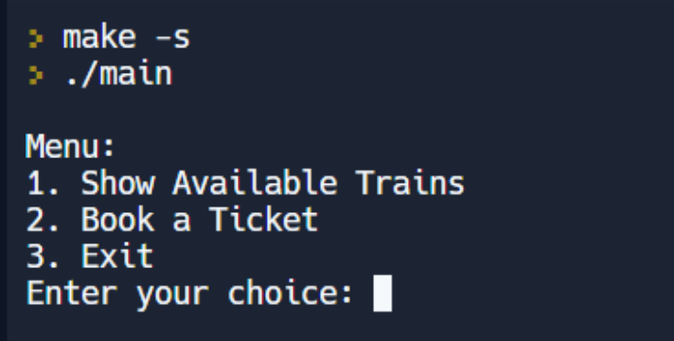

1. When the first choice is entered by the user the program displays the available trains between various stations available. The program then automatically prompts the user to either book a train ticket or exit the program

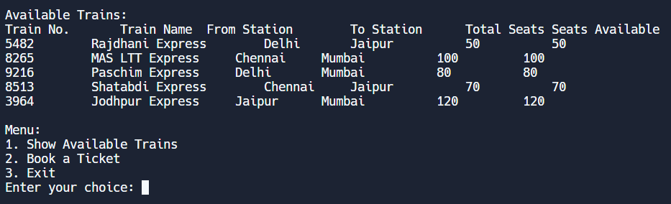

1. The user can either exit the program here or move on to book a train ticket.

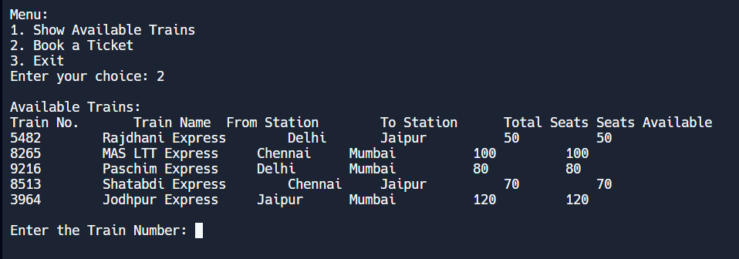

1. Now the program asks the user to enter the appropriate train number. Once a correct train number is entered, the program prompts the user to enter the passenger name, age and sex to confirm the ticket booking.

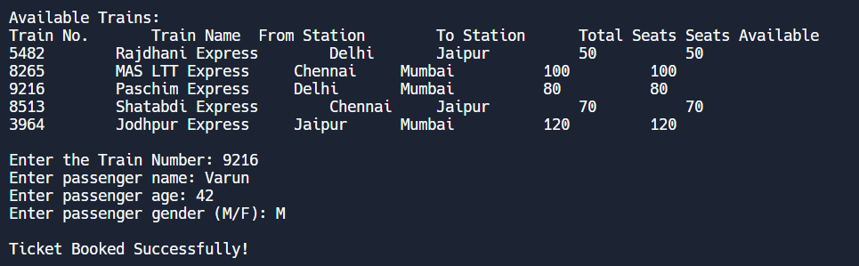

1. The next step is that after booking a ticket, the program automatically displays the ticket with the necessary details of the ticket booking.

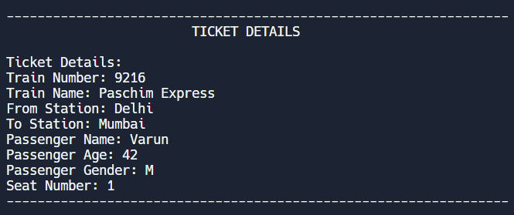

1. The program again prompts the user to the main menu, from there the user can exit after booking the ticket.

