**CONTENTS**

|  |  |  |
| --- | --- | --- |
| **S.No** | **Title** | **Page Number** |
| 1 | Project Description | 3 |
| 2 | Project implementation | 7 |
| 3 | Source code | 10 |
| 4 | Output | 19 |
| 5 | Conclusion | 22 |

2

**PROJECT DESCRIPTION**

The "Railway Reservation System" mini project is a simple yet effective software solution designed to streamline the process of booking train tickets and managing passenger information. With a user-friendly command-line interface, this system offers passengers the convenience of viewing available trains, reserving seats, and generating tickets effortlessly. The system supports multiple train routes, each with distinct departure and arrival stations, ensuring flexibility for passengers' travel needs.

BACKGROUND :

The traditional process of booking train tickets has long been synonymous with lengthy queues, manual paperwork, and occasional inconveniences. The time-consuming nature of this process not only poses challenges for passengers but also places considerable strain on railway authorities. Recognizing these inefficiencies and aiming to provide a seamless and hassle-free experience, the Railway Reservation System project comes to the fore as a beacon of change.

PROJECT OBJECTIVE :

The primary objective of the Railway Reservation System is to create a robust and user-friendly software solution that redefines the way passengers engage with the railway system. By introducing an automated and technologically advanced approach to ticket booking, the project seeks to enhance efficiency, accuracy, and user satisfaction. Through the utilization of modern programming languages, methodologies, and tools, the project aims to empower both passengers and administrators, ushering in a new era of convenience and organization in the realm of railway travel.

At its core, the Railway Reservation System project offers a range of innovative features designed to streamline the booking process and elevate the passenger experience.

Key features include the ability to display a list of available trains along with their relevant details such as train number, name, origin, destination, total seats, and available seats. Passengers can conveniently book tickets by providing their name, age, and gender, and the system automatically deducts the available seats for the chosen train. The generated tickets present comprehensive information, including the train's details and the passenger's booking specifics.

With a focus on simplicity and functionality, the "Railway Reservation System" enhances the traditional ticket booking process, making it more organized and efficient. Whether for individual travelers or small groups, this system provides a hassle-free experience that ensures a smoother journey ahead.

KEY FEATURES :

**Train and Station Management**

The system allows the management of various train routes, each with distinct departure and arrival stations. Administrators can easily add, update, or remove train and station details, ensuring accurate and up-to-date information for travellers.

**Availability Display**

Passengers can effortlessly view a list of available trains, complete with essential information such as train number, name, origin, destination, total seats, and the number of seats available for booking. This feature enables users to make informed decisions based on their travel preferences.

**Ticket Booking**

The system offers a streamlined ticket booking process, where passengers can input their personal details, including name, age, and gender, to reserve seats on their chosen train. The system ensures that the available seats are automatically updated after each successful booking.

**Seat Allocation and Management**

Seat allocation is managed efficiently to prevent overbooking. Passengers are assigned seat numbers upon successful booking, and the system ensures that the correct number of seats is maintained for each train.

**Ticket Generation**

Upon successful booking, the system generates detailed tickets containing essential travel information, including the train's details, departure and arrival stations, passenger's name, age, gender, and assigned seat number.

**Data Validation**

The system incorporates robust data validation techniques to ensure accurate and error-free input from users, reducing the risk of incorrect information and enhancing the overall user experience.

**User-Friendly Interface**

The graphical user interface (GUI) is designed for simplicity and ease of use, making the ticket booking process accessible to individuals of varying technological backgrounds.

**Data Persistence**

All booking and train details are stored securely in a database, ensuring data persistence and allowing administrators to retrieve historical information as needed.

BENEFITS :

**Efficiency and Convenience**

The Railway Reservation System streamlines the traditionally cumbersome ticket booking process, providing passengers with a convenient and time-saving way to plan their journeys.

**Enhanced Passenger Experience**

Passengers benefit from a simplified and organized booking process, reducing the stress associated with travel planning.

System administrators have the tools to manage train and station details efficiently, ensuring accurate information is presented to passengers.

**Data Integrity**

The system's data validation mechanisms contribute to maintaining accurate and error-free information, minimizing discrepancies and user frustration.

**PROJECT IMPLEMENTATION**

The implementation phase of the Railway Reservation System project involves the translation of design concepts and requirements into a functional software solution. This phase is crucial in bringing the envisioned system to life and ensuring that it aligns with the project's objectives. In this section, we will delve into the key aspects of the project's implementation, including the programming languages, tools, methodologies, and steps undertaken to transform the system from concept to reality.

PROGRAMMING LANGUAGES AND TOOLS :

The implementation of the Railway Reservation System is facilitated by a combination of programming languages and tools. The core logic of the system is developed using the C programming language, known for its efficiency, portability, and ability to handle complex data structures. Additionally, standard libraries such as <stdio.h>, <string.h>, and <ctype.h> are utilized for input/output operations, string manipulation, and character handling.

To manage and store data, a database system is integrated into the project. SQLite, a lightweight and self-contained relational database management system, is employed to ensure efficient data storage, retrieval, and manipulation. SQLite's simplicity and compatibility make it an ideal choice for this project's requirements.

DEVELOPMENT METHODOLOGY :

The project follows an iterative and incremental development methodology to ensure steady progress and adaptability to changing requirements. The Agile methodology is incorporated, allowing for flexibility, collaboration, and continuous improvement. This approach enables the project team to identify and address issues early in the development process, resulting in a more refined and reliable system.

IMPLEMENTATION STEPS :

**Database Design and Setup**

The implementation process kicks off with the design and creation of the database schema. Tables are established to store train, station, ticket, and passenger information. Relationships and constraints are defined to maintain data integrity.

**User Interface Development**

The user interface (UI) is developed using C's standard input/output functions. Menus, prompts, and displays are designed to facilitate user interaction. The UI is designed to be intuitive and user-friendly, guiding passengers through the booking process.

**Functional Logic Implementation**

The core functionalities of the Railway Reservation System are implemented next. These include displaying available trains, enabling ticket booking, validating passenger information, and updating seat availability.

**Data Integration**

The system integrates with the SQLite database to store and retrieve relevant information. Queries are developed to insert, update, and retrieve data efficiently. This integration ensures that booking and train details are persisted and accessible.

**Error Handling and Validation**

Robust error-handling mechanisms and data validation techniques are incorporated to prevent incorrect input and ensure data accuracy. Users are guided through the correct input process, enhancing the overall user experience.

**Testing and Debugging**

Rigorous testing is conducted to identify and address any bugs, issues, or inconsistencies in the system. Test cases are designed to cover various scenarios, ensuring the system's reliability and stability.

The implementation phase of the Railway Reservation System project transforms the conceptual design into a fully functional software solution. By leveraging the power of the C programming language and integrating the SQLite database system, the project achieves its goal of providing a user-friendly and efficient platform for booking train tickets. Through an iterative and incremental development approach, the system's core functionalities are realized, error handling is fine-tuned, and rigorous testing ensures reliability. The documentation produced during this phase serves as a roadmap for future enhancements and maintenance, marking a significant milestone in the project's journey towards completion.

**SOURCE CODE**

#include <stdio.h>

#include <string.h>

#include <ctype.h>

#define MAX_STATIONS 10

#define MAX_TRAINS 10

#define MAX_NAME_LENGTH 50

#define MAX_TICKETS 100

struct Station {

char name[MAX_NAME_LENGTH];

};

struct Train {

int number;

char name[MAX_NAME_LENGTH];

struct Station from_station;

struct Station to_station;

int total_seats;

int seats_available;

};

struct Ticket {

int train_number;

char passenger_name[MAX_NAME_LENGTH];

int seat_number;

int passenger_age;

char passenger_sex;

};

void initializeData(struct Train trains[], struct Station stations[], int* num_trains, int* num_stations) {

struct Station s1 = {"Delhi"};

struct Station s2 = {"Chennai"};

struct Station s3 = {"Jaipur"};

struct Station s4 = {"Mumbai"};

stations[0] = s1;

stations[1] = s2;

stations[2] = s3;

stations[3] = s4;

*num_stations = 4;

struct Train t1 = {5482, "Rajdhani Express", s1, s3, 50, 50};

struct Train t2 = {8265, "MAS LTT Express", s2, s4, 100, 100};

struct Train t3 = {9216, "Paschim Express", s1, s4, 80, 80};

struct Train t4 = {8513, "Shatabdi Express", s2, s3, 70, 70};

struct Train t5 = {3964, "Jodhpur Express", s3, s4, 120, 120};

trains[0] = t1;

trains[1] = t2;

trains[2] = t3;

trains[3] = t4;

trains[4] = t5;

*num_trains = 5;

}

int displayMenu() {

int choice;

printf("\nMenu:\n");

printf("1. Show Available Trains\n");

printf("2. Book a Ticket\n");

printf("3. Exit\n");

printf("Enter your choice: ");

scanf("%d", &choice);

return choice;

}

void showTrains(struct Train *trains, int num_trains) {

printf("\nAvailable Trains:\n");

printf("Train No.\t\tTrain Name\tFrom Station\t\tTo Station\t\tTotal "

"Seats\tSeats Available\n");

for (int i = 0; i < num_trains; i++) {

printf("%d\t\t%s\t\t%s\t\t%s\t\t\t%d\t\t\t%d\n", trains[i].number,

trains[i].name, trains[i].from_station.name,

trains[i].to_station.name, trains[i].total_seats,

trains[i].seats_available);

}

}

int isAlphabetic(char str[]) {

for (int i = 0; str[i] != '\0'; i++) {

if (!isalpha(str[i])) {

return 0; // Not alphabetic

}

}

return 1; // Alphabetic

}

void printTicketDetails(struct Ticket ticket, struct Train train) {

printf("\nTicket Details:\n");

printf("Train Number: %d\n", ticket.train_number);

printf("Train Name: %s\n", train.name);

printf("From Station: %s\n", train.from_station.name);

printf("To Station: %s\n", train.to_station.name);

printf("Passenger Name: %s\n", ticket.passenger_name);

printf("Passenger Age: %d\n", ticket.passenger_age);

printf("Passenger Gender: %c\n", ticket.passenger_sex);

printf("Seat Number: %d\n", ticket.seat_number);

}

void bookTicket(struct Train *trains, int num_trains, struct Ticket tickets[], int *num_tickets) {

int train_number, seat_number;

char passenger_name[MAX_NAME_LENGTH];

int passenger_age;

char passenger_sex;

showTrains(trains, num_trains);

printf("\nEnter the Train Number: ");

scanf("%d", &train_number);

int train_index = -1;

for (int i = 0; i < num_trains; i++) {

if (trains[i].number == train_number) {

train_index = i;

break;

}

}

if (train_index == -1) {

printf("Invalid Train Number.\n");

return;

}

if (trains[train_index].seats_available <= 0) {

printf("No seats available for the selected train.\n");

return;

}

while (1) {

printf("Enter passenger name: ");

scanf(" %[^\n]s", passenger_name);

if (isAlphabetic(passenger_name)) {

break; // Valid name, exit the loop

} else {

printf("Invalid name! Please enter alphabetic characters only.\n");

}

}

while (1) {

printf("Enter passenger age: ");

scanf("%d", &passenger_age);

if (passenger_age >= 0 && passenger_age <= 150) {

break; // Valid age, exit the loop

} else {

printf("Invalid age! Please enter a valid age (0-150).\n");

}

}

while (1) {

printf("Enter passenger gender (M/F): ");

scanf(" %c", &passenger_sex);

passenger_sex = toupper(passenger_sex);

if (passenger_sex == 'M' || passenger_sex == 'F') {

break; // Valid sex, exit the loop

} else {

printf("Invalid gender! Please enter 'M' or 'F' only.\n");

}

}

trains[train_index].seats_available--;

struct Ticket new_ticket = {

train_number,

"",

trains[train_index].total_seats - trains[train_index].seats_available,

passenger_age,

passenger_sex

};

strcpy(new_ticket.passenger_name, passenger_name);

tickets[*num_tickets] = new_ticket;

(*num_tickets)++;

printf("\nTicket Booked Successfully!\n");

printf("\n");

printf("-----------------------------------------------------------------\n");

printf("\t\t\t\t\t\tTICKET DETAILS\n");

printTicketDetails(new_ticket, trains[train_index]);

printf("-----------------------------------------------------------------\n");

printf("\n");

}

int main() {

struct Train trains[MAX_TRAINS];

int num_trains = 0;

struct Station stations[MAX_STATIONS];

int num_stations = 0;

struct Ticket tickets[MAX_TICKETS];

int num_tickets = 0;

initializeData(trains, stations, &num_trains, &num_stations);

int choice;

do {

choice = displayMenu();

switch (choice) {

case 1:

showTrains(trains, num_trains);

break;

case 2:

bookTicket(trains, num_trains, tickets, &num_tickets);

break;

case 3:

printf("\nThank you for using the Railway Reservation System.\n");

break;

default:

printf("\nInvalid choice. Please try again.\n");

break;

}

} while (choice != 3);

return 0;

}

**OUTPUT**

1. The prompt below is the output when the source code is implemented the first time

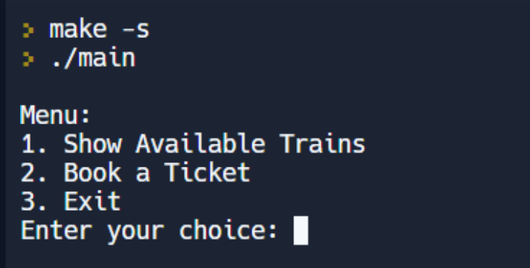

1. When the first choice is entered by the user the program displays the available trains between various stations available. The program then automatically prompts the user to either book a train ticket or exit the program

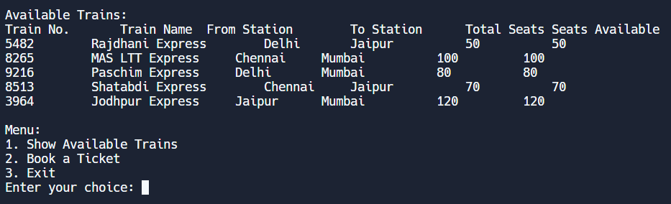

1. The user can either exit the program here or move on to book a train ticket.

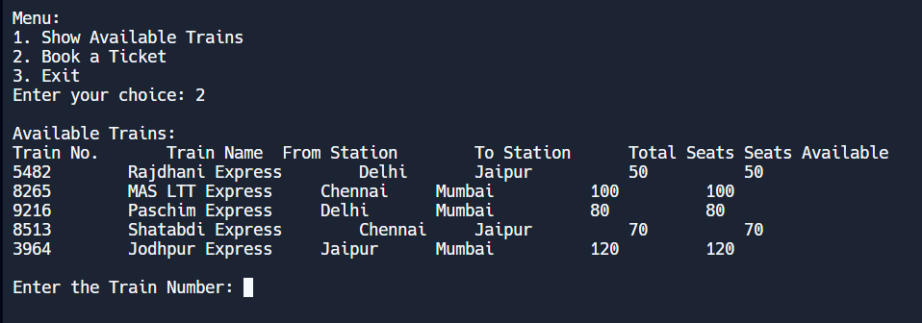

1. Now the program asks the user to enter the appropriate train number. Once a correct train number is entered, the program prompts the user to enter the passenger name, age and sex to confirm the ticket booking.

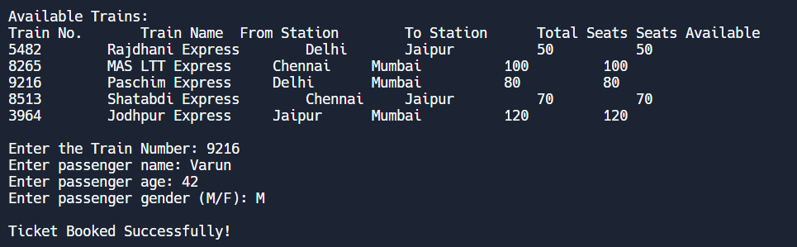

1. The next step is that after booking a ticket, the program automatically displays the ticket with the necessary details of the ticket booking.

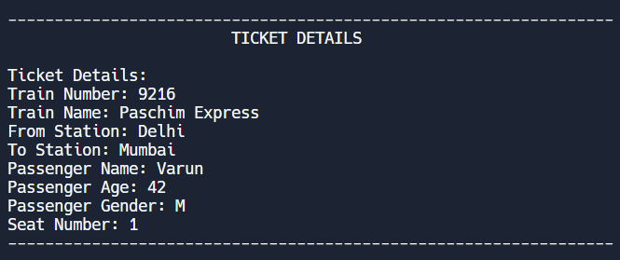

1. The program again prompts the user to the main menu, from there the user can exit after booking the ticket.

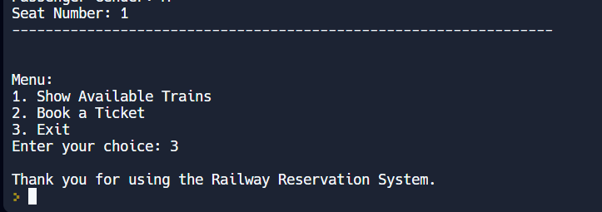

**CONCLUSION**

In conclusion, the Railway Reservation System project has successfully addressed the challenges and complexities associated with traditional train ticket booking processes.

Through careful planning, design, and diligent implementation, the project has culminated in the creation of a robust and user-friendly software solution that significantly enhances the efficiency and convenience of reserving train tickets.

The iterative and incremental development methodology, inspired by Agile principles, has facilitated adaptability, continuous improvement, and early issue detection. Rigorous testing and validation procedures have resulted in a dependable system that not only fulfils its intended purposes but also provides a strong foundation for potential future enhancements.

FUTURE ADVANCEMENTS :

While the Railway Reservation System has successfully revolutionized the process of booking train tickets, there are several avenues for future advancements and refinements. These possibilities include:

**Online Booking Portal**

Expanding the system to include an online booking portal would enable passengers to access the Railway Reservation System remotely, providing a convenient and accessible way to book tickets from the comfort of their own devices.

**Mobile Application**

Developing a mobile application for the Railway Reservation System would cater to the growing trend of mobile-first interactions, offering a more personalized and user-centric experience for travelers.

**Integration with Payment Gateways**

Incorporating secure payment gateways would allow passengers to make online payments directly through the system, eliminating the need for in-person transactions and further streamlining the booking process.

**Seat Selection**

Implementing a feature that allows passengers to choose their preferred seats during the booking process would enhance customization and improve overall passenger satisfaction.

**Real-time Updates**

Integrating real-time updates on train schedules, delays, and cancellations would provide passengers with accurate and up-to-date information, ensuring a smoother travel experience.

**User Profiles and History**

Creating user profiles and maintaining booking history would enable passengers to track their travel records, making future bookings even more convenient.

As we reflect on the journey from conceptualization to implementation, it is evident that the Railway Reservation System stands as a testament to the capabilities of modern software development. It redefines the way travelers engage with the booking process, ensuring a smoother and more organized travel experience. The project's documentation serves as a valuable guide for maintenance, expansion, and further refinement, making the Railway Reservation System a cornerstone in the evolution of railway travel management.

In a world where efficiency and user experience are paramount, the Railway Reservation System project exemplifies the potential of technology to reshape and optimize fundamental aspects of our lives. With its successful completion and the promise of future advancements, the project stands as a beacon of innovation and serves as an inspiration for future endeavours in the realm of software development and system optimization.